**How does infection with the digenean trematode, *Cercaria opaca*, modify benthic community structure by altering the behavior of its influential host, *Littoraria irrorata***

**By Abigail Henderson**

Senior Honors Thesis

Institute for the Environment

University of North Carolina at Chapel Hill

Spring 2018

Approved:



Dr. Rachel Noble, Thesis Advisor

Dr. Brian Silliman, Reader, Co-Advisor

**Abstract**

Shifts in temperature, salinity, and mean water level due to sea level rise in intertidal zones have a direct impact on parasitism in marine organisms. *Littoraria irrorata*, the marsh periwinkle, is a gastropod that lives in soft sediment intertidal flats. *L. irrorata* utilizes *Spartina alterniflora* as a food source, creating lacerations in the blades of cordgrass and farming fungus for nutritional input through nutrient excretion. When infected with *Cercaria opaca*, a digenian trematode parasite, the periwinkle exhibits behavioral alterations, including lower grazing rates on *Spartina irrorata.* Experimentation on the indirect effects of meiofauna-benthic invertebrate species that serve as a vital food source for higher trophic levels and facilitate biomineralization of organic matter and enhanced nutrient regeneration- due to parasitism of *Littoraria* showed significant results. Presence of *L. irrorata* infected with *C. opaca* exhibited an ability to mitigate *S. alterniflora* die-off (p=4.48E-05). A bivariant analysis taking square root transformed data and comparing it to treatments across time in JMP revealed a linear relationship between change in biomass of *S. alterniflora* and meiofauna abundance (R2 = .558). Presence of infected snails in plots reduced variability in meiofauna over time, as compared to noninfected plots, which exhibited a significant variability of initial abundance to final change, especially at higher initial abundances (P=0.0068). Data shows a positive linear relationship between *Uca pugnax* and meiofauna abundance, suggesting that species, particular nematodes, utilize the burrows of fiddler crabs for protection, oxygen in normally hypoxic or anoxic soil, and resources (R=0.788). Time, treatment, and the interaction between the two are significantly different for meiofauna in all treatments except for no snail plots, suggesting prominent meiofauna taxa to shift dramatically, especially in uninfected plots (significance for uninfected plots, infected plots, and open plots were p=0.01, 0.005, 0.03, respectively).Overall, data suggests that increased rates of parasitism in *Littoraria irrorata* in soft sediment mudflats are beneficial to the ecosystem, as Spartina offers a myriad ecosystem services for humans and the environment, and increased meiofauna diversity and abundance allow for biomineralization of organic matter while offering a food source for a variety of organisms. Parasites, which have been seen to increase with global warming due to more favorable conditions, may be an unlikely benefactor for shoreline protection in coming years.

**Introduction**

Global climate change is one of the most serious threats facing the integrity of our environment. Biological communities are responding to ambient environmental transformations through poleward shifts in distribution, as well as alterations in abundance and phenology of speciation. Intertidal species are particularly vulnerable to global climate change impacts, as increasing temperatures and salinity in intertidal zones salt water intrusion are directly correlated to increased parasitism.

Parasites often play a crucial role in modifying the behavioral of their host, consequently altering the ecology of the surrounding environment. Parasitism can cause increased likelihood of mortality, diminished fecundity, stunted growth, altered locomotion patterns, and change nutritional habits (Wood et al., 2007). These parasitic relationships alter the surrounding ecological community structure, especially when the host is relativity abundant, a keystone species, or important in food web structure.

*Littoraria irrorata,* the marsh periwinkle, is a marine gastropod found in the mid-low and shallow salt marsh areas from the Gulf to the Mid-Atlantic coasts of the United States. *L. irrorata* are grazers, playing a key role in the top-down control of marsh grass- particularly S*partina alterniflora*. Marsh periwinkles use their radulae, a foot like appendage, to create incisions on the blades of *S. alterniflora*, gaining nutritional benefit from the juices on the inner leaf, as well as from the fungus that grows on the gash due to periwinkle defecation (Zengel et al., 2016). This vegetation control, which results in the shedding and decomposition of *S. alterniflora,* makes *L. irrorata* a key productivity species, also aiding in nutrient cycling, detris production, and influencing microbial communities. In addition, *L. irrorata* are also an important prey species for *Callinectes sapidus* (blue crab), *Procyon lotor* (northern raccoon), *Rallus longirostris* (clapper rail), and *Malaclemys terrapin* (diamondback terrapin) (Silliman et al., 2002).

Parasitism in *Littoraria irrorata* has been seen to induce behavioral changes; particularly grazing intensity, locomotion, and growth rates. Infection with digenean trematodes have been seen to decrease climbing capabilities and grazing intensity of *Spartina alterniflora* as compared to uninfected *L. ittoraria.* Infected periwinkles have also been seen to congregate at the edge of healthy marsh grass, where die off zones increase in intensity. Trematodes have a complex life cycle, with eggs released from the feces of the host into the sediment of intertidal zones or intermediate host, or burrow to gain entry- in this case the marsh periwinkle (Torrijos et al., 2016). Following proliferation, the *Cercaria* preform massive amounts of asexual reproduction in the intestinal system, particular the gonads, of the intermediate host. These *Cercaria* then emerge from the snails to penetrate their second intermediate host, usually flounder or other fish, where they are finally consumed trophically to their final host, seabirds (Martorelli et al., 2008). Unpublished work by Joe Morton reveals the Atlantic ribbed muscle, *Geukensia demissa* to be a second intermediate host of *Cercaria opaca*. Subsequently, the *Cercaria* can also be consumed directly by their definitive host, normally the clapper rail or diamondback terrapin, via the periwinkle.

Experimentation on the effects of meiofauana and macrofauna from parasitism in organisms is fairly limited. However, experimentation on the effects of salt marsh density on benthic community structure could act as a proxy for parasitism. Osenga and Coull (1983) reported a positive relationship between nematode abundance and *S. alterniflora* root density, and Rader (1984) found meiofaunal and macroinfaunal densities were greater in sediments surrounding *Spartina* culums as opposed to barren sediment (Wardle et al., 2001). These positive relationships extended to sediment deposit feeders, showing that increased Spartina density helps increase primary consumers in the ambient ecosystem. It is hypothesized therefore, that increasing infection prevalence will preserve ecosystem structure by decreasing the magnitude of snail grazing, positively impacting meiobenthic community structure. By increasing infection rates of *L. irrorata* with *C. opaca*, it is assumed that grazing rates will decrease, increasing stem density and aboveground biomass of *S. alterniflora*. This will subsequently increase *Uca pugnax* abundance, due to their previously observed affinity for high density *Spartina* coverage. *U. pugnax* behavioral patterns such as burrowing and feeding on benthic micro and macro algae will increase organic nutrient matter in the soil, decrease belowground *Spartina* biomass, and reduce hypoxia and anoxia in the soil, which will increase meiobenthic abundance and taxa richness.

**Methods**

To determine the indirect influence of trematode parasitism on mudflat benthic community structure, we conducted a manipulative field experiment in which we directly manipulated parasite prevalence in periwinkle and subsequently measured changes to benthic community structure (the abundance and diversity of *Uca pugnax* burrows, meiofauna, and *Spartina* characteristics).

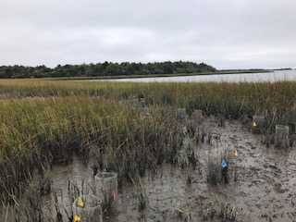Field experiments were conducted on an intertidal mudflat on Radio Island, Beaufort, North Carolina, U.S.A. following a similar methodology to Hunt et. al (1987) (Figure 1). Large adult *Littoraria irrorata* were collected from a mudflat on Gaming Island; a small marsh island in Core banks where infection prevalence of *Cercaria opaca* was known to be high (>40%).

Figure : Field Experiments were conducted on an intertidal mudflat on Radio Island, Beaufort, North Carolina.

Collected *Littoraria irrorata* were then isolated in small, nonaerated plastic dishes filled with artificial seawater (34 ppt) and left for 24 hours in a warm room to encourage the shedding of treamatode *C. opaca*. Following the isolation period, dish contents were examined under a dissecting microscope to determine infection status (figure 2, 3). To distinguish infected and noninfected periwinkle in the field, the shells of snails that shed *C. opaca* were marked with a dot of red water-resistant paint while snails that shed no *Cercaria* were painted with a dot of blue paint. The two groups of snails were placed in separate, aerated, flow through tanks and provisioned with S*. alterniflora* before being added to experimental plots in the field.

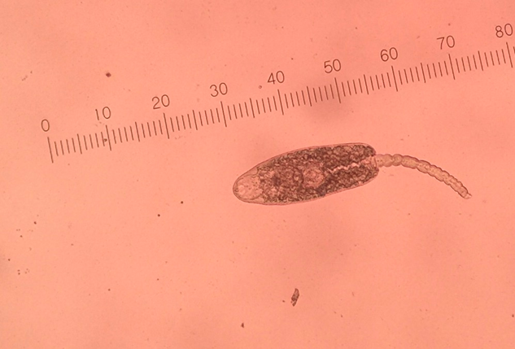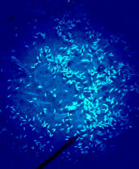

*Figure 2 (left): Experimental method of determining infection status of Littoraria irrorata. Specimen were placed in an airtight container and incubated for 24 hours to endorse the shedding of Cercaria, and water was examined for infection status under compound microscope.*

*Figure 3 (right): High infection density of Cercaria opaca in gonads of Littoraria irrorata under dissecting scope.*

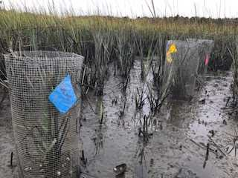Experimental plots consisted of circular enclosures crafted from galvanized hardware cloth (mesh size = 0.5-in), with a circumference of 0.654 m, diameter of 0.205 m, and total surface area of 3.31E-2 m2 when the edges were zip-tied together. 3.0 mm of the wall was folded into a lip at the top of each enclosure to prevent *L. irrorata* from escaping the plot, and the base of the enclosure was buried 2 mm deep into the sediment of the mudflats, leaving 60 mm of the enclosure vertically exposed above the surface of the sediment.

Each plot was assigned to one of the following treatments (n=10 replicates per treatment): (1) high infection prevalence (40% infected), (2) low infection prevalence (0% infected), and (3) no snails to test for the effects of periwinkle addition. Ten open plots acted as cage controls. *L. irrorata* were added to enclosures at a density of 30 individuals per enclosure. The enclosures were placed below the lower distribution of the periwinkles normal habitat during the summer months so that all enclosures contained no initial specimen (Hunt et al.,1987). Initial sampling and experimentation began on 6 October 2017, where cages were deployed, fiddler crab burrows-both juvenile and adult, S*partina alterniflora* stem density, stem height, and estimated mass inside each of the 40 experimental plots were taken. *U. pugnax* burrows were defined as juveniles if size was smaller than a pinhead. It was determined that using burrows were a viable as a proxy for fiddler crab abundance in *Uca* pugnax due to studies on *Uca* species returning a 0.91 correlation coefficient for Uca *annulipes* (Macia et al., 200). Three days after cages were deployed in the marsh meiobenthic samples were taken, with 40 meiofaunal cores. On 13 October, 2017, *L. irrorata* were deployed into their associated cage, with 40% infection prevalence cages marked with a red flag, 0% infection prevalence cages marked with yellow flags, and control cages with no snails marked with yellow flags (figure 4). The temporal scope was four weeks, and when field experimentation was terminated 14 November 2017, all initial parameters were retested. Samples were taken at low tide when sediment was fully exposed, taking cores 2 cm2 wide by 3cm deep for meiofauna. One sample for each plot was taken, resulting in forty samples.

Figure 4: Cages were marked by infection rate, where blue flags corresponded with a 0% infection rate, red flags with a 40% infection rate, and yellow flags as controls with no gastropods present.

Meiofauna samples were sieved first through 500 microns, and then sieved to 63 microns. Samples were preserved in a 10% formalin for 24 hours, and then ultimately preserved in 70% ethanol for analysis, which was dyed with Rose Bengal for identification purposes (figure 5).

 Figure 5: processed meiofauna samples were stored in 10% formalin for 24 hours for preservation of tissues (left), and then transferred to 70% ethanol stained with rose Bengal for identification and long term storage (right).

Using a bivariate analysis and Tukey hsd test for significance in JMP, components were tested across time with regards to treatment. Taking a square root transformation to account for variation to determine if there was a significant difference between presence and infection of *Littorea* and meiofauna diversity and abundance, *Spartina* density, stem height, and biomass, and active fiddler crab burrows.

Using a PRIMER 6 package for non-metric multi-dimensional scaling (nMDS), meiofauna abundance by taxa was incorporated in the model across time and treatment. Placing each observation in an 81 by 81 cell matrix, nMDS tested similarity between observational measurements and ordered them by similarity to each observation. A multivariate analysis of primary meiofauna taxa across time was first conducted using a pairwise of treatment by time PERMANOVA. Preforming PERMANOVA utilizes the PRIMER package to take out 999 random subsets and calculates mean and F-values, comparing them to the whole dataset F-value. These values create a distribution from the dataset unlike ANOVA, so less assumptions are involved. This Bray-Curtis resemblance matrix of biological counts plots the observations on a MDS plot graph according to similarity by treatment. It is important to note that one cannot measure distance on this graph- only relative similarities based on how far the two points are spaced. The number of dimensions necessary for an accurate representation of the data can be found looking at the stress on the number of dimensions. Stress represents the difficulty of compression into the number of dimensions; below a stress of 0.1 , the dimension is compressed correctly, at a level of 0.1-0.2 the number of dimensions should be used with caution, and any stress level above 0.3 should utilize another dimensional level for accurate interpretation of the dataset across time and space. Given a 0.13 stress level in 2D but only 0.09 stress level in 3D, 2D was maintained for easier interpretation.

Within PERMANOVA, the center of the treatments being significantly different in spread can be due to dispersion alone, so a PERMDIST of dispersion should be constructed to show how spread the centroids are. If no significant difference is found using this PRIMER function, then no significance found using PERMANOVA is caused by dispersion, only due to treatment and time.

The second test of multivariance utilizes the same similarity matric constructed in primer, but unlike PERMANOVA, a principal component analysis (PCA) is based on correlations between the datasets themselves, where a longer line on the by plot signifies an increased importance to the dimensional axis of the adjacent plot.

**Results**

3.1 Direct Effects of Parasitism on *Spartina alterniflora*

4 weeks after experimental plots were deployed into the field, final results were recorded and samples were taken. Figures 6-8 display visual results of *Spartina* die-off in three treatment plots. Uninfected plots were observed to have significant live biomass declines as compared to control plots with no periwinkle interaction. 40 percent infection plots showed an intermediate die-off, leading to preliminary conclusions that infection of *C. opaca* in *Spartina* has a mitigating effect on vegetation declines**.**

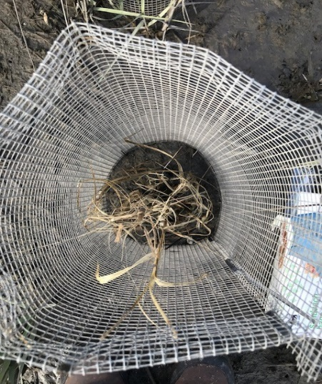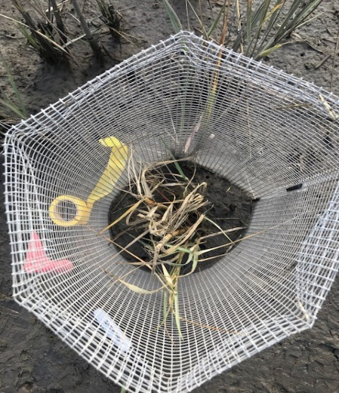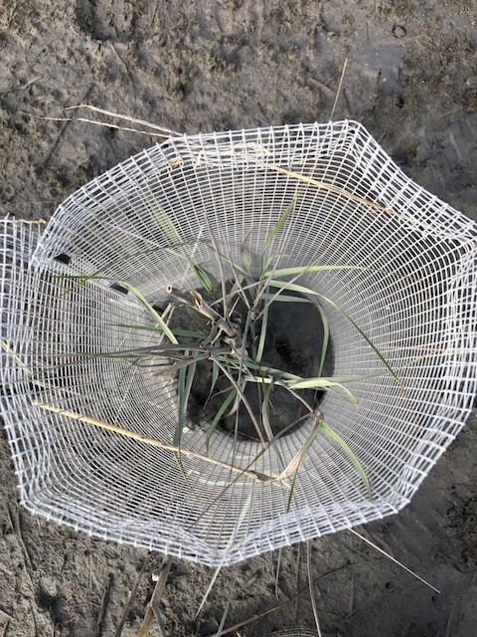

*Figure 6: Left- final uninfected plot Spartina data. Center-high infection plot. Right-control plo.t*

*L. irrorata* have been determined to exhibit a strong top-down control on salt marsh cordgrass *S. alterniflora*. Investigations have overturned previous assumptions that bottom-up interactions controlled trophic structures in salt marsh systems, showing that the grazing of herbivores on *S. alterniflora* may significantly affect growth and reproduction (Silliman et al., 2001). Unpublished field experiments conducted by Sarah Goodwin in 2016 at Duke marine lab showed a significant decline in grazing scars and infection of single stems of *Spartina* in *Littorari*a infected with *Cercaria* as compared to noninfected periwinkle (p = 4.48E-05) (Figure 9). On a small scale interaction field study looking at how plots fit with one snail and one stem of *Spartina*, grazing scars and leaf length were measured to determine the behavioral effect of parasitism on snail grazing. Results concluded infection may help to reduce negative impacts on marsh grass growth.

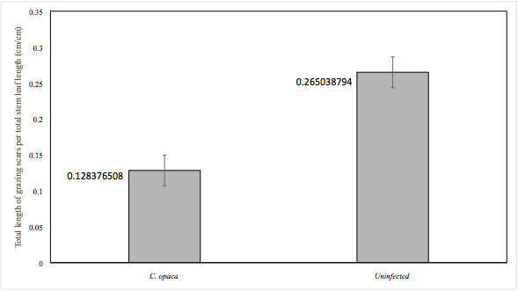

Figure 7: Experiment on the direct effect of infection of Littoraria irrorata with Cercaria on single stem. A grazing period of 3.5 weeks was implemented as the temporal scope, with one I. irrorata and one stem per plot (n=90). 30 infected plots, 30 uninfected plots, and 30 control plots with no snails were analyzed to measure grazing scars and leaf length.

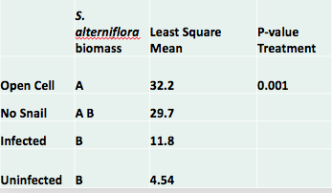

Further validating the effect of parasitism in *L. irrorata* on *Spartina* grazing, this study, which used an average initial stem density of 8.8 stems per plot, and an average initial biomass of 24.3 grams showed a significant decrease in biomass in uninfected plots as compared to control and open plots (figure 10, 11). Tukey hsd significance testing from bivariate analysis accounting for variation in data through a square root transformation of final data and initial data in respect to treatment returned a p-value of 0.001. Infected plots showed an intermediate effect on *Spartina* biomass although not significant, with a significant difference between uninfected plots and open cell plots.

Table:: Uninfected plots are significantly different than open treatments, while infected plots are an intermediate player, shown by an intermediate least square mean, insignificantly different from no snail or uninfected plots.

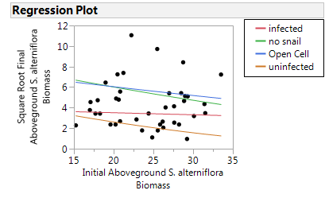

Figure 8: Plotted using a bivariate analysis in JMP, regressions between the four treatments with regard to initial aboveground Spartina alterniflora biomass and square root transformed final aboveground biomass us shown. Infection of L. irrorata causes a behavioral alteration which decreases grazing rates on Spartina alterniflora as compared to uninfected plots.

**3.2 Indirect impacts of *C. opaca* parasitism on meiofauna abundance**

Initial sampling of meiofauna before field experimentation began showed no significant difference between treatment plots for both species richness and abundance. However, infected and control plots had a higher species abundance, primarily in nematodes, even though random assignment of plots throughout the lower middle marsh was done in an attempt to avoid skewing of data. Due to this variation in initial data, square root transformation of data was conducted to scale differences overtime to a comparable system.

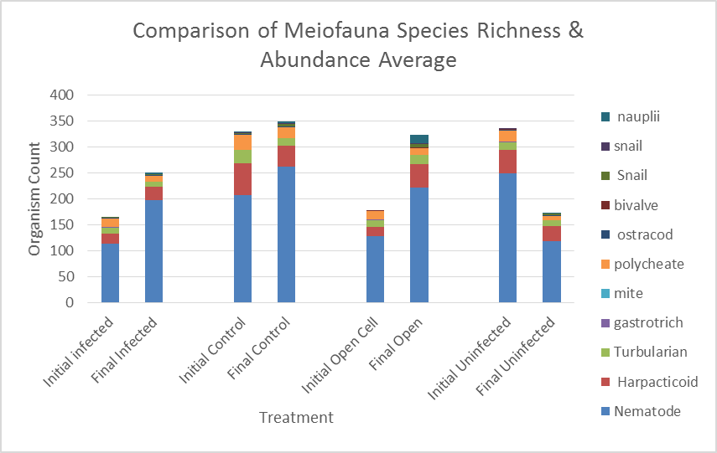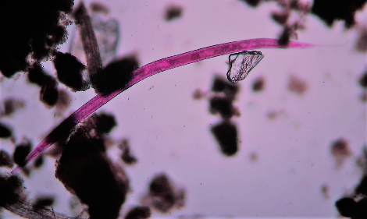 Species richness overtime is seen to increase in plots- although not significantly- with the addition of nauplii and embryonic species, which although were in high abundances, were not included in final analysis due to an inability for taxa determination (figure 9).

Figure 9: 80 total meiofauna samples were analyzed, where species within the size range of 63 and 500 microns were grouped by taxa to show species richness and abundance as an average per treatment. Each bar shows an average of abundance per species across 10 treatments.

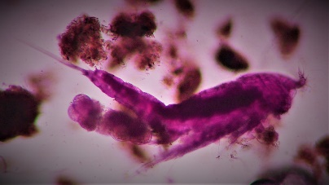 By far, the most abundant taxa identified in core samples were nematodes, which accounted for 63%-79% of all samples. Nematodes, which are small, multicellular threadlike organisms, inhabit most environments. Vegetation type and concentration modifies species type and distribution. Nematodes play a key role in bioturbation, utilizing organic matter for nutrients (Dum 2014). With the potential to be utilized as a proxy for ecosystem health, this taxa provides a nutritional source for higher trophic levels and are closely paired with detritus and bacterium. Harpacticoids, a subgroup of the taxa copepod consisting of over 4,500 species, are bio indicators that alter abundance from toxin, salinity, and dissolved oxygen flux, are the second most abundant grouping of meiofauna organisms discovered in sample analysis (Stephenson, 2008). Due to the nematodes overwhelming abundance in samples, another graph was created, omitting or excluding nematodes to better look at species richness and abundance (figure 12). Harpacticoids, now seen to consist of 10%-18% of meiofauna abundance, consume algae, bacteria, and organic waste, and play a key role in commercially important fish life cycles, as juveniles often eat these meiofauna groups. Preliminary analysis on interactions between these two most abundant taxa revealed an inverse relationship between nematodes and harpacticoids. Due to competition for microbenthos biomass, a limiting resource, this inverse relationship may be more pronounced as grazing rates of future organic matter are affected by *L. irrorata* (Wilson & Duarta, 2009).

Figure 10: Meiofauna taxa of nematode; a long, multicellular worm.

Figure 11: Copepod subgroup of harpacticoid; a highly diverse organism feeding on microbenthos.

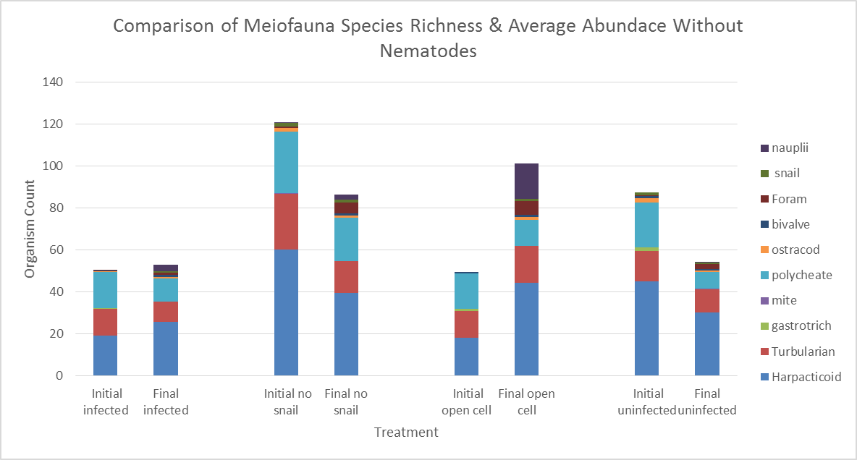

Figure 12: Taxa richness and abundance as an average per treatment. Each bar shows an average of abundance per species across 10 treatments, without nematodes included in graphing, to show other abundant species. Harpacticoid accounted for 10-18% of total meiofauna abundance, with other key players being Polychaeta and Turbellaria.

Four key taxa were found most prominent throughout all samples, and were used as a proxy for overall change in meiobenthic structure: nematodes, Polychaeta, harpacticoids, Turbullaria. A bivariate analysis was first conducted for each of these four taxa, to look at treatment significance. Initial counts with regards to treatment was analyzed against the square root transformed final counts to account for variation in data. Nematodes are seen to be the main driver of total change in these analyses, with uninfected plots being significantly different than all other treatments, retuning a p-value of 0.0041 (Table 1). Harpacticoids showed a significant difference between no snail and control plots, but not between uninfected and infected treatments. You can however see, through the least mean square values, that the infected plots have a value almost twice as large as uninfected plots, showing an intermediate effect is present. Overall effect of abundance over time using a covariate analysis showed infected plots to be an intermediate player, with infected plots being significantly different than both 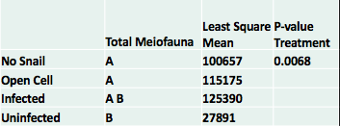control and no snail treatments (p= .0068).

*Table 2: Total meiofauna shows infected (40%) plots to be an intermediate between infected and other (p=0.0068). Normal behavior of uninfected snails seems to result in a decrease of total meiofauna.*

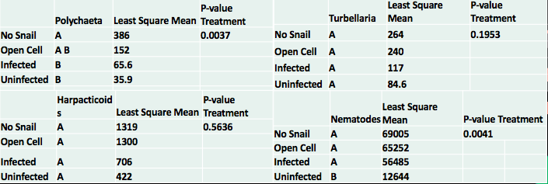 Neither Polychaeta nor Turbellaria had any significant differences among treatments. One hypothesis for this could be the ease of travel in and out of plots. Turbellaria and Polychaeta have a much easier time with locomotion than nematodes and Harapcticoid, so differences in treatments, which may have resulted in unfavorable conditions for these taxa, may have caused movement out of the system. However, since this is not reliable, two sets of multivariate analysis were conducted to determine if treatments had an effect on these two taxa when taking other factors into account.

*Table 3: Nematodes are shown to be the main driver of total change in this system, with a significant difference between infected and all other treatments (p=0.0041). Polychaeta returned no significant difference between difference between infected and uninfected blots, nut a significant difference from no snail treatment (p=0.0037). No significance is seen for Harpacticoid and Turbellaria.*

**3.2 Multivariate analysis of Prominent Meiofauna taxa**

Using PRIMER 6 to conduct a multivariate analysis on primary meiofauna taxa across time with regards to treatment, the first set of analyses was a pairwise of treatment by time PERMANOVA, which returned a significant difference between uninfected, open cell, and infected treatments: p= 0.01, 0.03, 0.005, respectively. There was however, no significant difference across time for no snail plots. An additional PERMDISP test of dispersion was conducted in order to ensure the spread of the centroids was not the cause of significance among treatments. Returning a p-value of 0.905, PERMANOVA significant results were ensured to be due to treatment, time, and the interaction between the two rather than due to dispersion. Plotting results in 2 dimensions was deemed to have a low enough stress level for accurate interpretation of results (Figure 13). Stress values retuned a 0.15 for 2D, but only a 0.09 for 3D, which is more difficult to analyze. Open cell treatments likely returned a significant difference over time due to chance. Because the plots were open to all potential predator-prey interactions, immigration and emigration, and other ambient environmental conditions, change over time was likely to occur. Due to the result that there was no significant difference across time for no snail treatment plots, this can be verified.

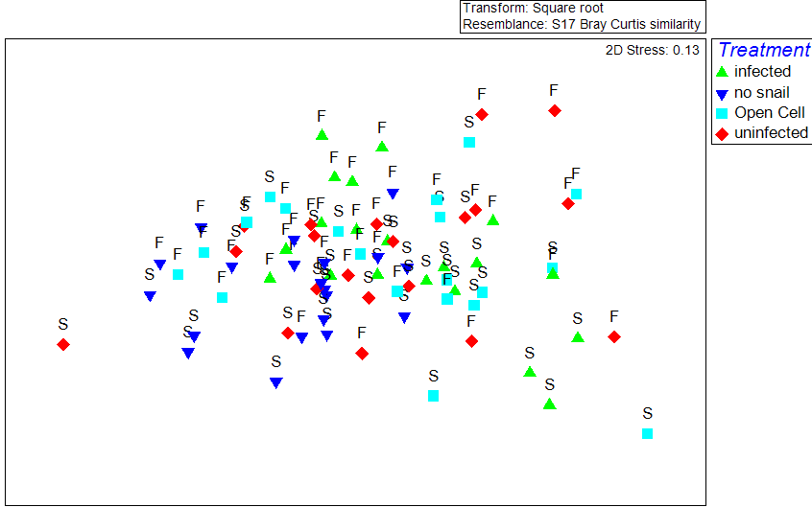

**Multivariate analysis of primary meiofauna taxa across time**

**S=**initial sampling

**F=**final sampling

*Figure 13: Using PRIMER6 to create a similarities matrix, a PERMANOVA analysis Bray Curtis similarity analysis of time, treatment, and the similarity between the two was analyzed for prominent meiofauna taxa. After a PERMDISP of dispersion was conducted to ensure significance was caused by interactions between factors and not the dispersion of centroids (p=0.907), it was seen that there was a significant difference across time for meiofauna in all treatments except the no snail treatment. Significance for uninfected plots, infected plots, and open plots were p=0.01, 0.005, 0.03, respectively.*

When conducting a bivariate analysis in section 3.1, Tukey hsd tests returned no significance in prominent meiofauna taxa harpacticoid and Turbellaria over time across treatments. Results could have been caused by the locomotor activity of these two taxa, allowing them to potentially move in and out of the system when unfavorable conditions arose. However, due to the unreliability of this conclusion, a second multivariate analysis was conducted to look at the correlation between prominent taxa across time by treatment. A principle component analysis, or PCA, is a test of correlation itself, where the byplot adjacent to the plotted data shows the strength of correlation among observational points according to meiofauna taxa. Results proved nematodes to be the most important taxa across treatments and time, showing a general decline, especially in infected plots. The results also showed the importance of harpacticoid, Polychaeta, and Turbellaria across time. Harpacticoids experienced a population decrease over time, but less effect was seen with infected and uninfected plots. This could be due to seasonal change, or associated with nematode decline. As previously mentioned, there seems to be an inverse relationship between harpacticoid and nematode, so as nematodes declined in infected plots, and significantly so in uninfected plots, this would allow for increased resources for harpacticoid, minimizing the effect of the taxa in these treatment plots across time.

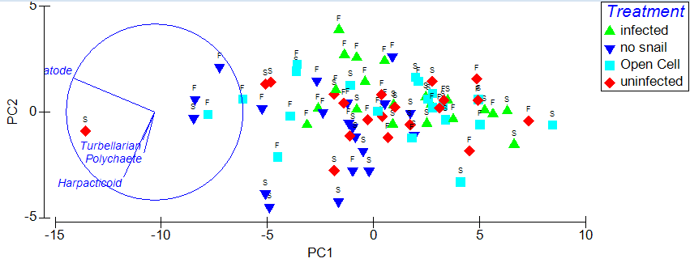

**PCA for Correlation**

**S=**initial sampling

**F=**final sampling

*Figure 14: In a principle component analysis, correlation among 80 samples was analyzed in a similarities matric, which was then plotted for importance of meiofauna taxa importance across treatment and time. Nematodes are seen to have the most significant impact, but all prominent meiofauna taxa, even Harpacticoid and Turbellaria, which were seen to have no significance using a bivariate analysis, played a key role in changes across treatments over time.*

**3.3 Direct effects of Spartina on community structure**

Consumption of *Spartina* by *L. irrorata* was seen to have direct effects on biomass and overall stem density. Stem density decreased by an average of 2.6 in uninfected plots, 2 in infected plots, and 0.6 in control treatments. Biomass in no snail treatment declined 1.5 grams on average, control plots an average of 1.9 grams, infected plots by 4.0 grams, and uninfected plots by 6.1 grams. Due to decline in both stem density and biomass in all treatments over time, seasonal change due to cold weather transitions is thought to play a role, making the need for standardization necessary in analysis. To look at change in non-sessile organisms, such as meiofauna and fiddler crabs, an average change across treatments was taken. This resulted in only 4 points per plot, one per treatment, but since you cannot look at the change in organisms, only *S. alterniflora*, this was the best option for analysis. This inability to test organisms across time is pause a single organism at the beginning does not correspond to a single organism at the final testing time. When taking meiofauna samples the organisms are physically removed from the environment and fixed in ethanol, and burrows of *U. pugnax* are not sure to be the same at exact time of testing. Given this information, there is no logical reason to compare the two. Therefore, final must be compared to initial with regards to variation in proportion with treatments, and so an average is taken across treatment in time. JMP showed a positive correlation between aboveground biomass and meiofauna abundance in plots (R2 = 0.558) (Figure 15). Where uninfected snails are present- where there is a greater change in biomass over time average meiofauna abundance is negatively affected. The negative affect is primarily caused by nematodes due to their overwhelming abundance in the system.

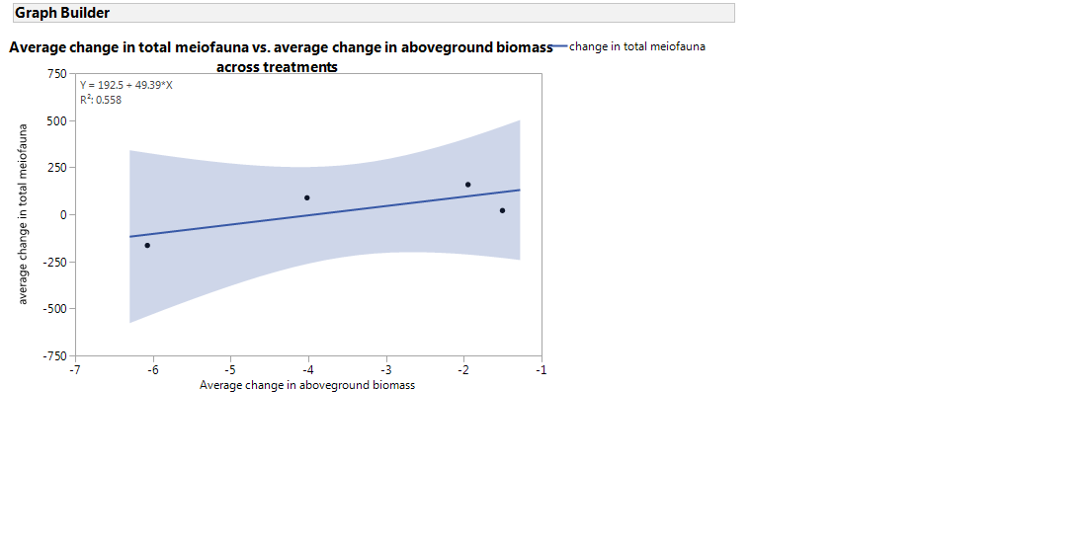

Figure 15: Intermediate effects of L. irrorata grazing on community structure shows as biomass in the system increases, prominent meiofauna taxa abundance increases, with an R2 of 0.558. Where uninfected snails are present- where there is a greater change in biomass over time-average meiofauna abundance is negatively affected. This negative effect is seen primarily from nematodes. The effect of stem density across time on meiofauna abundance: weak positive effect but nonsignificant (R2=0.157).

.

A positive correlation between *Spartina* *alterniflora* and *U. pugnax* would be present, as sediment oxygen levels and nutrient levels are greater around *Spartina* culums, and fiddler crabs utilize these vegetation outputs for survival. In a study conducted regarding facilitation effects of *Spartina* growth and fiddler crabs, it was shown that sediment oxygen levels were higher and *S. alterniflora* belowground biomass was reduced in the presence on *U. pugnax*, implying that *U. pugnax* facilitated *Spartina* growth (Gittman et al., 2013). Experimental data supported this hypothesis, as a positive correlation between *U. pugax* burrow presence and meiofauna over time was shown. An even stronger correlation between meiofauna change in time and fiddler crab density, with a correlation coefficient of 0.788 was seen (Figure 16). This is likely due to the overwhelming abundance of nematodes in samples, which utilize *U. pugnax* burrow for protection from predators, food, and oxygen in normally hypoxic or anoxic sediment.

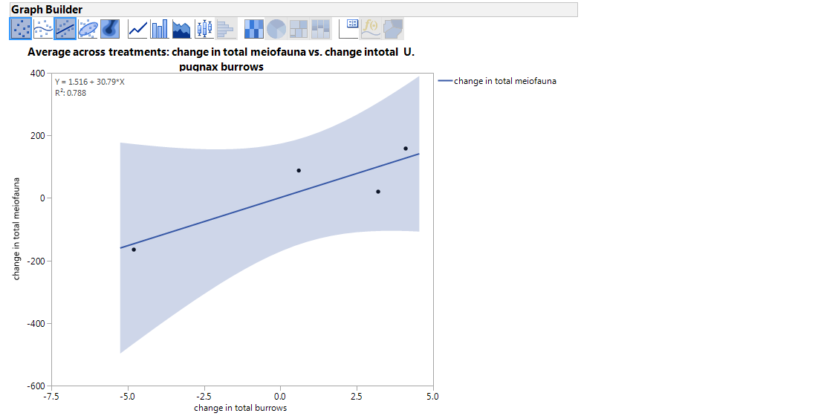

*Figure 16: Using an average across treatments to look at organismal change across time (each point consists of 10 observations, a direct positive relationship can be witnessed between meiofauna and Uca pugnax burrows. Increasing burrows increases the abundance of meiofauna, likely nematodes, who utilize fiddler crab burrows for oxygen in normally hypoxic and anoxic conditions, food, and protection from predators.*

**Discussion**

It is notoriously difficult to quantify an individual species impact on an ecosystem due to the various factors that play a role in ecosystem heath and individual component flux. A myriad of biotic and abiotic factors work together keep salt marsh systems healthy. In the Southeastern USA, die-off began to occur in large magnitudes at the end of the 20th century. Scientists initially believed that this large scale loss of *S. alterniflora* biomass was a result of climate change inducing higher salinity levels in the water and soil. However, through a number of experimental studies in southern salt marsh systems, it was revealed that a synergistic relationship between salinity and *L. irrorata* was taking place (Silliman, 2005). Decreases in predation rate from terrapin and blue crab to the marsh periwinkle through drought intensification and overharvesting allowed *L. irrorata* populations to grow exponentially. Since *L. irrorata* use *S. alterniflora* as a food source, creating lacerations and growing fungus on the blade grass*, Spartina* die-off occurred rapidly*.*

Parasites can act to control herbivores directly through a reduction in density or reproductive capacity, or indirectly by increasing probability of predation, or decrease in nutrition from behavioral modifications (Jones et al., 1997). Changes in phenotype can affect all members of a host community through cylindrical interactions, and so parasites may be able to alter ecosystem stability. *C. opaca* acts to reduce climbing rates and grazing *of L. irrorata* on *S. alterniflora* significantly. This occurs both on an individual level- one snail to one *Spartina* stem- and at relevant infection rates in nature -40 percent infect at an approximate 100 snails per meter given multiple culums of *Spartina* (figure 9,11*). Spartina* can then act as an intermediate facilitator for meiofauna reduction. Data clearly suggests a significant relationship between *Spartina* aboveground biomass and meiofauna abundance, especially nematodes, the most abundant meiofauna taxa in the system averaging approximately 70% of all samples (Figure 14). An increase in meiofauna followed an increase in aboveground biomass, which supports a hypothesis that meiofauna utilize *S. alterniflora* for resources and protection. Across treatments, uninfected plots had the highest loss of meiofauna and *Spartina* aboveground biomass, and infected plots showed an intermediate effect for *S. alterniflora* and meiofauna loss. This signifies that infected plots, which alter behavior or *L. irrorata* to decrease grazing on *S. alterniflora* positively affects meiobenthic community structure.

Limitations on ability to measure immediate alterations from the introduction of periwinkle infected with *C. opaca* and clean of any trematode infections shows change in snapshots rather than as a time lapse through time. Cage mesh may not have allowed the escape or entrance of macroinfaunal species such as gastropods and large and non-burrowing organisms, but meiofauna can easily escape experimental plots. Due to their size, meiofauna are highly dependent on tidal cycles as well as seasonal variation from temperature and salinity flux. To try and account for variation with tides, all samples were taken at low tide when the mudflat was exposed, but population shifts over time in all treatments to show a negative reaction to temperature decline with fall weather. Time constraints did not allow for different rates of infection to be tested for impacts on the surrounding ecosystem, or variation in concentration of snails per unit area of space. The difference in meiofauna abundance, even though random plot assignment across the marsh was conducted to mitigate difference due to elevation of *Spartina* density and fiddler crab abundance. Regardless of these limitations, the presence of periwinkle in the salt marsh system had a significant impact on meiofauna abundance, particularly nematode abundance, with a .0041 p-value after square root transformation of observations with regard to treatment across time (Table 3). Overall, there is a significant change caused by non-infected *L. irrorata*, with infected treatments (40% infection) resulting in an intermediate effect in the system (p=0.0068) (Table 2). multivariate analysis using PERMANOVA showed a significant difference in time, treatment, and the interaction between the two factors for all treatments except no snail plots (Figure 13). A PCA for correlation showed that there was a significant change across treatment and time mainly by nematodes, but also from other prominent meiofauna taxa harpacticoid, Polychaeta, and Turbellaria (Figure 14). Experimentation displayed a strong positive correlation between fiddler crab burrows and meiofauna abundance (R2=0.788), but no correlation between stem density and fiddler crab burrows, or change in meiofauna and stem density (weak R2=0.157). However, these are thought to be key role players in trophic system, and so manipulation tests to look at their effects on the surrounding environment must be conducted before finalizing conclusions on organismal role in salt marsh systems. In addition, looking at how snail density affects meiofauna structure and how fiddler crabs affect meiofauna will tie all conclusions together.

Experimental parameters created by a manipulation of parasitism of *C. opca* in *L. irrorata* in an intertidal salt marsh in Beaufort, North Carolina allowed the role of parasitism on the surrounding ecosystem to be measured. In the wake of increasing temperatures and more frequent drought induced salinity intensification due to global climate change, as well as increased occurrences of overfishing, particularly in crustaceans and fish, *Spartina alterniflora* die-off is increasing in magnitude, and predators such as blue crabs are becoming less frequent. These factors are allowing resilient keystone species *L. irrorata* to reproduce exponentially. However, parasitism in *Littoraria* by trematodes such as *Cercaria* opaca is also increasing, due to their affinity towards warmer temperatures. This parasite intensification may be a biological adaptation to help mitigate negative impacts of *L. irrorata* on the surrounding ecosystem. Altered behaviors, including decreased climbing rates and grazing on *Spartina* show that at moderate infection (40%), there is no significant difference in *Spartina* die-off meiofauna abundance, stem density, or fiddler crab burrows from control and open plots. Still very little is known about how parasites can modify the behaviors of keystone species, and how these phenotypic alterations can affect the resistance and resilience of ecosystems to press and pulse disturbances, but data suggests that modifications of *C. opaca* on *L. irrorata* in southern salt marsh systems have a positive impact both directly on *Spartina* and indirectly on meiofauna abundance.

**References**

Bell, S. S. (1980). Meiofauna-macrofauna interactions in a high salt marsh habitat. *Ecological Monographs, 50*(4), 487-505. doi:10.2307/1942654

Born-Torrijos, A., Poulin, R., Perez-del-Olmo, A., Culurgioni, J., Raga, J., & Holzer, A. (2016). An optimised multi-host trematode life cycle: Fishery discards enhance trophic parasite transmission to scavenging birds. *International Journal for Parasitology, 46*(11), 745-753. doi:10.1016/j.ijpara.2016.06.005

Du, Y., Gao, S., Warwick, R. M., & Hua, E. (2014). Ecological functioning of free-living marine nematodes in coastal wetlands: An overview.*Chinese Science Bulletin, 59*(34), 4692-4704. doi:10.1007/s11434-014-0592-z

Gittman, R. K., & Keller, D. A. (2013). Fiddler crabs facilitate spartina alterniflora growth, mitigating periwinkle overgrazing of marsh habitat.*Ecology, 94*(12), 2709-2718. doi:10.1890/13-0152.1

Hunt, J. H., Ambrose, W. G., & Peterson, C. H. (1987). Effects of the gastropod, ilyanassa obsoleta(say) and the bivalve, mercenaria mercenaria (L.), on larval settlement and juvenile recruitment of infauna.*Journal of Experimental Marine Biology and Ecology, 108*(3), 229-240. doi:10.1016/0022-0981(87)90087-6

Jones, C. G., Lawton, J. H., & Shachak, M. (1997). Positive and negative effects of organisms as physical ecosystem engineers.*Ecology, 78*(7), 1946-1957. doi:10.1890/0012-9658(1997)078[1946:PANEOO]2.0.CO;2

Lambert, W. J., Corliss, E., Sha, J., & Smalls, J. (2012). Trematode infections in littorina littorea on the new hampshire coast. *Northeastern Naturalist, 19*(3), 461-474. doi:10.1656/045.019.0308

Martorelli, S. R., Fredensborg, B. L., Leung, T. L. F., & Poulin, R. (2008). Four trematode cercariae from the new zealand intertidal snail zeacumantus subcarinatus (batillariidae).*New Zealand Journal of Zoology, 35*(1), 73-84. doi:10.1080/03014220809510104

Silliman, B. R., & Zieman, J. C. (2001). Top-down control of spartina alterniflora production by periwinkle grazing in a virginia salt marsh.*Ecology, 82*(10), 2830-2845. doi:10.2307/2679964

Silliman, B. R., & Bertness, M. D. (2002). A trophic cascade regulates salt marsh primary production.*Proceedings of the National Academy of Sciences of the United States of America, 99*(16), 10500-10505. doi:10.1073/pnas.162366599

Silliman, B. R., J. van de Koppel, M. D. Bertness, L. Stanton, and I. Mendelsohn. 2005 . Drought, snails, and large-scale die-off of southern U.S. salt marshes. **Science**310: 1803-1806. [doi:10.1126/science.1118229](http://www.sciencemag.org/content/310/5755/1803)

Born-Torrijos, A., Poulin, R., Perez-del-Olmo, A., Culurgioni, J., Raga, J., & Holzer, A. (2016). An optimised multi-host trematode life cycle: Fishery discards enhance trophic parasite transmission to scavenging birds.*International Journal for Parasitology, 46*(11), 745-753. doi:10.1016/j.ijpara.2016.06.005

Wardle, W. J., Minello, T. J., Webb, J. W., Wu, T., & Jewett-Smith, J. (2001). algal pigments, meiofauna, and macrofauna from two edaphic salt marsh microhabitats in galveston bay, texas, usa. *Wetlands, 21*(4), 474-483. doi:10.1672/0277-5212(2001)021[0474:APMAMF]2.0.CO;2

Wilson, M. J. (2009). *Nematodes as environmental indicators*. Wallingford, UK: CABI. doi:10.1079/9781845933852.0000

Zengel, S., Montague, C., Pennings, S., Powers, S., Steinhoff, M., Fricano, G., . . . Michel, J. (2016). Impacts of the deepwater horizon oil spill on salt marsh periwinkles (littoraria irrorata).*Environmental Science & Technology, 50*(2), 643-652. doi:10.1021/acs.est5b04371