Working and Playing
Mill-Sponsored Baseball in the Early Twentieth Century in the Piedmont of North Carolina

By
Emily Cathey

Senior Honors Thesis
History Department
University of North Carolina at Chapel Hill

25 March 2015

Approved:

Dr. Harry Watson, Thesis Advisor

Dr. Zaragosa Vargas, Reader

Dr. Matthew Andrews, Reader
Acknowledgements

I’d like to thank my advisor, Dr.Watson, for helping me through this entire process, even during the roughest of drafts and pointing me in the right direction. I’d also like to thank my additional readers, Dr. Vargas and Dr. Andrews, for agreeing to read my thesis, helping with my defense, and providing guidance throughout this journey. A big thanks to Dr. Duval for leading the class and all of her support. Thanks to Griffin, Andrew, Meg, Kayla, and Emily for reading and editing my drafts. Thanks to Brenna for all of the support, much needed stress relief, and late-night encouraging texts before deadlines, particularly on the hardest days. Thanks to Katie for putting up with me on the days when I felt like quitting and allowing me to vent when needed. Thanks to my entire thesis class for all of your feedback and helping me through the times when I felt stuck. Finally, thanks to my loving parents and wonderful brother. Without all of your support I would be nowhere close to where I am today and there is no way I could have finished this massive undertaking. You guys mean the world to me. From June until now, for everyone who has supported me through this process even if it was just listening to me vent, this is for you.

Table of Contents

Introduction……………………………………………………………...4

Chapter One………………………………………………………………8

Chapter Two……………………………………………………………..20

Chapter Three…………………………………………………………….34

Chapter Four……………………………………………………………...47

Conclusion………………………………………………………………..60

Bibliography……………………………………………………………...59

Introduction
The story of the Copeland family is a familiar tale. Around the turn of the century they lived on a small farm in rural Orange County, North Carolina, getting by selling cotton. Their family lived on the same plot of land for generations working as farmers and carpenters. They were never rich and life could be hard sometimes, but they had enough to survive on. All of this changed after the Civil War. Higher taxes drove them to commercial farming. They took on debt to expand their land to make it profitable, but then crop prices dropped exponentially. By 1894 a pound of cotton only cost five cents, or about half of the price it cost to grow it. Faced with crippling debt and unable to make enough money to put food on the table, the Copelands were forced to leave their land and move to the city to work for the mills. Here mill recruiters promised them a job, a home, a paycheck, and the stability that they desperately craved. They came to the mill in search of a better life. What they found was hard, monotonous labor that left them missing their life on the farm. As Chester Copeland described mill-work:
Nothing but a robot life. Robot-ing is my word for it—in the mill you do the same thing over and over again—just like on a treadmill. There’s no challenge to it—just drudgery. The more you do, the more they want done. But in farming you work real close to nature. There’s always something changing in nature. It’s never a boring job.

Many small farmers in North Carolina at the turn of the century faced the same fate as the Copelands. Within a span of thirty years from1880 to 1915, tens of thousands of farmers migrated to the mills. The number of workers employed in the industry increased from 10,000 to 51,000 and the number of mills in the state skyrocketed from 60 to 318 in the thirty year frame. These workers found their new home in the mill villages. The mills ran for five and a half days a week every week, but in the few hours off workers managed to create their own culture including string bands, box parties, and churches.
The textile workers were a unique cultural group in North Carolina. They were exceptionally poor to the point that if the poll tax was enforced, they would have been disenfranchised.Mill-hands worked long hours just to put food on the table and had little extra for entertainment or other luxuries. Along with being poor, they were also socially isolated from the outside communities. Most townspeople, whom the workers called “townies”, looked down upon mill workers and as Hoyle McCorkle recalled “even the blacks looked down on us.” Those that lived outside of the village took to calling the mill-hands “lintheads” and hurled insults at the people that they considered second-class citizens. This forced the mill workers to look inward to find their own sources of entertainment and to create their own culture; a culture which they embraced passionately.
At the same time, mill owners needed to find ways to control their new labor force. They struggled to find ways to prevent strikes, instill a sense of community life, and improve their relations with workers who were unhappy with their new lives.
Within this intersection of culture and management came mill-sponsored baseball. In the early twentieth century, almost every mill sponsored a team, and baseball quickly became an integral part of the mill village culture. Workers flocked to the ball-field to watch their compatriots play each week, and social lives revolved around the ball-field. For their part, mill owners pumped money into the teams. They funded everything from uniforms and equipment to massive stadiums and higher salaries for ball players. They invested so much that many mill teams rivaled minor league teams in terms of talent and in the size of their stadiums. Through these immensely talented teams, mill workers were able to garner some respect by the “townies.”
There is a notable lack of scholarship on mill-sponsored baseball teams in the early twentieth century in the piedmont of North Carolina. Most of the works on industrial baseball focus on textile mill baseball in South Carolina or the coal mining leagues in Appalachia. This thesis focuses on North Carolina, relying primarily on interviews conducted for the Southern Oral History Program, the memoirs of mill workers, and newspaper articles in conjunction with several secondary sources. It combines three different historiographies: North Carolina History, Labor History, and Sports history.
This thesis argues that mill-sponsored baseball originated as a welfare capitalist activity. Mill owners designed the teams as part of a massive program, to placate the workers, improve labor relations, and implement some degree of social control. However, despite the money the mill owners put into their teams, their objectives were not met. Rather, baseball became a beloved pop culture activity that workers enjoyed either watching or playing during their time off. This paper deals with the spectacle of mill-sponsored baseball it focuses mostly on mill-sponsored baseball at its peak.
The first chapter explores the origins of mill-sponsored baseball. It argues that both owners and workers accepted baseball, but for entirely different reasons. The mill owners sought to instill a degree of social control, improve labor relations, create a sense of community life, and forge a united and loyal labor force. In contrast, the workers desired a fun and physical game, a place to socialize, and a break from work.
The second chapter looks at how mill-sponsored baseball existed during its peak in the early twentieth century. It argues that the teams started out as small-scale organizations designed for welfare capitalism, but turned into a large phenomenon. Each mill-sponsored team and league was unique, but many were so grandiose that they rivaled local minor-league outfits in terms of talent.
The third chapter argues that although mill owners funded the teams with certain objectives in mind, their goals were not met. Rather, baseball turned into a large and popular pop-culture activity, just as the workers desired.
The fourth chapter investigates the end of the spectacle of mill-sponsored baseball teams. It pinpoints the beginning of the decline of mill-sponsored baseball in the late 1950s and argues that because its popularity was the only thing keeping mill-sponsored baseball around, once that popularity waned, mill owners stopped funding their teams. Furthermore, the mill-village system itself declined significantly, bringing the phenomenon of mill-sponsored baseball to an end.
Despite its popularity and the intentions of owners, mill-sponsored baseball did not change the course of American history, nor did it form the cornerstone of American pop-culture in the early twentieth century. However, for the hundreds of thousands of workers in North Carolina’s biggest industry it constituted a significant portion of their lives. Many of the people who grew up watching and playing mill-sponsored baseball are still living today and countless others heard their parents or grandparents describe the phenomenon. The impact of baseball is evident in the books that they wrote and the memories that they shared. These memories are still fresh. Baseball was their history and their history deserves to be told.

Chapter One

Play Ball

The Origins of Mill-Sponsored Baseball

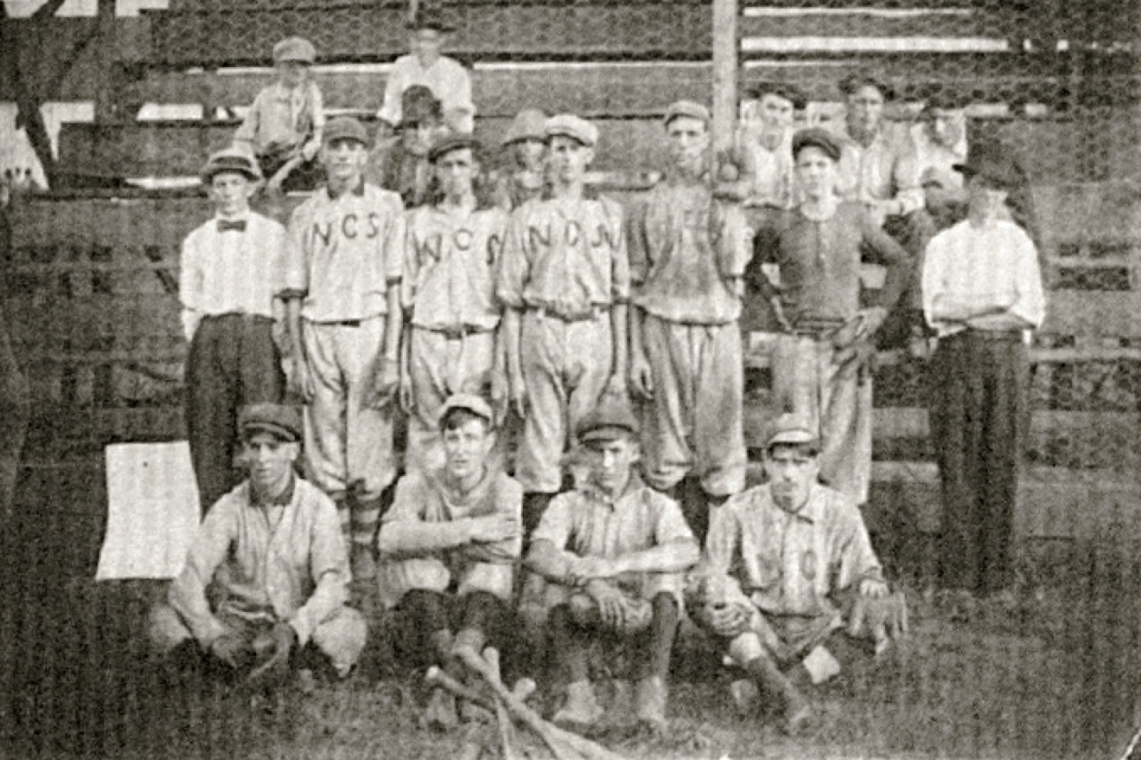
An Early Cooleemee Team, date unknown

“The biggest problem in the mill village for the past five years has been to meet the increased desire for more recreational and educational advantages… If the development, educationally and physically, continues in the industrial village in the south at the same rate as it has been in the last few years, in the next few years these former under-privileged primitive folk will stand head and shoulders above the rank of their former associates”—The Southern Textile Bulletin, 1926

Textile mill owners in North Caroina sought to provide recreation opportunities for their employees, the most famous of which was baseball. There is no record of the first mill village baseball game, just as there is no record of the last one. Yet, somewhere in between those two games, mill-sponsored baseball became a spectacle. The reason behind this growth was the vast amount of money that mill owners pumped into the teams to fund everything from equipment to coaches. Yet, all of this money did not come without reservations. Owners created the teams as one part of their overall welfare capitalist program. Through these activities, the mill owners sought to improve labor relations, create a united and loyal labor force, instill moral lessons, and develop a sense of community life.
Mill workers largely accepted the teams and helped them to become popular. They played on the teams, watched the games, and formed a loyal fan base. However, they did not share the mill owners’ desire to create a passive labor force. Rather, the workers wanted an outlet for recreation and a place to socialize. Ultimately, both mill owners and workers supported the implementation of baseball, though for different reasons.

The Labor Dispute
Tension and conflict between laborers and mill operators began almost as soon as the mills came to North Carolina. As early as 1931, labor historian and Columbia University professor George Sinclair Mitchell argued that the labor struggle was already long, spasmodic, and somewhat fruitless. Though calls for longer hours, better conditions, and higher pay dominated the early labor struggle, the South became primed for union activity in the 1920s when mill operators implemented the “stretch-out”.
The “stretch-out” was the term used by workers to describe the collective changes in labor demands that occurred in the 1920s. Under the stretch-out, wages were tied to output, production quotas skyrocketed, and formally trained managers expected mill workers to tend more and more machines. This grew to the point where some laborers tended over one hundred machines. One worker remarked that all of his machines took up acres of space. Efficiency also experts tracked the employees’ movements with stop watches, aiming to increase profits as much as possible. The system took a toll on the mill-hands. Workers were no longer able to take the small breaks they were accustomed to as they were constantly behind on their quotas and they even ate as they worked. Getting to all of their machines required strenuous exercise and damaged their bodies and those who could not keep up with the pace saw their wages slashed or their jobs lost. The Great Depression saw the intensity of the stretch out increase dramatically to the point where it was described as “the stretch[ing] out of the stretch out.”
Faced with the stretch out, Labor relations reached a climax in the late 1920s. The first major strike came in the summer of 1927 at Harriet Mill in Henderson, North Carolina. Shortly thereafter, in the spring of 1929, one of the largest strikes in the southern United States occurred at the Loray Mill in Gastonia, North Carolina. Following an independent evaluation, the Loray Mill decided to cut their labor force by over 1,000 positions at the end of 1928. The strike started months later, after the left-wing National Textile Workers Union (NTWU) arrived in Gastonia on April 1, 1929. Nearly all of the Loray workers participated in the strike and they called for higher wages, equal pay for women and children, the end of the stretch-out, and union recognition. While the strike remained relatively peaceful at first, good intentions gave way to violence within three months of the strike’s beginning. By the time the affair ended six months later, both the Police Chief, D.A. Aderholt, and organizer Ella May Wiggins were murdered. The strike disintegrated after the conviction of seven union members for the murder of Aderholt and the acquittal of the defendant in the Wiggins’ trial.
The incidents at Henderson and Loray were not the only ones to hit the region. Strikes proliferated throughout the southeast with major strikes taking place at Elizabethton, TN; Marion, North Carolina; Danville, Virginia, and High Point, North Carolina all prior to 1932. Due to all of the strikes, mill owners decided that improvements in labor relations were necessary.

Mill Villages and Welfare Capitalism
In an attempt to ease labor relations, employers turned to the mill village and welfare capitalism. Operators developed the first mill villages in New England in the late 1700s out of both economic and geographic necessity. The earliest mills in New England relied upon waterpower to power the mills’ machinery. Though the topography of New England provided investors with many sources of power, most of the ideal locations were in areas that were virtually unsettled, creating a need to attract workers to the area. Furthermore, with the introduction of the Slater System, mill operators relied upon the labor of poor families who lacked the wherewithal to move to the new mills. In order to recruit these families, owners began to build houses for their workers. This created a system in which each party depended on the other: the owners on the families for labor and the families on the owners for housing necessities. Though some textile mills no longer relied on waterpower by the time the industry began to grow in North Carolina in the 1880s, owners and operators still recruited the poorest families to work in the mills. Thus, they still needed to construct houses in order to entice labor to come to the mills.
The mill village contained one of the most prominent managerial techniques of the early twentieth century: welfare capitalism. Through welfare capitalism, owners sought to ameliorate the perennially strained relations between labor and management by providing a series of programs ranging from social events, such as mill bands and large cookouts, to night classes, all of which the mill ownership financed. Mill owners were exceptionally proud of these programs and took many opportunities to showcase their programs. For example, nearly all of the October 14th 1920 publication of the Mill News: The Great Southern Weekly for Textile Workers newspaper consisted of individual mills highlighting the wide variety of welfare services that they offered. Programs included the sixteen piece band, sports teams, or regular visits from the county nurse of the Carolina Cotton Mills in Stanley, North Carolina or the debating society and welfare department of the Proximity Manufacturing Company in Greensboro, North Carolina.

Mill Owners’ Objectives for Baseball
Recreation activities became popular welfare capitalist programs when employers learned that they could use recreation-based programs as a form of social control. This ideal is best demonstrated by the establishment of Elm Park in Worcester, MA in 1854. Here mill owners supported the creation of the park because it “would calm the ‘rough elements of the city’ and divert men from unwholesome, vicious, destructive methods and habits of seeking recreation”.
Recreation became so popular that companies produced textbooks on industrial recreation. These books outlined the importance of industrial recreation and how managers could integrate it into their own companies. According to these textbooks, industry provided recreation increases profits by meeting the needs of employees. These needs include: the need for activity, the desire for recreation, the desire to create, the competitive urge, the thirst for adventure, and the desire to combat. The book stipulates that if these needs are met, employees would be much happier and thus would be more efficient employees.
Baseball itself became one of the most popular recreation programs, as employers began to see that baseball could be a controlled, hierarchical environment that distinctly separated the owner and employee. The formation of the National League of Professional Base Ball Clubs in 1876, for example, turned baseball into an entertainment business controlled by wealthy owners, with players having little to no say in the operations of the club. In this system owners maintained total control over almost every aspect of their players’ lives, including off-field activities, salaries, and working conditions. Particularly onerous was the reserve clause, which prevented players from leaving the club and seeking better working conditions without being explicitly released from the teams by the owners, essentially leaving owners with a monopoly over their players. The dominance of the wealthy owners over their players resembled the typical owner and worker relationship in industry so much so that S.W. Pope argued that it offered a system of control “unequalled in American industry.”
The mill owners had as many objectives for baseball as they did motivations for funding it, including worker retention. Creating a loyal labor force was very important to mill owners. An article from the Southern Textile Bulletin, a publication written for textile operators, declared, “a highly efficient and economical labor supply is the best asset of the textile mill.” The article goes on to explain that an efficient mill required a skilled and experienced labor force to run the machines. An experienced worker could run more machines and create a higher quality product, thus making him or her more economical than hiring multiple new workers. As a testament to the desire for an experienced labor force, all of the advertisements for workers in the Southern Textile Bulletin desired experienced workers. Thus, operators needed to retain their workers in order to maximize profits and minimize the total payroll. Furthermore, particularly during the early years of the twentieth century, there were more jobs available than unemployed workers. Thus, operators needed to retain their workers so that their mills could even run.
In addition to having a seasoned labor force, employers sought to foster cooperation between the workers and the company. This sentiment appears in many different ways in operator publications. A superintendent from the Chatham Manufacturing Company, for example, declared that just “as a house divided against itself cannot stand” neither could the Chatham Manufacturing Company. Yet no matter how it was phrased the ideology remained the same; the mill owners and operators sought to create a docile and placated workforce that would work wholeheartedly for the company and not go on strike.
Recreation also provided the companies with an opportunity to teach moral lessons and adapt workers to the mill. A.S. Winslow, superintendent of the Clinton Cotton Mills, remarked that many of the games the workers played on the farms were loosely structured and suitable for “true child’s play.” The more structured play of the mills could be used to instill lessons in both children and adults, adapting them to the structure of the working day and how to accept instructions from supervisors and to respect their authority. A prominent moral lesson centered on the temperance movement. Operators were generally in favor of temperance, so much so that when asked about the greatest accomplishment of the Gastonia mills, Lee Love, the founder of the Loray Mill, stated that they prevented the building of distilleries. Welfare capitalist activities provided an alternative to going to the bar and drinking, and many of the services did not allow alcohol, such as when superintendent Louis Bonous of Valdese declared that no alcohol would be stored in the mill owned refrigerator.
Finally, owners strived to create a sense of community life and activity for their employees. They claimed that work performed without mental zest was not as successful as work performed with focus. Some went as far as saying that recreation activities were necessary in order to provide an outlet for the workers “spirit of self-expression.” If this outlet was not provided, workers would engage in destructive acts against the mill.
Welfare capitalism, and particularly recreation activities, provided an economical solution to meet the workers’ demands. Investing in mill village facilities and recreation programs for the workers was less expensive than directly increasing the salary of workers. Even the operators admitted in an article in the Southern Textile Bulletin that if the money used for the building, operating, and maintenance costs were redistributed in the form of raises for the employees the effect would have been minimal. Thus, in order for the worker to receive the same amount of benefit from an increase in pay as from the social programs, the operator would have had to spend much more money. This indicates that operators perceived social welfare programs to be the most economical solution for achieving their aims.
Mill Workers’ Motivations and Objectives for Baseball
The mills abandoned most of their welfare capitalist activities by the start of World War II. Yet even as welfare capitalism declined, mill village baseball flourished. This is largely due to workers themselves who took the initiative to install and maintain baseball in the mills. The workers largely supported mill-sponsored baseball. However, their motivations and objectives were different than those of the mill owners. For workers, Baseball was just a fun and physical activity that reminded them of rural life.
As a testament to their desire for baseball, many workers advocated for the institution of baseball teams in their communities. Sociologist Harriet Herring noted in her 1929 study on welfare capitalism and mill village activities:
there were few indications of the initiative coming from anybody except from the young men who want to play, though the writer guesses, from acquaintance with mill life, that the first suggestion may often come from the superintendent and certainly from foremen.

One of the most prominent examples of this advocacy is in the town of Badin, North Carolina. Their worker published newspaper, The Badin Bulletin, demonstrated the enthusiasm the town had for baseball and how the workers appealed to the management to fund better coaches and players for the baseball team in a series of two statements. The first claimed “well, folks; we have found that to get or secure anything these days, he haver to ‘holler.” This is closely followed by a statement expressing joy in learning that the company was “going to see that we have a ball team this year”. Both of these declarations demonstrate the importance of workers in the establishment of baseball teams and the enthusiasm they had for baseball. This eagerness contributed to its implementation and permanence in the mills despite the decline of other welfare capitalist activities.
While workers supported baseball, they backed these teams for reasons that were entirely different from the operators. The first reason was baseball’s familiarity to the workers. The longstanding myth of the creation of baseball by Abner Doubleday, a Union captain in the Civil War, in a field in Cooperstown, NY in 1839 is exactly that, a myth. The most credible evidence suggests that, in fact, by 1839 several different versions of baseball already existed throughout the country. However, the version that was closest to the modern rules originated with the Knickerbocker Base Ball Club in the mid-1840s. This version then spread into North Carolina and other southern states during the Civil War. Thus, almost twenty years prior to the mass migration of farm workers to the mills, North Carolinians were familiar with baseball.
When thousands of small, independent farmers gave up their farms and moved to the city to work for the developing textile mills, they did not entirely leave their way of life at home. In fact, mill workers often retained aspects of their old life. For example, many millworkers maintained personal gardens and raised as much livestock as they could. Other prominent examples include the prevalence of string bands, which were popular in the country, but proliferated in the mill villages, due to the close proximity of the musicians. Among these things workers retained as they moved from the farms to the mills was their love of baseball.
Baseball also provided an outlet for physical activity for the former farmers of backcountry North Carolina, who were now confined to the monotony of life in the mills. Joining a team often meant guaranteed time off for recreation and physical activity, an opportunity that the workers took advantage of in earnest. For many, there was little interest in playing the way mill owners prescribed; they simply sought recreation and additional time off work.

Conclusion: The Implementation of Baseball
By using welfare services and baseball in the mills, operators hoped to strengthen their relations with employees and prevent union organization. As a part of this strategy, they sought to create a unified workforce focused on the good of the mill and a community spirit while spending as little money as possible. Furthermore, they hoped that the structured recreation and highly controlled environment would help to instill the discipline needed to work in the factories into their workers. These were the motivations behind funding baseball teams in North Carolina during the turn of the century.
Although the mill owners had their objectives, they were not the only ones interested in the establishment of teams. The workers advocated for baseball because it reminded them of their previous lives as independent farmers and it allowed for a break from the monotonous routine of working in the mill. Thus, they had their own objectives for the use of mill town sponsored baseball teams. As the teams began to emerge and leagues began to form the actual implementation of the teams differed from the idealistic vision of both the workers and the operators.

Chapter Two
Play Ball
The Spectacle of Mill Sponsored Baseball in the Early Twentieth Century.

“SPINDALE RECEIVES ANOTHER DEFEAT AT THE HANDS OF THE WEAVERS”
The headline appears simply enough in the July 2, 1928 edition of The Concord Times, nestled among stories of politics, church activities, fires, and crime. The author, Radio King, recounts the exploits of the game, including the failure of Spindale’s left handed pitcher, the marvelous pitching of Concord’s pitcher, and a crazy eighth inning that involved “a stolen base, a couple of wild pitches, and two singles.” which resulted in two runs for Concord. It certainly was not the first review of a textile mill baseball game to grace the pages of a North Carolina newspaper, and it was far from the last.
It was neither the words of this article nor this particular game that impacted the course of the twentieth century. Rather, it was the larger tradition that this article was a part of that made it significant. Mill-sponsored baseball started out as a small, local activity in the late nineteenth century, but it turned into a huge phenomenon by the 1920s and 1930s. By then, baseball became a staple of mill village life in North Carolina and the teams and leagues quickly grew in popularity and athletic talent. Most mills fielded teams and nearly all of those who lived in the village came out to watch. Yet, each team was unique. The players, teams, and leagues of mill village baseball in North Carolina varied widely in terms of talent, funding, and style, but all came together to form a grandiose an entertaining spectacle for their community

The Players
Players from all walks of life joined the mill teams. Despite this, most of these players can be separated into three categories based on talent and money: the lifelong villagers for whom baseball was a hobby, the villagers who exploited their talent to make more money, and those that used the mill-sponsored teams as a minor league. As the teams and leagues grew to be more and more competitive, many mills paid lots of money to talented players who could improve their teams. As a result, the three categories emerged.
The first group of players was the lifelong mill workers such as George Shue. Shue’s family came from Germany and settled in Alamance County near Graham. From here they all worked in the mill. Shue entered the mill alongside his parents and sibling at age fourteen after finishing the sixth grade and knew the ins and outs of mill village life. He described mill village life earnestly: “I’ll tell you that right now, we didn’t make nothing. People was honest, you could you leave your doors open and go anywhere you wanted, there wasn’t nobody to bother nothing.” Shue participated in several aspects of mill village life, including baseball and the village band. He met his wife at the ballfield and forged strong ties with members of the community. Players like George Shue were mill workers first and ball players second. They mentioned little about migrating from mill to mill or the higher salary that often accompanied talented players. They may have incidentally made more money than the average mill worker, but it was not their primary concern. Baseball was simply a hobby they did after their shift ended.
The second category of players exploited their status as skilled baseball players in order to receive higher wages, but never ventured far out of the textile leagues. This category of player included Earnest Cagle, who when questioned about his baseball experience, responded: “Which ever mill would pay me the most to ketch for ‘em, why I’d quit and go there to work.” Another example was Frank Webster, who had ties in the mills, but was mainly concerned about money throughout his mill village baseball career. Webster accepted his first job in the mills after attending college on a baseball scholarship because he believed the mills would pay him more money than the St. Louis Cardinals’ minor league outfit. He then traveled around to whichever mill would pay him the most money. While these players certainly exploited their athletic abilities to make money, they neither played professionally nor left the textile league ranks.
The third category of player is the ringer. These are the players for whom the textile leagues served as a minor league system and either played or would go on to play professionally. Mills frequently recruited these players from professional or college teams for the sole purpose of playing baseball. This category included former and future professional players such as Ginger Watts and Charley Horne who Landis Mill recruited from the Charlotte Hornets and Herman Fink who played for Landis Mill, but then went on to sign for the Philadelphia Phillies. Finally, this group of players also included college players, such as Harvey Black, Sam Bell, and Artis Smith, who signed with textile league teams to play baseball during the summers when they were home from school. These players all possessed immense amounts of talent, little desire to work in the mill, and aspirations to play baseball full-time. Even when these players formally held jobs with the company, most did very little work and only held the positions to keep themselves eligible for the league or for the National Collegiate Athletic Association.
The third group of players proliferated as the teams grew in size, popularity, and competitiveness. In Cooleemee alone, eight players signed professional contracts during the tenure of the team and in Paw Creek (later incorporated into Charlotte), home of Kendall Mills, five players joined a major league team after playing for the mills. Hiring professional players grew so popular that at least one league had regulations limiting the amount of former professional players that teams could have on their rosters. Furthermore, teams frequently filed complaints to the league alleging that the opposing team violated this rule. For instance, in one game both teams filed this complaint against their opponent.

The Teams
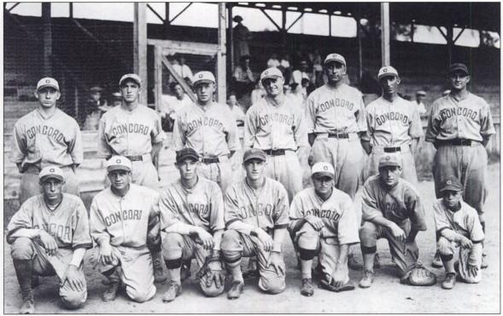 The 1929 Concord Weavers Composed Primarily of College Players
The players came together to form teams so varies that at times it appeared that the only thing that the textile league teams had in common was that a mill sponsored them. However, even the level of company sponsorship varied greatly between them. At the most basic level, companies provided time off for their employees to practice, play, and attend the games on Saturday afternoons. Other financial contributions included providing uniforms with the company logo, baseball equipment, and transportation for both players and fans alike to away games. One such mill is Bynum, where Vernon Durham claimed,
when Bynum went off the play ball, the company had a great big old truck, big long bed on it. And Earnest Wicker, a man that used to work around down at the mill, Mr. London would let him have that truck on Saturday to carry anyone to the ball game that wanted to go.

Some of the bigger mills built massive ballparks with bleachers and grandstands, which often rivaled or surpassed professional stadiums in terms of capacity. The biggest stadiums contained lights and scoreboards in their later years of operation, and employees, on at least one occasion, were willing to work extra hours to pay for these renovations.
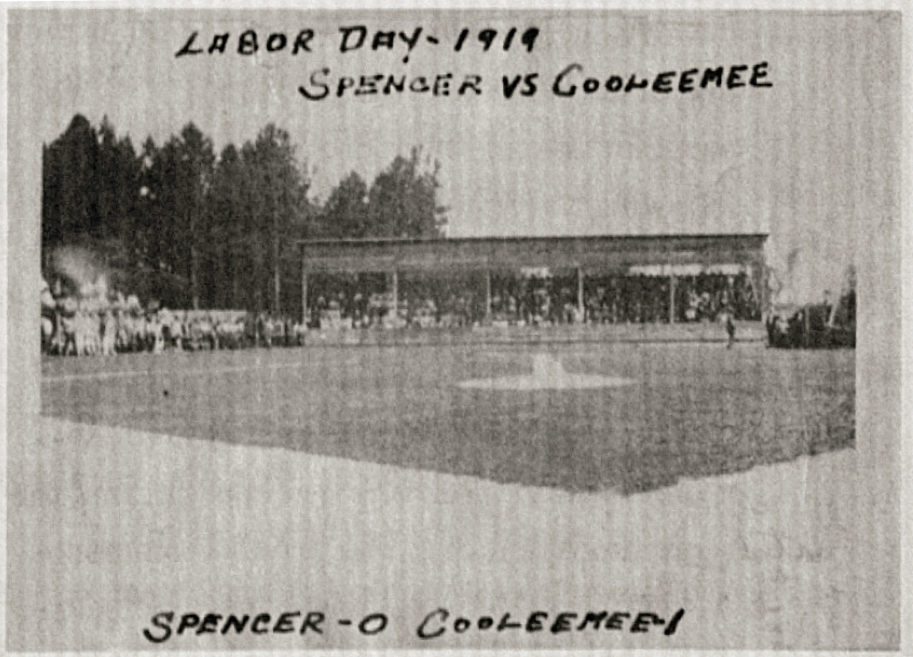
An Early Stadium in Cooleemee, Note the Grandstand in the Background

Some mills also provided support through hiring coaches and managers, such as at the aluminum plant in Badin, where operators hired Walter H. Quinlan, a former Cornell baseball and basketball player and semi-professional athlete, to be their coach and director of Athletics. In addition, some managers provided other incentives for players such as a share of the gate receipts, trips, or rewards for teams that performed exceptionally well or won the league championship. For example, mill owners promised Frank Webster and his team from Burlington Industries an all-expenses paid trip to New York to see The World Series if they won the Greensboro Industrial League championship.
In addition to the differences in funding, the competitiveness of the teams varied as well. The better funded teams tended to be more competitive because they could hire more talented players. Teams distinguished themselves between those classified as amateur and those classified as semi-professional. This distinction could be used as derogatory or insulting to particular teams. For instance, the few African American mill teams were permanently classified as amateur no matter their level of talent whereas White teams such as the Concord Weavers could earn semi-professional status. For the white teams, these classifications often varied from year to year. It was often difficult to discern which team played at what classification in a given year as the distinctions were often slight and sometimes self-determined. The semi-professional Carolina Textile League, which existed only during the 1935 season and consisted of eight teams including those from Concord, Coleemee, Kannapolis, Landis Mills, and Mooresville, exemplifies these frequent transitions. After the single season of existence, the league transformed into the Carolina League, an independent professional league, from 1936 to 1938. After the league folded in 1938, many of the players left to play for other professional teams and many of the teams returned to semi-professional status. Transitions such as these were commonplace throughout the early twentieth century.

The Leagues
The nature and type of the leagues varied tremendously because each league could set its own rules regarding player qualification, championships, and scheduling. However, most types of play can be sorted into three different categories: textile or industrial leagues, leagues not affiliated with any particular industry, and exhibition games. A prominent example of the textile and industrial leagues came from Gastonia, which had several of both types, including the Belmont Textile Loop, the Gastonia Textile Loop, and the Gastonia Industrial League, among many others. Other leagues featured a mixture of teams from different sponsors such as the case with the Concord Weavers who played in a league with Kendall Mills, Charlotte Firemen, and a few town teams. Finally, teams often took out advertisements in the newspapers to find teams willing to play in an exhibition game. These categories were not mutually exclusive, with both the Loray Mill in Gastonia and the Concord Weavers participating in league competition and playing exhibition games against Syracuse University and The House of David Bearded Beauties respectively.
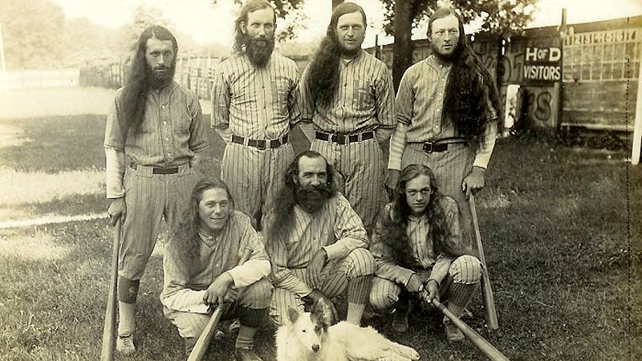
The House of David Baseball Team
Leagues formed and folded rather quickly and frequently changed from year to year. This often occurred for two reasons: when the league wanted to change rules, such as when the Carolina League formed because they wanted to have more professional players on their rosters, or when the league wanted to be more or less competitive. Membership within the leagues also changed at will, with some teams folding in the middle of the season and others joining or leaving between seasons.
In addition to establishing their own rules, each league determined how they ended their seasons. Some organizations like the Gaston Textile League had the first and second place team play a championship series after the regular season, such as the conclusion to the 1934 season where Carlton Mills scored eight runs in the bottom of the ninth inning to defeat Parkdale Mills. Other leagues had no championship series at all such as the 1928 Concord Weavers just voted to end the season as it was.

The Games
Once the teams and leagues formed, the games quickly began. Teams generally played between one to three games per week. Most games took place on Saturday afternoons when the mill was closed, but some of the more competitive teams played throughout the week.
Many aspects of mill town baseball from the games themselves to the interactions between fans, were rough, aggressive, and highly physical. Injuries were common such as when L.H. Thompson suffered a severely sprained ankle while sliding into home plate in the first game of the season for the Loray Mill team. Fights occurred both on the field and in the stands. During one incident in South Carolina rabid fans murdered the manager of the opposing team when he went into the stands to collect a foul ball and an argument ensued. This case is an extreme example, but the impassioned and violent fans were neither rare nor limited to South Carolina. In one town following a large fight between the fans of two teams, authorities asked a local sharpshooter to officiate the rematch in order to maintain the peace. Officials cancelled another series in Concord after rumors of planned fights at the game emerged.
In regards to the gameplay, some of the matches were lackluster, such as the 7-2 victory of Concord over Statesville on June 10, 1927 that broke a nine-game winning streak for Statesville. However, in most accounts sports writers filled their pages with stories of hard fought games, including when “Loray Fabrics won a hair-raising eleven inning game from Boger Crawford.” Other trends included incredible pitching from notable stars such as Lefty Smith who “twirled brilliantly” for Kendall Mills during the 1928 season, low-scoring pitching duels, and high scoring games dominated by offense.

The Environment
Mill village baseball was not just about the games. Rather, it was a complete experience. Every year thousands of fans came out to watch their hometown team play ball. The most popular games could attract crowds in the thousands, with one in South Carolina reaching ten thousand guests. Occasionally, the teams took up a nominal admission fee, such as the nickel fee at the Cooleemee, but more often than not the games were free to attendees, or villagers passed a collection plate around to collect money to pay for the players or the maintenance of fields or equipment.
Once inside the grounds, fans received an experience unlike any other, whether it was under the lights in the grandstand or standing by the fence on a primitive field. Fans braved the heat of the North Carolina summer and joined their compatriots in passionate cheers and heated arguments. For many teams, brass bands serenaded players and guests alike, adding to the spectacle. Vendors of ice cream, popcorn, and other food items sold their wares to the guests. Visitors could then expect to hang around for socializing or a party after the game. For children and adults alike it was a magical experience that they attended at every opportunity and it made such an impression that the fans remembered their experience for decades to come.

The Coverage
The experience of mill sponsored baseball spread beyond the outfield fence of the park and the walls of the mill and into the broader world through media coverage. The two greatest purveyors of this were the newspaper and the radio, and each provides insights into what the mill teams meant to their communities during the early twentieth century.
The newspaper played a much larger role in the coverage of textile league baseball teams. Yet, there were limitations regarding this coverage. Not every paper covered mill village baseball and not every paper covered it equally. First, newspapers that served small markets with a high density of mills were more likely to cover the games. For example, while The Gaston Gazette devoted ample resources to its coverage of mill village baseball during the 1934 season, the neighboring and much bigger Charlotte Observer barely covered the games at all. Larger papers such as these were more likely to cover the local minor league teams and the major league teams of the time.
The professional teams in the early twentieth century were certainly more popular and appealed to a larger group of readers. However, the lack of coverage of textile mill teams in large newspapers should not be interpreted as a lack of interest or prominence in the textile communities. Rather, the support for these teams was largely confined to the communities in which they played. Thus, newspaper coverage was primarily limited to smaller, regional newspapers that served these communities. For these newspapers, local mill-sponsored baseball was highly important. Articles appeared daily or weekly in these papers describing the exploits of the previous day’s games, the box scores, updated league standings, and the upcoming schedule of events. Many of these papers took pride in their coverage of the leagues, with the Gaston Gazette once promising to provide more coverage of mill and industrial league baseball than any other paper. Indeed, the headlines littered the sports pages almost daily and dynamic writers such as Radio King provided detailed and creative descriptions about the day’s events.
Further underscoring the importance of baseball to the communities is the placement of these articles in the papers. Although mill teams were rarely featured as the top headline on the sports page, their league standings frequently appeared directly underneath the professional league standings. In addition, on more than one occasion an article recapping a textile league game appeared next to an article recapping a major league game. This indicates that for the mill communities, their local teams were almost as important to them as those in the professional teams.
Radios also played a role in the media coverage in the later years of mill sponsored baseball, though to a much smaller extent. Although its use is much less documented than the newspaper, there is evidence that local media outlets broadcast some of the more competitive games on the radio during the early twentieth century. The fact that the teams could, and did, employ people to use this fairly new technology to broadcast these games underscores the importance of the teams to their communities. Radios and theatres were already immensely popular before the start of the war. Nearly forty percent of American families owned a radio by 1930 and an even higher percentage had one close by that they could listen to. However, despite the popularity of the radio and its importance in spreading baseball across America, it could not replace the excitement of going to the games and watching the players catch a fly ball or steal second base.

Conclusion
What began as a welfare capitalist activity grew into its own entity by the 1920s and 1930s. The teams were competitive, the games were exciting, and the players and their fields rivaled the professionals. All of these facets came together to form one of the greatest social institutions of the time: mill village baseball in the early twentieth century in North Carolina.
It is nearly impossible to describe the emotions, the experiences, and the preferences of the hundreds of thousands of people who participated in the activity, either playing or watching. Generalized terms must be used, and even then the best word that can be used is eclectic. There were a wide array of people, a wide array of teams, and a wide array of leagues. There was so much variety, that at times it appears that the only thing that connected all of these different groups was the fact that they all received funding from the mill. Even then, the connection to the mill and the degree of funding varied.
However, there is a stronger connection between these groups than their source of funding. This connection lies in the motives behind the organization of the teams and the leagues. The teams played the games and the fans cheered them on, but the question of whether those original objectives were met still remains.
Chapter Three
The Local Pastime
The Success, Failures, and Popularity of Mill Village Baseball
“CARLTON WINS TEXTILE CUP IN NINTH INNING RALLY IN REAL STORY-BOOK THRILLER”
The headline in the Gaston Gazette sports page screamed the accolades of the Carlton Mills baseball team and its manager, Bill Goodson, as the team scored eight runs in the bottom of the ninth inning to defeat Parkdale Mills and took home the 1934 Gastonia Textile league championship. During the early twentieth century most newspapers chronicled Adolf Hitler’s rise to power in Germany, the progress of the National Recovery Act, and the continuance of organized crime. Nestled among these headlines of the 1920s and 30s in the papers of the mill town communities of North Carolina are the box scores from mill-sponsored baseball leagues and the headlines which tell the details about the day’s games. While the international drama raged on, members of the mill town communities took time to play and watch their local mill team compete against their nearby rivals.
What began as a managerial concept that appealed to both employers and employees, though for different reasons, gained new meaning for the players and their communities. The main objective behind funding a baseball team was to create a united, loyal, and cooperative labor force that was focused on the workplace. However, once the leagues formed and the games began, the teams played a different role both for the players and the surrounding community. While these teams were very popular and played a prominent role in community life, their popularity and degree of involvement did not translate into a sense of loyalty to the company or drastically improved labor relations as the owners intended.
Baseball and Community Life
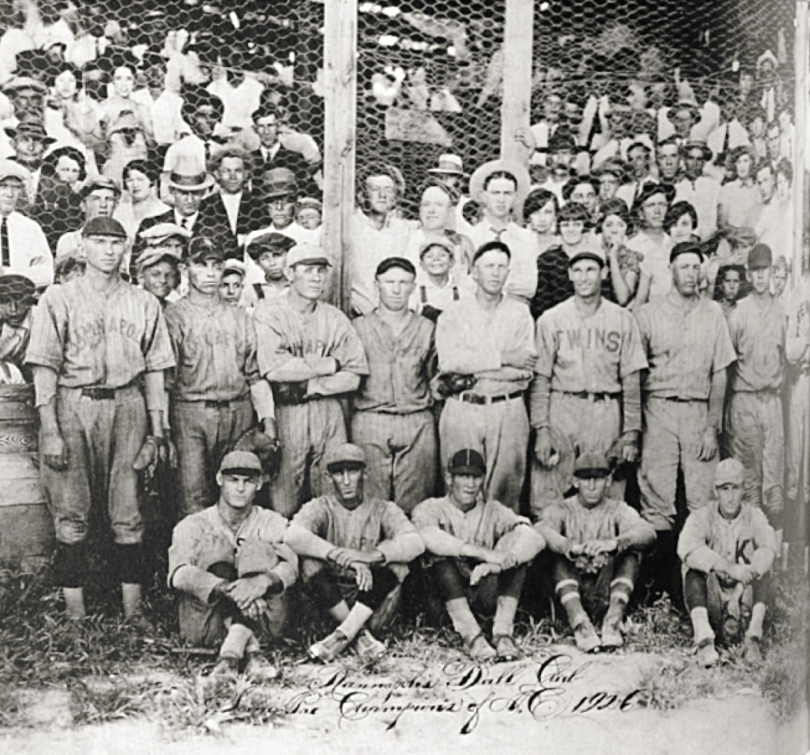
1926 Kannapolis Team, Note the many fans in the background
Baseball not only appealed to those playing on the teams, but to the communities as well. One of the objectives of the companies who sponsored the baseball teams was to create a sense of zest and a community spirit. In this respect they succeeded, as baseball and the events surrounding baseball became the foremost social activity in the mill village.
Mill-sponsored baseball games had strong participation from community members, who rarely missed a game. Attendance was so momentous that newspapers frequently made references to it in articles, such as when the Gastonia Gazette declared, “Despite threatening clouds a large crowd saw Houston Hines hold the heavy Carlton sluggers to five scant hits in twelve innings.” Occasionally, the high attendance was so remarkable that it became the subject of headlines, including “Many Fans See Industrial Games” and “Huge Crowds See Many Games.” The villagers themselves enthusiastically described the popularity of the games and declared that “everyone in the whole country would be there” and that “everybody would go to the ball game.”
In terms of actual numbers, the attendance varied between teams and towns. “Good” or “large” attendance could range from several hundred or several thousand depending on the team. This was significant considering the entire population of Cabarrus County only reached just over 44,000 in 1930 and the population of Gaston County, with more than one significant team, was about 78,000.
Yet, these attendance numbers do not completely illustrate how integral baseball was to the mill town community. For many people in the mill village, going to the baseball games was the primary form of social activity in the village.Frank Webster describes the social life of the community:
There wasn’t no radios and televisions, and what people had for recreation was fiddler’s conventions, churches. When baseball came around everybody would go to the ball game…do it for amusement, exercise and social things.

When the games occurred, villagers made strenuous efforts to go to the ballpark. They either walked, piled into the few cars or wagons available, or filed into a company-owned vehicle, depending on the distance from the field. Mill workers had very little time off, often only on Saturday afternoons in which most of the games were played and Sundays which were reserved for church. That they took so much effort to get to the games in their free time demonstrates the importance of baseball in their lives.
Once at the game, the mill employees socialized, enjoyed their time off, and formed the relationships that made the mill communities some of the tightest and closest in the world. The best examples of this came from romantic relationships. For many mill workers, baseball played a critical role in their dating rituals and for some, it was the primary outlet for dating, as was the case of Louise Jones who was only able to see her future husband at the ballgames. Several couples met at the games including George and Mamie Shue who met when he was a player at the Highland Park Mill when she was watching the team play. Many other relationships, such as the one of Eula and Frank Durham, developed on the ball field. Villagers such as the Durhams frequently went on dates both to mill league and local minor league games. Platonic relationships developed at the games as well, but the stories are far less pronounced.
Baseball became such a prominent part of the community that other events revolved around the sport, including everything from parties, to picnics and band events. These events could also be sponsored by the mills. One of the most popular of these was box party. At box parties, the women prepared a meal for two and placed it in a box. The men then purchased their favorite box and ate the meal with the woman who prepared it. At one such party, Eula Durham recalled sneaking down to the baseball field bleachers with her boyfriend after a game. She also specifically noted scheduling the box parties around the baseball games. Such events were very popular among the villagers. They frequently took place after the games and extended the comradery into the night.
Though perhaps the most popular, box parties were not the only activity to be connected to baseball. Mill operators frequently funded brass bands and paid for instruments and instructors. These bands not only served as welfare capitalist activities in their own right, but also frequently performed at the baseball games. Mini carnivals, picnics, and ice cream suppers, sponsored by the mill owners, all took place on the baseball grounds and were scheduled around the games. Few things were not scheduled around baseball games, one of which was church. Even though mills did not run on Sundays, the teamsdid not play because it was the Lord’s Day and according to Ethel Faucette, “you didn’t play on Sunday. If you did you got one of the worst whippings you ever got.”
Baseball became a major part of existing and important traditions of the time as well. Patriotism ran strong with mill workers and mill owners alike. In an editorial in The Charlotte Labor Herald, a left-wing newspaper affiliated with the North Carolina State Federation of Labor, a mill worker lamented that the Gastonia mills ran on the Fourth of July, citing that “boasted workers are 100 per cent Americans, yet have to work on holiday.” They then quickly pointed out that the Fourth of July was a patriotic holiday that celebrated “the very beginning of Americanism.” Mill owner writings do not explicitly mention their patriotism, but their willingness to fund large Independence Day celebrations indicated their patriotic sentiments. However, these sentiments may be due to a high level of Americanism in the political language of the time. This came as a result of World War I and the many patriotic programs that launched during the war including the rise of the American Legion, the open-shop American Plan of industrial relations (which included the stretch-out), and the dissemination of American cultural valued through popular culture. This may have limited the workers’ ability to express their true sentiments and how the labor movement could operate.
As a result, at least in their language, Fourth of July celebrations were extremely important to the mill villagers and each community held their own celebration. These celebrations were generally well attended and massive events funded by the mills, and all featured a baseball game as the highlight of the day. At Loray mill in Gastonia, over 3,500 attended the 1934 Fourth of July event at the ball field that featured an exhibition baseball game between the fattest (“fats”) and the skinniest (“leans”) employees of the mill, tug of war, three legged races, and other field games, which started early in the morning and lasted into the night. It all culminated in the most popular event of the day, a game between the Parkdale and Loray mill teams. Badin had a similar spectacle in 1934, with a baseball game between their industrial team and the Kannapolis “Y” team. In Concord in 1928, thousands attended a double header game between the Concord Weavers and the Kendall Mill Spinners where the fans “yelled and enjoyed the fourth as though it were Christmas.” The examples go on and on. No matter which community, they all prominently feature baseball in important cultural traditions such as The Fourth of July.
Baseball created a sense of zest in the community and became an extremely popular and important aspect of community life. Many of the mill villagers came out to socialize and break up the monotony of everyday mill life and the owners accomplished this objective. However there were several other goals the operators sought to attain.

Baseball and a United Labor Force
Another primary objective of the mill owners sponsoring baseball was to control worker turnover and to create a united labor force that benefitted their operations. This initiative particularly targeted the young adult males without families who were more likely to move around. However, when the mill operators implemented the baseball teams they fostered a sense of loyalty amongst the villagers, but not towards the company.
Mill town communities were close and tight-knit. Alice P. Evitt describes the community as close, loyal, and one that looked out for each other. If “there was somebody up in the country, some lady’s awful sick and didn’t have nobody to set up with her. We walked a mile and set up with that lady.” They were strong communities that were fiercely loyal to one another and quite distrustful of the outside community. Members would often not let boys from outside the mill community to date the women of the mill. Baseball did not create this loyalty, but it certainly helped to foster it. It did this by creating a rallying point for the community. Their team was something that the community could be proud of and they became so loyal that they were willing to fight if anyone disrespected their team.
This loyalty could be exploited for many different causes that the mill operators did not anticipate. It seemed to have few limits and could extend towards the union, the exact opposite of what the operators intended. In at least one instance the team sponsored by the Loray Mill in Gastonia took the Loray logo off of their uniform and replaced it with the National Textile Workers Union logo and played several games under their name. This example highlights how mill sponsored baseball teams created a sense of unity amongst the people, but that the unity did not necessarily benefit the mills.
In many instances it appeared that the creation of mill town baseball teams and the way that the teams operated created tension between the workers and did very little to prevent worker turnover. There are some examples of workers praising the operators for creating the teams such as in the town of Badin in 1920. There, in a newspaper editorial, the worker thanked his boss, Mr. Thorpe, for ensuring that the workers would have a baseball team. However, these cases appeared to be rare, with tensions coming more often than successes. These hostilities often resulted from the practice of hiring workers due to their athletic abilities. This practice of as discussed in Chapter Two, led to resentment towards the company from the workers who were proud of their jobs and distrusted outsiders. Workers such as Hoyle McCorkle took notice of this sentiment. As a result, the companies ultimately failed to create a unified labor force.
In addition to the workers, the system of hiring young men to play baseball failed to create any sort of loyalty to the company among the specifically targeted demographic of young, unmarried men. Rather, the players came to emphasize money, traveling to whichever mill paid them more. This was the case for Charles Foster and Earnest Cagle, two members of mill sponsored teams. Foster turned down a spot at the St. Louis Cardinals’ minor league team in Asheville because he believed he could make more money working for a mill and playing on one of their teams. He later moved from Monck-Judson Hosiery Mill to the Tower Hosiery Mill because they promised him the job of an injured player and more money. Cagle followed a similar path, moving from mill to mill playing baseball for whichever manager would pay him more and would pay for his room and board. This led him to play for Rex Cotton Mill, Park Cotton Mill, and Loray Cotton Mill, among many others. Thus, the implementation of baseball teams in the piedmont of North Carolina resulted in little to no loyalty to the companies and even higher worker turnover in their target demographic.

Overall Worker Relations and Strike Prevention
In addition to creating a unified and loyal labor force and promoting a community spirit, mill operators also sought to use baseball teams to improve worker relations overall and prevent strikes. As with the attempt to create a loyal and unified labor force, the implementation of mill sponsored baseball teams did little to ease the tensions between employees and employers and failed to prevent strikes.
There were some minor improvements in labor relations due to the implementation of baseball, but this was not a general trend and the improvements did not amount to sweeping changes in the landscape of labor relations. Some workers such as Hoyle McCorkle described his Superintendent, Arthur Jarrett, as “the most generous-hearted mill man I ever seen” after providing the mill with a quality baseball team among other welfare capitalist services. McCorkle also neglected to join when the union came to town. George Shue had a similar experience; he both approved of his overseers and supervisors and did not join a union. However this experience was by no means universal and often the improvements in labor were minimal. In addition, for many like Mack Duncan, the exact opposite happened and baseball did nothing to change their opinion on the mill. In one editorial, for example, a mill worker claimed that the operators simply “substituted cunning; for authoritarianism in their dealings with employees.
Further indicative of mill-sponsored baseball’s inability to improve the overall labor relations is its failure to prevent strikes. In 1934, mill-sponsored baseball teams prospered across the nation, particularly in Gastonia. However, less than a month after the Gastonia Textile League Championship in which Carlton Mills defeated the Parkdale team on August 23rd, hundreds of thousands of textile workers walked off of their jobs both in Gaston County and across the Carolinas. Thus, the popularity of baseball did not prevent the workers from going on strike when their demands were not met and the dreaded stretch out continued. Gaston County was not the only place where strikes continued despite baseball. Indeed, The Salisbury Post reported the news regarding both strikes and baseball games in the area, concurrently featuring headlines of “Lumberton Mill Resumes Work Today” following a strike regarding unfair dismissals on Thursday and then “Rowan Defeats Salisbury Mill” on Friday. This concurrency of both strikes and baseball lends credence to the idea that baseball had little impact on labor relations or the decision of workers to go on strike when they felt that their needs were not being addressed. Finally, there is no evidence of any workers either saying or implying that they would not go on strike or join a union because they had to play baseball or that the mill owners might “get mad” or remove their sponsorship of the baseball team if they did either of the aforementioned activities. Most people, when asked why they did not join the union, replied that they liked the union in theory but not in practice, because not everyone joined the union and thus it was ineffective, or because they had a family and could not afford to join the union or go on strike.
It cannot be ignored that there was less union activity in North Carolina beginning in the late 1930s. However, baseball was not the primary reason for this lack of activity. While the implementation of baseball by mill owners did not increase union activity, there are many other factors that contributed to this scarcity.
The first factor was an unfavorable political climate. The political climate of a state was exceptionally important in determining to what degree unions could operate in the states. For example, under the liberal governor Thomas Bickett, unions made great progress. During a strike at Highland Park Manufacturing Company, Bickett supported the union. With his support, the union was able to achieve a settlement where the workers would work a fifty-five hour week but get paid the same as when they worked sixty hours. The company also agreed to run an open shop. However, throughout most of its history North Carolina was decidedly conservative and decidedly anti-union. Under more conservative leaders, such as Governor Cameron Morrison, strikes were met with the force of the state militia. After the 1934 general strike the political climate in North Carolina remained strongly against unions and labor organization. Though the President, Franklin D. Roosevelt, urged companies to take back their striking workers without penalty, this effort was largely ineffective and lacked enforcement protocol. In addition, the Supreme Court of the United States found the National Industrial Relations Act to be unconstitutional. Both of which helped to neutralize the unions. Furthermore, though workers were able to make small gains through the New Deal, including the 1935 Wagner Act and the 1938 Fair Labor Standards Act, North Carolina lawmakers fought to discredit the New Deal and eliminate any labor gains. As a result, North Carolina’s textile industry remained largely unorganized.
Second, there were pragmatic concerns regarding striking. Workers were scared of losing their jobs. The workers needed every cent they made to feed their families. As one Greenville woman put it “Even though we might have had faith in the union we simply could’nt offord to quit because we live right up to every penny we make…It is true that every textile worker in the south would walk out of the Mill to day if they were not afraid of starvation.” These reasons were complicated. However, no discussion involved baseball as one of the foremost reasons as to why unionism never reached European levels. In short, the objectives of the mill owners were not met.
The company ownership of houses or, in the later years, the possession of a lease was the primary preventer of strikes. Workers were primarily concerned with keeping their homes and providing for their families. The other welfare capitalist activities may have improved worker happiness and eased some tension, but they certainly did not cause a sweeping change in labor relations.

Conclusion
Baseball became one of the most renowned and well-liked activities in the mill villages of the piedmont of North Carolina. Mill owners pumped a lot of money into the teams and furnished uniforms, coaches, stadiums, transportation, and equipment for their respective teams with the hope of instilling a sense of community life into the villages, creating a unified and loyal labor force, and improving overall labor relations. Their hopes were generally met with frustration. The mill town baseball teams were very popular and enhanced community life. Yet, the only unity and loyalty created was within the communities, which did not impact the company and any improvements in worker and employer relations were minimal.
Baseball did not end high worker turnover and baseball did not prevent strikes, but it did create a fun and memorable pastime that disturbed the monotony of working in the mill. Despite its popularity, the large attendance, and the impact that baseball made on the community in the early twentieth century, it eventually came to an end. Chapter Four will discuss why mill-sponsored baseball came to an end, as well as the impact it left on the players, the communities, and the mills.

Chapter Four
The End of an E.R.A.
The End of Mill Village Baseball as a Spectacle
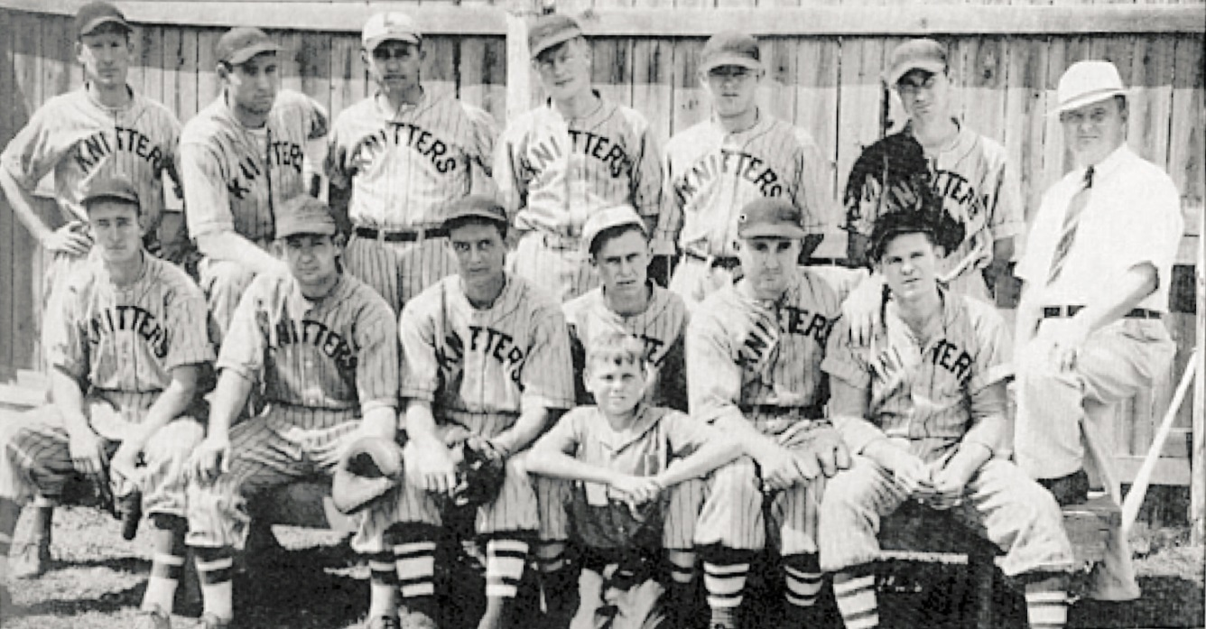
The 1935 Wiscassett Knitters
“The process presents an example of the break-up of an institution. If the movement continues the results will have social and economic significance for the entire Piedmont South”

When seventeen year old Wilt Browning watched the baseball team from his mill village compete for the 1954 league championship, he did not realize how much and how quickly his way of life was going to change. He watched star pitcher Hal Ensley hit a home run in the top of the ninth to tie the game and thought about one day playing catcher for Easley Mill. However, his dream would never come to fruition. Before the beginning of the next season the team would move to a less competitive county league, and within five years the entire team would cease to exist. From then on, mill village baseball at Easley existed only in memory. Browning’s story is one example of a broad sweeping trend of mill sponsored baseball teams in North Carolina either moving to less competitive leagues or disappearing altogether beginning in the late 1950s.
Baseball remained one of the most popular activities for mill villagers throughout the early twentieth century. However, after World War II ended, the landscape of America and the American South changed dramatically. These changes greatly impacted the lives of Wilt Browning and the other mill villagers and reached all facets of their lives, including baseball. Numerous factors including the proliferation of the affordable car, the economic inefficiency of the mill village, and the rise of television among many others, led to a decline of both the mill village and mill village baseball. The popularity that once sustained the sport, despite its failure to meet the objectives of the mill owners, could no longer prevent the decline and the eventual death of the institution.

The Decline of Baseball
Mill village baseball is no longer a prominent activity, but it is difficult to discern at what point the sport began its transition from one of the foremost social activities of the mill village into near extinction. While some argue that the 1940s was the beginning of the decline of mill village, it was not until the late 1950s that the ultimate decline actually began. Although many prominent textile leagues in North Carolina such as the Twilight League and the Piedmont Textile League either ended or took a hiatus during the 1940s, but this was only due to a lack of labor and resources during the war years. As soon as the men came back from World War II, baseball in North Carolina resumed as early as 1946.
Rather than systematically declining after the war, mill village baseball had a brief renaissance in the early 1950s. Many former villagers remember watching some of their childhood idols during this time. Wilt Browning watched the championships of the early fifties and recalled one of the best teams the mill ever had playing in the 1950s. The boys at North Belmont fondly recalled the time that they played and defeated their local team, the then-undefeated Acme Mill. Others simply recalled watching the regular season games with pride. However, this revival was short-lived. By the late 1950s mill-sponsored baseball began its official decline.
There are numerous factors that are responsible for the decline of mill-sponsored baseball, with the most prominent factor being a loss of popularity for the sport. Because baseball failed to address many of the expectations of the mill operators, the primary reason mill baseball remained a prominent part of community life was its immense popularity.
New developments in technology were prominent in the American social landscape after World War II and helped to replace baseball as the predominant social activity. With the popularity of the radio already in place, the 1950s saw the rise of the television which further steered the attention of the villagers away from the ball field and into the home. Nearly everyone who lived in the villages in the 1950s remembered who had the first television in their village. Some children even got jobs to help their families pay for the new luxury and remember fondly when the new television arrived in their home. Further emphasizing the popularity of the television, the newspapers began printing programming schedules for all of the local TV stations and electronics companies began taking out full page advertisements regarding their stock of televisions in the local papers.
The television also brought the community together, just as baseball had. As Mrs. Panel, a resident of North Belmont, recalled, “there was a custom that families that owned a TV set accepted the fact that other children of the village would come and ask to watch TV.” There, they eagerly awaited the beginning of that day’s programming. It became so popular that “people would watch the test pattern waiting for shows to come on in the afternoon.” But perhaps most importantly, they watched it together.
With this innovation, villagers no longer needed to head out to the local ball field to watch the sport. Now, villagers could physically see the games, a feature that the radio did not have. This explains why the radio did not contribute to the decline of baseball, but the television did. The workers could now watch their favorite professional players including Dizzy Dean and Pee Wee Reese play in the Saturday Game of the Week from the comfort of their couches. While the textile leagues had previously offered wages that pulled players away from the Major Leagues, increasingly the best players avoided the textile leagues.
With the founding of the Major League Baseball Players Association in 1954 and the onset of collective bargaining, professional players slowly gained better working conditions and eventually higher salaries. Though many of these improvements took decades, higher wages eventually slowed the flow of professional players to textile-supported teams. Simultaneously, low attendance at the textile league games caused some owners to invest less money in their teams, and the level of talent in some teams dropped significantly. Thus, the best way for mill villagers to see the best players was to watch them on television.
Many new diversions appeared in the mid-twentieth century, including other sports, such as slow pitch softball, which grew in popularity during the 1950s. This was evident to the villagers at the time who noted, “Slow pitch or ‘punkin’ ball as it was first called didn’t originate or take off until the 1950’s. The baseball leagues disappeared as slow pitch softball began to dominate the players’ time and effort.” The newspapers confirmed the villagers’ accounts. By 1959 The Gaston Gazette, which once promised to provide the most coverage of textile league baseball of any newspaper, no longer published any accounts of textile league games. Presumably, this was because the games either no longer occurred or were no longer of interest to their readers. However, reports of games and league standings for softball teams still occasionally appeared, including one article on June 15, which described how good pitching propelled Minette Mills over McLean-Whitney twice in a doubleheader.
With many other sources of entertainment available to the mill villagers, the popularity of local baseball teams slumped. Attendance began to drop and mill owners started to cut funding to the teams. Finally, “the long-term trend toward cutting welfare expenditures finally hit the baseball teams.” Though some fans remained loyal to their local mill village teams and some leagues and teams continued into the sixties and seventies, the spectacle of mill village baseball entered its ultimate decline.

The End of the Mill Village and Mill Village Baseball
The dissolution of the mill village in the south began in the 1930s when the owners began selling their houses, nearly two decades before the decline of mill village baseball began in the 1950s. The ultimate end of mill village baseball came with the decline and end of the mill village system altogether. Thus, understanding the causes behind the devolution of the mill village is paramount to understanding the death of mill village baseball.
The first sales occurred as a way for some struggling companies to survive the Great Depression, but the systematic selling of houses began shortly thereafter. By the time the United States entered World War II in 1941, mill owners throughout the south had sold sixty seven of their villages, including fifty four from North Carolina. At this point North Carolina owners had sold more of their villages both in gross numbers and percentage of total mills in the state than all the other states combined, as seen in the chart below.
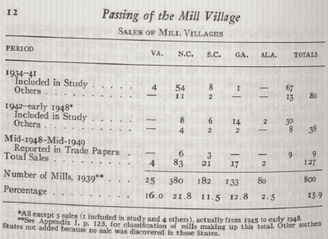
This trend leveled off during the war as many mills kept their villages to attract laborers. Some villagers let the families of soldiers stay, as was the case with the Eagle Mill and the family of Claude Ward in hopes of the laborer returning to the mill after the war was over. After the war ended, owners continued the trend of selling their houses. Their efforts then increased after the passage of new federal housing and civil rights legislation in the 1960s. Finally, with the sale of the Cannon Mill Village in Kannapolis in 1983, the mill village system in North Carolina came to an end.
The end of the mill village system brought about numerous changes including the ultimate end of mill village baseball. Yet, the reasons behind the decline and end of the mill village were just as numerous and varied as the changes that occurred because of it. Reasons for the sale of the houses in the mill village varied greatly from mill to mill, but can be simplified into four categories: the rise of the affordable car, mill villages no longer being economical for the mill owners, social movements within the village, and the postwar trend of rising home ownership nationwide after World War II.
Chief among the reasons behind the decline of both the mill village and mill village baseball was the rise of the affordable car. In 1922 Stuart Cramer, a Gastonia mill owner, remarked that “Henry Ford is certainly emancipating the average Southern small town worker.” His quotation was startlingly accurate. The affordable automobile first came to America in the early twentieth century when car ownership increased from 8,000 to 26 million between 1900 and 1931. Yet, Jaquelyn Dowd Hall noted that this ownership was widely varied, with less than one-third of working class families owning a car by the 1930s. As a result, only some mill villagers owned an automobile in the early twentieth century. This is supported by the testimony of many villagers who recalled few cars in the mill village, difficulties with transportation, and specific memories about when people saved enough to buy cars.
A dearth of cars and reliable public transportation made living away from the mills difficult, if not impossible, for the mill hands and ensured the survival of the mill village system for many years. Mills were often intentionally constructed outside of major cities to avoid regulation, and close to waterways when rivers were the primary source of power for the mills. For example Mildred Smith, who, when she was unable to secure a company owned home, had to wake up early and often left before daybreak in order to walk the two miles to her job.
Once the cars became affordable and the infrastructure improved, workers gaine the ability to live away from the mill. The transportation and roads were so important that Herring attributed North Carolina’s early road building efforts as one of the reasons that many North Carolina mill owners sold their villages earlier than owners in the rest of the South. The proliferation of affordable cars and paved highways in North Carolina allowed mill employees to live away from their job, often on affordable land in the suburbs. Here they could own their own home, avoid the social control inherent in the mill village system, and end their reliance on the mill for housing. Furthermore, living away from the village and access to cars brought about more recreation and social opportunities than workers had while living in the village. As Jefferson Robinette explained “[the car] gives folks more time to get out. They can go from place to place so much quicker.”
Eventually the mill villages also became economically unsustainable for mill owners to operate. When the mills opened around the turn of the century they relied heavily on the family labor system and almost always preferred hiring family units rather than a single provider. Mills at that time provided housing based on the general formula of one room per employee. However, the end of the family labor system and the introduction of child labor laws meant fewer children working in the mill and subsequently fewer workers per house. By 1920 mills only received the labor of a half of a worker per room, and by the 1940s this figure dropped to approximately three-tenths of a worker per room or about one employee per four room house.
At the same time that mill owners were not getting as much labor out of their village, demands for a higher standard of living and the costs of upkeep greatly increased. Workers wanted newer appliances and bigger houses. In addition, amenities such as electricity and running water became expected in the village houses. Caesar Cone of the Cone Mills in Greensboro cited the incorporation of Cone Mills into the city and increased utility costs in his decision to sell:
Originally, when the houses were built, there was maybe forty-watt bulb in each of the four rooms, maybe, period. And it didn't cost hell of lot to absorb that juice when you figured the juice that was being used in the plants and all. But then as electrical appliances came along and people wanted irons and stoves and bought all these items, it was patently unfair. So rather than get mixed up with our employees on how much we'll charge you for an iron or stove, we just decided to abolish the whole smear.

Costs to repair and maintain the houses, the roads, and the other community buildings continued to grow while most mills kept the same low rent that characterized the early villages. With the mill villages no longer providing the same amount of labor, the villages were now economically inefficient for many of the mill owners. Thus, with other housing options now available to their workers due to the affordable car, mill owners simply chose to sell their housing to cut costs.
At the same time, within the village there was the continuing rebuke of paternalism and the fear of losing control of the villagers. The mill village itself was a strong, tight-knit community which was often isolated away from the rest of the world. As Jacquelyn Dowd Hall accurately describes the community,
Recollections of factory work were something else again, but the village—red mud and all—was remembered with affection. The reasons were not hard to find. A commitment to family and friends represented a realistic appraisal of working people’s prospects in the late nineteenth and early twentieth century South

This sentiment permeated nearly all personal accounts of mill village life. Adding to the strength of the community was a sense of geographic and social isolation that drew mill villagers further into the community. This social isolation was best demonstrated by the use of the derogatory term “linthead,” which was used by cultural outsiders to insult mill workers, but evoked a sense of pride within the community.
By the 1930s, this intense feeling of community began to threaten the mill owners’ interests. There was a growing sense of discontent and resentment of paternalism in the village that mill owners such as Caesar Cone began to pick up on. Following a series of strikes in the 1930s, including the 1934 general textile strike, mill owners began to realize that the system that was designed for their control was slipping out of their grasp. Thus, the mill owners sought to change the mechanism of their control to home ownership with the idea that home ownership was the foremost way to make better citizens and better workers.
Finally, there was a growing trend of home ownership across the country in the post-war years. Home ownership grew from 43.6 percent to 62.9 percent nationwide and from 42.4 percent to 65.4 percent in North Carolina between the years of 1940 to 1970. Spurred by the G.I. bill and a change in ideology that promoted homeownership, the selling of mill village houses was part of a much larger social movement.
The selling of the mill village houses and the end of the mill village system led to a series of profound changes in the lives of the mill villagers. Many workers based their home lives away from the mill and no longer came to the village for their social and practical needs. Some of the families who bought the houses from the mill did not work at the mill. The community spirit that once characterized the mill village was gone forever.
Due to the loss of community, many of the institutions that shaped the mill village such as the schools and village stores either changed or closed. The spectacle of mill village baseball could not escape the same fate and disappeared along with the end of company ownership of housing. Some small informal teams persisted, but the grandiose teams that rivaled professional teams in terms of talent and crowd attraction, just like the community spirit, were gone forever.

Conclusion: Mill Village Baseball and Memory
Long after the lights went off in the stadiums and the bats were put away for the last time, mill village baseball left a profound impact on the people who played and watched it. This impact lay not on the field or in their everyday lives, but in their memories.
Mill workers remember the villages fondly. As George Shue affectionately notes, “the cotton mill village, it’s a wonderful life to live, it was.” Many were so influenced by their life in the village that they chose to write down their memories in order to preserve their way of life after the mill and its village closed down forever. Other groups such as the villagers from The Eagle Mill maintain an annual reunion. Both monumental efforts are testaments to what the mill village meant to the people who lived there and how it lives on in their memory.
Within all of the memories of mill village life, baseball teams hold a special place in the hearts of the villagers. As a testimony to its lasting impact, many of the young boys who watched the last teams play in the 1950s could remember the rosters of certain teams twenty or thirty years later. These players were their heroes and they dreamed about one day putting on that uniform and taking their place on the roster. It was a major part of their world. They grew up watching and playing mill village baseball and for some, it formed the cornerstone of their social life. Thus, it is no surprise the frequency with which they recall “the happy times of playing ball” decades later.
The memories fill pages and pages, all overflowing with positive recollections of baseball and other realities of life in the mill village. For Eddie Isenhour “”The highlight of the summers was going to watch baseball made up of teams from the different mill villages.” Alice Evitt recalled finer days in the mill village, stating that “Now, they won’t cross the street and do that. But people would then. They’d go it anybody’s sick, but looks like now, everybody’s for theirselves.” For Eula and Vernon Durham the popularity of baseball remained fresh in their minds noting, “lord, every gall and boy in Bynum would be in that truck. Go off to the ball games. Have the best time.” Their voices ensure that the memory of mill village baseball and mill village life will continue for generations.

Conclusion
We played baseball down here. We didn’t have any swimming pool, but we had sugar creek. We had two or three swimming holes back there, and we enjoyed that. We’d make slingshots and make our own kites. It was a pretty good life. And most of us went to school. But like I say, financially we didn’t have as much. Our parents didn’t make as much. But we survived pretty good
Though many families struggled with their new life working in the mills, the mill-village culture helped to ease the transition. Everything from visiting with friends to string bands helped to remind the villagers of home. One vital aspect of this culture was mill-sponsored baseball. Conceived as a part of a large, welfare capitalist program by mill owners, mill-sponsored baseball became what the workers needed. It provided a distraction from the tediousness of working in the mill for both the players and the fans. It also gave players a much-needed outlet for physical activity through a sport that they were already familiar with.
Through the input of funds by the mill owners, mill teams prospered. They attracted thousands of fans to their games and hired talented players to fill their rosters. However, despite all of the money they pumped into baseball, mill-sponsored teams never met the expectations of the owners. Baseball never became a magical cure-all for the labor problems.
There were, however, fewer strikes in the late 1930s. Yet this was not because of baseball. Rather, this lack of came down to two key factors. The first is an unfriendly political climate that largely prevented strikes. This was best demonstrated by the transition of the governorship from Thomas Bickett to Cameron Morrison. Under the governorship of Bickett, unions made significant gains including a shorter work week at the same weekly pay rate because Bickett recognized the right of the unions to organize. However, most of these gains faded away under the more conservative governor Cameron Morrison. Allied with big business, Morrison did not hesitate to call in the militia to crush strikes and effectively ended any ability of the unions to organize and fight for their rights. Second, workers were more concerned about attaining the basic necessities such as food and shelter. Thus, the reason that many workers did not join a union or go on strike was to keep their paycheck and their house in the village. As a result, the village itself prevented strikes, but the other welfare capitalist activities were mostly auxiliary. Baseball and other similar activities may have made the workers happier but did not make a sweeping change in labor relations.
However, this does not meant that baseball did not play an important role in mill village life. There were numerous tournaments, teams, leagues, and players. It reached all facets of their life. The mill workers met their significant others on the ball-field, they socialized at the games, and they organized social events around the games. It turned into one of the greatest social institutions of the early twentieth century. It may not have changed the world. But for the hundreds of thousands of workers in North Carolina’s textile industry, it was their world.

Bibliography
Primary Sources
Newspaper Articles:
"Various Articles." The Badin Bulletin, 1920.
"Various Articles." The Burlington Daily Times-News, 1933.
"Various Articles." The Charlotte Observer, 1934.
"Various Articles." The Charlotte Herald, 1923.
"Various Articles." The Chatham Blanketeer, 1933.
"Various Articles." The Concord Times, 1928.
"Various Articles." The Gastonia Gazette, 1934.
"Various Articles." The Gastonia Gazette, 1951.
"Various Articles." The Gastonia Gazette, 1959.
"Various Articles." Mill News Devoted to the Textile Industries, 1920.
"Various Articles." The Robesonian, 1934.
"Various Articles." The Salisbury Evening Post, 1927.
"Various Articles." The Salisbury Evening Post, 1937.
“Various Articles.” The Southern Textile Bulletin, 1926.
“Various Articles.” The Southern Textile Bulletin, 1927.
“Various Articles.” The Southern Textile Bulletin, 1932.
“Various Articles.” The Southern Textile Bulletin, 1933.
“Various Articles.” The Southern Textile Bulletin, 1933.

Interviews:
Austin, Ralph Charles Interview with James L. Leloudis, June 14, 1979, Interview H-0156, transcript. Southern Oral History Program Online Database. UNC Chapel Hill.
Evitt, Alice P., Interview with James L. Leloudis, July 18, 1979, Interview H-0162, transcript. Southern Oral History Program Online Database. UNC Chapel Hill.
Cagle, Ernest, Interview with Ben F. Bulla, September 11, 1981, Interview C-0111, transcript. Southern Oral History Program Online Database. UNC Chapel Hill.
Cone, Caesar, Interview with Harry Watson, January 7,1983, Interview C-0003, transcript. Southern Oral History Program Online Database. UNC Chapel Hill.
Durham, Eula and Vernon Interview with James L. Leloudis, November 29, 1978, Interview H-0064, transcript. Southern Oral History Program Online Database. UNC Chapel Hill.
Faucett, Ethel Marshall, Interview with Allen Tullos, November 16, 1978 & January 4, 1979, Interview H-0020, transcript. Southern Oral History Program Online Database. UNC Chapel Hill.
Glenn, Mrs. Howard K. Interview with Cliff Kuhn, June 27, 1977, Interview H-0022, transcript. Southern Oral History Program Online Database. UNC Chapel Hill.
Hopkins, Frank Interview by Hank Utley, accessed January 16, 2015, box 3, series 2, folder 25, Hank Utley Papers, Public Library of Charlotte and Mecklenburg County
Hinson, Betty M. From this Red Clay Hillside :The Eagle, 1924-1950 : Stories of Families from a North Carolina Cotton Mill Village. Belmont, NC: Spindle Books, 1997.
Jones, Louise Rigsbee Interview with Mary Frederickson, September 20, 1976, InterviewH-0085-1, transcript. Southern Oral History Program Online Database. UNC Chapel Hill.
McCorkle, Hoyle and Mamie Interview with James L. Leloudis, July 11, 1979, Interview H-0171, transcript. Southern Oral History Program Online Database. UNC Chapel Hill.
Robinette, Jefferson M., Interview with Cliff Kuhn, July 1977, Interview H-0041, transcript. Southern Oral History Program Online Database. UNC Chapel Hill.
Sanders, Albert interview with Allen Tullos, May 30, 1980, Interview H-256, transcript. Southern Oral History Program Online Database. UNC Chapel Hill.
Shue, George, Interview with James L. Leloudis, June 20, 1979, Interview H-177, transcript. Southern Oral History Program Online Database. UNC Chapel Hill.
Webster, Frank Nelson Interview with Allen Tullos, January 30, 1979, Interview H-0056, transcript. Southern Oral History Program Online Database. UNC Chapel Hill.

Memoirs:
Browning, Wilt. Linthead: Growing Up in a Carolina Cotton Mill Village. Asheboro, N.C.: Down Home Press, 1990.
Rhinehart, Quentin. Behalt North Belmont : A Book of a Mill Village's Memories. Gastonia, N.C.: Kearney, 2005.
Suggs, George G., 1929-. "My World is Gone" : Memories of Life in a Southern Cotton Mill Town. Detroit: Wayne State University Press, 2002.
Yandle, Mary Lois Moore, 1927-. The Spirit of a Proud People : Pictures and Stories of Highland Park Manufacturing Mill #3 and the People in the Village of North Charlotte. Charlotte, N.C.: L.M. Yandle, c1997 (Columbia, 1997.

Secondary Sources
Baseball in the Carolinas : 25 Essays on the States' Hardball Heritage. Jefferson, N.C.: McFarland, 2002.
Anderson, Jackson M. Industrial Recreation, a Guide to its Organization and Administration. McGraw-Hill Series in Health Education, Physical Education, and Recreation. New York: McGraw-Hill, 1955.
Arthur-Cornett, Helen. Remembering Kannapolis: Tales from Towel City. Charleston, SC: History Press, 2006.
Barnwell, Mildred Gwin and Southern Combed Yarn Spinners Association. Faces we See. Gastonia, N.C.: The Southern Combed Yarn Spinners Association, 1939.
Bolden, Don. Remembering Alamance County :Tales of Railroads, Textiles, and Baseball. Charleston, SC: History Press, 2006.
Cohen, Lizabeth. A Consumers' Republic : The Politics of Mass Consumption in Postwar America. New York: Knopf, 2003.
———. Making a New Deal : Industrial Workers in Chicago, 1919-1939. New York: Cambridge University Press, 1990.
DeNatale, Douglas. "Bynum : The Coming of Mill Village Life to a North Carolina County." 1985.
Dunwell, Steve. The Run of the Mill : A Pictorial Narrative of the Expansion, Dominion, Decline and Enduring Impact of the New England Textile Industry. Boston, Mass.: D.R. Godine, 1978.
Gerstle, Gary. Working Class Americanism : The Politics of Labor in a Textile City, 1914-1960.;New York: Cambridge University Press, 1989.
Glass, Brent D. The Textile Industry in North Carolina : A History. Raleigh: Division of Archives and History, North Carolina Department of Cultural Resources, 1992.
Hall, Jaquelyn Dowd, Robert Korstad, and James Leloudis. "Cotton Mill People: Work, Community, and Protest in the Textile South, 1880-1940," The American Historical Review 91, no. 2 (1986): 245-286.
Hall, Jaquelyn Dowd, Christopher B. Daly, Lu Ann Jones, Robert Rodgers Korstad, and James L. Leloudis. Like a Family : The Making of a Southern Cotton Mill World. Chapel Hill, NC: University of North Carolina Press, 2000.
Herring, Harriet L. Passing of the Mill Village: Revolution in a Southern Institution. Westport, Conn.: Greenwood Press, 1977.
———. Welfare Work in Mill Villages; the Story of Extra-Mill Activities in North Carolina. The University of North Carolina. Social Study Series. Chapel Hill: University of North Carolina Press, 1929.
Holaday, J. C. Baseball in North Carolina's Piedmont. Charleston, SC: Arcadia Pub, 2002.
Klehr, Harvey. The Heyday of American Communism : The Depression Decade. New York: Basic Books, 1984.
Lewis, Sinclair. Cheap and Contented Labor :The Picture of a Southern Mill Town in 1929. New York, N.Y.: United Textile Workers of America, Women's Trade Union League, 1929.
Mitchell, George Sinclair, 1902-1962. Textile Unionism and the South, 1931.
Minchin, Timothy J. Shutdowns in the Sun Belt: The Decline of the Textile and Apparel Industry and Deindustrialization in the South.
Moore, Toby. "Dismantling the South's Cotton Mill System." In the Second Wave: Southern Industrialization from the 1940s to the 1970s, edited by Scranton, Phillip, 114-145. Athens: The University of Georgia Press, 2001.
Peeler, Tim. Baseball in Catawba County, edited by McLawhorn, Brian,. Charleston, SC: Arcadia Pub, 2004.
Perry, Thomas K. Textile League Baseball : South Carolina's Mill Teams, 1880-1955. Jefferson, N.C.: McFarland & Co, 1993.
Pope, S. W. Patriotic Games:Sporting Traditions in the American Imagination, 1876-1926. Sports and History. New York: Oxford University Press, 1997.
Rascher, Daniel A. and Timothy D. Deschriver. "“Smooth Operators: Recent Collective Bargaining in Major League Baseball,” ." International Journal of Sport Finance 7, no. 2 (2012): 176-208.
Rosenzweig, Roy. Eight Hours for what we Will: Workers and Leisure in an Industrial City, 1870-1920. Interdisciplinary Perspectives on Modern History. Cambridge Cambridgeshire; New York: Cambridge University Press, 1983.
Rumley, Jim and Cooleemee Historical Association. Cooleemee :The Life & Times of a Mill Town. Cooleemee, N.C.: Cooleemee Historical Association, 2001.
Stoney, George. "Suffreage in the South, Part I, the Poll Tax." Survey Graphic 29, no. 1 (1940): 5.
Sumner, James. Separating the Men from the Boys : The First Half-Century of the Carolina League. Winston-Salem, N.C.: J.F. Blair, 1994.
Sutter, L. M.. Ball, Bat, and Bitumen : A History of Coalfield Baseball in the Appalachian South. Jefferson, N.C.: McFarland, 2009.
Taylor, Gregory S. The History of the North Carolina Communist Party. Columbia, S.C.: University of South Carolina Press, 2009.
Tullos, Allen. Habits of Industry : White Culture and the Transformation of the Carolina Piedmont. Chapel Hill: University of North Carolina Press, 1989.
Utley, R. G. The Independent Carolina Baseball League, 1936-1938 : Baseball Outlaws. Jefferson, N.C.: McFarland & Co, 2005.
———, Outlaw Ballplayers : Interviews and Profiles from the Independent Carolina Baseball League, edited by Peeler, Aaron. Jefferson, N.C.: McFarland & Co, 2006.
———, "Baseball Outlaws during the Great Depression." Tar Heel Junior Historian 51, no. 1 (2011): 1-5.
Vaught, David. The Farmers' Game : Baseball in Rural America. Baltimore: Johns Hopkins University Press, 2013.
Whitener, Daniel Jay. Prohibition in North Carolina,1715-1946. The James Sprunt Studies in History and Political Science...v.27. Chapel Hill: The University of North Carolina press, 1945.

Jacquelyn Dowd Hall et. al. Like a Family: The Making of a Southern Cotton Mill World (Chapel Hill: University of North Carolina Press, 2000) , 6
Hall, Like a Family, 53
Brent D. Glass, The Textile Industry in North Carolina: A History (Raleigh: Division of Archives and History; North Carolina Department of Cultural Resources, 1992), 30
More information on Box Parties can be found on page 36-37
“Suffrage in the South, Part I, The Poll Tax,” Survey Graphic, 29 (January 1940), 5-9, 41-43
Hoyle and Mamie McCorkle, Interview with James L. Leloudis, July 11, 1979, Interview H-0171, transcript.
Thomas K. Perry, Textile League Baseball: South Carolina’s Mill Teams, 1880-1955 (Jefferson, NC: McFarland & Co., 1993), 15
Notably Thomas K. Perry, Textile League Baseball: South Carolina’s Mill Teams, 1880-1955 (Jefferson, NC: McFarland & Co., 1993), and L.M. Sutter, Balls, Bats, and Bitumen: a History of Coalfield Baseball in the Appalachian South (Jefferson, NC: McFarland, 2009),
Jim Rumley, Cooleemee: The Life & Times of a Mill Town (Cooleemee, NC: Cooleemee Historical Association, 2001), 263
“The Southern Mill Village Problem,” Southern Textile Bulletin 30, no. 26 (August 12, 1926): 11
George Sinclair Martin, Textile Unionism and the South (Chapel Hill: The University of North Carolina Press, 1931), v
Jacquelyn Dowd Hall et. al. Like a Family: The Making of a Southern Cotton Mill World (Chapel Hill: University of North Carolina Press, 2000) , 206
Hall, Like a Family, 206-212, 236; This is an extremely basic overview of the stretch out. A more thorough explanation can be found in Jacquelyn Dowd Hall et al.’s Like A Family Chapter Four: Hard Rules
Ibid, 212
Brent D. Glass, The Textile Industry in North Carolina: A History (Raleigh: Division of Archives and History; North Carolina Department of Cultural Resources, 1992), 69
For more information on the NTWU see: Harvey Klehr, The Heyday of American Communism: The Depression Decade (New York: Basic Books, 1984).
Hall, Like a Family, 215
Ibid, 217
Steve Dunwell The Run of the Mill: A Pictorial Narrative of the Expansion, Dominion, Decline, and Enduring Impact of the New England Textile Industry (Boston: D.R. Godine, 1978), 17-18.
The Slater System began with Samuel Slater and his mill in Rhode Island. Also known as The Rhode Island System, it involved hiring families including young children and the establishment of a mill-village.
Dunwell, The Run of the Mill, 15
“Carolina Cotton Mills Maiden, N.C.”, Mill News: The Great Southern Weekly for Textile Workers. Devoted to the Textile Industries 22 no. 16 (October 14, 1920), 21
Roy Rosenzweig, Eight Hours for What We Will: Workers and Leisure in an Industrial City, 1870-1920 (Cambridge: Cambridge University Press, 1983),128
Jackson M. Anderson, Industrial Recreation, a Guide to its Organization and Administration (New York: McGraw-Hill Book Company Inc., 1955), 12-14
S.W. Pope, Patriotic Games : Sporting Traditions in the American Imagination, 1876-1926 (New York: Oxford University Press, 1997), 64-66
“Labor Called Mill’s Best Asset,” Southern Textile Bulletin 30, no. 7 (April 15, 1926): 31
Southern Textile Bulletin 30, no.1-24 (1926)
Meaning the combined salaries of all employees
Hall, Like a Family, 107; Though mill work at the time was highly routinized and could be done by uneducated workers, publications such as the Southern Textile Bulletin frequently expressed a desire for an experienced labor force and placed advertisements for workers with experience
General Superintendent, “Cooperation,” Chatham Blanketeer (Elkin, NC), August 1, 1933.
Hall, Like a Family, 137
“Anti-prohibition Movement”, Southern Textile Bulletin 30, no. 3 (March 18, 1926): 22; Allen Tullos, Habits of Industry: White Culture and the Transformation of the Carolina Piedmont (Chapel Hill: The University of North Carolina Press, 1989) , 106
“Visiting the Mills” Southern Textile Bulletin 44, no. 6 (April 6, 1933): 25
“The Church and the Mill”, Southern Textile Bulletin 31, no. 20 (January 13, 1927): 27; “Working With and Without the Mind,” Southern Textile Bulletin 31, no. 3 (September 16,1926): 31; Hall, Like A Family, 136
“The Southern Mill Village Problem,” Southern Textile Bulletin 30, no. 24 (August 12,1926): 34
Albert Sanders interview with Allen Tullos, May 30, 1980, Interview H-256, transcript.
Herring, Welfare Work in Mill Villages, 136
“Falls Power House Notes” The Badin Bulletin 2 no. 6 (March 1920), 68
David Vaught, The Farmers’ Game: Baseball in Rural America (Baltimore: Johns Hopkins University Press, 2013), 1-2; Jim L. Sumner “Baseball” last modified 2006 on NCpedia.org
George Shue, Interview with James L. Leloudis, June 20, 1979, Interview H-177, transcript. 10-13
Hall., Like a Family, 174
Ibid, 139
“Spindale Receives Another Defeat at the Hands of the Weavers,” The Concord Times, July 2,1928, 2; E. Ray “Radio” King was a prominent sports writer and editor at the Concord Tribune. Was also elected vice-president of the Concord Baseball Association for 1937
George Shue, Interview with James L. Leloudis, June 20, 1979, Interview H-177, transcript.
Ibid.
Ernest Cagle, Interview with Ben F. Bulla, September 11, 1981, Interview C-0111, transcript.
Frank Nelson Webster, Interview with Allen Tullos, January 30, 1979, Interview H-0056, transcript.
Interview with Frank Hopkins by Hank Utley, accessed January 16, 2015, box 3, series 2, folder 25, Hank Utley Papers, Public Library of Charlotte and Mecklenburg County
“College Ball Players Sign with Textile Leagues,” The Gastonia Gazette, June 2,1934, 2
Thomas K. Perry, Textile League Baseball: South Carolina’s Mill Teams, 1880-1955 (Jefferson, NC: McFarland & Co., 1993), 12
Jim Rumley, Cooleemee: The Life & Times of a Mill Town (Cooleemee, NC: Cooleemee Historical Association, 2001), 263
R.G. Hank Utley and Scott Verner, The Independent Carolina Baseball League, 1936-1938: Baseball Outlaw (Jefferson, N.C.: McFarland & Co., 1999), 49
J.C. Holaday, Baseball in North Carolina’s Piedmont. (Charleston, SC: Acadia Publishing, 2002), 31
Harriet Herring, Welfare Work in Mill Villages (Chapel Hill: The University of North Carolina Press, 1929), 137
Eula and Vernon Durham, interview with James L. Leloudis, November 20, 1978, interview H-0064, transcript.
Rumley, Cooleemee, 262; Quentin Rhinehart, Behalt North Belmont: A Book of Mill Village’s Memories(Kearney, NE: Morris Pub., 2005), 152; Wilt Browning, Linthead: Growing up in a Carolina Cotton Mill Village (Asheboro, NC: Downhome Press, 1990), 46
Rumley, Cooleemee, 262
Perry, Textile League Baseball, 23-25; Tim Peeler and Brian McLawhorn, Baseball in Catawba County (Charleston, SC: Arcadia Publishing, 2004); “Our Director of Atheltics,” Badin Bulletin, August 11, 1920, 16
“Parkdale, Carlton In Fast Series,” Gastonia Gazette, August 14, 1934, 2
Frank Nelson Webster, interview with Allen Tullos, January 30, 1979, interview H-0056, transcript.
L.M. Sutter, Balls, Bats, and Bitumen: a History of Coalfield Baseball in the Appalachian South (Jefferson, NC: McFarland, 2009), 24-35
Rumley, Cooleemee, 268
“A Fine Program,” Gastonia Gazette, April 5, 1934, 4
“Four Concord Weavers on All-Western Team,” Concord Times, August 13, 1928, 7
“Reduce Admission for Contest with Bearded Beauties,” Concord Times, August 2, 1928, 6; “Syracuse-Loray Tilt Object of Interest,” Gastonia Gazette, April 5, 1934, 5
http://hodmuseum.tripod.com/baseball.html; The House of David Baseball Team was a barnstorming baseball team that came from The House of David religious colony based in Benton Harbor, Michigan. They were known for their talent along with playing “tricks” on their opponents such as hiding the ball under their beards, much along the lines of the current Harlem Globetrotters.
Utley, The Independent Carolina Baseball League,74-75, 1
“Carlton Wins Textile Cup In Ninth Inning Rally In Real Story-Book Thriller,” Gastonia Gazette, August 23, 1934, 2
“Weavers Disband Today After Very Successful Year,” The Concord Times, September 3, 1928, 2
“Town Talk,” Gastonia Gazette, April 23, 1934, 1
Perry, Textile League Baseball, 47
Sutter, Ball, Bat, and Bitumen, 21; R.G.Utley. “Baseball Outlaws During the Depression,” Tar Heel Junior Historian 51 (2011): 1
“Concord Cops Opening Game,” Salisbury Evening Post, June 10, 1927, 9
“Loray Fabrics Beat Boger-Crawford,” The Gastonia Gazette, June 25, 1934, 6
“Kendall Gauzers win Thriller at Webb Field 3-1,”The Concord Times, August 27, 1928, 6
This figure was highly unusual, though did occasionally occur. A more thorough analysis of attendance records comes in chapter three
Rumley, Cooleemee, 263
George Shue, Interview with James L. Leloudis, June 20, 1979, Interview H-177, transcript.; Rumley, Cooleemee, 263; Rhinehardt, Behalt North Belmont;
Eula and Vernon Durham, interview with James L. Leloudis, November 20, 1978, interview H-0064, transcript.
Various articles from The Gaston Gazette, 1934
“The National Game,” The Gaston Gazette, April 23, 1934, 4
Various articles from The Concord Times
“Stanley Takes Fast Game From Threads,” The Gaston Gazette, June 4, 1934, 4; “Yankees Back on Top, Stars Come to Life,” The Gaston Gazette, June 4, 1934, 4
Perry, Textile League Baseball, 57
Jacquelyn Dowd Hall et. al. Like a Family: The Making of a Southern Cotton Mill World (Chapel Hill: University of North Carolina Press, 2000), 252; For a more thorough explanation of the impact of the radio on mill workers see: Lizabeth Cohen, A Consumer’s Republic: The Politics of Mass Consumption in Postwar America (New York: The Knopf Doubleday Publishing Group, 2003).
“Carlton Wins Textile Cup In Ninth Inning Rally In Real Story-Book Thriller,” Gastonia Gazette, August 23, 1934, 2
J.C. Holaday, Baseball in North Carolina’s Piedmont. (Charleston, SC: Acadia Publishing, 2002), 44
“Loray Defeats Carlton in Best Game of Year, 3-2,” Gastonia Gazette, June 4, 1934
“ Many Fans See Industrial Games” Gastonia Gazette, June 20, 1934, 6. “Huge Crowds See Many Games,” Gastonia Gazette, June 25, 1934, 6.
Eula and Vernon Durham, Interview with James L. Leloudis, November 29, 1978, Interview H-0064, transcript.; Ralph Charles Austin, Interview with James L. Leloudis, June 14, 1979, Interview H-0156, transcript.
“Parkdale defeats Carlton in exciting game 8-0,” The Gastonia Gazette, August 14, 1934; “Kendall Spinners take Second Game from Weavers 9-5,” The Concord Times, July 5, 1928,2 ; “NC County and State Historical Census Counts 1930-2010” demography.cpc.unc.edu/wp-content/uploads/2013/08/NC-County-and-State-Historical-Census-Counts-1930-2010.xls
Frank Nelson Webster, Interview with Allen Tullos, January 30, 1979, Interview H-0056, transcript.
Eula and Vernon Durham, Interview with James L. Leloudis, November 29, 1978, Interview H-0064, transcript.; Mrs. Howard K. Glenn, Interview with Cliff Kuhn, June 27, 1977, Interview H-0022, transcript.; George Shue, Interview with James L. Leloudis, June 20, 1979, Interview H-177, transcript. 10-13
Louise Rigsbee Jones, Interview with Mary Frederickson, September 20, 1976, InterviewH-0085-1, transcript.
George Shue, Interview with James L. Leloudis, June 20, 1979, Interview H-177, transcript.
Eula and Vernon Durham, Interview with James L. Leloudis, November 29, 1978, Interview H-0064, transcript.
Eula and Vernon Durham, Interview with James L. Leloudis, November 29, 1978, Interview H-0064, transcript.
Jacquelyn Dowd Hall et. al. Like a Family: The Making of a Southern Cotton Mill World (Chapel Hill: University of North Carolina Press, 2000), 136; Perry, Textile Baseball League, 23; Eula and Vernon Durham, Interview with James L. Leloudis, November 29, 1978, Interview H-0064, transcript.
Ethel Marshall Faucett, Interview with Allen Tullos, November 16, 1978 & January 4, 1979, Interview H-0020, transcript.
“Gastonia Mills Ran All Day on Fourth of July,” Charlotte Herald, July 13, 1923, 1.
Dr. Zaragosa Vargas, University of North Carolina at Chapel Hill; for more information see Lizabeth Coehn Making a New Deal : Industrial Workers in Chicago, 1919-1939 and Gary Gerstle, Working Class Americanism: The Politics of Labor in a Textile City, 1914-1960.
“Loray Park to Celebrate 4th,” Gastonia Gazette, June 2, 1934, 2.
Gastonia Gazette, June 2, 1934
“Fourth of July Crackers,” The Concord Times, July5, 1928, 2
Alice P. Evitt, Interview with James L. Leloudis, July 18, 1979, Interview H-0162, transcript.
Ibid.
Hall., Like a Family, 220; Gregory S. Taylor, The History of the North Carolina Communist Party (Columbia, S.C.: University of South Carolina Press, 2009), 25
“Falls Power House Notes” The Badin Bulletin 2 no. 6 (March 1920), 68
Hoyle and Mamie McCorkle, Interview with James L. Leloudis, July 11, 1979, Interview H-0171, transcript.
Frank Nelson Webster, Interview with Allen Tullos, January 30, 1979, Interview H-0056, transcript.
Ernest Cagle, Interview with Ben F. Bulla, September 11, 1981, Interview C-0111, transcript.
Hoyle and Mamie McCorkle, Interview with James L. Leloudis, July 11, 1979, Interview H-0171, transcript.
Hoyle and Mamie McCorkle, Interview with James L. Leloudis, July 11, 1979, Interview H-0171, transcript.
George Shue, Interview with James L. Leloudis, June 20, 1979, Interview H-177, transcript.
Hall et.al, Like a Family, 138
“Carlton Wins Textile Cup In Ninth Inning Rally In Real Story-Book Thriller,” Gastonia Gazette, August 23, 1934, 2
“Lumberton Mill Resumes Work Today,” Salisbury Post, June 11, 1937, 1.; “Rowan Defeats Salisbury Mill,” Salisbury Post, June 12, 1937, 5.
George Shue, Interview with James L. Leloudis, June 20, 1979, Interview H-177, transcript.; Ralph Charles Austin, Interview with James L. Leloudis, June 14, 1979, Interview H-0156, transcript.; Jefferson M. Robinette, Interview with Cliff Kuhn, July 1977, Interview H-0041, transcript.
Hall, Like a Family, 189
Ibid, 194
Hall, Like A Family, 350-355
Ibid, 349
J.C. Holaday, Baseball in North Carolina’s Piedmont. (Charleston, SC: Acadia Publishing, 2002), 35
Harriet L. Herring, The Passage of the Mill Village: Revolution in a Southern Institution (Westport, CT: Greenwood Press, Publishers, 1949), 3
Wilt Browning, Linthead: Growing up in a Carolina Cotton Mill Village (Asheboro, NC: Downhome Press, 1990), 39-40, 46
Mary Lois Moore Yandle, The spirit of a proud people : pictures and stories of Highland Park Manufacturing Mill #3 and the people in the village of North Charlotte (Columbia, SC: Wentworth Printing Corp., 1997), 110
Browning, Linthead, 39
Quentin Rhinehart, Behalt North Belmont: A Book of Mill Village’s Memories(Kearney, NE: Morris Pub., 2005), 37
Rinehart, Behalt North Belmont; Browning, Linthead, 68-69; “Radio and TV Programs,” Gastonia Gazette, April 4, 1959, 12; appeared in every issue of The Gastonia Gazette under this title
Rhinehart, Behalt North Belmont, 90; no first name given for Mrs. Panel
Ibid, 93
Browning, Linthead, 47
Daniel A. Rascher and Timothy D. Deschriver, “Smooth Operators: Recent Collective Bargaining in Major League Baseball,” International Journal of Sport Finance 7 (2012): 178-180
Toby Moore, “Dismantling the South’s Cotton Mill System,” in The Second Wave: Southern Industrialization from the 1940s to the 1970s,ed. Phillip Scranton (Athens: The University of Georgia Press, 2001), 136
Rinehart, Behalt North Belmont, 158
“Good Pitching is Feature in Minette Sweep,” The Gastonia Gazette, June 13, 1959, 9
Moore, “Dismantling the South’s Cotton,” 136
Moore, “Dismantling the South,” 136
Herring, Passing of the Mill Village, 8
Moore, “Dismantling the South’s Cotton,” 116; Herring, Passing of the Mill Village, 8, 11
From this Red Clay Hillside: the Eagle, 1924-1950: Stories of Families from a North Carolina Cotton Mill Village, ed. Betty M. Hinson (Belmont, NC: Spindle Books,1997), 62; the soldiers would have been former workers at the mill
Moore, “Dismantling the South’s Cotton,” 117, 114
Ibid., 118
Dowd Hall et al., Like a Family, 252
Hall., Like a Family, 252
Hinson, From this Red Clay Hillside, 50, 53,56
Jacquelyn Dowd Hall, Robert Korstad, and James Leloudis, “Cotton Mill People: Work, Community, and Protest in the Textile South, 1880-1940,” The American Historical Review 91, no.2 (1986): 247
Hinson, From this Red Clay Hillside, 56
Herring, Passing of a Mill Village, 13; By 1927, North Carolina had double the amount of paved roads (in terms of mileage) that Georgia and South Carolina had and 50 percent more than Alabama
Moore, Dismantling the South’s Cotton, 118
Jefferson M.Robinette, Interview with Cliff Kuhn, July 1977, Interview H-0041, transcript.
Hall, Korstad, and Leloudis, “Cotton Mill People,” 249
Herring, Passing of a Mill Village, 20-21
Herring, Passing of a Mill Village, 17
Caesar Cone, Interview with Harry Watson, January 7,1983, Interview C-0003, transcript.
Herring, Passing of a Mill Village, 26,17
Hall, Korstad, and Leloudis, “Cotton Mill People,” 253
Hoyle and Mamie McCorkle, Interview with James L. Leloudis, July 11, 1979, Interview H-0171, transcript., similar sentiment appears frequently in many interviews
Caesar Cone, Interview with Harry Watson, January 7,1983, Interview C-0003, transcript.
Hall, Like a Family; Moore, Dismantling the South’s Cotton, 120-124
https://www.census.gov/hhes/www/housing/census/historic/owner.html
Moore, Dismantling the South’s Cotton, 117
Ibid, 135
Ibid, 134-136
George Shue, Interview with James L. Leloudis, June 20, 1979, Interview H-177, transcript.
Examples Include: George Suggs: "My world is gone" : memories of life in a southern cotton mill town; Quentin Rhinehart: Behalt North Belmont; Don Bolden: Remembering Alamance County: Tales of Railroads, Textiles, and Baseball; and Betty M. Hinson: From this Red Clay Hillside: the Eagle, 1924-1950: Stories of Families from a North Carolina Cotton Mill Village among others
Hinson, From this Red Clay Hillside.
Rhinehart, Behalt North Belmont, 37; Browning, Linthead, 46-47; multiple interviews
Hoyle and Mamie McCorkle, Interview with James L. Leloudis, July 11, 1979, Interview H-0171, transcript
Rinehart, Behalt North Belmont, 37
Alice P. Evitt, Interview with James L. Leloudis, July 18, 1979, Interview H-0162, transcript.
Eula and Vernon Durham, interview with James L. Leloudis, November 20, 1978, interview H-0064, transcript.
Hoyle and Mamie McCorkle, Interview with James L. Leloudis, July 11, 1979, Interview H-0171, transcript.
Jacquelyn Dowd Hall et. al. Like a Family: The Making of a Southern Cotton Mill World (Chapel Hill: University of North Carolina Press, 2000) , 188-189, 194-195
Hall, Like a Family, 349

