SIX FOR SUCCESS: A POLICY STRATEGY TO INCREASE EXCLUSIVE BREASTFEEDING TO SIX MONTHS IN NORTH CAROLINA
HANNA ERHARDT, KAYLA MURPHY, SHALU RAVI, KASHYAH YOUNG
A thesis submitted to the faculty at the University of North Carolina at Chapel Hill in partial fulfillment of the requirements for the degree of Master of Public Heath in the Department of Health Policy and Management in the Gillings School of Global Public Health
Chapel Hill
2026
Approved by:
Ciara Zachary
Elizabeth Tomlinson

© 2026
Hanna Erhardt, Kayla Murphy, Shalu Ravi, Kashyah Young
ALL RIGHTS RESERVED

ABSTRACT
Hanna Erhardt, Kayla Murphy, Shalu Ravi, Kashyah Young: Six for Success: A Policy Strategy to Increase Exclusive Breastfeeding to Six Months in North Carolina
(Under the direction of Ciara Zachary & Elizabeth Tomlinson)

Exclusive breastfeeding through six months is recommended to reduce the risk of adverse health outcomes for infants and mothers. Black mothers in North Carolina disproportionately experience breastfeeding disparities that result in early breastfeeding cessation. Systemic barriers, including inadequate access to lactation services, drive these inequities. This thesis will examine policy recommendations aimed at increasing exclusive breastfeeding rates in North Carolina, focusing on Black mothers. Policies were assessed across affordability, impact, equity, and political feasibility. Our recommended policy is a Medicaid State Plan Amendment (SPA) to expand reimbursement eligibility to Certified Lactation Counselors (CLCs) and Certified Lactation Educators (CLEs). With an estimated three-year state cost of approximately $1.25 million, this approach offers a cost-effective, equity-centered strategy to expand access to culturally responsive lactation support across North Carolina.

ACKNOWLEDGEMENTS

We express gratitude to our community partner, Karida Giddings, with the NC Black Alliance, for her support, time, and feedback. We hope our proposal can improve breastfeeding outcomes, especially for Black mothers, across North Carolina.

TABLE OF CONTENTS
LIST OF FIGURES 1
LIST OF TABLES 2
LIST OF ABBREVIATIONS 3
SECTION 1: PROBLEM STATEMENT 4
SECTION 2: POLICY ANALYSIS 5
SECTION 3: BUDGET 9
APPENDIX A – ERHARDT INDIVIDUAL ASSIGNMENTS 5
Problem Statement 5
Policy Analysis 6
Program Budget 8
Legislative Fact Sheet 10
References 11
APPENDIX B – MURPHY INDIVIDUAL ASSIGNMENTS 14
Problem Statement 14
Policy Analysis 15
Program Budget 18
Legislative Fact Sheet 21
References 22
APPENDIX C – RAVI INDIVIDUAL ASSIGNMENTS 24
Problem Statement 25
Policy Analysis 26
Program Budget 30
Legislative Fact Sheet 32
References 33
APPENDIX D – YOUNG INDIVIDUAL ASSIGNMENTS 35
Problem Statement 35
Policy Analysis 37
Program Budget 40
Legislative Fact Sheet 42
References 43

LIST OF FIGURES

Figure 1. Percentage of Exclusive Breastfeeding at 6 months or Any Breastfeeding at 12
Months in North Carolina and the United States, compared to the Healthy People 2030 Target…………. Page 5

Figure 2. Program Budget Breakdown by Staff Costs, Reimbursable Costs,
and Provider Training and Outreach, and Funding Sources from the FMAP……………………………...Page 9

LIST OF TABLES

Table 1: Evaluation criteria and scoring definitions………………………………………………… ………Page 6
Table 2: Comparison of each policy based on the evaluation criteria………………………………………...Page 6
Table 3: Numerical scoring of evaluation criteria for each policy……………………………………………Page 8

LIST OF ABBREVIATIONS

CHW Community Health Worker

CLE Certified Lactation Educator

CLC Certified Lactation Counselor

CMS Center for Medicare & Medicaid Services

FMAP Federal Medical Assistance Percentage

IBCLC Internationally Board-Certified Lactation Consultant

NCGA North Carolina General Assembly

PRAMS Pregnancy Risk Assessment Monitoring System

WIC Special Supplemental Nutrition Program
for Women, Infants and Children

SECTION 1: PROBLEM STATEMENT
It is well-documented that breastfeeding is the best way to feed infants due to its’ nutritional benefits for both the mother and infant (Office of the Surgeon General, 2011). Nationally, only 27.9% of infants are exclusively breastfed at six months, falling well below the Healthy People 2030 target of 42.4% (Healthy People 2030). Nationally, the estimated cost of not breastfeeding is approximately $167 billion annually, driven by increased healthcare expenditures and premature mortality (Alive & Thrive, n.d.). It is important to examine the factors impeding and facilitating breastfeeding initiation and continuation because of the benefits it has to the infant, mother, and broader community (Association on Women’s Health, Obstetric, and Neonatal Nurses, 2021).
Impact on North Carolina
North Carolina ranks in “the middle of the pack” compared to other states in the percentage of infants being breastfeed at any point through the first six months of life (Fernandez, 2024). In NC, approximately 81.4% of infants are breastfed at hospital discharge, yet only 30.8% are exclusively breastfed through six months (US Department of Health and Human Services et al., 2023).
Health Inequities
According to 2023 CDC data, the percentage of North Carolina infants born to Black mothers and breastfed before hospital discharge was 71.6%, compared to 84% for infants born to white mother (NC Division of Public Health, 2026). Additionally, infants born to Black mothers in North Carolina experience an infant mortality rate approximately 1.7 times higher than the state average (NC Division of Public Health, 2026).
Current Efforts
The North Carolina Department of Health and Human Services (NCDHHS) has the Special Supplemental Nutrition Program for Women, Infants and Children (WIC) program, which provides breastfeeding promotion, support, and community referrals (NC DHHS, n.d.).
Rational and Summary
Improving breastfeeding continuation across North Carolina would strengthen maternal and infant health outcomes, reduce healthcare expenditures, and promote long-term economic stability (Harting et al., 2025). This is especially important in the context of racial disparities in breastfeeding outcomes. There are several policy actions that could address these gaps across the state, and ensure every family has the knowledge, support, and infrastructure available to breastfeed.

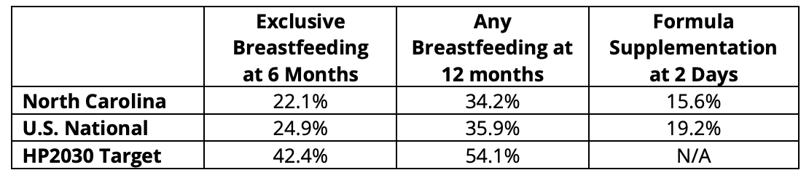
Figure 1. Percentage of Exclusive Breastfeeding at 6 months or Any Breastfeeding at 12 months in North Carolina and the United States, compared to the Healthy People 2030 Target. (U.S. Breastfeeding Committee, 2023).

SECTION 2: POLICY ANALYSIS
Policy Options
Status Quo: Our policies will be compared to maintaining the status quo, which means that no new policies or programs will be implemented to increase lactation support.
Policy #1 - Increasing access to Maternal Community Health Workers (CHWs): This policy recommendation aims to expand the maternal community health workforce, including community health workers, doulas, and maternal health educators, in existing health systems to improve breastfeeding continuation for mothers.
Policy #2 - Amending Medicaid reimbursement criteria to include CLCs and CLEs: This policy proposes expanding Medicaid provider eligibility to include Certified Lactation Educators (CLEs) and Certified Lactation Counselors (CLCs) by submitting a Medicaid State Plan Amendment (SPA) through NCDHHS to the Centers for Medicare & Medicaid Services (CMS). Currently, North Carolina Medicaid reimburses lactation services when provided by medical providers and International Board-Certified Lactation Consultants (IBCLCs). However, CLEs and CLCs are ineligible for reimbursement (NCDHHS, 2023).
Policy #3 - Adding IBCLCs as a provider in North Carolina Medicaid for direct telehealth billing: This policy would add Internationally Board-Certified Lactation Consultants (IBCLCs) as a provider type in North Carolina Medicaid, allowing them to directly enroll in and bill Medicaid. Currently, they must bill under a supervising physician (NCDHHS, 2023). Telehealth reimbursement can be especially difficult, so this policy focuses on removing administrative barriers for IBCLCs to provide tele-lactation services, with the goal of increasing access to this support.
Policy #4 – Smart Start Community-Based Peer Lactation Support Groups: This policy proposed a state appropriation to fund the creation of community-based peer lactation support groups using the evidence-based WIC peer-counseling model but coordinated and supported through Smart Start’s statewide early childhood network. Under this policy, the General Assembly would allocate recurring funds to Smart Start, enabling local partnerships in all 100 counties to recruit and train peer counselors, host culturally relevant lactation support groups, and provide postpartum breastfeeding assistance to breastfeeding families.
Policy Analysis and Evaluation
Table 1: Evaluation criteria and scoring definitions
Criterion | Definition | Scoring Scale (1-3)
Affordability | The total monetary cost to North Carolina to implement the policy, including required personnel, training, and resources | 1: over $5 million  2: between $2-4 million  3: under $1 million
Impact | The extent to which the policy impacts breastfeeding continuation through six months in North Carolina | 1: least impact  2: moderate impact  3: most impact
Equity | The degree to which the policy improves breastfeeding duration for Black mothers in North Carolina or reduces racial disparities in breastfeeding continuation. | 1: least equitable  2: moderately equitable  3: most equitable  ** Weighted x2
Political Feasibility | The likelihood that the North Carolina General Assembly (NCGA) would pass the policy, based on anticipated stakeholder support and opposition | 1: least feasible  2: moderately feasible  3: most feasible

Table 2: Comparison of each policy based on the evaluation criteria
Evaluation  Criteria | Affordability | Impact | Political Feasibility | Equity (x2)
Status Quo | Moderate  The status quo costs the state no money. However, low rates of breastfeeding continuation and exclusivity lead to higher costs for adverse infant and child health outcomes. | Low  Current policies do little to expand access to lactation services, leaving gaps in breastfeeding support. | High  Maintaining the status quo requires no policy changes, regulatory updates, or new spending commitments for the state. | Moderate  Some individuals can access lactation support through existing providers.
Policy #1 - Increasing access to Maternal Community Health Workers (CHWs) | Low  The policy would require both upfront and ongoing investments for training, salaries, and program administration to support additional community health work personnel. The estimated cost for expansion is roughly five to six million as seen in Virginia (Joint Commission on Heath Care, 2024). | High  Expanding CHW would assist in increased access to resources, education, and additional postpartum support. Evidence from states such as Maine and New York, have refined Medicaid reimbursement or developed programs to fund education and support job placement at rural hospitals/clinics (Center for Healthcare Strategies, 2025). | Moderate  The policy has potential to reach the NCGA, however based on cost estimates to the state, it is unlikely to be implemented as intended. Sustained funding commitments will face constraints as North Carolina has not passed a state budget (Fredde, 2025). | High  The policy would effectively reach populations who disproportionately experience breastfeeding disparities. Evidence supports CHW assistance in breastfeeding initiation and continuation for mothers (Israel, 2023).
Policy #2 - Amending Medicaid reimbursement criteria to include CLCs and CLEs | High  The policy would likely be highly affordable for the state. Illinois projected a federal budget impact of approximately $360,000 for fiscal year 2025 following implementation of its SPA (CMS, 2024). North Carolina’s implementation will likely be more as funding will go to the reimbursement of CLEs/CLCs. But with the Federal Medical Assistance Percentage (FMAP) for Medicaid set to 65%, state cost will remain low (KFF, 2026). | High  The policy is expected to have a high impact by increasing access to reimbursable lactation services. Evidence from states implementing SPAs expanding lactation coverage shows improvements in breastfeeding indicators within two years. Rates of infants exclusive breastfeeding at six months. increased by 0.1–4.9 percentage points (Biviji et al., 2025). | Moderate  Fourteen states have already amended their Medicaid SPAs to expand lactation coverage, with several recognizing additional LSPs beyond IBCLCs (Biviji et al., 2025). Illinois recently implemented SPA IL-23-0043, demonstrating the administrative feasibility of this approach (CMS, 2024). | High  Medicaid covers a large proportion of births in the state, making its coverage policies critical for improving breastfeeding support among low-income populations. Expanding reimbursement eligibility to include CLEs and CLCs may increase access to culturally responsive care and help reduce disparities in breastfeeding continuation among Black mothers.
Policy #3 - Adding IBCLCs as a provider in North Carolina Medicaid for direct telehealth billing | Moderate  The estimated cost of providing lactation support services under North Carolina Medicaid is estimated to be about 4.5 million dollars, however, the projected net cost savings are about 2.3  million dollars by decreasing health expenditures from the adverse infant and child health outcomes that breastfeeding mitigates (Biviji et al., 2025). | High  In an analysis of states that implemented SPAs to make IBCLCs a direct billable Medicaid provider, researchers found that when  comparing data from two years before and after SPA implementation,  there were improvements in breastfeeding outcomes in all states (Biviji et al., 2025). | Moderate  Medicaid Managed Care Organizations (MCOs) are a powerful group and would likely support this policy, as they would receive additional funds and save money in the long-term. There may be opposition from other types of providers who could view this policy as a threat to their patient base and scope of practice. | High  Black people make up only 22% of North Carolina’s population, but 37.4% of Medicaid recipients, and covers over half of births to Black mothers (U.S. Census Bureau; NCDHHS). This policy would provide services for Medicaid beneficiaries which serve a large proportion of Black residents who face other structural barriers, like being low-income (Biviji et al., 2025).
Policy #4 - Community-Based Peer Lactation Support Group | Low  When scaling to North Carolina, a statewide peer lactation support program coordinated by Smart Start would require an estimated $8-10 million annually, given Smart Start’s existing $150 million infrastructure and the cost of implementing a WIC-style peer counseling model across 100 counties (National WIC Association, 2019). | High  Peer counseling through a WIC model has been shown to significantly increase breastfeeding duration (National WIC Association, 2019). A WIC peer support program in Minnesota found a 3-5 percentage point increase at 3-6 months, so this policy is expected to produce similar strong improvements (Interrante, 2024). | Moderate  Smart Start is a well-established, bipartisan-supported early childhood network, which increases the likelihood that legislators would trust to coordinate a new statewide program. However, because the policy requires a new recurring appropriation of roughly $8-$10 million, it faces moderate fiscal resistance. | High  Peer lactation counseling has been shown to be especially effective for Black mothers, significantly increasing breastfeeding initiation and duration, and helping reduce long-standing racial disparities in breastfeeding rates (National WIC Association, 2019).

Table 3: Numerical scoring of evaluation criteria for each policy
Evaluation Criteria | Affordability | Impact | Political Feasibility | Equity (x2) | Totals
Status Quo | 2 | 1 | 3 | 2 | 8
Policy 1: Increasing access to Maternal Community Health Workers (CHWs | 1 | 3 | 2 | 6 | 12
Policy 2: Amending Medicaid reimbursement criteria to include CLCs and CLEs | 3 | 3 | 2 | 6 | 14
Policy 3: Adding IBCLCs as a provider in North Carolina Medicaid for direct telehealth billing | 2 | 3 | 2 | 6 | 13
Policy 4: Community-Based Peer Lactation Support Groups | 1 | 3 | 2 | 6 | 12

Final Recommendation
After evaluating all proposed policies, our final recommendation is a State Plan Amendment (SPA) to Medicaid reimbursement requirements to include CLEs and CLCs. This policy provides the most cost-effective path as compared to the other options and the status quo. By utilizing existing Medicaid reimbursement mechanisms, the policy addresses the financial burden associated with low breastfeeding rates while expanding access to lactation support services. Research has found breastfeeding saves millions in healthcare cost by mitigating adverse maternal and infant health outcomes.¹¹ Expanding Medicaid reimbursement to CLEs and CLCs will help ensure more families can access timely and culturally responsive lactation support.

Evaluation Metrics
Our quantitative process measure to evaluate the implementation of the policy is the number and proportion of Medicaid-reimbursable lactation providers in North Carolina who are certified as CLEs or CLCs after implementation of the SPA. Data can be collected through Medicaid provider enrollment records and billing claims.
Our qualitative outcome measure to evaluate the impact of the policy is perceived accessibility and cultural responsiveness of lactation support services among Black mothers. This will be collected through focus groups or community-based interviews conducted in partnership with local lactation organizations.

SECTION 3: BUDGET
PROGRAM SUMMARY
The primary goal of this policy is to increase rates of breastfeeding initiation and continuation by increasing the availability of culturally responsive and community-based lactation support. Over three years, the total program cost is projected at approximately $3.35 million, including personnel, service reimbursement, and provider outreach and training. Medicaid service expenditures are eligible for the Federal Medical Assistance Percentage (FMAP), with an estimated federal share of approximately $2 million and a state share of approximately $1.2 million over the three-year period.
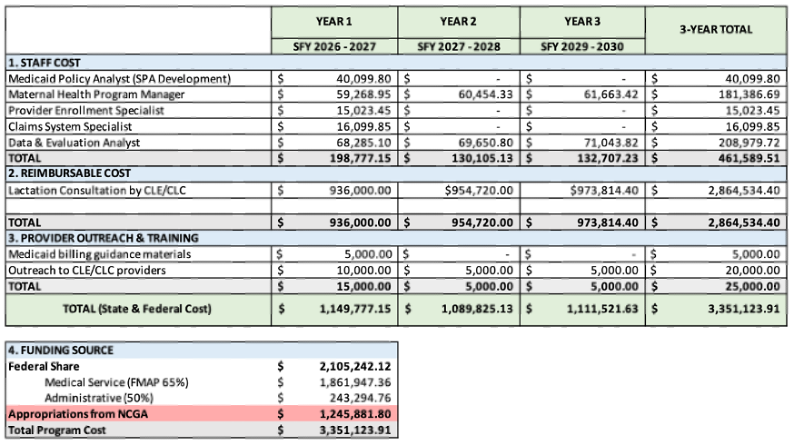
Figure 2 Program Budget Breakdown by Staff Costs, Reimbursable Costs, and Provider Training and Outreach, and Funding Sources from the FMAP.
BUDGET NARRATIVE
Staff Cost. Staffing costs are relatively low for the implementation of this policy because all the required roles already exist within the North Carolina Department of Health and Human Services (NCDHHS) and can be integrated into existing responsibilities. As a result, most positions are budgeted at partial Full-Time Equivalent (FTE) levels rather than new full-time hires. Several roles are only funded in the first year, as their responsibilities are primarily related to developing and submitting the SPA and supporting initial provider enrollment and billing system updates. Once these implementation activities are completed, ongoing oversight can be managed within existing program operations. Salary estimates were sourced from median salary data reported by ZipRecruiter for comparable positions in North Carolina (Medicaid Analyst Salary in North Carolina; Healthcare Program Manager Salary in North Carolina; Provider Enrollment Specialist Salary in North Carolina; Claims Processing Specialist Salary in North Carolina; Healthcare Data Analytics Salary in North Carolina). Budget assumptions include 30% for fringe benefits and a 2% annual cost-of-living increase applied to staff costs in Years 2 and 3.
Reimbursable Cost. The cost of reimbursing CLEs and CLCs providing lactation services represents the largest component of the budget. Several assumptions were used to estimate this cost. North Carolina reports approximately 120,000 live births annually, with about 50% covered by Medicaid, resulting in an estimated 60,000 Medicaid births per year (NC Birth Demographics, n.d.). A conservative utilization rate of 10% for lactation services was used to calculate annual estimated patient count with a 2% annually to indicate program success. Reimbursement is estimated at $13 per 15-minute unit, based on rates used in Illinois Medicaid (Illinois Department of Healthcare and Family Services, 2024). Each patient is assumed to receive three one-hour visits (12 total units), resulting in a cost of $156 per patient and an estimated annual cost of $936,000.
Provider Outreach & Training. Outreach will focus on educating CLEs and CLCs on Medicaid billing and reimbursement procedures. In the first year, The Maternal Health Program Manager will develop a Standard Operating Procedure (SOP) outlining billing and coding guidance. Initial costs support the creation and distribution of this material. Additional outreach activities include social media campaigns, stakeholder engagement, and recruiting outreach to lactation organizations and independent providers to encourage enrollment and participation in the first year. In the following years, funds will primarily be used to support ongoing outreach and dissemination of program updates.
Funding Source. The program will be funded through a combination of federal and state Medicaid funds. Medicaid expenditures are shared between the federal government and the state through the Federal Medical Assistance Percentage (FMAP). In North Carolina, the FMAP is approximately 65%, meaning the federal government covers the majority of Medicaid service costs through CMS. The federal government will also match 50% of program administrative costs (KFF, 2026). Based on the estimated total program cost of $3,351,124 over three years, the federal share is projected at $2,105,242, while the state share is estimated at $1,245,881.

References
An official position statement of the Association of Women's Health, Obstetric and Neonatal Nurses (2021). Breastfeeding and the Use of Human Milk. Nursing for Women's Health, 25(5), e4–e8. https://doi.org/10.1016/j.nwh.2021.06.005

Alive & Thrive. (n.d.). The Cost of Not Breastfeeding Tool. Retrieved January 30, 2026, from https://www.aliveandthrive.org/en/the-cost-of-not-breastfeeding-tool

Biviji, R., Mutyala, J., Syed, H., Muhammad, L., & Bever, J. (2025). Bridging the gap in lactation support through state Medicaid coverage and policy reform. Translational Behavioral Medicine, 15(1), ibaf061. https://doi.org/10.1093/tbm/ibaf061

Breastfeed Durham. (2023, February 16). 2023 North Carolina Breastfeeding Report. https://breastfeeddurham.org/north-carolina-breastfeeding-report-2023/

Carolina Global Breastfeeding Institute. (n.d.). Lactation consultant training. UNC Gillings School of Global Public Health. https://sph.unc.edu/cgbi/lactation-consultant-training/

Center for Health Care Strategies. (2025). Leveraging Community Health Workers to address rural health care needs. https://www.chcs.org/resource/leveraging-community-health-workers-to-address-rural-health-care-needs/

Centers for Disease Control and Prevention (CDC). (2025, May 16). Strategies for Continuity of Care in Breastfeeding. Breastfeeding. https://www.cdc.gov/breastfeeding/php/strategies/public-health-strategies-for-continuity-of-care-in-breastfeeding.html

Centers for Disease Control and Prevention (CDC). (2025, December 5). About Breastfeeding. Breastfeeding. https://www.cdc.gov/breastfeeding/php/about/?CDC_AAref_Val=https://www.cdc.gov/breastfeeding/about-breastfeeding/why-it-matters.html

Centers for Medicare & Medicaid Services (CMS). (n.d.). Medicaid State Plan Amendments. Medicaid.gov. https://www.medicaid.gov/medicaid/medicaid-state-plan-amendments

Centers for Medicare & Medicaid Services. (2024). State Plan Amendment (SPA): IL-23-0043. https://www.medicaid.gov/medicaid/spa/downloads/IL-23-0043.pdf

Fernandez, J. (2024, August 15). N.C. A&T conference highlights importance of breastfeeding to communities of color. NC Health News.
Fredde, A. (2025, November 25). NC budget stalemate deepens strain on safety nets, health system, advocates and providers say. North Carolina Health News. https://www.northcarolinahealthnews.org/2025/11/25/nc-budget-stalemate-strains-safety-nets/

Greensboro Chamber of Commerce. (2025, May 19). Creating Supportive Spaces: The Importance of Lactation Rooms in the Workplace. https://greensboro.org/creating-supportive-spaces-the-importance-of-lactation-rooms-in-the-workplace/

Harting, K. M., Singer, D., & Heiter, J. (2025). Optimizing breastfeeding for hospitalized newborns: A narrative review of midwifery-led interventions. European Journal of Midwifery, 9, 10.18332/ejm/200341. https://doi.org/10.18332/ejm/200341

Healthy Horizons. (2020, October 6). Difference between breastfeeding certifications: IBCLC, CLC, CLE and others.
Illinois Department of Healthcare and Family Services. (2024, December 19). Fee schedule for lactation counseling services. https://hfs.illinois.gov/content/dam/soi/en/web/hfs/sitecollectiondocuments/12192024lactationfs.pdf

Interrante, J. D., Fritz, A. H., McCoy, M. B., & Kozhimannil, K. B. (2024). Effects of breastfeeding peer counseling on county-level breastfeeding rates among WIC participants in Greater Minnesota. Women's Health Issues, 34(3), 232–240.
Israel, G. (2023). Integrating community health workers and nurse midwives on the health-care team to improve birth and breastfeeding outcomes. Journal of Perinatal Education, 32(1), 8–13. https://doi.org/10.1891/JPE-2022-0025

Joint Commission on Health Care. (2024). Strategies to extend health care access to vulnerable populations: Commission draft. Commonwealth of Virginia. https://jchc.virginia.gov/documents/JCHC%20EHCA%20Report%20-%20commisison%20draft.pdf

KFF. (2026, January 23). Federal Medical Assistance Percentage (FMAP) for Medicaid and multiplier. Retrieved March 6, 2026, from https://www.kff.org/medicaid/state-indicator/federal-matching-rate-and-multiplier/

Mamava Inc. (n.d.). Workplace Lactation Policies: Writing + Implementation. Resources. https://www.mamava.com/lactation-accommodation-policies

Mason, G., & Roholt, S. (2006). Promoting, Protecting and Supporting Breastfeeding: A North Carolina Blueprint for Action. North Carolina Division of Public Health.

Meek, J. Y., Noble, L., & Section on Breastfeeding. (2022). Policy Statement: Breastfeeding and the Use of Human Milk. Pediatrics, 150(1), e2022057988. https://doi.org/10.1542/peds.2022-057988

National WIC Association. (2019). Breastfeeding peer counselors: A successful program that should be expanded. https://media.nwica.org/2019-breastfeeding-peer-counselors.pdf

NC Medicaid, Division of Health Benefits. (2023, August 15). 1-I: Dietary evaluation and counseling and medical lactation services (Clinical Coverage Policy No. 1-I). https://medicaid.ncdhhs.gov/1-i-dietary-evaluation-and-counseling-and-medical-lactation-services/download?attachment

NCDHHS Division of Public Health. (2025, October 10). Title V Office Analysis of NC Resident Live Birth Certificate Data using NC Rural Health Urban/Rural Classifications. https://www.ncdhhs.gov/ruralurban-2019/open

North Carolina Department of Health and Human Services (DHHS). (n.d.). Special Supplemental Nutrition Program for Women, Infants and Children (WIC). Community Nutrition Services Section. https://www.ncdhhs.gov/ncwic

North Carolina Department of Health and Human Services, Division of Health Benefits. (2026, March 3). Understanding the impact of cuts to the NC Medicaid budget. NC Medicaid. https://medicaid.ncdhhs.gov/about-nc-medicaid/understanding-impact-cuts-nc-medicaid-budget

North Carolina Department of Health and Human Services. (2022, April). SL 2021-180 Section 9G.1(c) grants to improve maternal and child health [PDF]. https://www.ncdhhs.gov/sl-2021-180-section-9g1c-grants-improve-maternal-and-child-health-april-2022/download

North Carolina Department of Health and Human Services. (2025, December 8). Federal provider enrollment application fee increase for year 2026. NC Medicaid. https://medicaid.ncdhhs.gov/blog/2025/12/08/federal-provider-enrollment-application-fee-increase-year-2026

North Carolina Department of Health and Human Services. (n.d.). Medicaid enrollment dashboard. NC Medicaid. https://medicaid.ncdhhs.gov/reports/dashboards/enrollment-dashboard

North Carolina Division of Public Health. (n.d.). Infant death rate. N.C. Maternal and Infant Health Data Dashboard. Accessed March 1, 2026, from https://www.dph.ncdhhs.gov/programs/title-v-maternal-and-child-health-block-grant/nc-maternal-and-infant-health-data-dashboard/infant-death-rate

North Carolina Division of Public Health. (n.d.). NC birth demographics. N.C. Maternal and Infant Health Data Dashboard. https://www.dph.ncdhhs.gov/programs/title-v-maternal-and-child-health-block-grant/nc-maternal-and-infant-health-data-dashboard/nc-birth-demographics

North Carolina Office of the State Controller. (n.d.). State employee salary database search. Retrieved March 6, 2026, from https://www.ncosc.gov/public-information/state-employee-salary-database/state-employee-salary-database-search

Office of Disease Prevention and Health Promotion. (n.d.). Increase the proportion of infants who are breastfed exclusively through age 6 months — MICH-15. Healthy People 2030. Retrieved January 30, 2026, from https://odphp.health.gov/healthypeople/objectives-and-data/browse-objectives/infants/increase-proportion-infants-who-are-breastfed-exclusively-through-age-6-months-mich-15/data

Office of the Surgeon General (US); Centers for Disease Control and Prevention (US); Office on Women's Health (US). (2011). The Surgeon General's Call to Action to Support Breastfeeding. Office of the Surgeon General. https://www.ncbi.nlm.nih.gov/books/NBK52687/

Perinatal Equity Initiative. (n.d.). CLC vs. IBCLC: What's the difference? https://perinatalequity.org/clc-vs-ibclc-whats-the-difference/

Rosenzweig, C., Forster, J., Silow-Carroll, S., Savage, H., Rodin, D., & Rabinovitz, J. (2025, August). Medicaid Coverage of Breastfeeding Support and Supplies: Landscape Analysis. Health Management Associates, Inc. https://www.healthmanagement.com/wp-content/uploads/Meals4Families-Report-DRAFT_8.28.25_FINAL.pdf

Sankofa, N., & Seger, A. P. (2023, February 9). North Carolina Breastfeeding Report, 2023. U.S. Breastfeeding Committee (USBC).

Smart Start (The North Carolina Partnership for Children). (n.d.). https://www.smartstart.org/

U.S. Census Bureau. (n.d.). QuickFacts: North Carolina. https://www.census.gov/quickfacts/fact/table/NC/PST045225

U.S. Congress. (2022). Providing Urgent Maternal Protections (PUMP) for Nursing Mothers Act, Pub. L. No. 117-328. https://www.congress.gov/bill/117th-congress/house-bill/311

U.S. Department of Health and Human Services, Centers for Disease Control and Prevention, National Center for Health Statistics. (2023). National Vital Statistics System: Natality public use files. CDC WONDER Online Database. https://wonder.cdc.gov/

United States Department of Agriculture (USDA). (n.d.). Breastfeeding Benefits. WIC Breastfeeding Support. https://wicbreastfeeding.fns.usda.gov/breastfeeding-benefits

Uscher-Pines, L., Lawrence, R., & Waymouth, M. (2023). Telehealth for Breastfeeding Support and Lessons for Digital Equity. JAMA Health Forum, 4(3), e225464. https://doi.org/10.1001/jamahealthforum.2022.5464
ZipRecruiter. (n.d.). Claims processing specialist salary in North Carolina. https://www.ziprecruiter.com/Salaries/Claims-Processing-Specialist-Salary--in-North-Carolina

ZipRecruiter. (n.d.). Healthcare data analytics salary in North Carolina. https://www.ziprecruiter.com/Salaries/Healthcare-Data-Analytics-Salary--in-North-Carolina

ZipRecruiter. (n.d.). Healthcare program manager salary in North Carolina. https://www.ziprecruiter.com/Salaries/Healthcare-Program-Manager-Salary--in-North-Carolina

ZipRecruiter. (n.d.). Medicaid analyst salary in North Carolina. https://www.ziprecruiter.com/Salaries/Medicaid-Analyst-Salary--in-North-Carolina

ZipRecruiter. (n.d.). Provider enrollment specialist salary in North Carolina. https://www.ziprecruiter.com/Salaries/Provider-Enrollment-Specialist-Salary--in-North-Carolina

APPENDIX A – ERHARDT INDIVIDUAL ASSIGNMENTS

Problem Statement
Introduction
It is well-documented that breastfeeding is the best way to feed infants due to its’ nutritional benefits for both the parent and infant (Office of the Surgeon General et al., 2011). The American Academy of Pediatrics recommend exclusively breastfeeding infants through the first six months of life, with continued breastfeeding through the first year (Office of the Surgeon General et al., 2011). Breast milk is uniquely composed to meet the nutritional needs of an infant, and a robust body of research shows that it can help lower the risk of several infections and diseases, including ear infections, asthma, lower respiratory infections, childhood obesity, and type 2 diabetes (USDA, n.d.). Breastfeeding also has numerous benefits for the lactating person, including reducing the risk of high blood pressure, some ovarian and breast cancers, and type 2 diabetes (USDA, n.d.). Breastfeeding also facilitates the bond between mother and infant, having positive impacts on psychosocial health (Office of the Surgeon General et al., 2011).
Breastfeeding initiation typically occurs in the hospital after delivery, but not everyone receives this support equally (Fernandez, 2024). Breastfeeding continuation refers to how long the infant is breastfeeding after initiation, and the longer continuation, the more health benefits are realized (CDC, 2025). However, myriad factors lead to parents stopping breastfeeding sooner than planned (The Association of Women's Health, Obstetric and Neonatal Nurses (AWHONN), 2021). It is important to examine the factors impeding and facilitating breastfeeding continuation because of the benefits it has to the infant, birthing person, and broader community (AWHONN, 2021). Birthing person, lactating person, mother, and parent will be used interchangeably throughout this statement.
Impact on North Carolina
North Carolina ranks in “the middle of the pack” compared to other states in the percentage of infants being breastfeed at any point through the first 6 months of life (Fernandez, 2024). According to the 2019 National Vital Statistics System birth certificate data, 81.6% of NC births resulted in breastfeeding initiation, compared to 84.1% at the national level (Sankofa & Seger, 2023). Examining historical trends, the breastfeeding initiation rate in NC in 1999 was 64.2%, improving to 69.9% in 2003, also with increases in the percentage of infants being breastfed past eight weeks (Mason & Roholt, 2006). While the number of infants being breastfed at any time or exclusively through 6 months continually increased from 2009 to 2021, these rates remained below the Healthy People goals (Fernandez, 2024; Mason & Roholt, 2006).
In 2021, 60.3% of North Carolina infants had some breastfeeding at any point through 6 months (Fernandez, 2024). However, just under half of NC babies were exclusively breastfed through three months, and this number drops to just over a quarter at 6 months (Fernandez, 2024). In the 2023 NC Breastfeeding Report, only 22.1% of NC infants were breastfed exclusively through 6 months, compared to 24.9% nationally (Sankofa & Seger, 2023). The Healthy People 2030 goal for this same metric is 42.4%, showing that both the U.S. and NC have room for improvement, with NC trailing behind national numbers (Sankofa & Seger, 2023).
Health Inequities
Many determinants impact both breastfeeding initiation and continuation in NC, and there are documented disparities by race and ethnicity and geographic location (Standish & Parker, 2022). Firstly, there have been persistent disparities in breastfeeding initiation and continuation among Black and African American birthing people and infants in NC (Fernandez, 2024). At the national level, the average percentage of infants who are ever breastfed (exclusively or not) is about 86%, while only 76% of Black infants are ever breastfed on average (CDC, 2025). In NC, according to 2023 CDC data, the percentage of infants who were born to Black mothers and breastfed during the period between birth and hospital discharge was 71.6%, compared to 84% for infants born to white mothers (U.S. Department of Health and Human Services et al., 2023).
Disparities in breastfeeding are also seen between those living in rural versus urban areas in NC. From 2020-2024, 84.4% of infants in urban classified areas were breastfeeding at discharge, compared to 74.8% of infants in rural classified areas (NCDHHS Division of Public Health, 2025). Furthermore, counties in the northeastern and southeastern regions see some of the lowest breastfeeding initiation rates in the state (see Figure 1) (CDC, 2024).

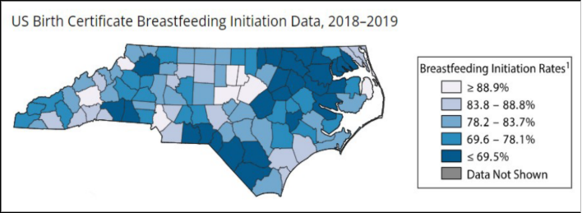
Figure 1, CDC Breastfeeding Initiation Rates and Maps by County, presenting 2018–2019 National Vital Statistics System data (CDC, 2024).

Historical Context
North Carolina has taken steps to improve breastfeeding rates and increase lactation support. The NC Department of Health and Human Services (DHHS) has the Special Supplemental Nutrition Program for Women, Infants and Children (WIC) program, which provides breastfeeding promotion, support, and community referrals (NC DHHS, n.d.). The WIC program also has two Breastfeeding-Friendly Designation Programs, which recognize medical centers and childcare centers for promoting and supporting breastfeeding within their space (NC DHHS, n.d.). These programs operate on a 5-star system, and a star is awarded for every two steps achieved in the “Ten Steps to Successful Breastfeeding” as defined by Baby Friendly USA (NC DHHS, n.d.). As of right now, seventeen medical centers across North Carolina have received five stars – most of which are in counties that already have high breastfeeding rates (NC DHHS, n.d.). This indicates that breastfeeding supports and resources may be unevenly distributed across NC, contributing to the disparities in breastfeeding outcomes.
The NC Breastfeeding Coalition (NCBFC) is a 501(c)(3) non-profit founded in 2005, and is a group of providers, agencies, organizations, individuals, and advocates to support and promote breastfeeding in NC (NCBFC, 2026). They are a resource hub for a variety of lactation supports and educational materials in the different regions across NC (NCBFC, 2026).
Rationale & Summary
There is a substantial body of research that shows the numerous benefits of breastfeeding for the infant, parent, and community. Improving breastfeeding continuation rates not only is advantageous for maternal and child health, but also economically beneficial (Office of the Surgeon General et al., 2011). At the national level, suboptimal breastfeeding rates add more than three billion dollars a year to U.S. medical costs (Office of the Surgeon General et al., 2011). Additionally, increasing breastfeeding duration will make infants healthier, meaning parents won’t need as much time off work to care for sick children, incurring fewer medical expenses, and leading to higher productivity (Office of the Surgeon General et al., 2011).
It is important that we address factors that may facilitate or impede breastfeeding continuation through six months. This is especially important in the context of racial and geographic disparities in breastfeeding outcomes across North Carolina. There are several policy actions that could address these gaps across the state, and ensure that every family has the knowledge, support, and infrastructure available to breastfeed.

Policy Analysis
Evaluation Criteria and Scoring
Criterion | Definition | Scoring Scale (1-3)
Affordability | The monetary cost to the state of NC to implement the proposed policy, including resources, personnel. | 1: over $5 million  2: between $1-5 million  3: under $1 million
Impact | How much the policy impacts breastfeeding continuation through 6 months in NC. | 1: least impact  2: moderate impact  3: most impact
Equity | How much the policy will positively affect breastfeeding duration for black mothers in NC or is the most likely to reduce racial disparities in breastfeeding continuation. | 1: least equitable  2: moderately equitable  3: most equitable  ** Weighted x2
Political Feasibility | How likely the policy would be passed by the NC General Assembly, and based on opposition and support from stakeholders | 1: least feasible  2: moderately feasible  3: most feasible

Policy 1 - Funding Lactation Room Implementation through Smart Start
The federal PUMP Act required employers to accommodate breastfeeding employees, such as providing break time and a private space, but does not require creation of permanent lactation rooms (U.S. Congress, 2022). Furthermore, this law only provides for employees and places of employment, not dedicated lactation spaces in the community, like libraries, parks, and shopping centers (Greensboro Chamber of Commerce, 2025). These policies are crucial to creating breastfeeding friendly environments, which increases the likelihood of exclusive breastfeeding through six months and longer breastfeeding duration (ACOG, 2021). As a local example, a non-profit “Breastfeed Durham” used the Improving Community Outcomes for Maternal and Child health (ICO4MCH) funds, managed by the county’s Department of Public Health, to implement lactation spaces in thirty eight businesses over three years (Breastfeed Durham, n.d.). A similar model could be replicated at the state level, leveraging the infrastructure that already exists within the NC Partnership for Children “Smart Start” agencies. Smart Start receives and allocates state funds for various maternal and child health initiatives, including some related to lactation, so it is feasible for them to direct this initiation (Smart Start, n.d.).
Evaluating this policy based on the criteria listed above, this policy would be moderately affordable. Breastfeed Durham received one million dollars in ICO4MCH funds to build lactation rooms in the county and utilized additional funding from the county public health department (NCDHHS, 2022). Smart Start already receives over $120 million in state funds, and this policy would require an additional five million dollars to be allocated across agencies to implement this program. This policy will have a moderate impact on breastfeeding continuation, as this policy addresses the built environment to make breastfeeding more accessible, but is highly dependent on location and knowledge of lactation rooms. In terms of political feasibility, this policy would be moderately more feasible given the use of existing funds and infrastructure. Fiscal conservatives may oppose appropriating additional funds to Smart Start given they already receive significant state funding. Perinatal providers and professional organizations like the NC Breastfeeding Coalition would be strong supporters of this policy. Finally, this policy is moderately equitable; implementation will vary substantially across the state and may not have a high impact on breastfeeding outcomes for Black mothers if rooms aren’t implemented in relevant spaces.
Policy 2 - Adding IBCLCs as a provider type to NC Medicaid for direct telehealth billing
Coverage for lactation support through Medicaid is fragmented, creating gaps in these services for Medicaid beneficiaries (Biviji et al., 2025). NC Medicaid allows medical lactation services to be delivered via telehealth under Clinical Coverage Policy 1-H, however, IBCLCs cannot enroll as independent Medicaid providers and therefore cannot be reimbursed directly for tele-lactation services, creating coverage gaps (NCDHHS, 2023; Rosenzweig et al., 2025). These administrative hurdles make it less likely that IBCLCs will provide services, and that patients will know what services are available to them (Rosenzweig et al., 2025). States can make changes to how their Medicaid program is administered through State Plan Amendments (SPAs) (CMS, n.d.). There are eight states with SPAs that allow IBCLCs to bill as independent providers though Medicaid (Biviji et al., 2025). NC Medicaid could create a similar SPA, so IBCLCs can bill for preventive tele-lactation services and get reimbursed without physician supervision, thereby increasing access to these services. The development of the SPA would require legislative approval, and if authorized by the NCGA and approved by CMS, the NCGA will allocate additional funds to the state's Medicaid budget.
This policy is most affordable because lactation services are reimbursable through Medicaid, just not directly to IBCLCs (NCDHHS, 2025). This policy will have a high impact on breastfeeding. In an analysis of states that implemented SPAs to make IBCLCs a direct billable Medicaid provider, researchers found that when comparing data from two years before and after the SPA implementation, there were improvements in breastfeeding outcomes (Biviji et al., 2025). This policy is moderately politically feasible. Medicaid Managed Care Organizations (MCOs) are a powerful group and would likely support this policy, as they would receive additional funds and save money in the long-term. There may be opposition from other types of providers who could view this policy as a threat to their patient base and scope of practice. This policy is highly equitable given it is specific to Medicaid beneficiaries, and there is a high proportion of Black mothers on Medicaid in NC.
Evaluation Criteria | Policy 1: Appropriations to build lactation rooms in the community | Policy 2: Allowing IBCLCs to directly bill Medicaid
Affordability to NCGA | 2 | 2
Impact on breastfeeding outcomes | 2 | 3
Political Feasibility | 3 | 2
Equity (x2) | 4 | 6
Totals | 11 | 13

Final Recommendation
The final policy recommendation to increase breastfeeding continuation rates is to create an SPA that allows IBCLCs to bill as independent Medicaid providers. Both policies were similar in affordability, while the lactation room policy is slightly more politically feasible; the SPA is more equitable and will have a higher impact.
Potential Evaluation Metrics
The process measure to evaluate the effectiveness of the implementation of this policy is a statewide survey of IBCLCs. The survey will ask about perceived barriers and facilitators to delivering tele-lactation services and getting Medicaid reimbursement. The outcome measure is breastfeeding continuation rates through six months, which will be assessed by using data from the years before and after the SPA and will be compared to improvements in other racial groups and across insurance types.

Program Budget
The budget for this policy included staffing costs, provider training and support, beneficiary outreach and marketing, and revenue from the Federal Medical Assistance Percentage. Personnel Costs included six different roles needed to implement, manage, monitor, and evaluate this policy. Most of these personnel already exist within NC Medicaid, so most have 0.25 FTEs. The Medicaid Program Manager position is the only position at 0.75 FTE, as they will be responsible for overseeing the implementation and progress of this policy. Salaries were estimated by taking averages from the NC State Employee Salary Database Search, and Indeed and ZipRecruiter.
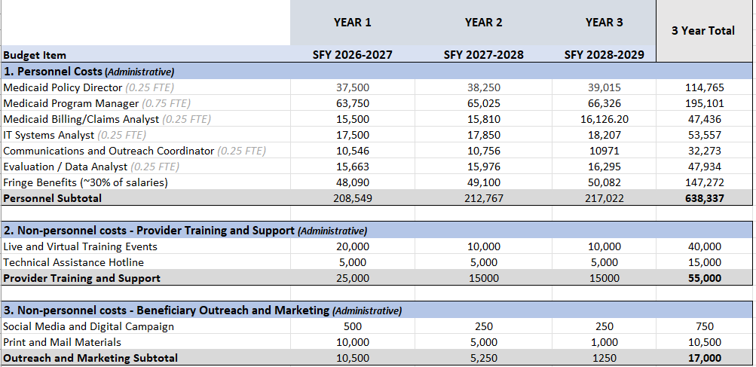
Non-personnel Costs include costs for IBCLC training and support and for beneficiary outreach and marketing, which includes training events and a technical assistance hotline. Some of these costs can be absorbed by NCDHHS and NC Medicaid, given they already participate in provider training and beneficiary outreach. Live and virtual training events were included, as IBCLCs will require training in enrolling and billing Medicaid. These training events will mainly focus on the administrative complexity of enrolling in and billing Medicaid, as this policy aims to reduce these hurdles to increase IBCLC enrollment. A technical assistance hotline will be created for IBCLCs, with $5,000 budgeted for all three fiscal years for staffing and cell service. Modest marketing and outreach costs were included, as a digital campaign and printed materials would be very low cost. Marketing costs were included given that many families are unaware they are eligible for lactation support services (Biviji et al., 2025).
It is estimated there will be 122,000 births in North Carolina per year, and about half of these will be paid for by Medicaid. If we assume a 3% utilization rate of IBCLCs out of 111,000 Medicaid births, it is estimated that 3,300 mothers will utilize an IBCLC. The 3% utilization was used under the assumption that utilization is already lower than this, while still keeping expected utilization low. There is very limited research on the exact percentage of NC Medicaid beneficiaries utilizing an IBCLC. The Medicaid reimbursement rate is an average of $15 per unit, which is 15 minutes - or about $60 for an hour-long appointment. It was also assumed these mothers will average two appointments with an IBCLC.
The Federal Medical Assistance Percentage (FMAP) is the percentage of Medicaid costs the federal government gives to states. Thus, costs will be offset by 50% FMAP for administrative costs, and 65% FMAP for service costs.
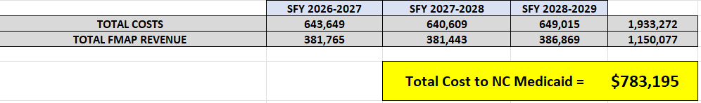

Legislative Fact Sheet
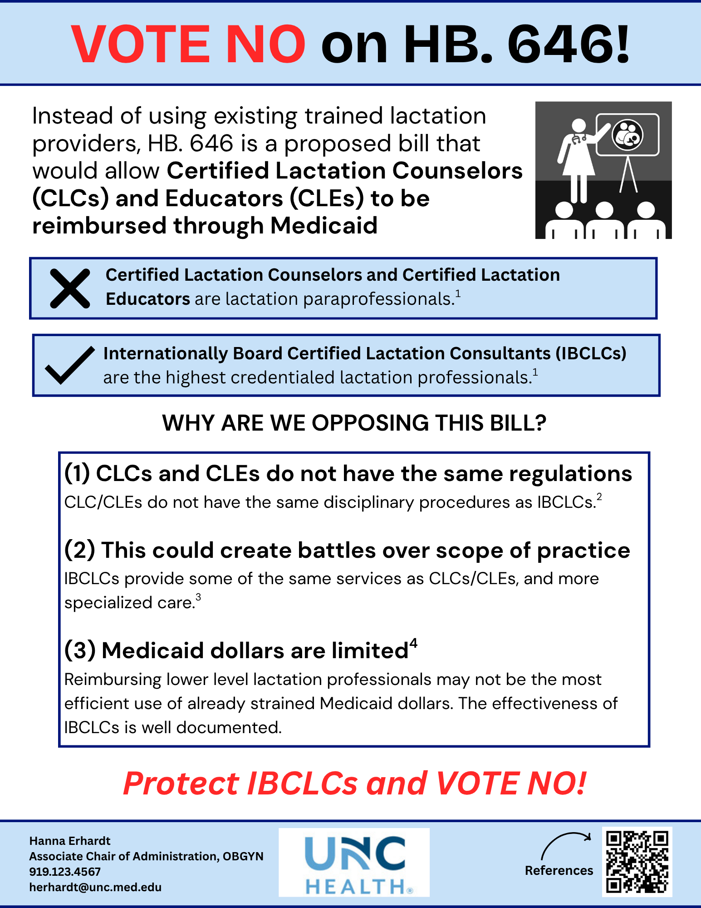

References
American College of Obstetricians and Gynecologists' (ACOG) Committee on Health Care for Underserved Women and the Breastfeeding Expert Work Group. (2021, February). Barriers to Breastfeeding: Supporting Initiation and Continuation of Breastfeeding. Obstetrics and Gynecology, 137(2), e54–e62. https://doi.org/10.1097/AOG.0000000000004249

An official position statement of the Association of Women's Health, Obstetric and Neonatal Nurses (2021). Breastfeeding and the Use of Human Milk. Nursing for Women's Health, 25(5), e4–e8. https://doi.org/10.1016/j.nwh.2021.06.005

Biviji, R., Mutyala, J., Syed, H., Muhammad, L., & Bever, J. (2025). Bridging the gap in lactation support through state Medicaid coverage and policy reform. Translational Behavioral Medicine, 15(1), ibaf061. https://doi.org/10.1093/tbm/ibaf061

Breastfeed Durham. (n.d.). New Lactation Areas in Durham Businesses. https://breastfeeddurham.org/new-lactation-areas-in-durham-businesses/

Carolina Global Breastfeeding Institute. (n.d.). Lactation consultant training. UNC Gillings School of Global Public Health. https://sph.unc.edu/cgbi/lactation-consultant-training/

Centers for Disease Control and Prevention (CDC). (2025, May 16). Strategies for Continuity of Care in Breastfeeding. Breastfeeding. https://www.cdc.gov/breastfeeding/php/strategies/public-health-strategies-for-continuity-of-care-in-breastfeeding.html

Centers for Disease Control and Prevention (CDC). (2025, December 5). About Breastfeeding. Breastfeeding. https://www.cdc.gov/breastfeeding/php/about/?CDC_AAref_Val=https://www.cdc.gov/breastfeeding/about-breastfeeding/why-it-matters.html

Centers for Medicare & Medicaid Services (CMS). (n.d.). Medicaid State Plan Amendments. Medicaid.gov. https://www.medicaid.gov/medicaid/medicaid-state-plan-amendments

Fernandez, J. (2024, August 15). N.C. A&T conference highlights importance of breastfeeding to communities of color. NC Health News. https://www.northcarolinahealthnews.org/2024/08/15/ncat-hosts-conference-on-importance-of-breastfeeding-to-black-brown-communities/

Greensboro Chamber of Commerce. (2025, May 19). Creating Supportive Spaces: The Importance of Lactation Rooms in the Workplace. https://greensboro.org/creating-supportive-spaces-the-importance-of-lactation-rooms-in-the-workplace/

Healthy Horizons. (2020, October 6). Difference between breastfeeding certifications: IBCLC, CLC, CLE and others. https://www.healthyhorizons.com/blogs/blog/difference-between-breastfeeding-certifications-ibclc-clc-cle-and-others

KFF. (n.d.). Federal matching rate and multiplier. Retrieved March 6, 2026, from https://www.kff.org/medicaid/state-indicator/federal-matching-rate-and-multiplier/

Mamava Inc. (n.d.). Workplace Lactation Policies: Writing + Implementation. Resources. https://www.mamava.com/lactation-accommodation-policies

Mason, G., & Roholt, S. (2006). Promoting, Protecting and Supporting Breastfeeding: A North Carolina Blueprint for Action. North Carolina Division of Public Health.

Meek, J. Y., Noble, L., & Section on Breastfeeding. (2022). Policy Statement: Breastfeeding and the Use of Human Milk. Pediatrics, 150(1), e2022057988. https://doi.org/10.1542/peds.2022-057988

NC Medicaid, Division of Health Benefits. (2023, August 15). 1-I: Dietary evaluation and counseling and medical lactation services (Clinical Coverage Policy No. 1-I). https://medicaid.ncdhhs.gov/1-i-dietary-evaluation-and-counseling-and-medical-lactation-services/download?attachment

NCDHHS Division of Public Health. (2025, October 10). Title V Office Analysis of NC Resident Live Birth Certificate Data using NC Rural Health Urban/Rural Classifications. https://www.ncdhhs.gov/ruralurban-2019/open

North Carolina Breastfeeding Coalition. (2026). North Carolina Breastfeeding Coalition. https://www.ncbfc.org/

North Carolina Department of Health and Human Services (DHHS). (n.d.). NC Maternity Center Breastfeeding-Friendly Designation Program. Community Nutrition Services Section. https://www.ncdhhs.gov/divisions/ncmcbfdesignation

North Carolina Department of Health and Human Services (DHHS). (n.d.). Special Supplemental Nutrition Program for Women, Infants and Children (WIC). Community Nutrition Services Section. https://www.ncdhhs.gov/ncwic

North Carolina Department of Health and Human Services, Division of Health Benefits. (2026, March 3). Understanding the impact of cuts to the NC Medicaid budget. NC Medicaid. https://medicaid.ncdhhs.gov/about-nc-medicaid/understanding-impact-cuts-nc-medicaid-budget

North Carolina Department of Health and Human Services. (2022, April). SL 2021-180 Section 9G.1(c) grants to improve maternal and child health [PDF]. https://www.ncdhhs.gov/sl-2021-180-section-9g1c-grants-improve-maternal-and-child-health-april-2022/download

North Carolina Department of Health and Human Services. (2025, December 8). Federal provider enrollment application fee increase for year 2026. NC Medicaid. https://medicaid.ncdhhs.gov/blog/2025/12/08/federal-provider-enrollment-application-fee-increase-year-2026

North Carolina Department of Health and Human Services. (n.d.). Medicaid enrollment dashboard. NC Medicaid. https://medicaid.ncdhhs.gov/reports/dashboards/enrollment-dashboard

North Carolina Office of the State Controller. (n.d.). State employee salary database search. Retrieved March 6, 2026, from https://www.ncosc.gov/public-information/state-employee-salary-database/state-employee-salary-database-search

Office of the Surgeon General (US); Centers for Disease Control and Prevention (US); Office on Women's Health (US). (2011). The Surgeon General's Call to Action to Support Breastfeeding. Office of the Surgeon General. https://www.ncbi.nlm.nih.gov/books/NBK52687/

Perinatal Equity Initiative. (n.d.). CLC vs. IBCLC: What's the difference? https://perinatalequity.org/clc-vs-ibclc-whats-the-difference/

Rosenzweig, C., Forster, J., Silow-Carroll, S., Savage, H., Rodin, D., & Rabinovitz, J. (2025, August). Medicaid Coverage of Breastfeeding Support and Supplies: Landscape Analysis. Health Management Associates, Inc. https://www.healthmanagement.com/wp-content/uploads/Meals4Families-Report-DRAFT_8.28.25_FINAL.pdf

Sankofa, N., & Seger, A. P. (2023, February 9). North Carolina Breastfeeding Report, 2023. U.S. Breastfeeding Committee (USBC).

Smart Start (The North Carolina Partnership for Children). (n.d.). https://www.smartstart.org/

U.S. Census Bureau. (n.d.). QuickFacts: North Carolina. https://www.census.gov/quickfacts/fact/table/NC/PST045225

U.S. Congress. (2022). Providing Urgent Maternal Protections (PUMP) for Nursing Mothers Act, Pub. L. No. 117-328. https://www.congress.gov/bill/117th-congress/house-bill/311

U.S. Department of Health and Human Services, Centers for Disease Control and Prevention, National Center for Health Statistics. (2023). National Vital Statistics System: Natality public use files. CDC WONDER Online Database. https://wonder.cdc.gov/

United States Department of Agriculture (USDA). (n.d.). Breastfeeding Benefits. WIC Breastfeeding Support. https://wicbreastfeeding.fns.usda.gov/breastfeeding-benefits

Uscher-Pines, L., Lawrence, R., & Waymouth, M. (2023). Telehealth for Breastfeeding Support and Lessons for Digital Equity. JAMA Health Forum, 4(3), e225464. https://doi.org/10.1001/jamahealthforum.2022.5464

APPENDIX B – MURPHY INDIVIDUAL ASSIGNMENTS

Problem Statement
Introduction
For mothers in the United States, breastfeeding is recommended for at least six months, with continuation through one to two years (Meek & Noble, 2022). Evidence demonstrates that breastfeeding improves maternal and infant health outcomes, including reduced risks of type two diabetes mellitus, respiratory tract infections, and infant mortality (Louis-Jacques & Stuebe, 2020). Given evidence supporting health benefits, breastfeeding continuation to six months represents a critical public health priority in North Carolina (U.S. Breastfeeding Committee, 2023).
Impact on North Carolina
The Healthy People 2030 targets aim for 42.4% of infants to be exclusively breastfed through six months and 54.1% of infants to receive any breastfeeding through 12 months (Raju, 2023). However, current rates fall below these benchmarks. Nationally, 24.9% of infants are exclusively breastfed at six months and 35.9% receive any breastfeeding at 12 months (U.S. Breastfeeding Committee, 2025). North Carolina reports lower rates, with 22.1% of infants exclusively breastfeeding at six months and 34.2% of infants continue any breastfeeding at 12 months (U.S. Breastfeeding Committee, 2025). These gaps indicate systemic shortcomings in postpartum care, lactation support infrastructure, and policy implementation in North Carolina.
Health Inequities
In North Carolina, Black mothers initiate breastfeeding at a rate of 71.6% compared to the national average rate of 76.5% (America’s Health Rankings, n.d.). Research across eight North Carolina medical centers found that non-Hispanic Black race, lack of commercial insurance, and residence in lower-education zip codes were independently associated with earlier breastfeeding cessation (McCloskey et al., 2023). Breastfeeding inequities among Black mothers are rooted in historical injustices, including the exploitation of Black mothers' reproductive labor through forced wet-nursing, and ongoing structural racism that limits access to culturally responsive lactation support (Adekunle, 2025). In addition, Black mothers disproportionately occupy positions that offer limited paid maternity leave, inflexible scheduling, and inadequate lactation accommodations (Milli & Buchanan, 2022).
Past Efforts to Address the Problem
North Carolina has implemented various initiatives to improve breastfeeding outcomes, such as the North Carolina Women, Infants, and Children (WIC) Breastfeeding program and the NC Maternity Breastfeeding-Friendly Designation program (NC MBFD). The NC WIC Breastfeeding Program provides comprehensive breastfeeding counseling, breast pump access, and nutritious food benefits for low-income breastfeeding families (NCDHHS, 2022). The NC MBFD program awards maternity centers who implement evidence-based clinical protocols that promote and support lactation (NCDHHS, n.d.).
Importance of Addressing the Problem
Improving breastfeeding continuation across North Carolina would improve maternal and infant outcomes, reduce healthcare expenditures, and strengthen fiscal sustainability. Sustained breastfeeding reduces infant hospitalizations, chronic diseases, and emergency healthcare utilization (Harting et al., 2025). Addressing breastfeeding continuation in North Carolina requires targeted policy action to expand the lactation workforce, integrate culturally responsive lactation care, and strengthen postpartum support systems to improve breastfeeding continuation rates through six months.
Figure 1: Comparison of Breastfeeding Rates to the Healthy People 2030 Target
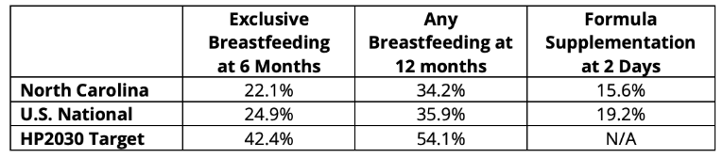
Source: (U.S. Breastfeeding Committee, 2023)

Policy Analysis
Evaluation Criteria and Scoring
Criterion | Definition | Scoring Scale (1-3)
Cost | The monetary cost to the state of NC to implement the proposed policy, including resources and personnel. | 1: over $5 million  2: between $1-5 million  3: under $1 million
Impact | How much the policy impacts breastfeeding continuation through 6 months in NC | 1: least impact  2: moderate impact  3: most impact
Equity | How much the policy will positively affect breastfeeding duration for black mothers in NC or is the most likely to reduce racial disparities in breastfeeding continuation. | 1: least equitable  2: moderately equitable  3: most equitable  ** Weighted x2
Political Feasibility | How likely the policy would be passed by the NC General Assembly, and based on opposition and support from stakeholders | 1: least feasible  2: moderately feasible  3: most feasible

Analysis
Statewide expansion of the maternal community health workforce would increase access to consistent, culturally responsive, community-based lactation education and support across North Carolina. CHWs deliver ongoing support through home visits, phone or text follow-up, and coordination with healthcare providers (Kowalczyk et al., 2024). Evidence conducted in Michigan found that the use of CHWs was significantly associated with reduced risk of adverse birthing outcomes (Meghea et al., 2023). A CHW-led home visiting program targeting low-income Black mothers in Cleveland, Ohio demonstrated improved breastfeeding continuation rates (Hamilton et al., 2025). These findings demonstrate that expanding the maternal community health workforce can directly reduce early breastfeeding discontinuation in North Carolina.
The first policy recommendation scored 1/3 on cost, as statewide expansion of the community health workforce requires upfront and ongoing investment in training, salaries, and program administration. The policy recommendation scored 3/3 on impact, as it creates additional job opportunities, improves workforce retention, and expands access to breastfeeding services for mothers statewide. The policy recommendation scored 2/3 on political feasibility, as the expansion aligns with existing infant and maternal health priorities and workforce development initiatives. Sustained funding commitments may face legislative constraints, as North Carolina H.B. 888 is currently pending in committee during the 2025-2026 session, illustrating the continued challenges in securing stable funding (North Carolina General Assembly, 2025). The policy recommendation scored 3/3 on equity, as CHWs effectively reach populations who disproportionately experience breastfeeding disparities and can provide access to culturally responsive lactation support.
The second policy recommendation incorporates culturally responsive training for maternal healthcare professionals such as CHWs, CLCs, CLEs, breastfeeding peer counselors, midwives, and doulas. The Breastfeeding Heritage and Pride Initiative in Connecticut and Massachusetts demonstrates that culturally grounded training and support increase breastfeeding duration among Black and Hispanic mothers (Rhodes et al., 2021). The second policy recommendation scored 2/3 on cost, as culturally responsive training can be integrated into existing continuing education and professional development systems, but statewide implementation would require funding. The second policy recommendation scored 1/3 on impact, as training alone does not address structural barriers associated with breastfeeding. The second policy recommendation scored a 3/3 on political feasibility, as provider training requirements are common and align with existing quality improvement goals. The second policy recommendation scored 2/3 on equity, as culturally responsive training can reduce implicit bias and improve patient experiences. However, its effectiveness depends on consistent reinforcement across healthcare settings.
Evaluation Criteria | Policy 1: Maternal Community Health Workforce Expansion | Policy 2: Culturally Responsive Training
Cost | 1 | 2
Impact | 3 | 1
Political Feasibility | 2 | 3
Equity (x2) | 6 | 4
Total Score | 12 | 10

Stakeholder Analysis
Potential supportive stakeholders of the first policy recommendation include the NC Department of Health and Human Services, rural health coalitions (e.g., Western NC Breastfeeding Coalition), and maternal and child health advocacy organizations such as Nurture NC. Potential opposition may come from fiscal conservative members of the NC General Assembly (NCGA) concerned about long-term state budget commitments (Lewis, 2023). Potential supportive stakeholders of the second policy recommendation include hospital systems who focus on quality improvement (e.g., Duke University Health System), academic institutions such as the Mountain Area Health Education Center, and expectant mothers and families (Talley et al., 2024; Lewis, 2023). Potential opposition may come from healthcare providers who may not have to pursue additional education mandates and training requirements.
Final Recommendation
The recommended policy to increase breastfeeding continuation is expanding the maternal community health workforce. The first policy recommendation demonstrated higher potential of impact by directly addressing access barriers, workforce shortages, and geographic inequities associated with access to lactation support. To ensure the effectiveness of the first policy recommendation, clear metrics are required. The qualitative process measure will be defined with interviews involving CHW supervisors and program coordinators periodically to assess implementation fidelity, cultural responsiveness, and barriers to service delivery, with data collected through structured interviews and field reports. The quantitative outcome metric will be defined as a 20% increase in 6-month breastfeeding continuation rates and a 10% reduction in racial disparities within three years, measured using the Pregnancy Risk Assessment Monitoring System (PRAMS) survey and North Carolina vital statistics data.

Program Budget
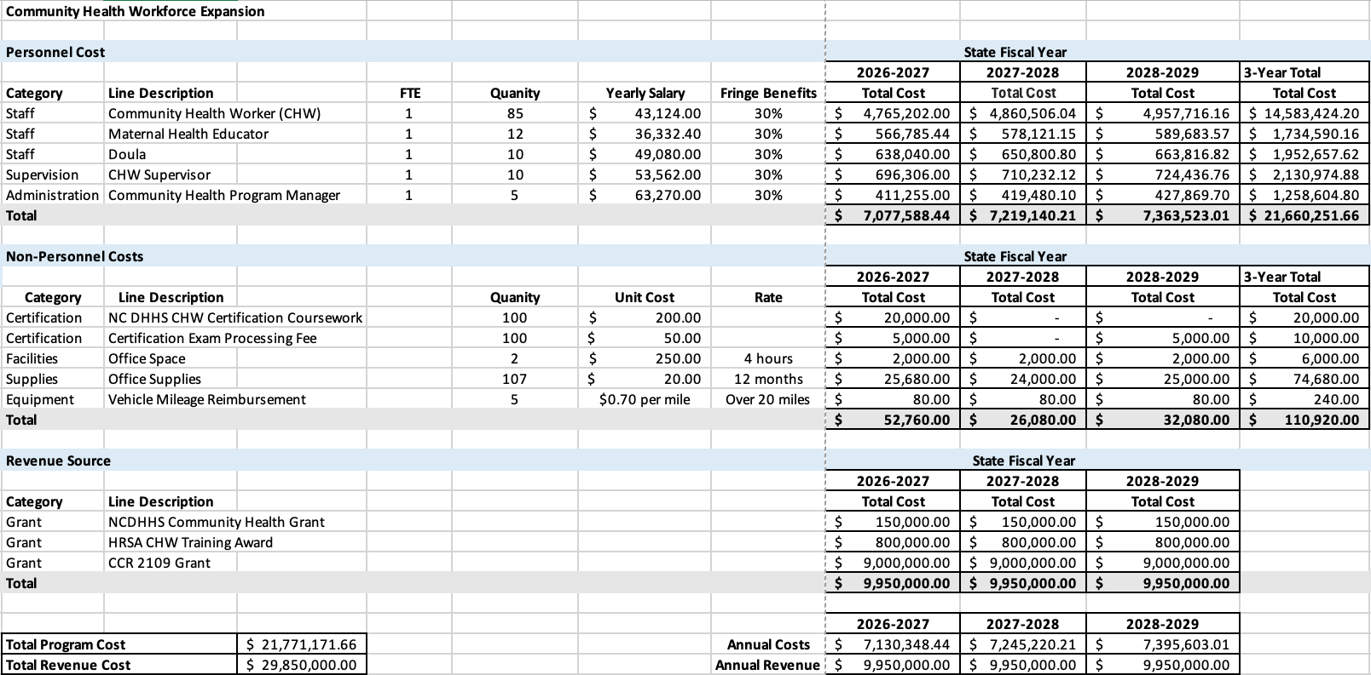
Program Overview
The Community Health Workforce Expansion addresses low breastfeeding continuation rates by expanding community-based workforce across six regional hubs aligned with North Carolina’s Department of Health and Human Service region map (NCDHHS, 2022). Funded through three sources, the NCDHHS Community Health grant, the HRSA CHW Training Award, and the CCR 2109 Grant, the program generates approximately $9.95 million against estimated annual costs of approximately $ 7.5 million.
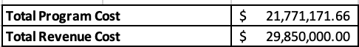
Personnel Costs
Personnel represent the largest budget category. All salaries reflect current NC statewide labor market data and increase at 2% annually. Fringe benefits are calculated as a percentage of salary to account for payroll taxes, retirement contributions, and health insurance.
Community Health Workers: CHWs serve as the primary direct-service workforce across seven regional hubs, with a $43,124 annual salary (ZipRecruiter, n.d.-a). At an estimated caseload of 50–60 active breastfeeding families per CHW annually, 85 FTEs are required to serve the projected statewide volume. CHWs conduct in-home visits, breastfeeding counseling, care coordination, and follow-up support.
CHW Supervisors: Supervisors provide oversight and mentorship at a ratio of approximately 1:8–9 CHWs, consistent with community health best practices with a $50,000 annual salary (Salary.com, n.d.). Supervisors serve as regional liaisons with healthcare systems and ensure quality and consistency of service delivery across hubs.
Community Health Educators: Educators develop and deliver structured breastfeeding and maternal health education, with a $36,332 annual salary (ZipRecruiter, n.d.-b). Hybrid delivery allows educators to serve broad audiences efficiently and reduces facility and travel costs.
Doulas: Doulas provide hands-on breastfeeding guidance, latch/positioning support, and emotional support with a $49,080 annual salary (ZipRecruiter, n.d.-c). Evidence indicates doula support improves breastfeeding initiation and duration among underserved populations (Israel, 2023).
Community Health Program Managers: Managers form a central administrative team overseeing statewide operations, funder compliance, HR, finance, and cross-hub coordination with a $53,632 annual salary (ZipRecruiter, (n.d.-d). Centralized management prevents duplication and ensures consistent program implementation.
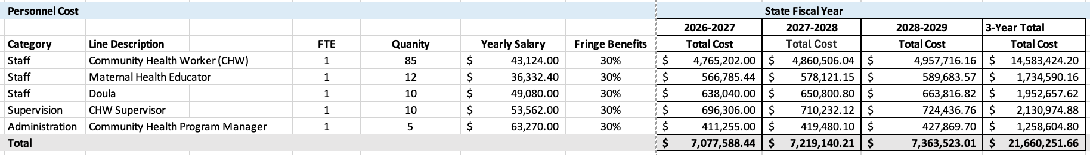
Non-personnel Costs
CHW Certification Coursework: CHWs complete initial certification through Durham Technical Community College's CHW Continuing Education Program at $200/participant (Durham Technical Community College, n.d.). Costs are front-loaded in year one during onboarding.
Certification Exam Processing Fee: NC Community Health Worker Association certification exam fee of $50/participant is incurred in year one for initial credentialing and in year three for renewal, per the three-year renewal cycle (North Carolina Community Health Worker Association, n.d.).
Office Space: Shared office space for 2 locations at $250/month (4 hours of usage) supports administrative and coordination functions (Chron, n.d.). Staff primarily operate in community settings and via virtual platforms, minimizing facility overhead.
Office Supplies: Administrative materials, printing of breastfeeding education resources, and program documentation for 107 staff, focusing on CHWs, doulas, and educators. Digital distribution of materials is prioritized where it is feasible to reduce printing costs.
Vehicle Mileage Reimbursement: Reimbursement for staff travel over 20 miles, per NC mileage guidelines at $0.70/mile (North Carolina Industrial Commission, 2025). The regional hub structure and virtual delivery model minimize travel distances, resulting in low mileage costs.
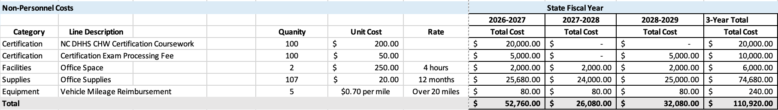
Revenue Source
The program is supported by three funding streams totaling $9,950,000/year across all three fiscal years (FY2026–2029). Annual revenue ($9,950,000) exceeds projected annual costs (~$7.4M), ensuring program sustainability and capacity to expand reach over the three-year period.
NCDHHS Community Health Grant: supports community health workforce activities and program coordination at $150,000/year (NCDHHS, n.d.).
HRSA CHW Training Award: funds CHW training, certification, and continuing education at $800,000/year based on estimate from Hendersonville, NC (HRSA, 2022).
CCR 2109 Grant: primary funding source for personnel and operational costs at $9,000,000/year (NCDHHS, 2021)
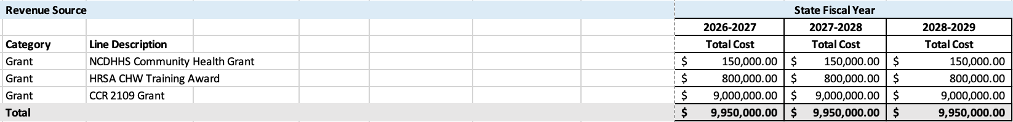

Legislative Fact Sheet
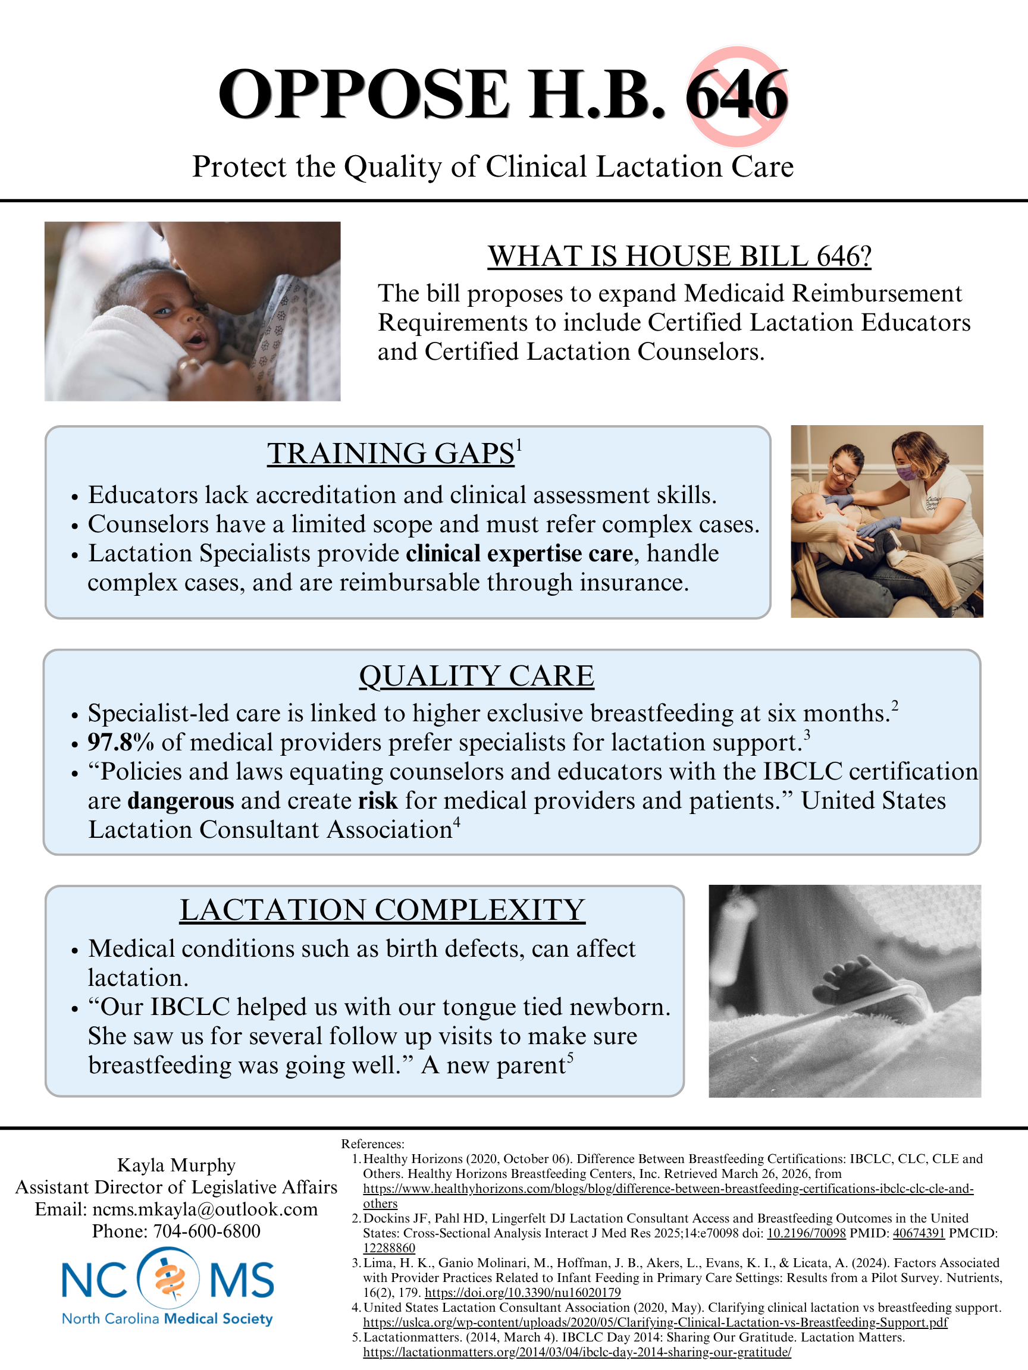

References
Adekunle T. E. (2025). Reproductive coercion, medical mistrust, and Black women's health from the
antebellum period to the 21st century. International journal for equity in health, 24(1), 302. https://doi.org/10.1186/s12939-025-02665-2

America’s Health Rankings. (n.d.) Explore Breastfeeding Initiation in North Carolina. Retrieved January
23, 2026, from https://www.americashealthrankings.org/explore/measures/breastfeeding_initiation/breastfeeding_black/NC

Chron. (n.d.). Average cost per month for office supplies.
https://smallbusiness.chron.com/average-cost-per-month-office-supplies-12771.html

Durham Technical Community College. (n.d.). Community health worker (continuing education).
https://www.durhamtech.edu/continuing-education/community-health-worker-continuing-education-program

Hamilton, D., Pérez, J., & Furman, L. (2025). Reducing Disparities in Breastfeeding: "Breast for Success"
Excels a Second Time. Breastfeeding medicine : the official journal of the Academy of Breastfeeding Medicine, 20(1), 19–24. https://doi.org/10.1089/bfm.2024.0229

Harting, K. M., Singer, D., & Heiter, J. (2025). Optimizing breastfeeding for hospitalized newborns: A
narrative review of midwifery-led interventions. European journal of midwifery, 9, 10.18332/ejm/200341. https://doi.org/10.18332/ejm/200341

Health Resources and Services Administration, (2022, September). FY 2022 community health worker training
awards. https://bhw.hrsa.gov/funding/community-health-worker-training-fy2022-awards

Israel G. Integrating Community Health Workers and Nurse Midwives on the Health-Care Team to Improve Birth
and Breastfeeding Outcomes. J Perinat Educ. 2023 Jan 1;32(1):8-13. doi: 10.1891/JPE-2022-0025. PMID: 36632517; PMCID: PMC9822562.

Kowalczyk, M., Yao, N., Gregory, L., Cheatham, J., DeClemente, T., Fox, K., Ignoffo, S., & Volerman,
A. (2024). Community health worker perspectives: examining current responsibilities and strategies for success. Archives of public health = Archives belges de sante publique, 82(1), 94. https://doi.org/10.1186/s13690-024-01313-5

Lewis, I. (2023, August 10). During the pandemic, community health care workers provided a bridge to
care for marginalized populations. Now what? North Carolina Health News. https://www.northcarolinahealthnews.org/2023/08/10/community-health-care-workers-lobby-sustainble-funding/

Louis-Jacques, A. F., & Stuebe, A. M. (2020). Enabling Breastfeeding to Support Lifelong
Health for Mother and Child. Obstetrics and gynecology clinics of North America, 47(3), 363–381. https://doi.org/10.1016/j.ogc.2020.04.001

McCloskey, K., Henao, D., Gregory, C., Corsig, L., & Plummer, D. (2023). Breastfeeding Disparities
During the COVID-19 Pandemic: Race/Ethnicity, Age, Education, and Insurance Payor. Journal of human lactation : official journal of International Lactation Consultant Association, 39(4), 615–624. https://doi.org/10.1177/08903344231187907

Meek, J. Y., Noble, L., & Section on Breastfeeding (2022). Policy Statement: Breastfeeding and the Use
of Human Milk. Pediatrics, 150(1), e2022057988. https://doi-org.libproxy.lib.unc.edu/10.1542/peds.2022-057988

Meghea, C. I., Raffo, J. E., Yu, X., Meng, R., Luo, Z., Vander Meulen, P., Sanchez Lloyd, C., & Roman,
L. A. (2023). Community Health Worker Home Visiting, Birth Outcomes, Maternal Care, and Disparities Among Mothers With Medicaid Insurance. JAMA pediatrics, 177(9), 939–946. https://doi.org/10.1001/jamapediatrics.2023.2310

Milli, J., Frye, J., & Buchanan, M. J. (2022, April 3). Black Women Need Access to Paid Family and
Medical Leave - Center for American Progress. Center for American Progress. https://www.americanprogress.org/article/black-women-need-access-to-paid-family-and-medical-leave/

North Carolina Community Health Worker Association. (n.d.). CHW certification: Steps to certification.
https://ncchwa.org/services/certification/

North Carolina Department of Health and Human Services. (n.d.). SFY 2027 community health grant RFA.
https://www.ncdhhs.gov/about/grant-opportunities/rural-health-grant-opportunities/sfy-2027-community-health-grant-rfa

North Carolina Department of Health and Human Services. (2021, September). NCDHHS awarded $9M from CDC
to support statewide community health worker infrastructure. https://www.ncdhhs.gov/news/press-releases/2021/09/28/ncdhhs-awarded-9m-cdc-support-statewide-community-health-worker-infrastructure#:~:text=The%20$9%20million%20in%20CDC%20funding%20will,for%20CHWs%20that%20builds%20on%20the%20pandemic

North Carolina Department of Health and Human Services. (2022, February). Map of regions.
https://www.ncdhhs.gov/map-regions

North Carolina Department of Health and Human Services. (2022). Understanding North Carolina WIC
Breast Pump Program. Division of Child and Family Well-Being. Retrieved January 25, 2026, from https://www.ncdhhs.gov/understanding-north-carolina-wic-breast-pump-program/download?attachment#:~:text=We%20provide%20breastfeeding%20support%20to,issuance%20of%20breast%20pumps%20to

North Carolina General Assembly. (2025). H.B. 888, Funds for NC Community Health Worker Assn.,
2025–2026 session. https://www.ncleg.gov/BillLookup/2025/H888

North Carolina Industrial Commission. (2025, July). Form 25T: Itemized statement of charges for travel (Form
25T). https://www.ic.nc.gov/forms/form25t_07.08.25.pdf

NC Maternity Center Breastfeeding-Friendly Designation Program | NCDHHS. (n.d.). Retrieved January
20, 2026, from https://www.ncdhhs.gov/divisions/ncmcbfdesignation#BenefitsofDesignation-4421

Raju T. N. K. (2023). Achieving healthy people 2030 breastfeeding targets in the United States:
challenges and opportunities. Journal of perinatology : official journal of the California Perinatal Association, 43(1), 74–80. https://doi.org/10.1038/s41372-022-01535-x

Rhodes, E. C., Damio, G., LaPlant, H. W., Trymbulak, W., Crummett, C., Surprenant, R., & Pérez-
Escamilla, R. (2021). Promoting equity in breastfeeding through peer counseling: the US Breastfeeding Heritage and Pride program. International journal for equity in health, 20(1), 128. https://doi.org/10.1186/s12939-021-01408-3

Salary.com. (2026, March 1). Community health worker supervisor salary, hourly rate in the United States.
https://www.salary.com/research/salary/position/community-health-worker-supervisor-salary

Talley, H., Federspiel, J. J., Oakes, M. J., Shaw, M. I., Junker, J., McDuffie, K., Murray, M., & Lawdley,
J. (2024). Duke Health receives 2024 Perinatal Quality Collaborative of NC (PQCNC) quality improvement award. Duke Department of Obstetrics and Gynecology. https://obgyn.duke.edu/news/duke-health-receives-2024-perinatal-quality-collaborative-nc-pqcnc-quality-improvement-award

U.S. Breastfeeding Committee. (2023). North Carolina breastfeeding report.
https://www.usbreastfeeding.org/state-breastfeeding-reports.html

ZipRecruiter. (n.d.-a). Community health worker salary in North Carolina.
https://www.ziprecruiter.com/Salaries/Community-Health-Workers-Salary--in-North-Carolina

ZipRecruiter. (n.d.-b). Community health educator salary in North Carolina.
https://www.ziprecruiter.com/Salaries/Community-Health-Educator-Salary--in-North-Carolina

ZipRecruiter. (n.d.-c). Postpartum doula salary in North Carolina.
https://www.ziprecruiter.com/Salaries/Postpartum-Doula-Salary--in-North-Carolina

ZipRecruiter. (n.d.-d). Community health manger salary in North Carolina.
https://www.ziprecruiter.com/Salaries/Community-Health-Manager-Salary--in-North-Carolina

APPENDIX C – RAVI INDIVIDUAL ASSIGNMENTS

Problem Statement
Introduction: Breastfeeding provides well-documented health benefits for both infants and mothers (CDC, 2025). Breast milk supports infant growth, development, and immune protection, reducing risks of asthma, obesity, childhood leukemia, gastrointestinal infections, SIDS, and infant mortality (Purkiewicz et al., 2025). Mothers also benefit through lower risks of breast and ovarian cancer, hypertension, and type II diabetes (CDC, 2025). National guidelines recommend exclusive breastfeeding for six months, yet continuation rates remain low (HHS, 2021). In 2013, although 81% of infants were breastfed at birth, only 44% were exclusively breastfed by three months (U.S. Breastfeeding Committee, 2023). Addressing barriers to six-month breastfeeding continuation is therefore essential.
Impact on NC: Low breastfeeding continuation through six months remains a major public health issue in North Carolina and contributes to preventable maternal and infant health risks. In NC, 81.4 percent of infants are breastfed at hospital discharge, but only 22.1 percent are exclusively breastfed at six months (CDC, 2023). In the figure below, it is apparent North Carolina has made progress over the past two decades, increasing exclusive breastfeeding at six months from 6.9 percent in 2007 to 30.8 percent in 2022, but recent declines show that earlier gains are not being sustained (NCDHHS, 2024). NC also trails nearby states such as Tennessee at 24.9 percent and Virginia at 25.8 percent, indicating room for improvement within the region (CDC, 2023).
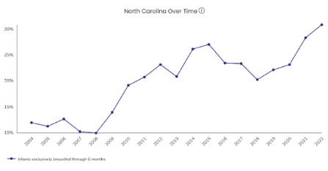
Figure 1: Breastfeeding Continuation Rates in North Carolina
Nutrition, Physical Activity, and Obesity: Data, Trends, and Maps | DNPAO | CDC
Health Inequities: Breastfeeding outcomes and related infant health indicators in North Carolina vary significantly across racial, socioeconomic, and geographic groups, with disproportionate impacts on Black families, low-income households, and communities with limited access to maternity care. Racial disparities are especially important in the context of maternal and infant health. Infants born to Black mothers in North Carolina experience an infant mortality rate approximately 1.7 times higher than the state average (NCDHHS, 2024). Black infants are also more likely to be born at low birth weight, with 14.3% of low birthweight births occurring among Black infants as compared to the average rate for white infants (7.3%) (March of Dimes, 2026). These adverse birth outcomes are associated with greater challenges in breastfeeding initiation and continuation. Breastfeeding initiation rates also vary substantially by race, with Black mothers having the lowest initiation rate of 74.5% as compared to White mothers (85.9), contributing to one of the largest racial gaps in breastfeeding initiation in the state (Marks et al., 2023).
Historical Context: North Carolina has prioritized breastfeeding through the Title V Maternal and Child Health Block Grant and has also participated in federal initiatives such as Healthy Start, which provided more than $3.4 million to reduce racial and ethnic disparities in infant mortality through community-based supports that can include lactation education and counseling. More recently, the extension of Medicaid postpartum coverage to 12 months has expanded access to maternal health services during a critical period for breastfeeding continuation. Despite these efforts, most programs focus on initiation rather than sustained breastfeeding, contributing to the decline between birth and six months.
Rationale: Breastfeeding also offers economic benefits to state health systems. Higher breastfeeding rates have been associated with reduction in Medicaid spending, including an estimated 111.6 million decrease in federal Medicaid costs attributable to reducing disease incidence (USDA, 2019). Overall, total health-related costs could be reduced by $9.1 billion nationally, with most savings from reduction in early deaths, as well as decreased medical and nonmedical costs (USDA, 2019). A scoping review found suboptimal breastfeeding results in annual economic losses exceeding $100 billion in the United States alone, costs largely driven by preventable medical expenses and long-term impacts such as premature death and reduced cognitive development (Jegier et al., 2024).

Policy Analysis
Evaluation Criteria and Scoring

Criterion | Definition | Scoring Scale (1-3)
Affordability | The monetary cost to the state of NC to implement the proposed policy, including resources, personnel. | 1: over $5 million  2: between $1-5 million  3: under $1 million
Impact | How much the policy impacts breastfeeding continuation through 6 months in NC | 1: least impact  2: moderate impact  3: most impact
Equity | How much the policy will positively affect breastfeeding duration for black mothers in NC or is the most likely to reduce racial disparities in breastfeeding continuation. | 1: least equitable  2: moderately equitable  3: most equitable  ** Weighted x2
Political Feasibility | How likely the policy would be passed by the NC General Assembly, and based on opposition and support from stakeholders | 1: least feasible  2: moderately feasible  3: most feasible

Policy Option 1: Integrating Postpartum Mental Health Screening into Well Child Visits
The American Academy of Pediatrics recommends screening mothers for postpartum depression (PPD) at the infant’s 1-, 2-, 4-, and 6-month well-child visits, yet fewer than half of mothers are screened nationally (AAP, 2022; Lamere, 2022). PPD, anxiety, and trauma are known risk factors for early breastfeeding cessation because untreated distress interferes with lactation and caregiving (Hoff, 2019). Breastfeeding can also become stressful when mothers face complications such as mastitis, latching problems, or severe pain, which can impede continuation without timely support (Rowles, 2024). Since OB/GYN visits end soon after birth, embedding PPD screening into well-child visits ensures continued contact with the health system.
AAP Bright Futures already permits billing CPT code 96161 under the child’s Medicaid ID, so the billing infrastructure exists. With 43.8 percent of NC births covered by Medicaid, this pathway reaches many mothers (NCDHHS, 2024). Michigan’s 2018 policy using this approach led to modest screening increases, and evidence shows screening is most effective when paired with care coordination that improves detection, referrals, and maternal outcomes (van der Zee-van den Berg et al., 2017; Gordon, 2025).
Affordability: Costs are low because NC Medicaid already reimburses maternal mental health services. This policy does not create a new benefit; it clarifies and promotes use of CPT code 96161. Expected costs include a small increase in claims and minor administrative or training needs.
Impact: Impact on breastfeeding continuation is low to moderate. Although maternal mental health strongly influences breastfeeding duration, no studies directly link PPD screening during well-child visits to improved breastfeeding outcomes. Screening improves detection and treatment, but breastfeeding is shaped by multiple factors beyond mental health.
Political Feasibility: Feasibility is moderate to high. The policy aligns with AAP guidance, uses an existing billing pathway, and builds on NC’s current Medicaid reimbursement for maternal depression screening. Bipartisan support is likely because the policy centers on maternal and infant health. Provider workflow concerns may arise but are manageable.
Stakeholders
- North Carolina Pediatric Society: Strongly supportive of breastfeeding initiatives and policies
- Private Pediatric Practices: May raise workflow concerns but have limited influence given AAP support.
Equity: This policy can advance equity for Black mothers, who face higher PPD rates, reduced access to mental health care, and lower breastfeeding continuation (March of Dimes, 2021). Because nearly all infants attend well-child visits, this model increases screening consistency even after OB/GYN care ends. However, equity gains depend on the availability and quality of follow-up services
Policy Option 2: Community-Based Peer Lactation Support Groups
Evidence shows that peer counseling delivered through structured WIC programs significantly increases breastfeeding initiation, duration, and exclusivity among low-income and minority women (Assibey-Mensah et al., 2019). This policy would establish community-based peer lactation support groups coordinated through North Carolina WIC agencies. Minnesota’s WIC Breastfeeding Peer Program offers a strong model, using paraprofessional counselors from the communities they serve who are trained with the WIC Breastfeeding Curriculum and supported through regular supervision and documentation (Minnesota Department of Health, 2025). The program emphasizes frequent contact and early postpartum outreach, which has been shown to improve breastfeeding outcomes, particularly in communities with low breastfeeding prevalence. North Carolina could adopt a similar structure to expand culturally relevant breastfeeding support statewide.
Affordability: Costs are moderate. North Carolina would need to hire and train peer counselors and support supervision and documentation. Minnesota’s experience shows that these costs are manageable and scalable.
Impact: Peer support directly addresses breastfeeding challenges and has strong evidence of improving breastfeeding duration. Frequent, proactive contact is a key driver of effectiveness, making this policy likely to have a stronger and more immediate impact than indirect approaches.
Political Feasibility: Feasibility is moderate. WIC is well established, and Minnesota’s success provides a clear implementation model. The primary challenge is securing funding and staffing, but the program aligns with federal priorities and has been adopted in other states, making it politically realistic.
Stakeholders
- The North Carolina Obstetrical and Gynecological Society: Strong supporters of breastfeeding initiatives and influential with policymakers.
- International Lactation Consultant Association: May raise concerns about role overlap with IBCLCs and resource allocation, but influence is moderate.
Equity: The equity impact is high. Minnesota’s program intentionally hires peer counselors who reflect the racial and ethnic backgrounds of the families they serve, a strategy especially important for Black mothers who face systemic breastfeeding barriers. Racial concordance improves trust, communication, and engagement with breastfeeding support (Johnson et al., 2022). Implementing a similar model in North Carolina would expand culturally relevant support and better reach populations most affected by breastfeeding inequities.
Final Recommendation
Based on the evaluation criteria of feasibility, affordability, impact, and equity, Policy Option 2, Community-Based Peer Lactation Support Groups, is the stronger recommendation for improving breastfeeding continuation through six months in North Carolina. Although both policies score similarly on cost and feasibility, peer support has substantially greater evidence of improving breastfeeding outcomes and reducing racial disparities. This approach directly targets breastfeeding behaviors and provides structured, culturally relevant support, as demonstrated in Minnesota’s program. While the policy requires investment in WIC staffing, training, and supervision, these costs are manageable. Given the scale of breastfeeding disparities in North Carolina, this option offers the greatest overall benefit.
Evaluation Criteria | Policy 1: PPD Screening during Well-Child visits | Policy 2: Community-Based Peer Lactation Support Groups
Affordability | 2 | 2
Impact on breastfeeding outcomes | 2 | 3
Political Feasibility | 2 | 2
Equity (x2) | 4 | 6
Totals | 10 | 13

Evaluation Metrics
To assess the effectiveness of the recommended policy, two evaluation metrics will be used to measure whether the policy was implemented as intended and if it is producing meaningful improvements. The first metric is a quantitative outcome measure that will track the proportion of participating mothers who are still breastfeeding at six months postpartum, stratified by race. This measure assesses whether the policy produces the intended improvement in breastfeeding continuation.
The second metric is a qualitative process measure that will assess Black mothers’ perceptions of the cultural relevance, trustworthiness, and usefulness of the peer support they received, collected through brief interviews or open-ended survey responses. This measure evaluates whether the program is being implemented in a culturally responsive and effective manner.

Program Budget
The program will employ 200 part-time peer counselors to offer prenatal education, postpartum follow-up, and ongoing breastfeeding assistance through phone, text, and in-person contact. Their work will be supported by 100 Local Program Coordinators who oversee training, supervision, documentation, and quality assurance in alignment with WIC Section 4.8 requirements. Finally, 100 Designated Breastfeeding Experts, who must have an IBLC certification, will provide more dedicated assistance if needed. State-level staff will include a Program Coordinator, a Training Specialist, and a Data Analyst who will provide centralized training, technical assistance, data management, and program oversight. Key program activities include standardized training using the WIC Breastfeeding Curriculum, provision of breastfeeding supplies and education materials, community outreach to increase awareness of services, and consistent data collection to monitor outcomes. By leveraging Smart Start’s statewide infrastructure and WIC’s proven peer support model, this program offers a sustainable, community centered approach to improving maternal and infant health across NC.
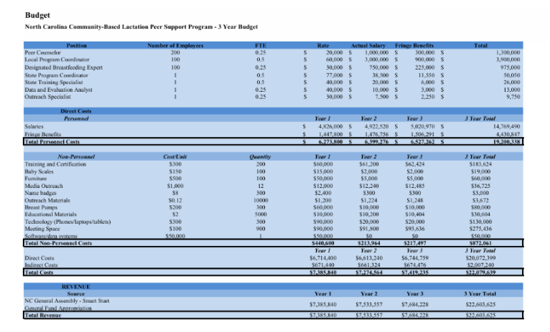
Budget Narrative
This budget outlines the projected three-year costs for the North Carolina Community-based Lactation Peer Support Program. All staffing and programmatic assumptions are grounded in the existing evidence-based WIC model and Smart Start’s early childhood health mission.
Personnel Costs: Staffing represents the largest share of program expenses and includes 200 part-time Peer Counselors, 100 Local Program Coordinator, 100 Designated Breastfeeding Experts (IBCLCs) and designated state- level staff (Program Coordinator, Training Specialist, Data Analyst, and an Outreach Specialist). Peer Counselors and Coordinators are budgeted at 0.24-0.5 FTE to reflect flexible, community-based service delivery. Salaries are based on comparable salaries in existing programs and comparable salaries in the state, with a 30% fringe benefit rate to cover taxes and health insurance. A 2% annual increase is applied to all personnel costs to account for inflating and cost-of-living adjustments.
Non-Personnel Costs: Non-personnel expenses included supplies, equipment, technology, and operational support required for effective program implementation. Training and certification costs reflect onboarding and annual continuing education using the WIC breastfeeding curriculum. Baby scales, breast pumps, and educational materials support direct service delivery and are purchases primarily in year 1, with modest replacement costs in subsequent years. Technology costs include phones, laptops, and tablets for peer counselors and coordinators, with partial replacement in Years 2 and 3. Meeting space, outreach materials, and media outreach support ongoing engagement with families and community partners. Software and data system costs include a one-time setup investment in year 1 to support statewide documentation and reporting for all 100 counties.
Indirect Costs: These were calculated at 10% of total direct costs, consistent with the federal Uniform Guidance (2 CFR §200.414), which permits a 10% de minimis indirect cost rate for programs without a negotiated rate. This approach is commonly used by Smart Start partnerships and public health programs to cover administrative and overhead expenses.
Revenue Assumptions: The program is fully funded through the North Carolina General Assembly’s recurring Smart Start General Fund appropriation, which supports statewide easy childhood health and family support initiatives.

Legislative Fact Sheet
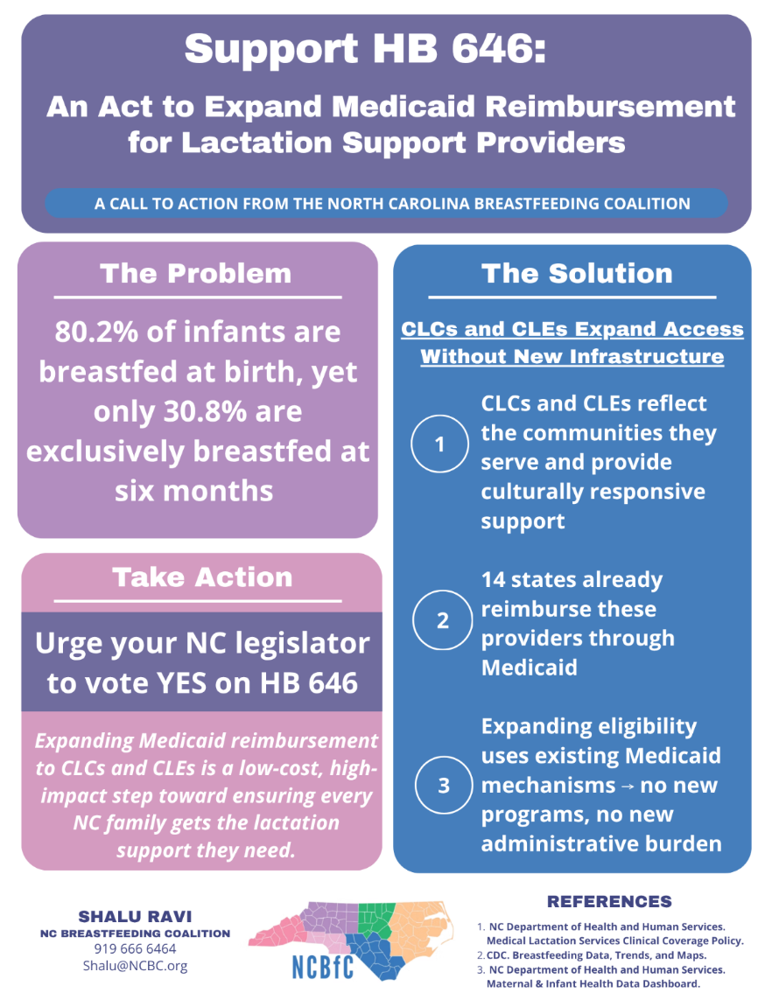

References
American Academy of Pediatrics. (n.d.). Integrating postpartum depression screening in your practice in 4 steps. https://www.aap.org/en/patient-care/perinatal-mental-health-and-social-support/integrating-postpartum-depression-screening-in-your-practice-in-4-steps/

Assibey-Mensah, V., Suter, B., Thevenet-Morrison, K., Widanka, H., Edmunds, L., Sekhobo, J., & Dozier, A. (2019). Effectiveness of peer counselor support on breastfeeding outcomes in WIC-enrolled women. Journal of Nutrition Education and Behavior, 51(6), 650–657. https://doi.org/10.1016/j.jneb.2019.03.005

Centers for Disease Control and Prevention. (2022). National Center for Chronic Disease Prevention and Health Promotion, Division of Nutrition, Physical Activity, and Obesity: Data, trends and maps. https://dnpao-dtm.cdc.gov

Centers for Disease Control and Prevention. (2024a). Infant mortality. https://www.cdc.gov/reproductivehealth/maternalinfanthealth/infantmortality.htm

Centers for Disease Control and Prevention. (2024b). Maternity Practices in Infant Nutrition and Care (mPINC) survey. https://www.cdc.gov/breastfeeding/data/mpinc

Centers for Disease Control and Prevention. (2025). Breastfeeding benefits both baby and mom. https://www.cdc.gov/breastfeeding/
Gordon, S. H., Lee, S., Deen, N., Cole, M. B., Feinberg, E., & Galbraith, A. (2025). Medicaid reimbursement for maternal depression screening and care for postpartum depression. JAMA Pediatrics, 179(9), 1009–1016. https://doi.org/10.1001/jamapediatrics.2025.1790

Hoff, C. E., Movva, N., Rosen Vollmar, A. K., & Pérez-Escamilla, R. (2019). Impact of maternal anxiety on breastfeeding outcomes: A systematic review. Advances in Nutrition, 10(5), 816–826. https://doi.org/10.1093/advances/nmy132

Jegier, B. J., Smith, J. P., & Bartick, M. C. (2024). The economic cost consequences of suboptimal infant and young child feeding practices: A scoping review. Health Policy and Planning, 39(9), 916–945. https://doi.org/10.1093/heapol/czae069

Johnson, A. M., Kirk, R., Muzik, M., & Rosenblum, K. (2022). Racial concordance and breastfeeding support. Breastfeeding Medicine, 17(3), 201–208.

Lamere, K., & Golova, N. (2022). Screening for postpartum depression during infant well child visits: A retrospective chart review. Clinical Pediatrics, 61(10), 699–706. https://doi.org/10.1177/00099228221097272

March of Dimes. (2023). Nowhere to go: Maternity care deserts across the U.S. https://www.marchofdimes.org
March of Dimes. (2024). Maternity care deserts in North Carolina. https://www.marchofdimes.org
March of Dimes. (2026). Birthweight. https://www.marchofdimes.org/peristats
Marks, K. J., Nakayama, J. Y., Chiang, K. V., Grap, M. E., Anstey, E. H., & Boundy, E. O. (2023). Disaggregation of breastfeeding initiation rates by race and ethnicity — United States, 2020–2021. Preventing Chronic Disease, 20, 230199. https://doi.org/10.5888/pcd20.230199

Medicaid and CHIP Payment and Access Commission. (2025, January). Access in brief: Postpartum mental health in Medicaid. https://www.macpac.gov/wp-content/uploads/2025/01/Access-in-Brief-Postpartum-Mental-Health-in-Medicaid.pdf

Minnesota Department of Health. (2025). Section 4.8: Breastfeeding peer program management. Minnesota WIC Program. https://www.health.state.mn.us

North Carolina Department of Health and Human Services. (2023). Birth statistics. https://schs.dph.ncdhhs.gov/data/births/2023.htm

North Carolina Department of Health and Human Services. (2024). Maternal & infant health data dashboard. https://medicaid.ncdhhs.gov

North Carolina Department of Health and Human Services. (2025). NC Medicaid enrollment reports. https://medicaid.ncdhhs.gov

Policy Center for Maternal Mental Health. (2024). A comprehensive look at state maternal mental health screening and reimbursement legislation. https://policycentermmh.org/a-comprehensive-look-at-state-maternal-mental-health-screening-and-reimbursement-legislation/

Policy Center for Maternal Mental Health. (2025). The role of Medicaid in advancing OB-MMH screening and treatment. https://policycentermmh.org/app/uploads/2025/03/The-Role-of-Medicaid-in-Advancing-OB-MMH-Screening-and-Treatment-3-2025.pdf

Purkiewicz, A., Regin, K. J., Mumtaz, W., & Pietrzak-Fiećko, R. (2025). Breastfeeding: The multifaceted impact on child development and maternal well-being. Nutrients, 17(8). https://doi.org/10.3390/nu17081326

Rowles, G., Keenan, J., Wright, N. J., et al. (2025). Investigating the impact of breastfeeding difficulties on maternal mental health. Scientific Reports, 15, 13572. https://doi.org/10.1038/s41598-025-98357-6

U.S. Breastfeeding Committee. (2022). North Carolina breastfeeding report. https://www.usbreastfeeding.org/state-breastfeeding-reports

U.S. Department of Agriculture, Food and Nutrition Service. (2011). WIC breastfeeding model components for peer counseling. https://wicworks.fns.usda.gov

U.S. Department of Agriculture, Food and Nutrition Service. (2019). WIC breastfeeding policy and guidance. https://wicworks.fns.usda.gov/resources/wic-breastfeeding-policy-and-guidance

U.S. Department of Agriculture, Food and Nutrition Service. (n.d.). WIC breastfeeding curriculum. https://wicbreastfeeding.fns.usda.gov

Van der Zee-van den Berg, A. I., Boere-Boonekamp, M. M., IJzerman, M. J., Haasnoot-Smallegange, R. M. E., & Reijneveld, S. A. (2017). Screening for postpartum depression in well-baby care settings: A systematic review. Maternal and Child Health Journal, 21(1), 9–20. https://pmc.ncbi.nlm.nih.gov/articles/PMC5226980/

Yuen, M., Hall, O. J., Masters, G. A., Nephew, B. C., Carr, C., Leung, K., Griffen, A., McIntyre, L., Byatt, N., & Moore Simas, T. A. (2022). The effects of breastfeeding on maternal mental health: A systematic review. Journal of Women's Health, 31(6), 787–807. https://doi.org/10.1089/jwh.2021.0504

APPENDIX D – YOUNG INDIVIDUAL ASSIGNMENTS

Problem Statement
Breastfeeding is widely recognized as one of the most effective strategies for promoting infant health and survival, providing essential nutrients and antibodies that protect against infectious diseases and support healthy growth and development (WHO, 2025; National Academies of Sciences, Engineering, and Medicine, 2025). Major health organizations recommend exclusive breastfeeding (EBF) for the first six months of life, as it is associated with reduced risks of sudden infant death syndrome (SIDS), respiratory infections, and chronic conditions such as type 1 diabetes in infants (American Academy of Pediatrics, n.d.). Mothers also benefit, with longer breastfeeding duration linked to decreased risks of breast and ovarian cancers, cardiovascular disease, and type 2 diabetes (Chowdhury et al., 2015).
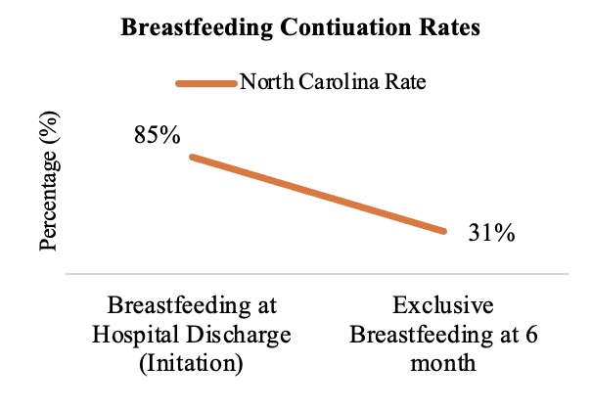
Despite strong evidence and high breastfeeding initiation rates, continuation declines significantly over time. Nationally, approximately 86% of infants are breastfed at hospital discharge, yet only about 28% are exclusively breastfed at six months, well below the Healthy People 2030 target of 42.4% (CDC, 2025; ODPHP, n.d.). North Carolina reflects this trend, with initiation rates around 85% but only about 31% of infants exclusively breastfed at six months (CDC, 2025). This drop-off means many infants miss critical health protections during a key developmental period, contributing to poorer maternal and infant health outcomes and increased healthcare utilization.
These trends are particularly significant in North Carolina, where roughly 120,000 births occur annually and more than half are covered by Medicaid (NCDHHS, 2023a). Early cessation of breastfeeding contributes to higher healthcare costs due to increased rates of preventable illness in both infants and mothers (Jegier et al., 2024). Nationally, the economic cost of not breastfeeding is estimated at $167 billion annually, driven by healthcare expenditures and premature mortality (Alive & Thrive, n.d.). In North Carolina, expanding breastfeeding support has the potential to generate substantial cost savings, with estimates suggesting millions could be saved annually through improved lactation support and continuation rates (Sullivan C., & Chetwynd E., n.d.).
Breastfeeding outcomes are also shaped by significant health inequities. Black mothers have the lowest rates of breastfeeding initiation and continuation both nationally and within North Carolina (Beauregard J. L. et al., 2019; KFF, n.d.). Structural barriers, including limited paid parental leave, inflexible work environments, and inadequate workplace lactation accommodations, disproportionately affect working mothers (Moret-Tatay et al., 2025). Geographic disparities further compound the issue, as rural and underserved communities often lack access to lactation consultants and postpartum support services.
North Carolina has implemented several initiatives to promote breastfeeding, including the Maternity Center Breastfeeding-Friendly Designation Program, which aligns with the World Health Organization’s Ten Steps to Successful Breastfeeding (NCDHHS, n.d.). However, these efforts are largely concentrated in hospital settings and the immediate postpartum period, focusing heavily on initiation rather than sustained support. Medicaid coverage for lactation services is limited, often requiring medical necessity and restricting reimbursement to specific providers, which reduces access to ongoing, community-based care (NCDHHS, 2023b). Overall, while North Carolina has made progress in promoting breastfeeding initiation, current efforts fall short in supporting long-term continuation.
Policy Analysis
Policy Option 1: Amendment to Medicaid Reimbursement Requirements to include CLEs and CLCs
Currently, North Carolina Medicaid reimburses breastfeeding support services under Clinical Coverage Policy 1-1: Preventive Services, administered by the North Carolina Department of Health and Human Services (NCDHHS), Division of Health Benefits. Under this policy, lactation services are reimbursable when provided by medical providers and International Board-Certified Lactation Consultants (IBCLCs) (NCDHHS, 2023b). This policy proposes expanding Medicaid provider eligibility to include Certified Lactation Educators (CLEs) and Certified Lactation Counselors (CLCs) by submitting a Medicaid State Plan Amendment (SPA) through NCDHHS to the Centers for Medicare & Medicaid Services (CMS).
Several states have already implemented similar changes. A review of Medicaid SPAs found that fourteen states have amended their Medicaid plans to expand lactation coverage, with seven states recognizing additional lactation support providers beyond IBCLCs.⁷ Illinois, for example, approved SPA IL-23-0043, which established Medicaid coverage for lactation services provided by IBCLCs and includes CLCs (CMS, 2024). They projected a federal budget impact of approximately $360,000 for fiscal year 2025 following implementation of its SPA, suggesting that expanding provider eligibility can be achieved with relatively moderate fiscal strain (CMS, 2024).
Policy Option 2: State-funded Grant Program to Build Lactation Support Provider (LSP) Workforce
IBCLC certification is the most comprehensive and labor-intensive credential for lactation service providers (LSPs). Considered the gold standard for lactation support, IBCLCs are trained to address complex breastfeeding challenges and are commonly employed in hospital and clinical settings. However, obtaining IBCLC certification requires significant investments in coursework, supervised clinical hours, and examination fees, making it one of the most expensive pathways in lactation care (Patel, S., & Patel, S., 2016).Community-based LSPs, such as CLCs and CLEs, play an important role in providing breastfeeding education and support outside of clinical environments. These providers are often embedded in programs such as the Special Supplemental Nutrition Program for Women, Infants, and Children (WIC) or work as independent community providers. While the certification process for CLCs and CLEs is shorter and more affordable than the IBCLC pathway, the out-of-pocket costs associated with training and certification can still pose barriers to workforce entry.
North Carolina has previously taken steps to address shortages and lack of diversity within the LSP workforce. For example, Senate Bill 840 appropriated funding to Historically Black Colleges and Universities (HBCUs) to support the recruitment, training, and retention of lactation consultants across the state (S.840, 2024). Building on this precedent, a statewide state-funded grant program could help reduce financial barriers to certification for aspiring lactation providers. By supporting training for CLEs, CLCs, and IBCLCs, the program would expand and diversify the lactation workforce and strengthen access to breastfeeding support services across North Carolina.
Evaluation criteria.
Criterion | Definition | Scoring Scale (1-3)
Affordability | The monetary cost to the state of NC to implement the proposed policy, including resources, personnel. | 1: over $5 million  2: between $2-5 million  3: under $1.5 million
Impact | How much the policy impacts breastfeeding continuation through 6 months in NC | 1: least impact  2: moderate impact  3: most impact
Equity  (2x) | How much the policy will positively affect breastfeeding duration for black mothers in NC or is the most likely to reduce racial disparities in breastfeeding continuation. | 1: least equitable  2: moderately equitable  3: most equitable
Political Feasibility | How likely the policy would be passed by the NC General Assembly, and based on opposition and support from stakeholders | 1: least feasible  2: moderately feasible  3: most feasible

Policy Analysis
Amendment to Medicaid Reimbursement Requirements to include CLEs and CLCs
Criteria | Score | Description
Political Feasibility | 2 | This policy option has moderate political feasibility, as implementation would occur through a State Plan Amendment (SPA). Fourteen states have already amended their Medicaid plans to expand lactation coverage, with several recognizing additional LSPs beyond IBCLCs.⁷ Illinois recently implemented SPA IL-23-0043, demonstrating the administrative feasibility of this approach (CMS, 2024). Legislative approval may still face some resistance since the North Carolina General Assembly controls Medicaid appropriations and may raise concerns about cost and provider oversight.
Affordability | 3 | The policy would likely be moderately affordable for the state. Illinois projected a federal budget impact of approximately $360,000 for fiscal year 2025 following implementation of its SPA.8 Reimbursement is also structured in 15-minute increments, with IBCLCs reimbursed at higher rates than CLCs ($17 vs. $13 per unit), illustrating how tiered reimbursement can help manage program costs (HFS, 2024). North Carolina already reimburses IBCLCs under Clinical Coverage Policy 1-1, meaning expansion would increase utilization rather than require new administrative systems.
Impact | 3 | The policy is expected to have high impact by increasing access to reimbursable lactation services. Evidence from states implementing SPAs expanding lactation coverage shows improvements in breastfeeding indicators within two years. Rates of infants exclusive breastfeeding at six months increased by 0.1–4.9 percentage points (Biviji et al., 2025).
Equity | 3 | This policy has strong equity potential by expanding access to community-based LSPs who frequently serve Medicaid-enrolled families. Medicaid covers a large proportion of births in the state, making its coverage policies critical for improving breastfeeding support among low-income populations (Biviji et al., 2025).Expanding reimbursement eligibility to include CLEs and CLCs may increase access to culturally responsive care and help reduce disparities in breastfeeding continuation among Black mothers.
State-funded Grant Program to Build Lactation Support Provider (LSP) Workforce
Criteria | Score | Description
Political Feasibility | 2 | This policy has moderate political feasibility. North Carolina has previously invested in lactation workforce development through legislation such as Senate Bill 840, which funded training programs at Historically Black Colleges and Universities. Expanding this effort into a statewide grant program would require sustained legislative appropriations. Budget constraints and competing funding priorities may limit political support for a long-term funding commitment.
Affordability | 1 | This policy would involve higher costs to the state because it requires ongoing funding to subsidize certification and training costs for lactation providers. NC A&T, one of the HBCUs to receive funding from the state, supplemented the cost of its lactation program with a $2.5 million grant (S.840, 2024; Bernhart, 2025). Supporting a meaningful number of trainees statewide could require annual appropriations of roughly $1 million or more, along with administrative costs for grant management and program oversight.
Impact | 2 | The expected impact is moderate. Financial support for certification would increase the number of trained lactation providers and address workforce shortages over time. Greater workforce capacity may improve geographic access to breastfeeding support services. Workforce development initiatives typically take several years before measurable improvements in breastfeeding continuation rates occur.
Equity | 2 | This policy has moderate equity potential. Reducing certification costs may increase workforce diversity and allow individuals from underrepresented communities to enter the lactation profession. A more diverse workforce may improve culturally responsive breastfeeding support. Equity improvements depend on whether newly trained providers ultimately practice in communities experiencing the greatest breastfeeding disparities.

FINAL RECOMMENDATION

Criteria | Policy Option 1 | Policy Option 2
Politically Feasibility | 2 | 2
Affordability | 3 | 1
Impact | 3 | 2
Equity (x2) | 3 | 2
Total | 14 | 9

Based on the evaluation criteria, Policy Option 1: Amendment to Medicaid Reimbursement Requirements to include CLEs and CLCs is recommended. Both policies address low breastfeeding continuation rates, but Policy Option 1 provides greater impact and equity while maintaining moderate cost. Expanding provider eligibility through a Medicaid State Plan Amendment (SPA) allows North Carolina to increase access to lactation support services without creating a new program or administrative structure. This policy also leverages existing Medicaid reimbursement mechanisms, making it more efficient to implement and more likely to reach Medicaid-enrolled mothers who face barriers to breastfeeding support. To evaluate implementation and effectiveness of this policy, the following metrics will be used:
Process Measure: Increase in the number and proportion of Medicaid-reimbursable lactation providers in North Carolina who are certified as CLEs or CLCs after implementation of the SPA. Data can be collected through Medicaid provider enrollment records and billing claims.
Outcome Measure: Perceived accessibility and cultural responsiveness of lactation support services among Black mothers, collected through focus groups or community-based interviews conducted in partnership with local maternal health organizations.

Program Budget
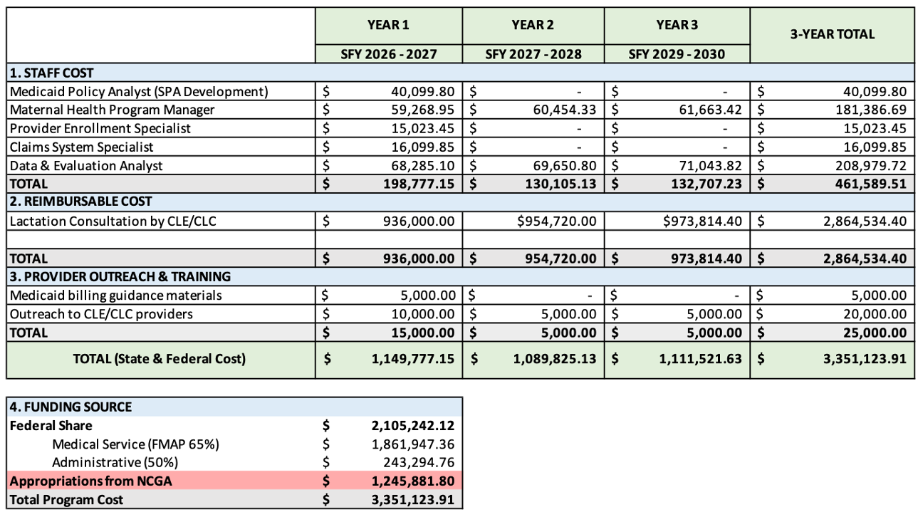
Staff Cost. Staffing costs are relatively low for the implementation of this policy because all of the required roles already exist within the North Carolina Department of Health and Human Services and can be integrated into existing responsibilities. As a result, most positions are budgeted at partial Full-Time Equivalent (FTE) levels rather than new full-time hires. Several roles are only funded in the first year, as their responsibilities are primarily related to developing and submitting the SPA and supporting initial provider enrollment and billing system updates. Once these implementation activities are completed, ongoing oversight can be managed within existing program operations. Salary estimates were sourced from median salary data reported by ZipRecruiter for comparable positions in North Carolina (ZipRecruiter, n.d.-a, n.d.-b, n.d.-c, n.d.-d, n.d.-e). Budget assumptions include 30% for fringe benefits and a 2% annual cost-of-living increase applied to staff costs in Years 2 and 3.
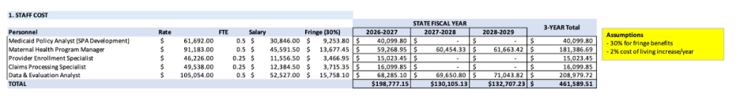Reimbursable Cost. The cost of reimbursing CLEs and CLCs providing lactation services represents the largest component of the budget. Several assumptions were used to estimate this cost. North Carolina reports approximately 120,000 live births annually, with about 50% covered by Medicaid, resulting in an estimated 60,000 Medicaid births per year.⁷ A conservative utilization rate of 10% for lactation services was used to calculate annual estimated patient count with a 2% annually to indicate program success. Reimbursement is estimated at $13 per 15-minute unit, based on rates used in Illinois Medicaid (CMS, 2024). Each patient is assumed to receive three one-hour visits (12 total units), resulting in a cost of $156 per patient and an estimated annual cost of $936,000.
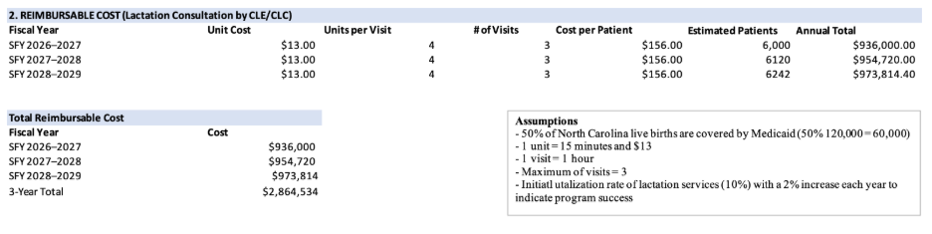Provider Outreach & Training. Will focus on educating CLEs and CLCs on Medicaid billing and reimbursement procedures. In the first year, The Maternal Health Program Manager will develop a Standard Operating Procedure (SOP) outlining billing and coding guidance. Initial costs support the creation and distribution of this material. Additional outreach activities include social media campaigns, stakeholder engagement, and recruiting outreach to lactation organizations and independent providers to encourage enrollment and participation in the first year. In the following years, funds will primarily be used to support ongoing outreach and dissemination of program updates.
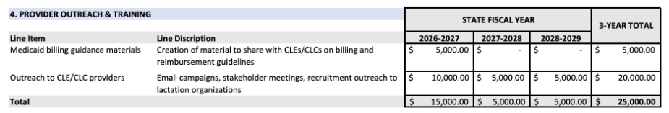
Funding Source. The program will be funded through a combination of federal and state Medicaid funds. Medicaid expenditures are shared between the federal government and the state through the Federal Medical Assistance Percentage (FMAP). In North Carolina, the FMAP is approximately 65%, meaning the federal government covers the majority of Medicaid service costs through CMS. The federal government will also match 50% of program administrative costs (KFF, 2026). Based on the estimated total program cost of $3,351,124 over three years, the federal share is projected at $2,105,242, while the state share is estimated at $1,245,881.

Legislative Fact Sheet
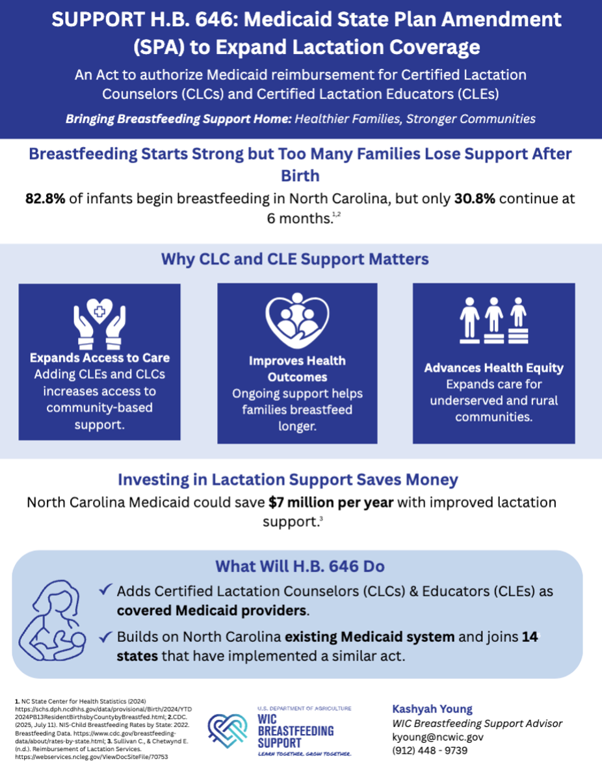

References
Alive & Thrive. (n.d.) The Cost of Not Breastfeeding Tool. Retrieved January 30, 2026, from https://www.aliveandthrive.org/en/the-cost-of-not-breastfeeding-tool

American Academy of Pediatrics (AAP) (n.d). Breastfeeding. (n.d.). Retrieved February 17, 2026, from https://www.aap.org/en/patient-care/newborn-infant-and-early-childhood-nutrition/newborn-and-infant-breastfeeding/

Beauregard J. L., Hamner H. C., Chen J., Avila-Rodriguez W., Elam-Evans L. D. & Perrine C. G., (2019). Racial Disparities in Breastfeeding Initiation and Duration Among U.S. Infants Born in 2015. MMWR. Morbidity and Mortality Weekly Report, 68. https://doi.org/10.15585/mmwr.mm6834a3

Bernhardt, L. (2025, November 18). Human Lactation Training Program Receives $2.5M Grant. https://www.ncat.edu/news/2025/11/lactation-program-grant.php

Biviji, R., Mutyala, J., Syed, H., Muhammad, L., & Bever, J. (2025). Bridging the gap in lactation support through state Medicaid coverage and policy reform. Translational Behavioral Medicine, 15(1), ibaf061. https://doi.org/10.1093/tbm/ibaf061

CDC. (2025, July 11). NIS-Child Breastfeeding Rates by State: 2022. Breastfeeding Data. https://www.cdc.gov/breastfeeding-data/about/rates-by-state.html

Centers for Medicare & Medicaid Services. State Plan Amendment (SPA): IL-23-0043. 2024. https://www.medicaid.gov/medicaid/spa/downloads/IL-23-0043.pdf

Chiang, K. V. (2021). Racial and Ethnic Disparities in Breastfeeding Initiation ─ United States, 2019. MMWR. Morbidity and Mortality Weekly Report, 70. https://doi.org/10.15585/mmwr.mm7021a1

Chowdhury, R., Sinha, B., Sankar, M. J., Taneja, S., Bhandari, N., Rollins, N., Bahl, R., & Martines, J. (2015). Breastfeeding and maternal health outcomes: A systematic review and meta-analysis. Acta Paediatrica (Oslo, Norway : 1992), 104(Suppl 467), 96–113. https://doi.org/10.1111/apa.13102

Funds for Lactation Cnslt. Programs at HBCUs, S.840. (2024). https://www.ncleg.gov/BillLookup/2023/S840

Illinois Department of Healthcare and Family Services (HFS). (19 December 2024) Fee Schedule For Lactation Counseling Services. https://hfs.illinois.gov/content/dam/soi/en/web/hfs/sitecollectiondocuments/12192024lactationfs.pdf

Jegier, B. J., Smith, J. P., & Bartick, M. C. (2024). The economic cost consequences of suboptimal infant and young child feeding practices: A scoping review. Health Policy and Planning, 39(9), 916–945. https://doi.org/10.1093/heapol/czae069

KFF. (2026, January 23). Federal Medical Assistance Percentage (FMAP) for Medicaid and multiplier: KFF State Health facts. https://www.kff.org/medicaid/state-indicator/federal-matching-rate-and-multiplier/?activeTab=map&currentTimeframe=0&selectedDistributions=fmap-percentage&sortModel=%7B%22colId%22%3A%22Location%22%2C%22sort%22%3A%22asc%22%7D

KFF. North Carolina Maternal & Infant Health Data. (n.d.). Retrieved January 30, 2026, from https://www.kff.org/interactive/womens-health-profiles/united-states/

Moret-Tatay, A., Pérez-Bermejo, M., Asins-Cubells, A., Moret-Tatay, C., & Murillo-Llorente, M. T. (2025). A Systematic Review of Multifactorial Barriers Related to Breastfeeding. Healthcare, 13(11), 1225. https://doi.org/10.3390/healthcare13111225

National Academies of Sciences, Engineering, and Medicine. 2025. Breastfeeding in the United States: Strategies to Support Families and Achieve National Goals. Washington, DC: The National Academies Press. https://doi.org/10.17226/12398.

NCDHHS (2023a) 2023 NC Resident Live Births: Maternal Medicaid Status. (n.d.). Retrieved January 30, 2026, from https://schs.dph.ncdhhs.gov/schs/births/matched/2023/2023-Births-Medicaid.html

NCDHHS (2023b). NC Medicaid Medicaid and Health Choice Dietary Evaluation and Counseling Clinical Coverage Policy No: 1-I and Medical Lactation Services. https://medicaid.ncdhhs.gov/1-i-dietary-evaluation-and-counseling-and-medical-lactation-services/open

NCDHHS (n.d.). NC Maternity Center Breastfeeding-Friendly Designation Program. Retrieved January 30, 2026, from https://www.ncdhhs.gov/divisions/ncmcbfdesignation#ApplicationfortheNorthCarolinaMaternityCenterBreastfeedingFriendlyDesignation-3967);%20https://pubmed.ncbi.nlm.nih.gov/40110985/

ODPHP. (n.d). Increase the proportion of infants who are breastfed exclusively through age 6 months—Data—Healthy People 2030 | odphp.health.gov. Retrieved January 30, 2026, from https://odphp.health.gov/healthypeople/objectives-and-data/browse-objectives/infants/increase-proportion-infants-who-are-breastfed-exclusively-through-age-6-months-mich-15/data

Patel, S., & Patel, S. (2016). The Effectiveness of Lactation Consultants and Lactation Counselors on Breastfeeding Outcomes. Journal of Human Lactation, 32(3), 530–541. https://doi.org/10.1177/0890334415618668

Provider Enrollment Specialist Salary in North Carolina. (n.d). https://www.ziprecruiter.com/Salaries/Provider-Enrollment-Specialist-Salary--in-North-Carolina

Sullivan C., & Chetwynd E. (n.d.). Reimbursement of Lactation Services. https://webservices.ncleg.gov/ViewDocSiteFile/70753

WHO. Breastfeeding. (n.d.). Retrieved January 30, 2026, from https://www.who.int/health-topics/breastfeeding

ZipRecruiter. (n.d.-a). Claims processing specialist salary in North Carolina. https://www.ziprecruiter.com/Salaries/Claims-Processing-Specialist-Salary--in-North-Carolina

ZipRecruiter. (n.d.-b). Healthcare data analytics salary in North Carolina. https://www.ziprecruiter.com/Salaries/Healthcare-Data-Analytics-Salary--in-North-Carolina

ZipRecruiter. (n.d.-c). Healthcare program manager salary in North Carolina. https://www.ziprecruiter.com/Salaries/Healthcare-Program-Manager-Salary--in-North-Carolina

ZipRecruiter. (n.d.-d). Medicaid analyst salary in North Carolina. https://www.ziprecruiter.com/Salaries/Medicaid-Analyst-Salary--in-North-Carolina

ZipRecruiter. (n.d.-e). Provider enrollment specialist salary in North Carolina. https://www.ziprecruiter.com/Salaries/Provider-Enrollment-Specialist-Salary--in-North-Carolina

