A Multidimensional Analysis of the Structure and Function of The C-Terminal Region of The Microtubule Polymerase, Minispindles

By: Brian Saway

Senior Honors Thesis

Biology Department

University of North Carolina at Chapel Hill

April 11, 2016

Approved:

Dr. Kevin Slep, Thesis Advisor

Dr. Steve Rogers, Reader

Dr. Aussie Suzuki

Abstract
Microtubules (MTs) are highly dynamic polymers that provide tracks for cargo transport within the cell, establish cell polarity, aid in cell motility, and form the mitotic spindle. MTs are nucleated from centrosomes and their plus ends exhibit dynamic instability. These dynamics are tightly regulated by Microtubule Associated Proteins (MAPs). One MAP family of particular interest is the highly conserved XMAP-215 family of polymerases. Members of the XMAP-215 family contain a varying number of N-terminal hexa-HEAT repeats known as TOG (tumor over-expressed gene) domains that bind to tubulin heterodimers. Minispindles (Msps), the XMAP-215 Drosophila homologue, localizes to MT plus ends to enhance MT polymerization and regulate the mitotic spindle morphology. While much of Msps’s structure has been solved, the vital C-terminal region structure and function remains a mystery. Furthermore, the C-terminal region of Msps may contain an additional 6th TOG domain. To determine the cellular role of this domain we utilized live cell fluorescent microscopy, immunohistochemistry, and mutagenesis assays to test the hypothesis that the hypothesized 6th TOG domain of Msps is necessary for functional MT polymerization and mitotic spindle assembly. Depletion of endogenous Msps and subsequent expression of a truncated Msps construct lacking the proposed 6th TOG Domain results in aberrant localization of the Msps protein, significantly slower MT growth velocities, and abnormal spindle phenotypes. This proposed 6th TOG domain contains highly conserved residues, which we hypothesize are required for Msps localization and function. To test this hypothesis we will generate a suite of constructs that have key conserved residues mutated and test which lesions phenocopy deletion of the entire domain.
Introduction:
Eukaryotic cellular structure is enforced by cytoskeletal elements present throughout the cytoplasm. This cytoskeletal network affords the cell the ability to organize itself in space and interact with its environment. The cytoskeleton is composed of intermediate filaments, actin filaments, and microtubules¹. In particular, my work focuses on the regulation of the microtubule cytoskeleton. Microtubules (MTs) provide tracks for cargo transport within the cell, form the shape of the cell, establish cell polarity, and aid in cell motility². In most eukaryotic cells, MTs are nucleated from and organized at the centrosome, an organelle that provides a stable base to assemble microtubules³. MTs are dynamic polymers that undergo rapid growth known as polymerization and catastrophic shrinkage, known as depolymerization. The dynamic length is derived from the addition of free tubulin subunits to the plus-end of the MT and the sequential depolymerization of bound tubulin². Additionally, MT are the main component of the mitotic spindle that is essential for proper cell division and partitioning of the cell’s genetic material (Figure 1)². Through attachment to the kinetochore, MTs establish the mitotic machinery that is vital for chromosome segregation⁵. Misregulation of the MT cytoskeleton during cell division often results in mitotic abnormalities where the chromosomes are segregated unevenly, leading to aneuploidy, which has been implicated in many different types of genetic diseases and cancer⁷. Interestingly, many therapeutic agents for cancers target MTs or MT associated proteins (MAPs), and therefore disrupt cell division⁸.
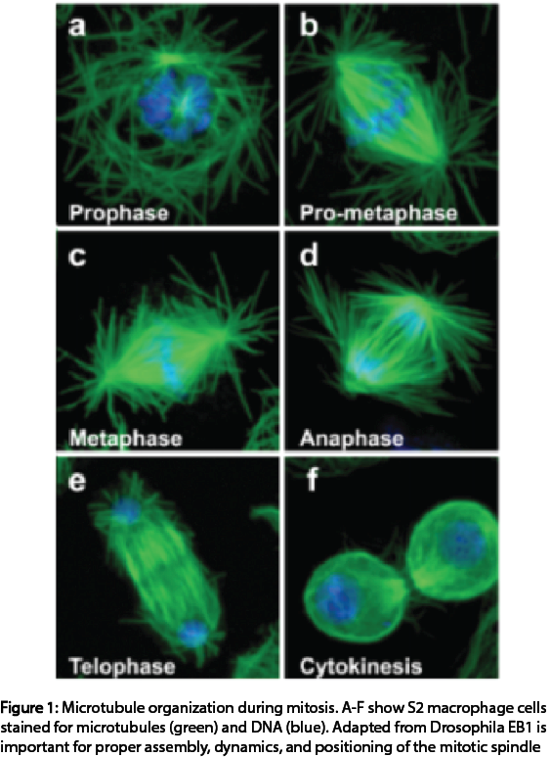
In order to selectively perturb and regulate MT dynamics, it is necessary to fully understand the mechanisms and the various proteins that regulate these dynamics. MAPs regulate MT dynamics to promote growth, depolymerization, and/or pause of MTs through preferential localization to the plus-end and lattice of MTs⁹. My research examined the role of an essential MAP, Minispindles (Msps), as a MT polymerizing factor during interphase and mitosis. Msps belongs to a conserved family of polymerases that includes Xenopus XMAP215¹⁰. This evolutionarily ancient family of MAPs is required for eukaryotic cell division and proper cytoskeletal architecture. The first identified protein of this family was isolated from Xenopus egg extract and classified as a potent polymerase based upon its ability to promote centrosome-nucleated MT assembly in vitro^{11,12}. Msps, the Drosophila homologue, localizes to the plus end of MTs through interaction with the MAP, Sentin. Sentin binds to EB1 thus acting as bridge for Msps with the MT plus end^{13,14}. These multiple interactions allow for Msps to processively potentiate MT polymerization through closely tethering itself to the MT plus end. With this established proximity, Msps utilizes its N-terminal tumor overexpressed gene (TOG) domain array with multiple tubulin binding sites to increase MT polymerization rates through a process that is not fully understood (Figure 2)¹⁶⁻¹⁸. Previous studies have shown that in the absence of Msps, MT polymerization is decreased and mitotic spindles are shorter and improperly formed¹⁹⁻²¹.

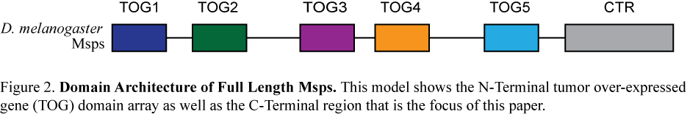
While much research has focused on understanding the mechanistic function of the N-terminal TOG domains, very little is known about the conserved C-terminal region. Previous studies have shown that this region is required to localize Msps at MT plus ends and has been shown to have an affinity for polymerized tubulin²². To further investigate the role of this domain I preformed a multiple sequence alignment and secondary structure predictions. These analyses, in agreement with previous research, highlighted a conserved region containing a series of alpha helices, which I hypothesize to be a 6th TOG domain²³. I hypothesize that the 6th TOG domain of Msps is necessary for Msps localization, functional MT polymerization and mitotic spindle architecture. To test these hypotheses, I preformed live cell microscopy, immunohistochemistry, and mutagenesis assays. These assays allowed us to analyze the localization of Msps, MT growth velocities, and spindle phenotypes of cells lacking endogenous Msps version of the C-Terminal region of Msps. I found that depletion of endogenous Msps and subsequent transfection of a truncated Msps construct lacking the proposed 6th TOG domain results in aberrant localization of the Msps protein, significantly slower MT growth velocities, and abnormal spindle phenotypes.

Methods

A. Drosophila S2 cell culture
Drosophila melanogaster S2 cells were cultured in a SF900 media containing 1X anti-anti. The cells were maintained at 40-90% confluency. For knock down experiments, ¼ million cells were seeded into a well of a 12 well plate on Day 0. Over the course three days the cells were treated with 4 µL of Msps 3’UTR dsRNA of 800 base pairs and 4 µL of Msps 5’UTR dsRNA of 375 base pairs or 4 µL or scrambled control dsRNA. dsRNA was generated using a previously published protocol²⁴ detailed below. On Day 3, cells were transfected with the desired DNA. The 100 µl transfection reaction contained 750 ng of desired Msps-eGFP construct and 500 ng of EB1-tRFP, 3 µL of the transfection reagent, Fugene HD, and the rest of sterile water. On Day 4 the expression of the transfected DNA in cells was induced with copper sulfate at a final concentration of 200 µM. On Day 5 the cells were seeded on Concanavalin A (Con A) coated plates (Mat Tech) for 2 hours for either live-cell imaging or immunofluorescence experiments.

B. Double Stranded RNA Production
Double stranded RNA (dsRNA) was produced in order to eliminate endogenous Msps from Drosophila S2 cells. The knock down design utilized a 3’ UTR of 800 base pairs of dsRNA and a 5’ UTR of 375 base pairs of dsRNA introduced to Drosophila S2 cells in tandem. Scrambled dsRNA was generated and introduced into Drosophila S2 cells as a control. The original Msps and scrambled DNA, from which the dsRNA was created, were amplified from pUC19 vectors containing the desired DNA and PCR purified. The purified DNA was used to generate dsRNA via a reaction performed with RNA nucleotides (25mM rATP, rCTP, rGTP, rUTP), T7 RNA polymerase (1mg/mL), and an IVT 5X Buffer (200mM Tris-HCL (pH 7.9), 30mM MgCl₂, 10mM spermidine, 50mM NaCl). To ensure proper dsRNA production gel electrophoresis was preformed with 2 µL of 1:10 diluted dsRNA.

C. Immunofluorescence microscopy

Cells were seeded onto Con A coated dishes (Mat Tech) with fresh Schneider’s Media + FBS –A/A and allowed to sit for 2 hours. Cells were washed with 1X PBS, 1 quick wash in -80° C chilled methanol and fixed with 1 mL of methanol at -20° C for 10 minutes. Methanol was removed and cells were washed with PBS-T (1X PBS supplemented with 0.2% Triton X-100). Cells were blocked overnight with PBS-T + 2% BSA. Primary antibodies were added for 1 hour. Cells were then washed 3 times with PBS-T and secondary antibodies and DAPI were added for 45 minutes. Cells were washed 3 times with PBS-T and left at 4° C with 1 mL of PBS prior to imaging. Primary antibodies used in this study were: rabbit anti-GFP (Living Colors), 1:1000; mouse anti-tubulin (DM1α; Sigma-Aldrich), 1:1000; guinea pig anti-Asterless (Rusan Lab), 1:10,000. Secondary antibodies used in this study were: goat anti-rabbit Cy2, goat anti-mouse Cy3, goat anti-guinea pig Cy5 (Jackson ImmunoResearch Laboratories), 1:500. Guinea pig anti-Asterless antibody addition was performed after other primary and secondary antibodies for tubulin and GFP were completed to prevent cross-reaction with antibodies. Asterless antibody has been shown to cross react with primary antibodies raised in rabbit and mouse. Cells were imaged using a 100x objective with numerical aperture 1.45 using a wide-field fluorescence microscope, Eclipse Ti-E (Nikon), and captured by a CoolSnap Camera (Roper Scientific). Nikon Element Software drove the Eclipse Ti-E (Nikon). Images were used to determine mitotic spindle phenotypes based on previous research’s determined phenotypes²⁵. Spindle length was determined by measuring the distance between centrosomes for cells classified as bipolar using the ImageJ’s line-tool function (Figure A2).

D. Live Cell microscopy

Drosophila S2 cells treated with appropriate dsRNA and transfected were seeded on Concanavalin A (Con A) coated plates (Mat Tech) for 2 hours prior to live-cell imaging. Total Internal Reflection Fluorescence (TIRF) Microscopy was utilized to minimize background noise. Time-lapse movies were acquired with a 100x objective with a 1.45 numerical aperture using the Nikon TI2000 Microscope. Images were captured every second for 90-120 seconds with the Andor CCD camera. Nikon Element Software drove the Nikon microscope.

E. Automated EB1-Comet tracking

EB1-tRFP velocities were acquired from time-lapse movies (described earlier) using the Automated Tracking Feature in the Nikon Elements Software. For each cell, a region of interest was cropped in order to remove areas of the cell containing crowded MT networks that are difficult to track. Nikon Elements Software’s Background Subtraction Toolkit removed any unwanted noise from the background of the images, and a threshold was manually set to identify the signal from EB1-tRFP comets. The software then used the segmented images to delineate tracks based on the moving signal, and the microtubule growth velocity was calculated by analyzing the distance travelled from one track point to the next. The average velocity of each track was then calculated and compared using the statistical software, Prism. In all calculations, the data from cells of the same treatment were pooled (Figure A1).

Results
Residues 1596-1852 of the C-terminal region of Msps required for proper localization of the FL molecule and are necessary to promote MT growth
To examine the role of the C-terminal region of Msps as a regulator of MT growth velocities Msps knock-down and rescue experiments were conducted in S2 cells. Since Msps knock down decreases MT growth rates⁹, I hypothesized that the C-terminal region of Msps is required for wild type MT growth velocities. To test this hypothesis, I examined whether a Msps truncated-eGFP construct (ΔTOG6) could localize to the MT plus and/or rescue MT growth velocities. This TOG6 region had previously been hypothesized to be a TOG domain and upon performing a species alignment analysis it was found that this region contains many conserved residues¹⁴ (Figure 3B).
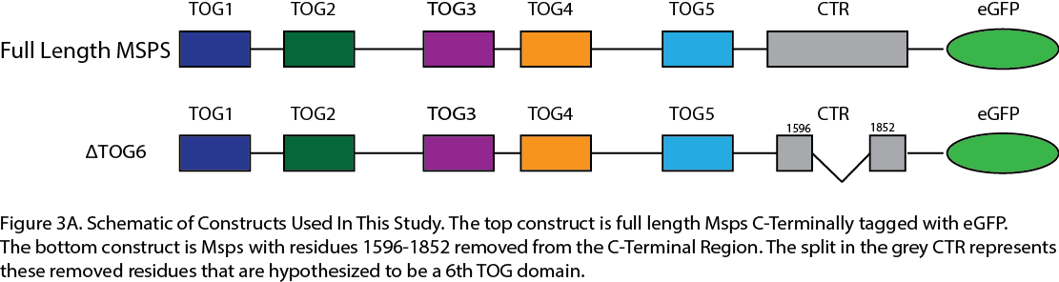
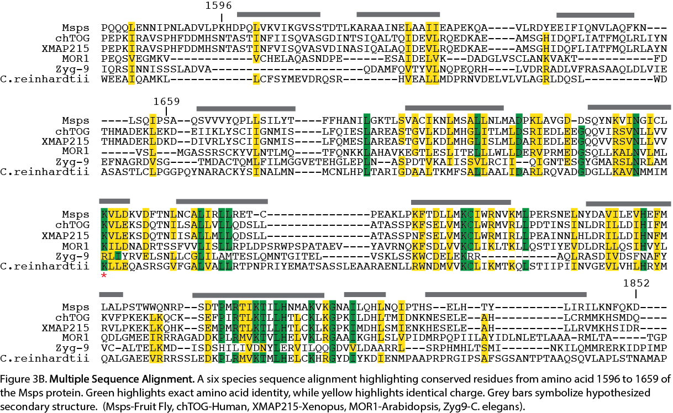
An observable decrease in signal at the MT tip is seen for cells treated and transfected with Msps dsRNA + ΔTOG6 as compared to cells treated and transfected with Msps dsRNA + FL Msps (Figure 4). The MT growth velocities acquired from the automated tracking of the EB1 comets were analyzed for differences in mean growth velocities between four groups (Control dsRNA + eGFP, Msps dsRNA +eGFP, Msps dsRNA + FL Msps Rescue, and Msps dsRNA + ΔTOG6). Analysis of growth velocities showed that TOG6 is required to rescue Msps growth velocities since there was no significant difference in growth velocities between Msps KD and ΔTOG6 (Figure 5).
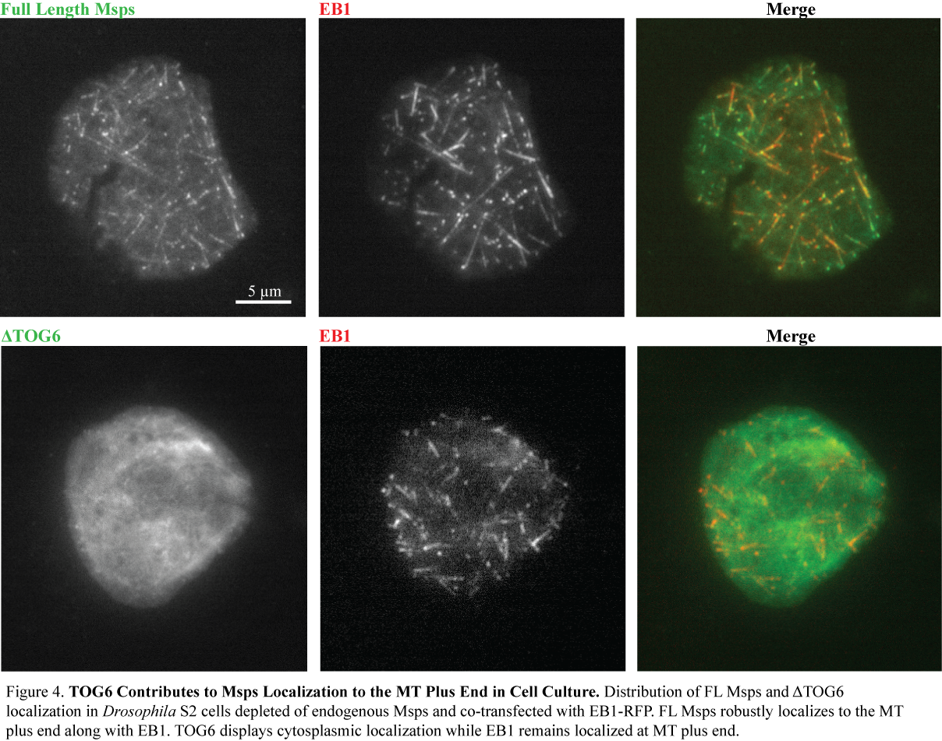

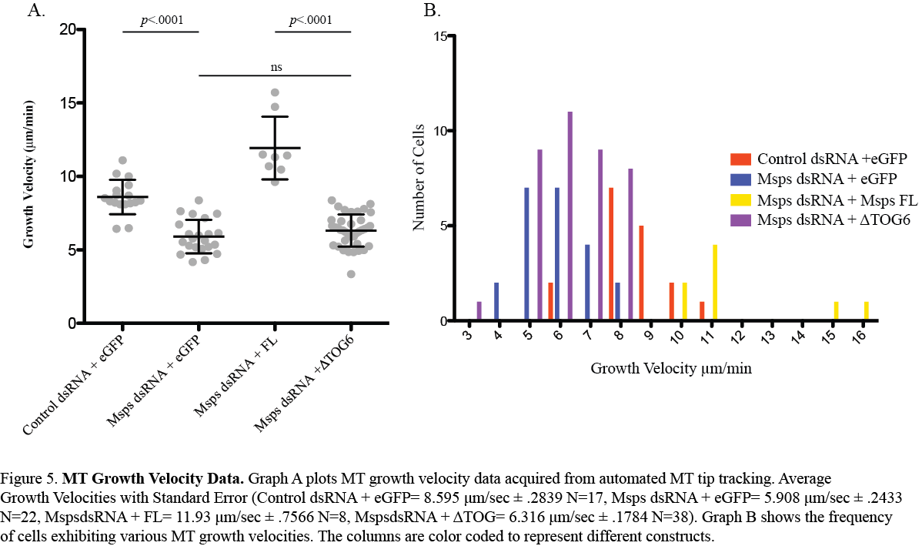
Residues 1596-1852 of the C-Terminal Region are necessary for proper mitotic spindle localization and mitotic spindle formation.
An immunohistochemistry assay was performed to test the hypothesis that the proposed 6th TOG domain of the C-terminal region is necessary for proper mitotic spindle architecture and formation. Mitotic spindle phenotypes were categorized and analyzed upon Msps depletion and subsequent transfection with various constructs. Images of mitotic spindles were binned into four categories. Spindles with two centrosomes were binned into the bipolar phenotype. Spindles that were observed to be anastral, multipolar, or had congression defects were binned in the unorganized phenotype. Lastly, Bipolar monastral spindles and monopolar spindles were binned in their own category. Due to the hypothesized localization nature of Msps’s 6th TOG domain, it was predicted that depletion of this domain would lead to a shorter spindle length as Msps would be unable to localize to the mitotic spindle. There was an observable decrease in signal on the mitotic spindle and centrosomes for cells treated and transfected with Msps dsRNA + ΔTOG6 as compared to cells treated and transfected with Msps dsRNA + FL Msps (Figure 6). Additionally, the length of the spindle from centrosome to centrosome was recorded. If the phenotype was binned as bipolar, the imaging software ImageJ’s line-tool function was used to determine the spindle length (Figure A2). Cells treated with Msps dsRNA and transfected with ΔTOG6 were found to have a bipolar frequency of 47.2%. Bipolar frequency of the rescue construct transfected with FL Msps was 59.7%. Analysis of spindle length showed that the TOG6 is required to rescue mitotic spindle length since there was no significant difference in spindle length between Msps KD and ΔTOG6. There was a significant difference in the mean spindle lengths for the Msps dsRNA + ΔTOG6 (M=6.288, SD=.3335, N=38) and Msps dsRNA + FL Msps (M=9.401, SD=.4264, N=34) conditions; t(5.812), p=<.0001. (Figure 7).
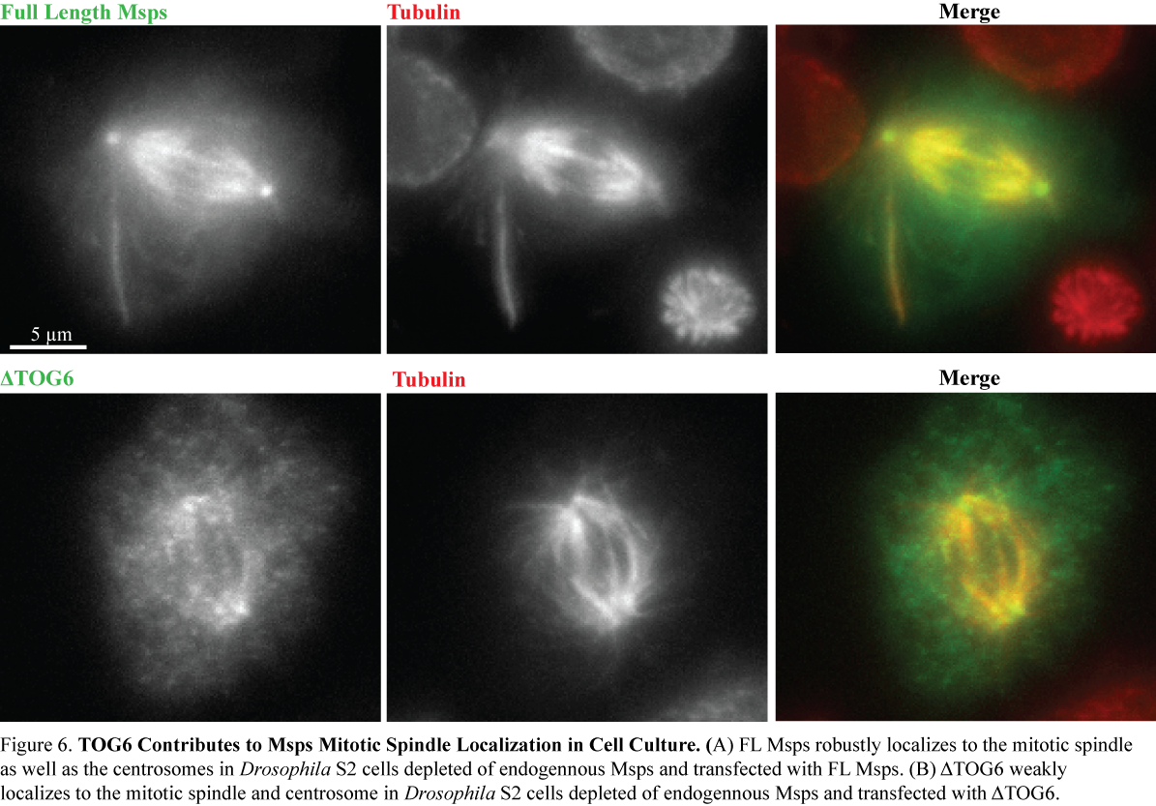
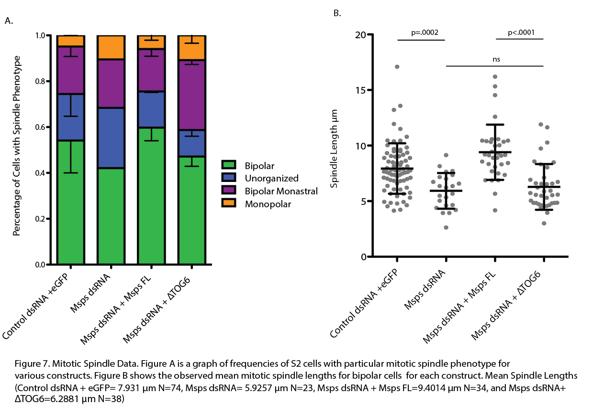

Discussion
The fundamental method used in biology for studying the function of a protein in a cell model is through the comparison of the system with and without the protein of interest. This blanket analysis provides insight on the function of the protein and ultimately can uncover its importance to the system as a whole. Once its broad function is understood, a fine-combed analysis of specific regions of the protein can allow for a more holistic understanding of its structure and interaction with other proteins/substrates. This analytical technique has a strong application in the study of MAPs, and specifically Msps, as this MT polymerase effectively alters the functioning of a cytoskeletal element that is critical for cell activity and proliferation. Ultimately, uncovering the nature of the C-terminal region of the Msps protein is necessary for a holistic understanding of the protein and to further our knowledge on the mechanisms that shape the cytoskeleton. My work this semester has further elucidated the function of the MAP, Msps, through unveiling that the TOG6 domain, residues 1596-1852, is necessary for proper localization of the full length molecule, proper MT growth velocities and proper mitotic spindle formation.
Previous research has shown that Msps is essential for establishing MT growth velocities in S2 cells¹⁹⁻²¹. Msps depletion drastically lowered MT growth velocities and a rescue with full-length Msps regained wild type MT growth velocities. The five, N-terminally located repeating TOG domains are known to actively participate in enhancing MT polymerization, however, the C-terminal region’s function is poorly understood. My results show that Msps depleted cells transfected with a Msps construct lacking the 6th TOG domain, residues 1596-1852, show a significant decrease in MT growth velocities as compared to depleted cells rescued with full length Msps. This phenotype signifies that the C-terminal region of Msps, specifically the TOG6 domain, plays an important role in the context of the full-length protein. Localization data shows that TOG6 is necessary for proper localization to MT plus ends, therefore, it is possible that this region allows for the correct positioning and/or orientation of Msps along the MT, and without, Msps is unable to polymerize at an optimal rate. Similarly, the TOG6 domain may be required for proper interaction of the protein with other MAPs. Msps is known to directly interact with Sentin¹³, loss of this interaction could ablate recruitment of Msps to the MT plus end. Additionally, where Sentin binds Msps is unknown, thus this data may point to the TOG6 region as a possible area of interest for locating this unknown area of interaction in Msps. Alternatively, or in addition to, TOG6 could interact with MTs independently of other proteins and play an active role in increasing MT growth velocities. It could function as a sixth tubulin-binding TOG domain or a unique subunit that has its own mechanism for functioning in tandem with the other TOG domains. Further co-sedimentation assays that explore direct protein to protein interactions must be performed to assess the affinity of TOG6 for MTs. Additionally, previous research has shown that proteins in the XMAP215 family interact with Sentin, gamma-TuRC, and XTACC3^{8,9}. Immunoprecipitation assays that use antibodies to remove a specific protein out of solution and Knock-sideways experiments that localize a specific protein to a new/unique subcellular region could be performed in order to evaluate TOG6’s role in interaction with the Drosophila proteins: Sentin, gamma-TuRC, and dTACC.
Cell division is essential for cell propagation and survival, and within eukaryotic organisms, MTs are the cytoskeletal structure that mediate this event through the generation of the mitotic spindle. Consequentially, the precise regulation of MT dynamics within this mitotic spindle is essential for cell survival. The even segregation of chromatids to each daughter cell is accomplished through the formation of the bipolar, mitotic spindle that produces the appropriate forces to drive segregation. There are numerous protein factors that influence the 3-dimensional structure of the spindle and assure that its MT based spindle is properly regulated. My research shows that the TOG6 region of Msps is necessary for proper localization to the mitotic spindle. Additionally, without this region, there is a significant decrease in mitotic spindle length and bipolar spindle frequencies. While the dominant phenotype for the wild type S2 cell was an even, bipolar spindle of average length (59.7% of cells, 7.931µm), the Msps depleted cells transfected with ΔTOG6 displayed an increased percentage of bipolar monastral spindles (32.4%) and a lower percentage of even bipolar spindles (47.2%). Additionally, for cells transfected with ΔTOG6 that contained a bipolar spindle, there was a shorter spindle length (Mean Spindle Length=6.288µm) than the bipolar spindle length for the rescue construct (Mean Spindle Length=9.401µm) with instances of unusually small spindles. This is consistent with previous data that showed that low expression of the MT polymerase decreased the mitotic spindle length as the MTs were not able to polymerize at wild type levels, ultimately resulting in shorter MTs¹³. These results indicate that the C-terminal region of Msps plays a functional role in assembling the bipolar nature of the mitotic spindle and possibly establishing proper spindle length.
In addition to the previously proposed assays, for future experiments I would like to gather more data sets to further confirm the observations reported in this paper. Additionally, I would like to further evaluate, at high resolution, the localization of the delta? TOG6 construct within the mitotic spindle to further understand the role of the TOG6 domain in Msps-dependent spindle formation. Lastly, we have performed a TOG6 sequence alignment and hydrophilic, conserved residues within TOG6 that are likely to be surface exposed on the domain have been identified. A mutagenesis assay of conserved residues combined with live cell microscopy and immunohistochemistry could potentially identify which residues of the hypothesized 6th TOG domain are responsible for its localization and/or mechanistic properties.
These experiments have given us insight into the functional role of the C-Terminal region of Msps. We have found that TOG6 is necessary for proper localization of Msps to the MT plus end and the mitotic spindle. Additionally, without TOG6, there is a significant decrease in MT growth velocities, mitotic spindle length, and bipolar spindle frequencies. While the work presented has uncovered much information on this poorly understood region of Msps, more data must be collected to confirm the conclusions made in this paper. This research has brought us one step closer to a holistic understanding of Msps and the intricate cytoskeleton.

Acknowledgements
I would like to thank everyone in the Slep Lab. I would like to thank Dr. Kevin Slep for giving me the opportunity to be a part of the UNC research community and for all the help and guidance he has given me. I would like to give special thanks to Rebecca Adikes for being an incredible mentor and a great friend. I would also like to thank Steve Rogers and Naser Russan for reagents. I would like to thank Dr. Amy Maddox and all of the students in Honors Biology 692 for aiding me in completing my Honors Thesis. Lastly, I would like to thank my parents for encouraging me to pursue research and for all the support they have given me.

Appendix
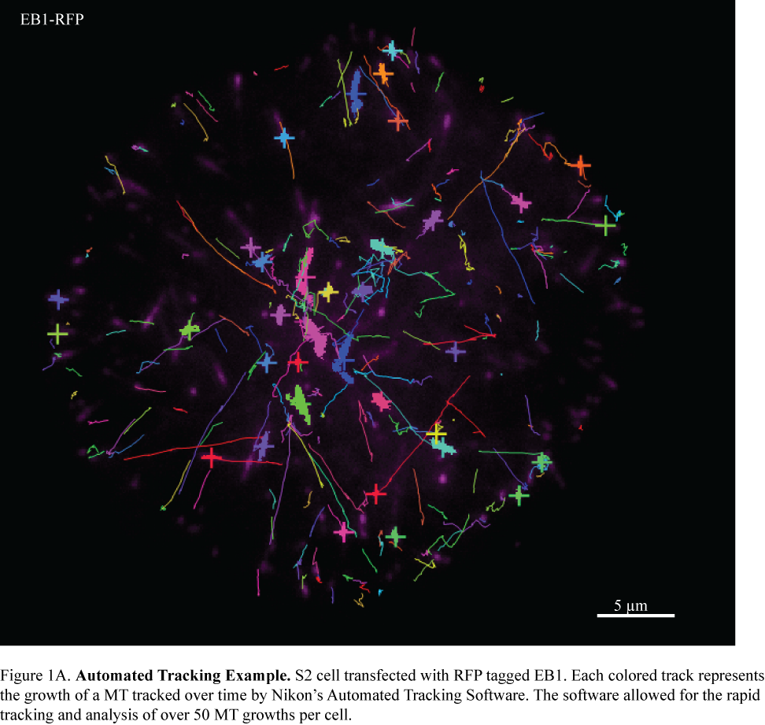
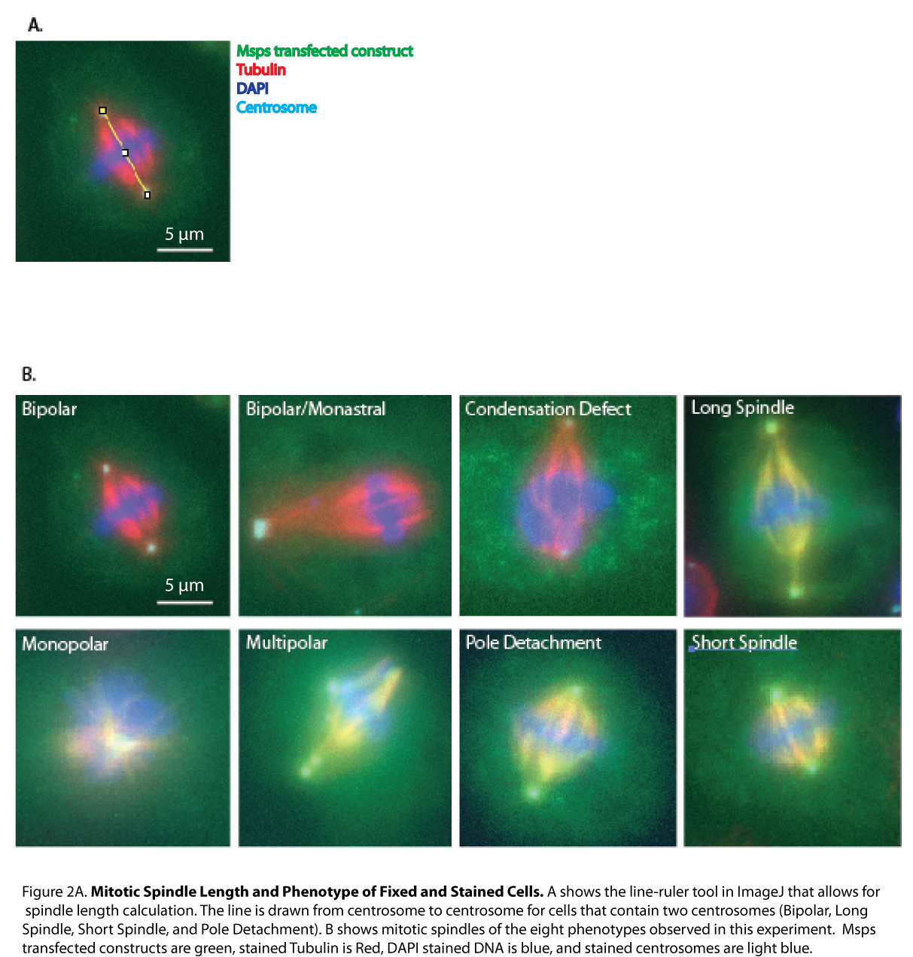

References
- Hawkins, T., Mirigian, M., Selcuk Yasar, M., & Ross, J. L. (2010). Mechanics of microtubules. Journal of Biomechanics, 43(1), 23–30. http://doi.org/10.1016/j.jbiomech.2009.09.005
- Avila, J. (1992). Microtubule functions. Life Sciences, 50(5), 327–334. http://doi.org/10.1016/0024-3205(92)90433-P
- Desai, A., & Mitchison, T. J. (1997). Microtubule polymerization dynamics. Annual Review of Cell and Developmental Biology, 13, 83–117. http://doi.org/10.1146/annurev.cellbio.13.1.83
- Mitchison, T., & Kirschner, M. (1984). Dynamic instability of microtubule growth. Nature, 312(5991), 237–42. http://doi.org/10.1038/312237a0
- Cheeseman, I. M. (2014). The Kinetochore. Cold Spring Harbor Perspectives in Biology, 6(7). http://doi.org/10.1101/cshperspect.a015826
- Chan KS, Koh CG, Li HY. Mitosis-targeted anti-cancer therapies: where they stand. Cell death & disease. 2012;3:e411. doi: 10.1038/cddis.2012.148. PubMed PMID:23076219; PubMed Central PMCID: PMC3481136.2.
- Voutsinas, G., Zarani, F. E., & Kappas, A. (1997). The effect of environmental aneuploidy-inducing agents on the microtubule architecture of mitotic meristematic root cells in Hordeum vulgare. Cell Biology International, 21(7), 411–418. http://doi.org/10.1006/cbir.1997.0171
- Su, L. K., Burrell, M., Hill, D. E., Gyuris, J., Brent, R., Wiltshire, R., … Kinzler, K. W. (1995). APC binds to the novel protein EB1. Cancer Research, 55(14), 2972–2977.
- Kinoshita, K., Habermann, B. and Hyman, A. A. (2002). XMAP215: a key component of the dynamic microtubule cytoskeleton. Trends Cell Biol. 12: 267-273. PubMed ID: 12074886
- Brittle, A. L., & Ohkura, H. (2005). Mini spindles, the XMAP215 homologue, suppresses pausing of interphase microtubules in Drosophila. The EMBO Journal, 24(7), 1387–96. http://doi.org/10.1038/sj.emboj.7600629
- Gard, D. L., & Kirschner, M. W. (1987). A microtubule-associated protein from Xenopus eggs that specifically promotes assembly at the plus-end. Journal of Cell Biology, 105(5), 2203–2215. http://doi.org/10.1083/jcb.105.5.2203
- Vasquez, R. J., Gard, D. L., & Cassimeris, L. (1994). XMAP from Xenopus eggs promotes rapid plus end assembly of microtubules and rapid microtubule polymer turnover. Journal of Cell Biology, 127(4), 985–993. http://doi.org/10.1083/jcb.127.4.985
- Li W, Miki T, Watanabe T, Kakeno M, Sugiyama I, Kaibuchi K, et al. EB1 promotes microtubule dynamics by recruiting Sentin in Drosophila cells. The Journal of cell biology. 2011;193(6):973-83. doi: 10.1083/jcb.201101108. PubMed PMID: 21646401; PubMed Central PMCID: PMC3115803.
- Currie JD, Stewman S, SchimizziG, Slep KC, Ma A, Rogers SL. The microtubule lattice and plus-end association of Drosophila Mini spindles is spatially regulated to fine-tune microtubule dynamics. Molecular biology of the cell. 2011;22(22):4343-61. doi: 10.1091/mbc.E11-06-0520. PubMed PMID: 21965297; PubMed Central PMCID: PMC3216660.4.
- Wang PJ, Huffaker TC. Stu2p: A microtubule-binding protein that is an essential component of the yeast spindle pole body. The Journal of cell biology. 1997;139(5):1271-80. PubMed PMID: 9382872; PubMed Central PMCID: PMC2140218.
- Fox JC, Howard AE, Currie JD, Rogers SL, Slep KC. The XMAP215 family drives microtubule polymerization using a structurally diverse TOG array. Molecular biology of the cell. 2014;25(16):2375-92. doi: 10.1091/mbc.E13-08-0501. PubMed PMID: 24966168; PubMed Central PMCID: PMC4142611.6.
- Slep KC. The role of TOG domains in microtubule plus end dynamics. Biochem Soc Trans. 2009;37,1002–1006. doi: 10.1042/BST0371002 PubMed PMID: 19754440
- Al-Bassam, J., Larsen, N. A., Hyman, A. A., & Harrison, S. C. (2007). Crystal Structure of a TOG Domain: Conserved Features of XMAP215/Dis1-Family TOG Domains and Implications for Tubulin Binding. Structure, 15(3), 355–362. http://doi.org/10.1016/j.str.2007.01.012
- Goshima, G., & Scholey, J. M. (2010). Control of mitotic spindle length. Ann. Rev. of Cell and Dev. Biol., 26, 21–57. http://doi.org/10.1146/annurev-cellbio-100109-104006
- Coquelle, F. M., Vitre, B., & Arnal, I. (2009). Structural basis of EB1 effects on microtubule dynamics. Biochemical Society Transactions, 37(Pt 5), 997–1001. http://doi.org/10.1042/BST0370997
- Mortuza, G. B., Cavazza, T., Garcia-Mayoral, M. F., Hermida, D., Peset, I., Pedrero, J. G., … Montoya, G. (2014). XTACC3-XMAP215 association reveals an asymmetric interaction promoting microtubule elongation. Nature Communications, 5, 5072. http://doi.org/10.1038/ncomms6072
- Popov, A. V., Pozniakovsky, A., Arnal, I., Antony, C., Ashford, A. J., Kinoshita, K., … Karsenti, E. (2001). XMAP215 regulates microtubule dynamics through two distinct domains. EMBO Journal, 20(3), 397–410. http://doi.org/10.1093/emboj/20.3.397
- Hood, F. E., Williams, S. J., Burgess, S. G., Richards, M. W., Roth, D., Straube, A., … Royle, S. J. (2013). Coordination of adjacent domains mediates TACC3-ch-TOG-clathrin assembly and mitotic spindle binding. Journal of Cell Biology, 202(3), 463–478. http://doi.org/10.1083/jcb.201211127
- Kim, H., Ling, S. C., Rogers, G. C., Kural, C., Selvin, P. R., Rogers, S. L., & Gelfand, V. I. (2007). Microtubule binding by dynactin is required for microtubule organization but not cargo transport. Journal of Cell Biology, 176(5), 641–651. http://doi.org/10.1083/jcb.200608128
- Goshima G. Assessment of mitotic spindle phenotypes in Drosophila S2 cells. Methods in cell biology. 2010;97:259-75. doi: 10.1016/S0091-679X(10)97015-5. PubMed PMID: 20719276

