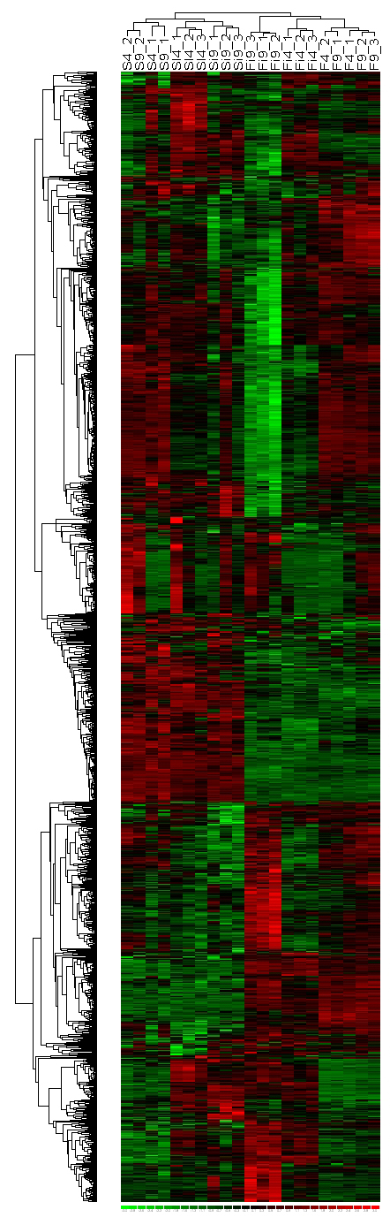
Additional data file 7. Hierarchical clustering of 1,547 genes exhibiting host effect.
Redundant probe sets were excluded from the analysis. The heat map shows color-coded expression levels (red = high expression, black = medium expression, and green = low expression). Gene trees are drawn vertically and sample trees vertically.

