Supplemental Table 1. Primer and probe sequences, reaction mixtures and cycling conditions used in this study.
Assay | Primer & Probe Sequences (5’ 3’) | Reaction Mixture | Cycling Conditions | Ref
All Plasmodia qPCR | Forward primer GTT AAG GGA GTG AAG ACG ATC AGA TA  Reverse primer AAC CCA AAG ACT TTG ATT TCT CAT AAG  Probe VIC-TCG TAA TCT TAA CCA TAA AC-NFQ | FastStart Universal Probe Master Mix (Roche, Indianapolis, IN, USA)  1μM primers  200nM probe  4μL template | 95℃ 2 min  40 cycles:  95℃ 15 s  60℃ 1 min | [1]
Nested PCR Round 1 | rPLU1 TCA AAG ATT AAG CCA TGC AAG TGA  rPLU5 CCT GTT GTT GCC TTA AAC TCC | FastStart High Fidelity PCR System (Roche, Indianapolis, IN)  200nM primers  5μL template  HotStarTaq Master Mix (Qiagen, Hilden, Germany)  200nM primers  5μL template | 95℃ 2 min  35 cycles:  95℃ 30 s  53℃ 30 s  72℃ 1 min  72℃ 5 min  95℃ 15 min  35 cycles:  94℃ 1 min  50℃ 1 min  72℃ 1 min  72℃ 10 min | [2]
Nested PCR Round 2  (genus-specific) | rPLU3 TTT TTA TAA GGA TAA CTA CGG AAA AGC TGT  rPLU4 TAC CCG TCA TAG CCA TGT TAG GCC AAT ACC | FastStart High Fidelity PCR System (Roche, Indianapolis, IN)  200nM primers  5μL template | 95℃ 15 min  35 cycles:  94℃ 1 min  55℃ 1 min  72℃ 1 min  72℃ 10 min | [2]
Nested PCR Round 2  (falciparum) | rFAL1 TTA AAC TGG TTT GGG AAA ACC AAA TAT ATT  rFAL2 ACA CAA TGA ACT CAA TCA TGA CTA CCC GTC | HotStarTaq Master Mix (Qiagen, Hilden, Germany)  200nM primers  5μL template | 95℃ 15 min  35 cycles:  94℃ 1 min  62℃ 1 min  72℃ 1 min  72℃ 10 min | [2]
Nested PCR Round 2  (malariae) | rMAL1 ATA ACA TAG TTG TAC GTT AAG AAT AAC CGC  rMAL2 AAA ATT CCC ATG CAT AAA AAA TTA TAC AAA | HotStarTaq Master Mix (Qiagen, Hilden, Germany)  200nM primers  5μL template | 95℃ 15 min  35 cycles:  94℃ 1 min  58℃ 1 min  72℃ 1 min  72℃ 10 min | [2]
Nested PCR Round 2  (ovale) | rOVA1 ATC TCT TTT GCT ATT TTT TAG TAT TGG AGA  rOVA2 GGA AAA GGA CAC ATT AAT TGT ATC CTA GTG | HotStarTaq Master Mix (Qiagen, Hilden, Germany)  200nM primers  5μL template | 95℃ 15 min  35 cycles:  94℃ 1 min  62℃ 1 min  72℃ 1 min  72℃ 10 min | [2]

Supplemental Figure 1. Sample flow diagram.
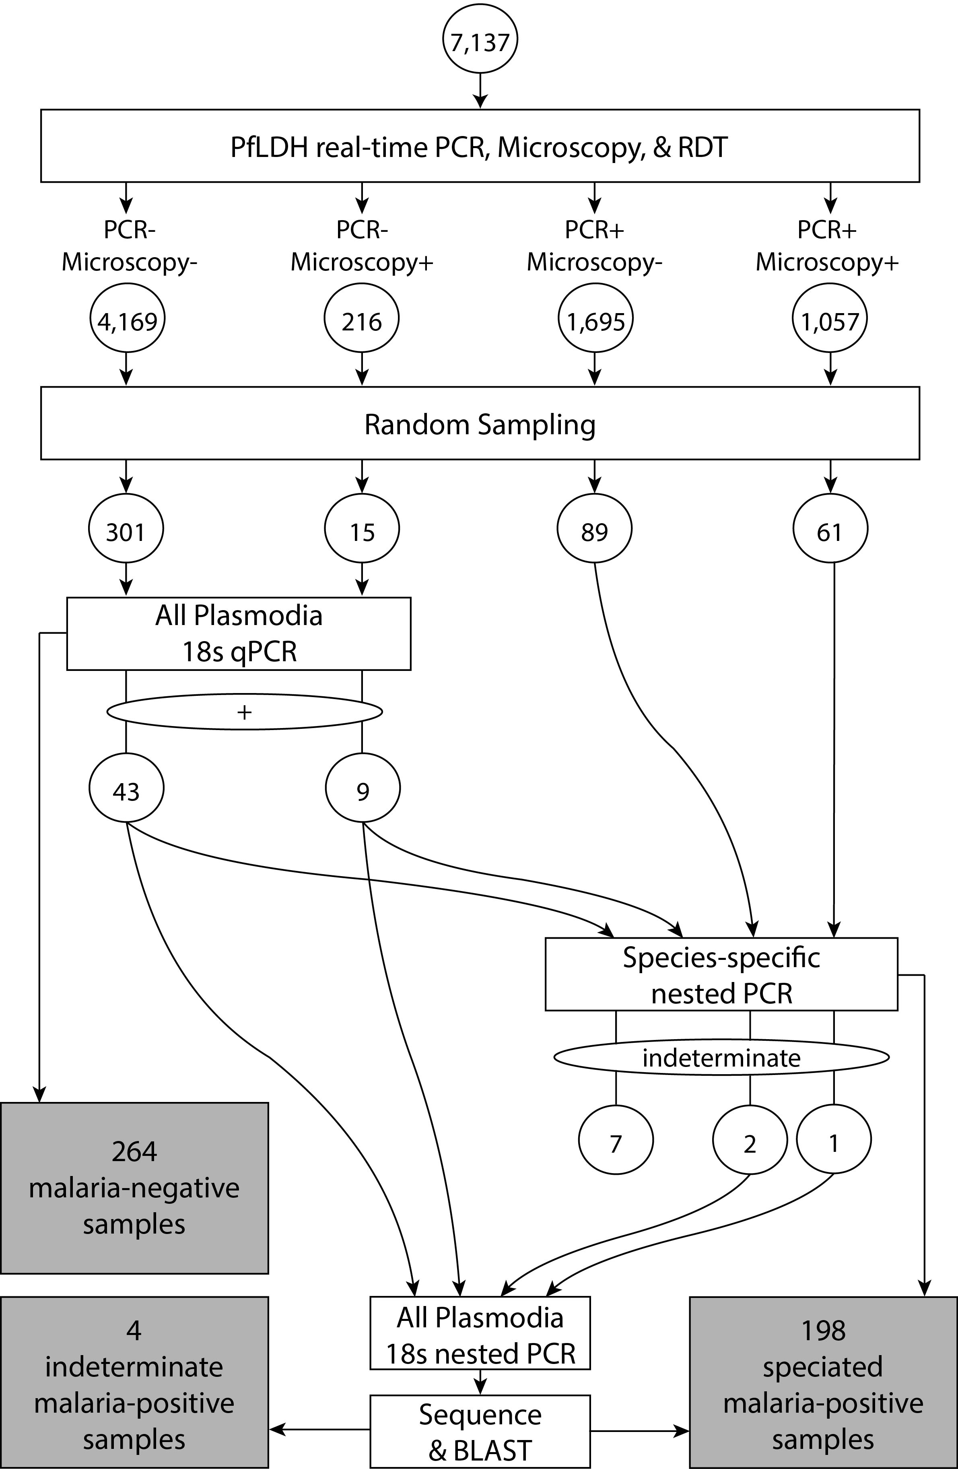
References
1. Taylor SM, Juliano JJ, Trottman PA, Griffin JB, Landis SH, Kitsa P, Tshefu AK, Meshnick SR: High-throughput pooling and real-time PCR-based strategy for malaria detection. J Clin Microbiol 2010, 48:512-519.
2. Singh B, Bobogare A, Cox-Singh J, Snounou G, Abdullah MS, Rahman HA: A genus- and species-specific nested polymerase chain reaction malaria detection assay for epidemiologic studies. Am J Trop Med Hyg 1999, 60:687-692.

