The Effect of Estrogen on Cardiac-Skeletal Muscle Biomarkers Following Prolonged Aerobic Exercise in Eumenorrheic Women

Timmons Williams

An honors thesis submitted to the faculty of the University of North Carolina at Chapel Hill in partial fulfillment of the requirement for the honors thesis in the Department of Exercise and Sports Science.

Approved by:

Anthony C. Hackney Ph.D., D.Sc.
Rebecca Battaglini, M.A.
Barbara Osborne, J.D.

ABSTRACT

TIMMONS E. WILLIAMS: The Effect of Estrogen on Cardiac Biomarkers Following Prolonged Aerobic Exercise in Eumenorrheic Women
(Under the direction of Anthony C. Hackney, Ph.D., D.Sc.)

Purpose: This study assessed the influence of estrogen (E2) on skeletal muscle creatine kinase (CK) and cardiac muscle CK (CK-MB) responses to prolonged aerobic exercise. Elevations in these biomarkers are indicative of muscle trauma-damage. Methods: Eumenorrheic women (n=10) who were physically active completed two 60-minute treadmill running sessions at ~60-65% maximal intensity during low E2 (midfollicular menstrual phase) and high E2 (midluteal menstrual phase) hormonal conditions. Blood samples were collected prior to exercise (following supine rest), immediately post-, 30 min post-, and 24 hr post-exercise to determine changes in muscle biomarkers. Resting blood samples confirmed appropriate E₂ hormonal levels Results: CK concentrations increased following exercise and at 24 hr post-exercise were higher in the midfollicular phase (p<0.001). However, CK-MB concentrations were unaffected by E₂ level or exercise (p=0.442). Conclusions: E₂ levels influence the CK biomarkers response for skeletal but not cardiac muscle following prolonged aerobic exercise. These findings imply elevated E₂ is protective of skeletal muscle from exercise-induced damage.
ACKNOWLEDGEMENTS
I am eternally grateful to Dr. Anthony C. Hackney for allowing me to work with him on my senior honors thesis. The enthusiasm and passion he puts into all of his work is contagious. Thank you to my committee members, Dr. Barbara Osborne and Mrs. Rebecca Battaglini, for graciously agreeing to review my work and for giving me valuable feedback. To my study subjects, I am so thankful for your willingness to participate in my study and to run for 60-minutes on a treadmill on two separate occasions. Lastly, thank you to all of the Endocrine Group: Liz, Michelle, Colin, and Amy, your help and guidance are something I deeply cherish.
TABLE OF CONTENTS
PAGE
LIST OF TABLES …………………………………………………………………………………………….. 7
LIST OF FIGURES …………………………………………………………………………………………… 8
CHAPTER I …………………………………………………………………………………………………….. 9
INTRODUCTION………………………………………………………………………………………….….. 9
Basis For Study………………………………………………………………………………….….11
Purpose………………………………………………………………………………………………..11
Research Hypothesis………………………………………………………………………….....11
Definition of terms………………………………………………………………………………..11
Estrogen…………………………………………………………………………………………...….11
Creatine Kinase…………………………………………………………………………...............11
Delimitations …………………………………………………………………………………….…11
Limitations ……………………………………………………………………………………….…12
Significance of study ………………………………………………………………………….…13
CHAPTER II………………………………………………………………………………………………..… 14
REVIEW OF LITERATURE……………………………………………………………………………... 14
CHAPTER III…………………………………………….…………………………………………………... 20
METHODOLOGY…………………………………………….……………………………………………... 20
Participants……………………………………………………………………………………….... 20
Instrumentation……………………………………………...……………………………….......21
Protocol…………………………………………….……………………………………………..… 22
Pre-Screening…………………………………………….…………………………...…………… 22
Orientation Session I…………………………………………….………………………………. 22
Experimental Sessions…………………………………………….…………………..………… 25
Follow Up Blood Draws Session III and V……………………………………….……...… 26
Blood Procedures…………………………………………….……………………………………….……. 26
Hematocrit………………………………….…………………………………………….………… 26
Hemoglobin…………………………………………….…………………………………………... 27
Plasma Volume Shift…………………………………………….………………….…………… 27
Creatine Kinase (CK), CK-MB, Estradiol, and Lactate Assays………...…………….. 27
Data Analysis………………………………………….…………………………………………….……….. 28
CHAPTER IV…………………………………………….…………………………………………….………29
RESULTS…………………………………………….…………………………………………….……………29
Subject Characteristics………………………………………………………………………….29
Hormonal Condition Determination…………..…………………………………………..30
Experimental Treadmill Running Protocol (60 min)………………………………..31
Plasma Volume Shift……………………………………………………………………………..32
Blood Responses to Experimental Treadmill Running Protocol…………...……33
CHAPTER V…………………………………………….…………………………………………….………..36
DISCUSSION…………………………………………….…………………………………………….………36
Hormonal Condition Determination………………………….…….…………………………36
Experimental Treadmill Running Session………………….……………………....……37
Creatine Kinase (Total CK) …………………………..…….…………………………....…….39
Creatine Kinase- MB…………..…………………………...…………………....……………….39
Conclusion…………………………………………………………………………………….……..41
Limitations…………………………………………………………………………………………..41
Future Studies………………………………………………………………………………………42
APPENDIX A: SAMPLE SIZE CALCULATIONS……………………………………………….……43
APPENDIX B: INFORMED CONSENT………………………………………………………….……..44
APPENDIX C: MEDICAL SCREENING FORMS…………………………………………….….……49
Medical History Questionnaire……………………………………………………….………50
Physical Examination Screening………………………………………………………….…55
APPENDIX D: ACSM METABOLIC EQUATION FOR DETERMINING EXERCISE INTENSITY……………………………………………………………………………………………………..56
APPENDIX E: MENSTRUAL CYCLE QUESTIONNAIRE…………………………………………58
APPENDIX F: FOOD LOG………………………………………………………………………………….61
APPENDIX G: DATA COLLECTION FORMS……………………………………………..…………63
Orientation Session………………………………………………………………………………64
Experimental Session……………………………………………………………………………65
Hematocrit and Hemoglobin………………………………………………………….………66
Subject Compliance………………………………………………………………………………67
REFERENCES…………………………………………….…………………………………………….……..69

LIST OF TABLES
- Bruce protocol treadmill test
- Participant physical and menstrual characteristics
- Descriptive data (mean ± SD) for VO₂, HR and RPE for each experimental treadmill running protocol in each hormonal condition (MF and MF)
- Mean (± SD) plasma volume shifts
- Mean ± SD for CK at rest, immediately post exercise (IP), 30 minutes post exercise (30P), and 24 hours post exercise (24P)
- Mean ± SD for CK-MB at rest, immediately post exercise (IP), 30 minutes post exercise (30P), and 24 hours post exercise (24P)

LIST OF FIGURES
- An overview of the menstrual cycle
- A flow diagram showing the order of the experimental sessions
CHAPTER I
INTRODUCTION
Basis For Study:
The protective benefits of estrogen on the cardiovascular system are well established. There is still debate, however, on the influence of estrogen on cardiac muscle damage during and following prolonged aerobic exercise, and if estrogen acts as a protectant against cardiac damage, and the mechanism by which estrogen protects the cardiac muscle (Squadrito et al., 1997). The intent of this study is to examine the influence of estrogen on cardiac muscle in women following exercise.
Estrogen is a sex and steroid hormone produced in the ovaries that regulates the menstrual and reproductive cycles in women. There are three types of estrogen: estrone, estradiol, and estriol. Estradiol is the strongest and most potent of the three types and is considered the most important type of estrogen in females between the menarche and menopause stages of life (National Institute on Aging, 2013).
Estrogen acts by diffusing through a cell membrane into the cytoplasm, binds to an estrogen receptor and then moves into the nucleus in order to modulate the expression of many genes (Babiker et al., 2001). There are two dominant types of estrogen receptors: ERα and ERβ.
Estrogen receptors have been found to be present in many different types of tissues including skeletal and cardiac muscle (Babiker et al., 2001). Skeletal and cardiac muscle cells are structurally and functionally very similar as they both consist of the structural proteins actin and myosin myofilaments that form sarcomeres. These proteins alternate in segments of thin and thick protein filaments creating a striated appearance. This structural similarity allows both cells to generate muscle contractions through actin and myosin cross-bridge cycling.
It is widely known that unaccustomed exercise results in temporary muscle damage. Estrogen has shown to protect skeletal muscle from inflammation in various studies through its attenuation of circulating cytokines and as a result attenuating inflammation as a result of the inflammation. (Tiidus, P.,2003; Pfeilschifter et al., 2002; Pottratz et al., 1994; Puder et al., 2001; Schwarz et al., 2000). However, a clear relationship between estrogen and inflammation after exercise induced cardiac muscle damage in women is yet to be determined. As cardiac and skeletal muscles are very similar structurally and functionally, it is logic to assume the protective effect of estrogen observed for skeletal muscle would exist for cardiac too.
Creatine kinase is a leakage enzyme used to make ATP via phosphorylation of ADP from creatine phosphate by catalyzing the reversible phosphorylation of creatine by ATP to form phosphocreatine + ADP (Cornell University, 2013). Creatine kinase is composed of two types of monomers: the M and B subunits. Together, these monomers form the isoenzyme creatine kinase-MB (CK-MB), which is present in highest concentrations in cardiac muscle. Creatine kinase is assayed in blood tests as a marker of myocardial damage as elevated levels of CK indicate muscular damage. As prolonged exercise causes increased muscular damage, CK-MB levels have been shown to increase after intense exercise. (Chen, Serfass & Apple, 2000).

Purpose
The purpose of this study will be to determine if differing levels of estrogen during a menstrual cycle influences the cardiac muscle damage markers of CK and CK-MB following moderate intensity prolonged exercise in eumenorrheic women.
Research Hypothesis
If estrogen is related to the cardiac biomarker CK and CK-MB then higher estrogen levels in eumenorrheic women will attenuate CK and CK-MB concentrations following moderate intensity exercise.
Definition of Terms

Estrogen

Estrogen is a 18-carbon corticosteroid molecule secreted by the ovary in females. Estrogen is primarily involved in the development and reproductive functions in women, but also plays a role in many cardiovascular, musculoskeletal, immune and central nervous system functions (Enns & Tiidus 2010).
Creatine Kinase
Creatine Kinase is an enzyme in the muscles that functions by making ATP through the phosphorylation of ADP from creatine phosphate. As creatine kinase is found mostly in muscle tissue, it is the most common blood marker of muscle damage (Ebbeling & Clarkson, 1989). High CK values are an indicator of muscle damage.
Eumenorrhea
Eumenorrhea is normal or regular menstruation by a woman that occurs at least nine times in the preceding year and lasts between 21 to 35 days.
Amenorrhea
Amenorrhea is an absence of menstruation. An absence of three or more periods in a row classifies women as amenorrheic. Strenuous physical activity, excessive weight loss, use of some antidepressants, and stress can cause a woman to have amenorrhea.
Delimitations
- Participants will be healthy females between the ages of 18-30.
- Must be eumenorrheic and not currently taking or have taken oral contraceptives or other hormone therapy six months prior to participation in this study.
- Have not sustained an injury within the last six months that has limited ability to exercise.
- Must not be currently taking anti-inflammatory medicines, such as ibuprofen, naproxen, or aspirin.
- Are not pregnant or become pregnant during the study.
- Become ill with an immune responding condition, such as a cold or respiratory infection during the study.
- Must have a current minimum training volume of 3-5 days a week, 45-120 minutes per session of aerobic activity, and have a VO₂ max of at least 45ml/kg/min.
- Abstain from strenuous physical activity and maintain a diet similar in calories and carbohydrate content 24 hours prior to experimental protocol.
- Women must be premenopausal.
- Estrogen’s role in cardiac illnesses or pathologies will be not considered within this study.
- This study will provide knowledge on the effects of estrogen on physiological systems not related to sexual and reproductive functions.
Limitations
- Results may not be applicable to men and some women (amenorrheic or post-menopausal).
- Subjects may not comply with specific pre-test instructions.
- CK and CK-MB concentrations will be the only cardiac biomarkers measured in the blood. Other cardiac biomarkers such as troponin T (cTnT), troponin I (cTnI), and lactate dehydrogenase (LDH) will not be measured.
- Technician error
Significance of study
Understanding estrogen’s role on cardiac muscle damage following high intensity exercise is important for both women and researchers. There has been an increased amount of research on post-menopausal women and the possibility of a correlation between decreased estrogen levels and cardiac illness over the past few decades. However, the role of estrogen in premenopausal women has been less studied. Through this study, the influence of estrogen related to cardiac muscle damage and the potential protective influence estrogen may have on cardiac muscle will provide researchers with more current knowledge. This information may be useful to create training programs centered on fluctuating estrogen levels during a menstrual cycle to increase performance and minimize risk. With the limited amount of research available on the subject, more research needs to be done to clarify the role of estrogen on exercise-induced cardiac muscle damage following a moderate intensity training protocol to provide basic physiological knowledge.
Chapter II
REVIEW OF LITERATURE
In this review, the influence of estrogen on exercise-induced cardiac muscle damage will be examined. There appears to be little research in the influence of estrogen on cardiac muscle in humans. However, skeletal and cardiac muscle is structurally and functionally very similar and since there is research supporting estrogen’s role in skeletal muscle, it can logically be hypothesized that estrogen could play a role in cardiac muscle also. This review will discuss how estrogen acts a protectant against muscle damage, research supporting estrogen’s protective role in skeletal muscle, and research on estrogen’s influence on cardiac muscle.
Estrogen is a steroid hormone that regulates and maintains sexual and reproductive function in females. While estrogen is present in both males and females, it is significantly higher in women in their reproductive years compared to males. There are three types of estrogen: estrone, estradiol, and estriol. Estrogen affects many physiological systems including the cardiovascular, musculoskeletal, immune and central nervous systems. The most potent and abundant form of estrogen that has the largest effect on these systems is 17β-estradiol (Enns & Tiidus, 2010). During the menstrual cycle estrogen fluctuates. At the beginning of the menstrual cycle known as the follicular phase, estrogen is at its highest as it steadily increases reaching a max right before the onset of ovulation. Estrogen then drastically decreases with the onset of ovulation and then begins to slightly increase before dropping again during the luteal phase signaling the end of the cycle. Estrogen is low during the luteal phase of the menstrual cycle. This fluctuation of estrogen is seen in detail in Figure 1.
Creatine kinase (CK) and the isoenzyme creatine kinase-MB (CK-MB) are two cardiac biomarkers that are examined during blood assays as markers of cardiac damage. CK-MB is very useful indicator of myocardial damage as only myocardium tissue has substantial amounts of it present. During unaccustomed exercise the muscles of the body such as the heart are damaged which causes a release of CK and CK-MB. This was demonstrated in a study of fifteen young men who performed 90 minutes of cycling for 3 consecutive days. Blood assays showed that CK levels were significantly elevated after the first training protocol and steadily increased after each consecutive training protocol (Totsuka et al., 2002). This increase in CK levels was also shown to correlate with increased CK-MB levels. This was seen in a study on mongrel dogs that analyzed ventricular myocardium for total CK and CK-MB content and found that CK-MB levels were slightly although insignificantly higher in trained versus caged dogs (Miller et al., 1989). Another study had rats swim for 3.5 hours straight and then sacrificed the rats immediately, 2 hours, 24 hours, and 48 hours post exercise. The researchers found that CK-MB was released into circulation in the highest concentrations immediately post exercise and returned to normal 24 hours post exercise (Chen, Serfass & Apple, 2000). This indicates that intense endurance exercise induces myocardial damage and is highest immediately post exercise.
Estrogen is an antioxidant and membrane stabilizer making it unique as a steroid hormone. During physical activity, oxygen consumption increases to meet metabolic demand. This increase in oxygen consumption corresponds with an increase in free radical production. Antioxidants protect tissues from free radical molecules, which cause inflammation. Estrogen is structurally similar to cholesterol, which allows it to insert within membrane phospholipids (Ennus & Tiidus &; 2010). This allows estrogen to act as a membrane stabilizer by preventing disruptions of the muscle membrane, which leads to muscle damage and inflammation. (Tiidus, 2005). These properties have allowed researchers to deduce that estrogen may help mitigate the effects on post-exercise muscle damage (Tiidus, 2005). However, the direct effect of estrogen on muscle structural damage after exercise is still debated.
The potential influence of estrogen on post-damage inflammation in various tissues has increased with research in the field over the past two decades. In the few human studies conducted, estrogen has shown to prevent inflammation related leucocyte infiltration into both skeletal and cardiac muscle after unaccustomed exercise or damaging insult (Tiidus, 2005; Tiidus & Bombardier et al., 2001). Bar and his associates (1998) proposed that that the levels of creatine kinase after exercise-induced stress differed between males and females as a result of estrogen’s protective role on the female muscle membrane. Research conducted in animals has found that estrogen influences skeletal muscle damage and leukocyte infiltration after exercise (Komulainen et al., 1999). The infiltration of leukocytes such as neutrophils and macrophages remove damaged muscle tissue and stimulate the repair processes. A study conducted by Tiidus and Bombardier reported that male rats had significantly attenuated neutrophil infiltration into skeletal muscles 24 hours after running exercise compared to female rats. When the same male rats were supplemented with estrogen, however, they exhibited a similar response of post-exercise neutrophil infiltration as female rats (Tiidus & Bombardier, 1999).
Estrogen is also thought to effect the activation and proliferation of satellite cells. Satellite cells proliferate in response to injury in order to provide the necessary materials needed to initiate muscle growth and repair. In a study conducted in male rats, Tiidus et al. (2005) observed that the skeletal muscles of estrogen-supplemented male rats had increased numbers of satellite cells 72 hours after downhill running. Further studies performed by Tiidus et al. (1999; 2005; 2008) found that sex-mediated differences in muscle fiber regeneration and satellite cell numbers may be directly influenced by estrogen.
Estrogen’s influence on cardiovascular health is well established. In relation to cardiac disease, pre-menopausal women have a lower incidence of cardiac illness compared to age-matched men (Milne & Noble; 2008). It has also been shown that estrogen reduces the degree of myocardial injury following ischaemia-reperfusion injury (Booth et al., 2008). Oestradiol-17β, a form of estrogen, was also shown to positively affect the heart in a study on the acute effects of oestradiol-17β on myocardial ischaemia. Researchers found that oestradiol-17β had a beneficial effect on myocardial ischaemia in women with coronary artery disease due to a direct coronary-relaxing effect and to peripheral vasodilation (Rosano et al., 1993). Research, however, is limited in respect to the influence of estrogen on healthy, pre-menopausal women’s cardiac muscle tissue. With this said, research has shown to support that the levels of creatine kinase (CK), a prominent blood biomarker of cardiac muscle damage, is higher in male rats compared with female rats following muscle injury (Bar et al.; 1988, Amelink et al.; 1990). These findings, however, can be problematical due to high variability and to factors related to CK clearance rates from the blood due to sex differences. Rose et al and Smith et al. found that postmenospausal women and premenarchial girls both display high levels of serum CK activity that correspond with their low levels of estrogen (Lane and Roses, 1981; Smith et al., 1979). This is thought to be due to estrogens stabilizing effect on the muscle membrane, which in turn reduce the level of CK activity caused by muscle damage. A sex difference in serum CK levels was also shown to be present at rest and after acute eccentric exercise training suggesting that estrogen might be responsible for this difference (Amelink & Bar, 1986).
In summary, research on the role of estrogen on cardiac muscle damage in humans after prolonged endurance exercise is still unclear. The knowledge gained through this research will be beneficial towards expanding the area of research literature pertaining to estrogens role in protecting the heart against self-induced muscle damage from exercise. As demonstrated in this review, estrogen is an important hormone in many physiological systems as well as sexual and reproductive functions. After looking at the research pertaining to estrogens effect on skeletal muscle, it has been suggested in this review that estrogen may attenuate cardiac muscle damage in a similar fashion. The results of this study will contribute to this body of knowledge and provide insight into what role estrogen has on the cardiac biomarkers CK and CK-MB after prolonged aerobic exercise.
Figure 1: An overview of the menstrual cycle 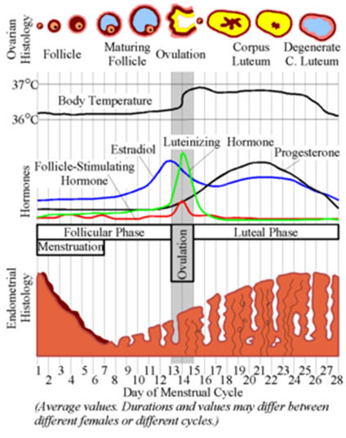
Gilbert, S. F. (2013). Hormones and Mammalian Egg Maturation. Retrieved from http://scientopia.org/img-archive/scicurious/img_674.jpg
Chapter III
METHODOLOGY
Participants made five visits to the Applied Physiology Laboratory (APL) at the University of North Carolina (UNC-CH). The first visit consisted of an orientation where consent will be obtained. The visit also determined if a participant was eligible for the study and allowed for the acquirement of descriptive characteristics, record of menstrual history, and measurement of maximal oxygen consumption (VO₂max). The second session was an experimental protocol requiring subjects to run 60 minutes on a treadmill at ~60-65% of their predetermined VO₂max. The variables CK and CK-MB were measured at baseline, immediately post-exercise, and 30 minutes post-exercise. The third session was the day after the exercise protocol and was a 24-hour post-exercise blood draw. The fourth and fifth sessions repeated the second and third sessions.
Participants
Fifteen healthy, highly trained, pre-menopausal women between the ages of 18-30 were recruited. Samples size was estimated from previous research in the literature to ensure adequate statistical power (Appendix A). Participants eligible for the study needed to be eumenorrheic for the past six months, not taken oral contraceptives or other hormone therapy prior to participation in the study, and not be currently using anti-inflammatory medications, such as ibuprofen, naproxen, or aspirin. Participants were also required to report a current minimum training volume of 3-5 days of aerobic activity lasting between 45-120 minutes per sessions and a VO2 max of 45 ml/kg/min and no major injuries that would limit the ability to exercise. If a participant reports an injury in the past 6 months, a physician’s signed clearance must be obtained before beginning participation in the study. Participants were dropped from the study if they become pregnant or ill with an immune responding condition, such as a cold or respiratory infection. Consent was obtained from the participants after being cleared of all eligibility criteria and thoroughly informing them of the experimental protocol and any risks or rewards related to the study. Participants were asked to abstain from strenuous physical activity and maintain a normal diet in calories and carbohydrate content 24 hours prior to the two experimental trials.
Instrumentation
Height was measured with a portable stadiometer (Perspectives Enterprises, Portage, MI USA) and body mass was measured using a mechanical scale (Detecto, Webb City, MO USA). Skinfolds was measured with a Lange skin caliper (Beta Technology, Inc., Santa Cruz, CA USA). Maximal oxygen consumption was measured during a continuous, incremental treadmill run on a Quinton Q65 treadmill (Bothell, WA USA). Respiratory gases were obtained for the orientation and two experimental sessions using the Parvo Medics TrueMax 2400 Metabolic System (Parvo Medics, Salt Lake City, UT USA). A continuous measurement of heart rate was taken using the Polar telemetry system (Polar Electro, Inc., Lake Success, NY USA). Ratings of perceived exertion (RPE) were determined using Borg’s 20-point scale. Hematocrit was measured using an Adams MHCT II microhematocrit centrifuge (Becton Dickinson, Franklin Lakes, NJ USA) and an International Microcapillary Reader (International Equipment Company, Needham Heights, MA USA). Hemoglobin will be determined from a Stanbio Lab Hemopoint H² analyzer (Boerne, TX USA). Whole blood samples were kept in an IEC Centra-8R refrigerated centrifuge (International Equipment Company, Needham Heights, MA USA) and the resultant separated plasma were stored and frozen at -80˚C. Serum CK and CK-MB were measured using a Ortho-Clinical Diagnostics Vitros DT60II analyzer (Rochester, NY). Plasma E₂ was measured using the enzyme-linked immunoassay (ELISA) technique, (Abnova Corporation, Taiwan, China).

Protocol
Pre-screening
Interested participants in the study emailed the investigator directly in order to determine eligibility. Eligible participants then were scheduled for an orientation and experimental session.
Orientation Session I
The orientation session took place in the Applied Physiology Laboratory at The University of North Carolina, Chapel Hill. Participants arrived and were informed of the experimental protocol, possible risks and rewards associated with the study, and sign an informed consent form. The Office of Human Research Ethics, Institutional Review Board, of The University of North Carolina, Chapel Hill, approved the informed consent form before beginning the experimental protocol. After giving informed consent, participants filled out the Exercise and Sports Science medical history questionnaire, and underwent and passed a medical screening. Height, weight, and age were measured.
Next, a VO₂max test was performed using a continuous, incremental treadmill protocol. Participants performed a five-minute warm up before beginning the test consisting of biking at their preferred pace and light stretching. After the warm up, resting oxygen consumption VO₂ were measured for three minutes. Participants then began the exercise test using the Bruce treadmill protocol (ACSM Guidelines, 2010). Table 1 lists the Bruce protocol treadmill test. Heart rate and respiratory gas exchange were measured continuously throughout the test as well as the 20-point scale ratings of perceived exertion (RPE). At the conclusion of the test, participants were allowed to recover either actively or passively and were permitted to leave the laboratory when heart rate drops below 100 beats per minute (bpm). The VO₂ test was determined as a maximal test rather than a peak test through the participants displaying three of the four criteria: a plateau or decrease in VO₂ with increases in workload, respiratory exchange ratio (RER) greater than or equal to 1.1, RPE ≥ 18, and a HR within 10% of predicted heart rate max (220-age of participant). ACSM guidelines were used to estimate exercise intensity corresponding to ~60-65% of VO₂ (American College of Sports Medicine, 2011).

Table 1: Speed in miles per hour (mph) and grade for each three-minute stage of the Bruce protocol incremental exercise test.
Stage | Speed (mph) | Grade (%)
1 | 1.7 | 10
2 | 2.5 | 12
3 | 3.4 | 14
4 | 4.2 | 16
5 | 5.0 | 18
6 | 5.5 | 20
7 | 6.0 | 22

Experimental Sessions
Figure 2: A flow diagram showing the order of the experimental sessions.
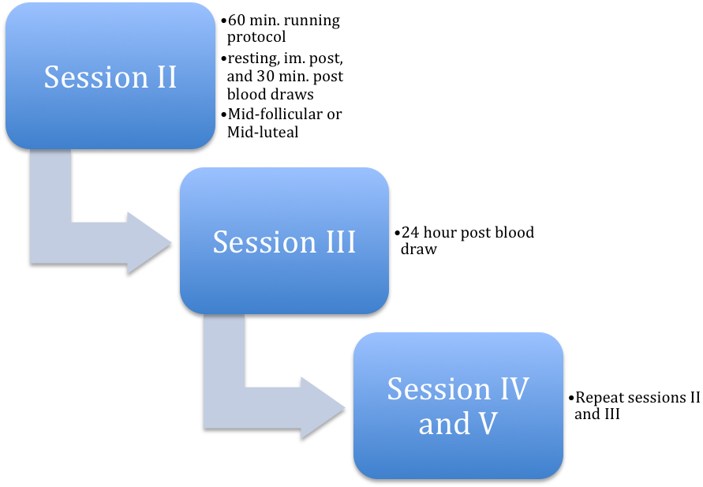
Experimental Sessions II and IV
Participants visited the Applied Physiology Laboratory once during their mid-follicular (MF, low estrogen) and mid-luteal (ML, high estrogen) phases respectively. Appointment dates were determined using the forward counting method (Chavanne & Gallup, 1998). The two experimental sessions were counterbalanced to prevent order effects. The testing occurred during the MF and ML phases of the menstrual cycle in order to find the largest differences between naturally fluctuating estradiol levels and maximize effect size. The MF phase typically occurs between days 3-7 of the menstrual cycle when estradiol is lower, whereas, the ML phase occurs roughly between days 20-24 of the menstrual cycle when estradiol is much higher. These date ranges can vary among participants depending upon the length of a participant’s menstrual cycle and are only used as approximations. These will be calculated and are reported exactly once the study is complete.
Participants were asked to refrain from intense physical activity and maintain a similar diet 24 hours prior to the experimental sessions. Participants were asked if they followed all guidelines prior to the testing sessions, and a food diary will be used to ensure similar nutrient intake between trials, as well as adequate caloric and carbohydrate intake. If participants complied to these terms, the experimental trial continued. Participants rested supine in a quiet environment for 10 minutes. After this resting period, blood was obtained via individual blood draws or catheter, based on participant preference. The blood sample was split in two and placed in a sterile K₂ –EDTA (purple top) and a sterile SST (yellow top) Vacutainer ™ tubes and then immediately put on ice. Participants then completed a five minute warm-up consisting of cycling and light stretching, followed by 60 minutes of treadmill running at their previously determined workload of 65% of VO₂ as determined by the ACSM formula (ACSM, 2010). Blood samples were taken immediately post exercise and 30 minutes post exercise and promptly put on ice. Plasma was separated from blood samples and stored until later analysis for CK and CK-MB. Blood samples will be stored for three years.
The 60-minute time length for the treadmill protocol was chosen to mimic a normal exercise training session. Previous research from the Applied Physiology Laboratory at the University of North Carolina (UNC-CH) has shown that this length of time as sufficient in inducing muscle creatine kinase responses (Kallman, 2011).
Follow Up Blood Draws Session III and V
Participants returned to the laboratory 24 hours post exercise for additional blood draws. Participants were asked to lay supine for 10 minutes in a quiet environment. Blood samples were obtained to measure for CK and CK-MB using the same procedures specified in sessions I and II. Participants were asked to refrain from any exercise that is more than what is necessary for activities of daily living for 24 hours after the blood draw.
Blood Procedures

Hematocrit
Immediately post each exercise test, resting and post-exercise Hematocrit (Hct) values were determined in triplicate from whole blood samples. Whole blood were put into 75mm Allied Corporation microcapillary tubes (Fisher Scientific, Pittsburgh, PA) and sealed using Critoseal (Krackeler Scientific, Albany, NY). Capillary tubes were spun in a microhematocrit centrifuge for three minutes at 10,000 RPM and then placed on a hematocrit wheel to determine the hematocrit values of each sample. A mean was calculated from three samples and used in data analysis.

Hemoglobin
Resting, immediately post-exercise, and recovery hemoglobin (Hb) values from each experimental session were measured in duplicate from the whole blood samples using the Stanbiolab Hemopoint H² analyzer (Boerne, TX). These values were determined immediately after completion of the exercise tests. A mean was calculated from three samples and used in data analysis.

Plasma Volume Shift
Hb and Ht values were used to calculate exercise induced plasma volume shifts according to the Dill and Costill equation (Dill & Costill 1974).

Creatine Kinase (CK and CK-MB), and Estradiol Assays
To separate plasma and serum from whole blood, the blood samples were centrifuged at 3,000 x g for 10 minutes. The separated plasma and serum were transferred to storage tubes and stored until analyses are conducted. Enzyme-linked immunoassay (ELISA) techniques (Abnova Corporation, Taiwan, China) were used to measure plasma estradiol concentrations. The assay manufacturer reports a minimum detectable concentration of 2.0 pg/mL. The Vitros DT60II analyzer uses a highly specific dry chemistry colorometric procedure for assessing CK and CK-MB. The minimum detectable concentration is 1.0 u/L for CK and 1.0 u/mL for CK-MB. All blood assays (unknown samples) were performed in duplicate while standards were done in triplicate.

Data Analysis
SPSS statistical software was used to analyze data (version 18.0, Chicago, IL USA). Significance for all data was set at α < 0.05. Descriptive statistics was shown as means ± standard deviations (SD). Effect size was calculated for all significant measures to determine if significance has practical meaning.
A 2x3 (estradiol level x time) totally within, repeated measures ANOVA and where appropriate, Bonferoni post hoc test, was used to assess the effects of estradiol on CK and CK-MB concentrations. A 2x2 (estradiol level vs. time) ANOVA was used to evaluate the percent change (%Δ) in CK values between pre and post exercise, as well as pre- exercise and recovery during each menstrual cycle phase (estradiol level). These two same procedures were used to assess the effects of estradiol on CK-MB. The %Δ will be calculated using this equation:
%Δ = [(Post-exercise – Baseline)/Baseline] x 100
At dependent t-test analysis was used to evaluate statistical significance between resting levels of estradiol at MF and ML phase experimental sessions.
CHAPTER IV
RESULTS
Originally, the goal of the study protocol was to have a sample size of fifteen subjects in order to ensure adequate statistical power based off of previous research literature. However, due to difficulties of finding women who met the inclusion criteria, only ten women completed the study protocol.
Additionally, one participant was unable to complete the second experimental session treadmill running (ML phase) due to medical reasons. Therefore, the subject’s missing data were approximated using mean substitution through the SPSS (version 18.0) missing variables function in order to maintain the integrity of both experimental session results within the statistical analysis.
Subject Characteristics
Ten highly trained, eumenorrheic women participated in the study. The subjects met the inclusion criteria: healthy females between the ages of 18-30 years, eumenorrheic, not currently taking or have taken oral contraceptives or other hormone therapy 6 months prior to participation, have not had an injury in the previous six months, not currently taking anti-inflammatory medication, and have a current minimum training volume of 3-5 days per week, 45-120 minutes per session of aerobic activity and a VO₂ max of at least 45 mL/kg/min. The physical and menstrual characteristics of the 10 subjects who completed the study are reported in Table 2.

Table 2: Participant physical and menstrual characteristics (n=10)
Measure | Mean ± SD | Range
Age (yrs) | 21 ±1 | 20-23
Height (cm) | 164.5 ± 5.7 | 149.6- 172
Body Mass (kg) | 61.3 ± 8.3 | 49.5- 80.4
Body Fat (%) | 24.0 ± 3.0 | 17.9-27.4
Menstrual Cycle (days) | 28 ± 1 | 27-30
MF day | 7 ± 2 | 4-10
ML day | 23 ± 3 | 20-27
MF= Midfollicular; ML=Midluteal phases of menstrual cycle
VO₂Peak Testing
The criteria for a maximal oxygen consumption test was not achieved by all subjects, thus all maximal oxygen consumption tests (VO₂max) are referred to as VO₂ peak tests. The average VO₂peak (mean ± SD) was 53.5 ± 4.7 ml/kg/min (range 45.1- 60.0 ml/kg/min). The average peak RPE obtained was 18 ± 1Borg Units (range 16-20 Borg Units). The average peak heart rate (HR) was 191 ± 1 bpm (range 180-208 bpm). The time to reach VO₂peak ranged between 12:35 to 16:10 mins:sec. Based upon the results of this maximal testing, the average calculated 65% of VO₂ peak to use in the 60-minute exercise session was 34.8 ± 3.0 ml/kg/min.
Hormonal Condition Determination
Menstrual cycle length was calculated for each subject. The average menstrual cycle length (mean ± SD) was 28 ± 1 days (range 27- 30 days). Individual menstrual cycle phases were determined using the forward counting method as mentioned in the methodology chapter. The onset of menses was denoted as day 1. Subjects were tested at 7 ± 2 days (range 4-10 days) after the onset of menses during the midfollicular phase (MF). Subjects were tested at 23 ± 3 days (range 20-27) after the onset of menses during the midluteal phase (ML) of the cycle.
Hormonal analysis of resting blood samples at the MF and ML testing sessions for 17β-estradiol (E2) confirmed the appropriate menstrual phase and hormonal status of the subjects. The MF E2 concentration was 39.8 ± 18.3 pg/ml, while the ML E2 concentration was 148.1 ± 35.2 pg/ml. These concentrations were significantly different (p< 0.01) which confirms the desired hormonal treatment effect were achieved. The biochemical within assay coefficient of variation for E2 was 5.20%.
Experimental Treadmill Running Protocol (60 min)
The subjects followed and complied with protocol guidelines as stated in the methodology chapter. Specifically, they reporting to the laboratory well hydrated (urine specific gravity < 1.030 cc³) and having replicated a standardized diet, and abstained from strenuous physical activity for the 24 hours prior. Three subjects participated in light exercise prior to the first testing session, and this exercise was replicated exactly prior to the second prolonged running session. The order of the subject testing (MF → ML vs. ML → MF) was counter-balanced. Mean body mass prior to running for MF was 61.4 ± 8.6 kg and for ML was 61.1 ± 8.3 kg.
All subjects completed the 60-minute sessions at the calculated running speed to elicit 65% of the individual’s VO₂ peak . Actual running speed was replicated for each experimental treadmill running protocol at 14.7 ± 1.3 km/hr with a corresponding actual VO₂ of 61.7 ± 5.0 % during MF and 59.7 ± 2.8 % during ML. Measurements obtained for VO₂, HR and RPE were nearly identical for each running session. Descriptive data at each measurement time for these variables is shown in Table 3 below.
Table 3: Descriptive data (mean ± SD) for VO₂, HR and RPE for each experimental treadmill running protocol in each hormonal condition (MF and MF)
Hormonal Condition | Measure | Time (min)
Hormonal Condition | Measure | Rest | 10 | 30 | 60
MF | VO₂ (mL/kg/min) | 4.9 ± 0.6 | 30.4 ± 4.2 | 33.2 ± 3.2 | 35.2 ± 2.9
MF | HR  (bpm) | 63 ± 7 | 150 ± 15 | 157 ± 13 | 165 ± 13
MF | RPE  (Borg units) | - | 11 ± 1 | 12 ± 1 | 14 ± 1
ML | VO₂ (mL/kg/min) | 4.9 ± 0.4 | 30.0 ± 3.2 | 32.7 ± 3.3 | 33.1 ± 4.5
ML | HR  (bpm) | 61 ± 4 | 149 ± 7 | 154 ± 6 | 164 ± 6
ML | RPE  (Borg units) | - | 11 ± 1 | 12 ± 1 | 14 ± 2

Plasma Volume Shift
The Dill and Costill method of determining plasma volume shifts was used in this study. Plasma volume decreased over the prolonged treadmill running protocol. Table 4 reports the average percentage plasma volume shifts for fluid moving from the vascular spaces during the exercise and the recovery periods from exercise. The responses for plasma volumes shifts were very comparable in each of the 60-minute running sessions.

Table 4: Mean (± SD) plasma volume shifts
Hormonal Condition | Rest-Immediate Post Exercise  (%) |  | Rest-24 hr Post Exercise  (%)
  Rest-30 min Post Exercise
  (%)
MF | -8.5 ± 6.9 | -3.1 ± 8.0 | 6.6 ± 16.1
ML | -8.1 ± 5.9 | -8.6 ± 7.6 | -2.6 ± 6.8

Blood Responses to Experimental Treadmill Running Protocol
Creatine Kinase
Resting, immediate post-exercise, 30 min post exercise, and 24 hr post-exercise CK activity is reported in Table 5. The main effect for hormonal status was significant (p < 0.05; MF>ML). The main effect for time was also significant (p < 0.01), with post-hoc revealing levels were significantly increased from 30 min post-exercise to 24 hr post-exercise from rest. Most importantly, the interaction of hormonal status and time was significant (p < 0.01). Post hoc tests indicated the increase observed at 24 hr post-exercise was significantly greater in MF than ML. Examination of the statistical analysis using the percent change data (see Table 5) did not change the interpretation of the responses.
Creatine Kinase - MB
Creatine kinase - MB (CK-MB) response to the experimental treadmill running protocol is presented in Table 6. The main effect for hormonal status was not significant (p= 0.72). The main effect for time was not significant (p= 0.47). Furthermore, there was not a significant interaction effect for hormonal condition and time (p= 0.44). Examination of the statistical analysis using the percent change data (see Table 6) did not change the interpretation of the responses.
The within assay coefficient of variation for the CK biochemical analysis was 9.50%. The within assay coefficient of variation for the CK-MB biochemical analysis was 9.50%
Table 5: Mean ± SD for CK at rest, immediately post exercise (IP), 30 minutes post exercise (30P), and 24 hours post exercise (24P)
Hormonal Condition | CK (U/L)
Hormonal Condition | Rest | IP | IP Change (%) | 30P | 30P Change  (%) | 24P | 24P Change (%)
MF | 106.8 ± 34.5 | 129.9 ± 38.0 | 24.3 ± 24.9 | 161.2 ± 60.9 | 51.1 ± 25.9 | 378.7 ± 176.5 | 280.0 ± 196.2
ML | 104.2 ± 3.1 | 118.6 ± 18.7 | 19.4 ± 28.0 | 153.4 ± 28.9 | 55.2 ± 38.9 | 279.6 ± 100.8 | 205.1 ± 207.6

Table 6: Mean ± SD for CK-MB at rest, immediately post exercise (IP), 30 minutes post exercise (30P), and 24 hours post exercise (24P)
Hormonal Condition | CK-MB (ng/mL)
Hormonal Condition | Rest | IP | IP Change (%) | 30P | 30P Change (%) | 24P | 24P Change (%)
MF | 4.7 ± 3.4 | 4.8 ± 1.4 | 22.9 ±40.8 | 6.2 ± 1.5 | 61.2 ± 54.3 | 5.6 ± 2.0 | 51.7 ± 78.6
ML | 5.0 ± 2.3 | 6.0± 2.3 | 26.8 ± 38.9 | 5.4 ± 1.0 | 19.2 ± 31.8 | 5.7 ± 1.4 | 29.0 ± 52.4

CHAPTER V
DISCUSSION

The purpose of this study was to determine if fluctuations in E2, corresponding to menstrual cycle phase, influenced blood CK and CK-MB response to prolonged aerobic exercise. It was hypothesized that if E2 influences CK and CK-MB response then higher E2 levels (ML phase) would attenuate CK and CK-MB concentrations following prolonged aerobic activity. This hypothesis was tested by examining the response of 10 highly trained females who completed two 60-minute moderate intensity treadmill running sessions during the MF phase and ML phase o the menstrual cycle. Subjects returned 24-hours after each exercise session for follow up blood samples to assess CK and CK-MB responses.
Hormonal Condition Determination
In the present study, there was a significant treatment condition between the MF (low E2) and ML (high E2) menstrual cycle phases (p=0.003). E2 concentration was approximately four times greater in the ML than MF (39.3 ± 18.3pg/ml to 148.1 ± 35.2 pg/ml, respectively). These results fell within expected values determined by the ELISA biochemical procedures used in analysis in which MF levels typically range from 30-100pg/ml and ML levels typically range from 60-400pg/ml (Human E₂, Abnova, Walnut, CA & Taiwan, China). Also, the difference in E2 concentration between hormonal conditions measured in this study agrees with other studies investigating the effect of estrogen on inflammatory markers in eumenorrheic women (Hackney et al., 1991; Timmons et al., 2005).

Experimental Treadmill Running Session
The running speed of the participants within each of the 60-minute treadmill runs corresponded to an average intensity of 61.7 ± 5.0 % VO2peak during the MF phase and 59.7 ± 2.8 % VO2peak during the ML phase, slightly lower than the desired intensity of 65% VO2peak. However, the mean VO2 responses between hormonal conditions were similar at each time measurement in both of the 60-minute exercise sessions and did not differ. The VO2 measurements slightly increased from the start to end of the treadmill run due to the manual adjustments in running speed to meet target VO2 levels, and as the result of the cardiac drift phenomenon [see below] (Dawson et al., 2005).
Heart rate responses between hormonal conditions were very similar too, but did show a gradual increase over the 60-minute treadmill running sessions. This gradual increase in heart rate during prolonged aerobic activity is not unusual. During such prolonged aerobic exercise, body temperature gradually increases. To maintain homeostasis in this situation, blood is redirected towards the skin to release water within blood plasma through the form of sweat so that evaporative cooling can occur. This action reduces the plasma volume making the blood more viscous and decreases venous return to the heart. Therefore, the heart contractility must increase (increasing heart rate) to maintain cardiac output and exercise intensity. This is known as the cardiac drift phenomenon. This concept is supported by the data obtained in this study by the reduced plasma volume observed following both experimental treadmill running sessions (Dawson et al., 2005).
Ratings of perceived exertion (RPE) in each of the 60-minute running sessions were nearly identical between hormonal conditions too; although, during both experimental running sessions the RPE did gradually increase which is a typical response. Prolonged aerobic activity requires adequate motivation, hydration levels, and nutritional status. Thus, RPE could have increased from a lack of any of these factors; lack of motivation, monotony of treadmill running, dehydration, or prior nutritional status, towards the end of the running session. Although, it should be pointed out the subjects were allowed to drink water as often as desired.
The similar findings of RPE between the two experimental sessions are somewhat atypical. Previous research has shown an increase in RPE during the ML phase. This is speculated to be due to the increase in body temperature during the luteal phase, which negatively affects a woman’s capability of maintaining thermal balance which can increase the perception of the difficulty of the exercise (Pivarnik et al., 1992). That is, the body must work harder and sweat more to prevent overheating making exercise seem more difficult. Why the present findings are at odds with the work of Pivarnik et al. is unclear
Overall, the VO2, HR, and RPE measurements obtained in each of the 60-minute exercise sessions were in line with expected physiological outcomes caused by prolonged aerobic exercise and were very similar between the hormonal conditions (ACSM, 2011; Kallman, 2011). This suggests that any differences in blood levels of CK or CK-MB response observed in this study were the result of differences in hormonal condition and not differing exercise conditions.
Creatine Kinase (Total CK)
A significant interaction effect of hormonal status and time was observed for CK (i.e., exercise induced CK changes but the magnitude of response varied with E₂ levels). Further statistical analyses indicated that the increase in CK observed at 24 hr post-exercise was significantly greater in MF than ML. These results are similar and relate to a study by Carter et al. who found naturally elevated estrogen levels during the ML had a protective effect on muscle following eccentric exercise (Carter et. al, 2001). Specifically, Carter et al. found significantly less CK response 72 hours after exercise in subjects during high estrogen (ML) versus low estrogen menstrual phases (MF) when doing downhill running to introduce muscular trauma. These and the current results also are in line with previous research supporting the notion that high levels of estrogen attenuate inflammation that causes delayed onset muscle soreness (DOMS) after exercise (Tiidus et al., 2001).
In skeletal muscle, studies on animals have shown that estrogen may potentially prevent the release of CK into the bloodstream (Amelink et al., 1990; Enns & Tiidus, 2010). The mechanism by which estrogen reduces muscle damage and CK release is not fully understood, but it is thought that estrogens exhibit antioxidant properties, act as a membrane stabilizer, and has an ability to bind to estrogen receptors and regulate downstream genes inducing decreased inflammation (Tiidus et al, 2010).
Creatine Kinase - MB
There was not a significant interaction effect for hormonal condition and time for CK-MB activity (i.e., exercise did not induce CK-MB changes nor did response vary with E₂ levels). CK-MB is very useful indicator of myocardial damage as essentially only myocardium tissue has substantial amounts of this biomarker present. Therefore, this lack of a significant interaction effect (i.e., increase in response to the exercise) for CK-MB suggests that the increase seen in CK levels 24 hrs post-exercise was a result of skeletal inflammation and not cardiac muscle damage (i.e., a component of the CK response is made up on the CK-MB sub-fraction). These results are not in line with some previous research on long-distance runners that found elevated CK-MB levels 1, 24, 48, and 72 hours after a marathon race in men (Apple et al, 1984, 1985). Another study in rats found that after 3.5 hours of swimming with an 8% bodyweight workload attached to their tails, CK-MB concentrations from the heart significantly increased (Chen et al., 2000). These studies supported the notion that prolonged aerobic exercise elicited cardiac muscle damage; but the duration of the exercise used in these studies was substantially greater than that in the current study.
The lack of an interaction effect for CK-MB values may be a result of the limitations in the current study design. It is possible that the duration and intensity of the treadmill running protocol were not great enough to elicit a significant difference in CK-MB levels between hormonal conditions. Therefore, it is possible that the heart was not put under enough stress to elicit the release of a significant amount of CK-MB between hormonal conditions and thus may have masked the influence of E2. A study conducted by Hutcheson et al. found that strenuous exercise (i.e., marathon running) elicited elevated CK-MB levels in men and women (Hutcheson et. al, 1998). Furthermore, the original power calculations for this study required 15 subjects to be part of the study. Therefore the sample size of 10 subjects may have been too small to detect changes, which limits the statistical strength of the results and could have contributed to the lack of a relationship found between CK-MB and E2.
Conclusion
In conclusion, the inflammatory marker CK significantly increases 24 hrs post-exercise during periods of low E2 (MF phase). However, the lack of a significant increase in CK-MB levels following exercise suggests that this increase in CK is from skeletal inflammation not from cardiac muscle damage. Therefore, it is unclear if estrogen hormonal status influences the potential cardiac muscle damage from prolonged aerobic exercise. Due to the lack of significance for changes in CK-MB levels, suggestions for women to alter their training programs in relation to their menstrual phase to possibly prevent cardiac muscle damage cannot yet be made. However, the significant interaction effect for hormonal condition and time for the skeletal inflammatory marker CK suggest that women should consider ingesting an NSAID while training during their MF phase (low E2) to alleviate exercise induced inflammation. Given the limited research present on the influence of E2 on cardiac biomarkers following prolonged aerobic exercise, additional research is recommended.
Limitations
Several limitations in the current study do exist. The sample size relative to CK-MB may have been inadequate to reach statistical significance. Therefore, additional subjects are needed to reach adequate statistical power. Furthermore, all of the subjects did not reach the criteria for a maximal oxygen consumption test (VO₂max) during their initial exercise testing session. Also, the intensity of the exercise was not as difficult as originally intended in the study design, which could have affected the results obtained.
Future Studies
Future studies should consider increasing the intensity or duration of the running protocol to elicit a greater physiological stress response. Future studies should also obtain a greater number of subjects to reach optimal statistical power. Also, additional cardiac biomarkers such as troponin should be examined in order to have a greater understanding of the relationship between E2 and cardiac damage. Overall, more future research is needed to further understand E₂ effect on exercise and to add to the knowledge gained from the limited number of studies on the topic.
APPENDIX A
SAMPLE SIZE CALCUATIONS
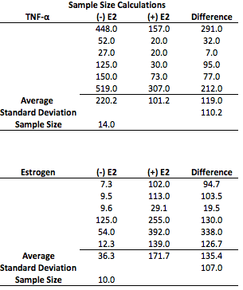
APPENDIX B
INFORMED CONSENT
University of North Carolina at Chapel Hill
Consent to Participate in a Research Study
Adult Participants
Consent Form Version Date: _______2013-2014_______
IRB Study # 10-2109
Title of Study: Influence of Estrogen on Cytokine Response to Prolonged Treadmill Running
Principal Investigator: Anthony Hackney
Principal Investigator Department: Exercise And Sport Science
Principal Investigator Phone number: (919) 962-0334
Principal Investigator Email Address: ach@email.unc.edu
_________________________________________________________________
What are some general things you should know about research studies?
You are being asked to take part in a research study. To join the study is voluntary.
You may refuse to join, or you may withdraw your consent to be in the study, for any reason, without penalty.
Research studies are designed to obtain new knowledge. This new information may help people in the future. You may not receive any direct benefit from being in the research study. There also may be risks to being in research studies. Deciding not to be in the study or leaving the study before it is done will not affect your relationship with the researcher, your health care provider, or the University of North Carolina-Chapel Hill. If you are a patient with an illness, you do not have to be in the research study in order to receive health care.
Details about this study are discussed below. It is important that you understand this information so that you can make an informed choice about being in this research study.
You will be given a copy of this consent form. You should ask the researchers named above, or staff members who may assist them, any questions you have about this study at any time.
What is the purpose of this study?
Recent work has shown a negative relationship between concentration of estrogens and the inflammatory response, specifically cytokines, at rest. Females in the midluteal phase of the menstrual cycle, high estrogen concentration, exhibited significantly lower circulating cytokines (and creatine kinase) compared to females in the midfollicular phase, low estrogen concentration. These demonstrated fluctuations at rest begs the question - Is there an altered cytokine response during exercise at different points within the menstrual cycle as estrogen changes?
To date, few exercise studies on human female subjects with respect to estrogen concentration and cytokines exist. The studies that do exist present divergent results. The studies performed have limitations; primarily small sample sizes, potential inaccurate menstrual phase determination, or dosage of exercise was not enough to provoke a response.
The purpose of this research study is to learn about the influence estrogen has on the cytokine response to prolonged treadmill running. The results of this study will add to the limited body of knowledge available on the influence of estrogen on cytokine expression in response to exercise within women, potentially providing insight as to how training regimens might be altered for optimal performance and minimal risk.
The main aim of the study is to determine if there is a significant difference in cytokine response at rest, immediately post exercise, 30 minutes post exercise, and 24 hours post exercise between two phases of the menstrual cycle, midluteal and midfollicular. On separate days, you will perform an exercise test on a treadmill to determine your maximal aerobic capacity (VO₂max), two 60-minute running bouts at approximately 65-70% VO₂max, and have blood drawn before, immediately post, 30 minutes post, and 24-hours post the 60-minute running bout. Blood samples will be assessed for estrogen and cytokine concentration and creating kinase levels.
You are being asked to be in the study because you are a healthy, highly trained woman between the ages of 18 and 30 with a normal menstrual cycle for at least 6 months. You have not used oral contraceptives for at least six months prior. Have no major injuries within the last six months that limit ability to engage in exercise or if have sustained an injury are completely recovered and cleared by a physician to partake in exercise. Your current VO₂max is at least 45 ml/kg/min. Your current minimum training volume is 3-5 days a week, 45-120 minutes per session of aerobic activity.
Are there any reasons you should not be in this study?
You should not be in this study if you are knowingly pregnant or become pregnant during the study, if you have an irregular or absent menstrual cycle, are currently taking or have taken within the six months prior oral contraceptives, you have sustained an injury within the last six months that has limited your ability to exercise, use substances known to alter immune response (e.g. NSAIDS) the week before each 60-minute exercise session, or you become ill with immune responding conditions (i.e., colds, respiratory infections…etc.).
How many people will take part in this study?
There will be approximately 25 people in this research study.
How long will your part in this study last?
You will be enrolled in the study for approximately 6 weeks. Within the 6 weeks, 3 visits are made to the Applied Physiology Laboratory at the University of North Carolina at Chapel Hill.
- Visit 1: Orientation Session, duration is approximately 90 minutes
- Visit 2 (approximately 1-6 weeks after visit 1): Prolonged treadmill running bout (60 min) with a before and immediately, and 30 minutes after exercise blood draws performed by a certified phlebotomist (NCPT 56147) visit, duration is approximately 2 hours
- Visit 3: 24-hours after prolonged running bout blood draw, duration is approximately 30 minutes
Visits 4-5 will be a repeat of visits 2-3 approximately 2-6 weeks after visit 2. Blood specimens will be stored for 3 years following the completion of the study.
What will happen if you take part in the study?
Orientation/Familiarization Session, duration approximately 90 minutes (visit 1):
- The study protocol, schedule, inherent benefits, and potential risks will be explained to you, followed by signing the informed consent.
- You will go through a physical screening that includes completing the Department of Exercise & Sport Science (EXSS) medical history questionnaire and undergoing a physical examination and 12-lead electrocardiogram in the Applied Physiology Laboratory. The physical examination includes auscultation of blood pressure, review of heart sounds, and pulmonary assessment. The physical examination and 12-lead electrocardiogram will be conducted and assessed by approved personnel.
- Height and mass will be obtained and you will be fitted for a heart rate monitor and then asked to rest lying down for 10 minutes. After obtaining your resting heart rate, you will be fitted for a mouthpiece that will be used to collect expired air.
- You will then perform a modified Bruce Protocol to volitional fatigue to determine VO₂max. The protocol consists of 3-minute stages with progressive speed at 0% inclined to near max, then grade will be introduced to maximal exertion (e.g. 3 minutes: 6.0, 0%, 3 minutes: 7.5, 0%, 3 minutes: 9.0, 0%, 3 minutes, 9.0, 2.5%). Heart rate (HR), rating of perceived exertion (RPE), and expired air will be monitored throughout the test. VO₂max attained will be used to determine running speed for the specific menstrual phase prolonged running bout for each individual subject.
Menstrual Phase Determination:
You will need to inform the principal investigator at the start of menses (the first menses following visit 1 to the lab), which will be denoted as day one. Scheduling of the prolonged treadmill running bout will correspond to a specific menstrual phase.
Prolonged treadmill running bout 1, duration approximately 2 hours (Visit 2 and 4):
The time lapse between visit 1 and visit 2 is not determined by investigators, rather it is determined based upon your menstrual cycle. The start of your menstrual cycle (e.g. menses, day 1) and the approximate length of your menstrual cycle (day 1 of menses to the start of the next menses) will determine when you are scheduled for the prolonged running bouts so as to ensure you are in the appropriate menstrual cycle phase. The approximate time between visit 1 and visit 2 can be 1-6 weeks. Between visit 1 and 24-hours before visit 2 you can partake in normal daily activities and exercise training with no restrictions. Twenty-four hours prior to the prolonged running bout you will be asked to refrain from exercise, drink plenty of fluids, and eat a diet rich in carbohydrates.
- Upon arrival, you will be asked to urinate into a sterile specimen container. The urine will be assessed for hydration status. If the urine analysis comes back as dehydrated you will not participate in the prolonged running bout, you will be encouraged to consume plenty of fluids, and you will be rescheduled.
- If the urine analysis comes back normal you will be weighed, fitted with a HR monitor, and asked to rest lying down for 10 minutes. After, a resting HR will be recorded and a 1-teaspoon blood sample will be drawn from your arm by a certified phlebotomist (NCPT 56147), placed into a K₃-EDTA blood collection tube and immediately put on ice. The blood sample will be used to confirm menstrual cycle status and resting IL-6, and estrogen levels.
- You will then be transferred to the treadmill and fitted for a mouthpiece. You will be asked to sit quietly for 4 minutes as your expired air is collected to determine resting VO₂.
- You will then have 10 minutes to warm-up: 5 minutes will be dedicated to easy walking on the treadmill followed by 5 minutes of stretching appropriate muscles used in the upcoming prolonged running bout (e.g. calf stretch, hamstring stretch, quadriceps stretch, and hip flexor stretch). During the walking, you will practice going on and off the mouthpiece as you are moving.
- Following warm-up, you will run on a treadmill at a 0% incline and a speed to elicit 65-70% VO₂max. At 6 minutes, 26 minutes, and 56 minutes you will be asked to return to the mouthpiece and expired air will be recorded for four minutes. This is to ensure appropriate intensity and make adjustments in running speed if necessary. Heart rate and RPE will be recorded during the last 10 seconds of minutes 9, 29, and 59 of the running bout.
- Throughout the running bout you will have a fan to keep you cool, can drink water at your convenience, and listen to music.
- At the completion of exercise, another 1-teaspoon blood sample will be drawn following the same procedure, placed in K₃-EDTA blood collection tube, and immediately placed on ice. This blood sample will be analyzed for IL-6 and estrogen concentrations. After blood collection you will cool down. The cool down will consist of walking on the treadmill at an easy pace for 5 minutes, stretching muscles used during the prolonged running bout (e.g. calf stretch, hamstring stretch, quadriceps stretch, and hip flexor stretch), and sitting quietly in a chair.
- 30 minute post blood draw
- Once your heart rate has returned to 100 bpm you are free to leave the laboratory.
Follow-up Blood Draws, duration approximately 30 minutes:
At 24 hours after the running bout you will report to the laboratory for additional blood draws. You will be asked to rest lying down for 10 minutes. Blood samples will be obtained following the same blood draw procedures as explained above. These blood samples will be analyzed for IL-6 and estrogen concentrations. During the 24 hours of recovery from the exercise you are asked to refrain from performing any physical activity other than that of daily routine living.
Prolonged treadmill running bout, duration approximately 2 hours:
You will be asked to repeat the aforementioned protocol during two different phases of your menstrual cycle. The time frame between the prolonged running bouts is approximately 2 to 6 weeks. Between visit 4 and 24-hours before visit 5 you can partake in normal daily activities and exercise training with no restrictions.
Blood Analysis:
The blood samples will be separated by centrifuging and frozen until later analysis. The blood plasma will be analyzed for estrogen levels, creatine kinase and immune markers.
What are the possible benefits from being in this study?
Research is designed to benefit society by gaining new knowledge. There is little chance you will benefit from being in this research study. The benefits to you from being in this study may be the obtaining of your Vo2max (aerobic capacity) which you can use in setting up a specific exercise training program.
What are the possible risks or discomforts involved from being in this study?
The potential risks to you from participating in this study may be related to exercise or the blood draw process.
Potential risks associated with exercise are outlined by American College of Sports Medicine as: sudden cardiac death, musculoskeletal injury, and falling.
- The risk of sudden cardiac death is low in healthy individuals; however, to minimize risk a health history questionnaire and physical examination will occur prior to testing.
- To minimize risk of musculoskeletal injury a proper warm-up will be completed prior to all testing.
- Given the prolonged nature of the exercise bout dehydration is a potential risk. To minimize this risk your hydration status will be determined before testing begins ensuring you are in normal hydrated state; if dehydrated the testing session will be cancelled and rescheduled. You will be asked to consume plenty of fluids 24 hours before testing and encouraged to drink water throughout and after the running bout.
- The universal sign for stopping an exercise session will be explained to you prior to all testing sessions. Research technicians will closely monitor your status during the exercise sessions for signs and symptoms of fatigue or a cardiac event to reduce risk of injury or falling.
Furthermore, the potential risk of exercise for you will be minimal because you have performed similar exercise intensities and durations within previous training programs.
Risks associated with blood draws include infection, bruising of the area around the needle insertion, and dizziness/fainting.
- To minimize infection, cleaning of the puncture area and sterile equipment will be used.
- Proper needle gauge and firm pressure applied to the puncture following the blood draw will help minimize risk of bruising.
- Following the blood draw, to minimize the risk of syncope you will be asked to move from a supine position to sitting and eventually standing slowly. Research technicians will monitor complexion and skin temperature for adverse signs.
A certified phlebotomist will perform all blood draws. First aid procedures and universal precautions will be followed during blood draws and handling of blood samples.
There may be uncommon or previously unknown risks. You should report any problems to the researcher.
What if we learn about new findings or information during the study?
You will be given any new information gained during the course of the study that might affect your willingness to continue your participation.
How will information about you be protected?
Following initial screening, an identification number will be assigned to you for future identification. A hard copy of records will be stored in a locked cabinet in the Applied Physiology Laboratory. Electronic records will be maintained on a secured, password-protected computer. All identifiable hard-copy files will be shredded and disposed of using UNC-CH mechanisms and procedures. Blood samples will be stored in a secured ultra-freezer behind a access code protected door within a laboratory involving only electric ID card access. These specimens will be encoded and labeled so that no personal identifying information will be revealed. The identification number will consist of a unique number along with phase and the sample time (e.g. 00913, 009 is the subject ID, 1 is indicative of menstrual phase, 3 is time sample). Study data and specimens will only contain the identification number. These numbers will be indiscernible unless access to the master list which will be locked in a file cabinet in the Applied Physiology Laboratory. Only the principal investigator will have access to the records.
Participants will not be identified in any report or publication about this study. Although every effort will be made to keep research records private, there may be times when federal or state law requires the disclosure of such records, including personal information. This is very unlikely, but if disclosure is ever required, UNC-Chapel Hill will take steps allowable by law to protect the privacy of personal information. In some cases, your information in this research study could be reviewed by representatives of the University, research sponsors, or government agencies (for example, the FDA) for purposes such as quality control or safety.
What will happen if you are injured by this research?
All research involves a chance that something bad might happen to you. This may include the risk of personal injury. In spite of all safety measures, you might develop a reaction or injury from being in this study. If such problems occur, the researchers will help you get medical care, but any costs for the medical care will be billed to you and/or your insurance company. The University of North Carolina at Chapel Hill has not set aside funds to pay you for any such reactions or injuries, or for the related medical care. You do not give up any of your legal rights by signing this form.
What if you want to stop before your part in the study is complete?
You can withdraw from this study at any time, without penalty. The investigators also have the right to stop your participation at any time. This could be because you have had an unexpected reaction, or have failed to follow instructions, or because the entire study has been stopped.
Will you receive anything for being in this study?
You will not receive anything for taking part in this study.
Will it cost you anything to be in this study?
It will not cost you anything to be in this study.
What if you are a UNC student?
You may choose not to be in the study or to stop being in the study before it is over at any time. This will not affect your class standing or grades at UNC-Chapel Hill. You will not be offered or receive any special consideration if you take part in this research.
What if you have questions about this study?
You have the right to ask, and have answered, any questions you may have about this research. If you have questions about the study (including payments), complaints, concerns, or if a research-related injury occurs, you should contact the researchers listed on the first page of this form.
What if you have questions about your rights as a research participant?
All research on human volunteers is reviewed by a committee that works to protect your rights and welfare. If you have questions or concerns about your rights as a research subject, or if you would like to obtain information or offer input, you may contact the Institutional Review Board at 919-966-3113 or by email to IRB_subjects@unc.edu.

Participant’s Agreement:
I have read the information provided above. I have asked all the questions I have at this time. I voluntarily agree to participate in this research study.
______________________________________________________  Signature of Research Participant | ____________________  Date
______________________________________________________
Printed Name of Research Participant

______________________________________________________  Signature of Research Team Member Obtaining Consent | ____________________  Date
______________________________________________________
Printed Name of Research Team Member Obtaining Consent

APPENDIX C

MEDICAL SREENING FORMS

Copyrighted by University of North Carolina at Chapel Hill Department of Exercise and Sports Science

Medical History Questionnaire
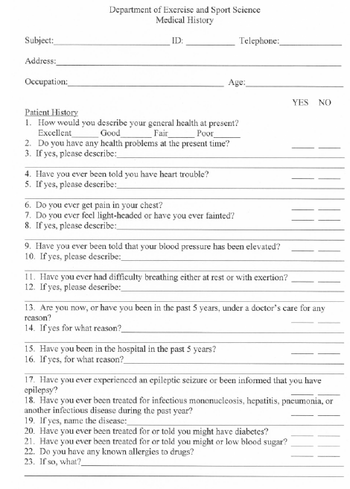

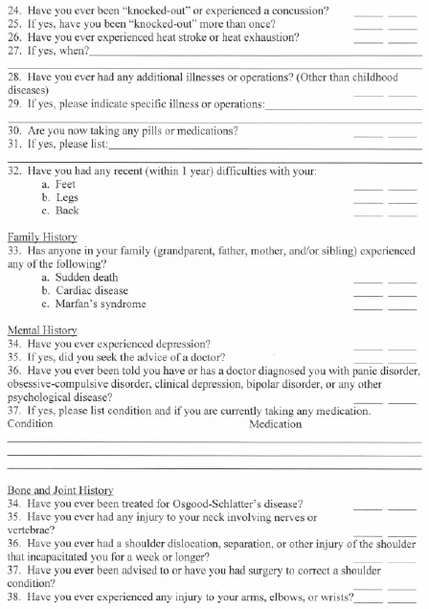

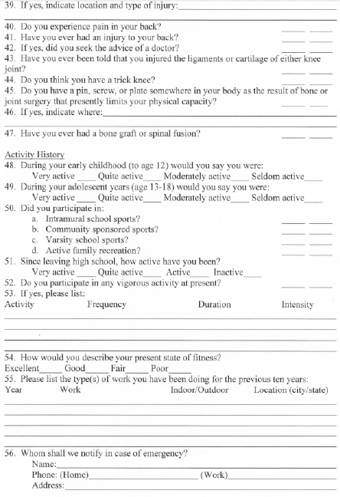



Physical Examination Screening
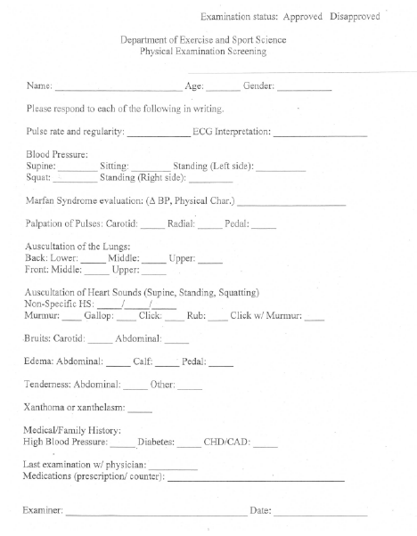

APPENDIX D

ACSM METABOLIC EQUATION FOR DETERMINING EXERCISE INTENSITY

ACSM Metabolic Equation (ACSM Guidelines, 2010)

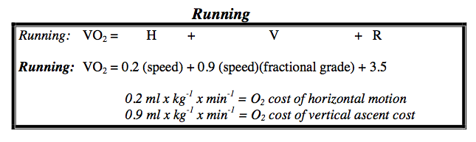

APPENDIX E
MENSTRUAL CYCLE QUESTIONNAIRE

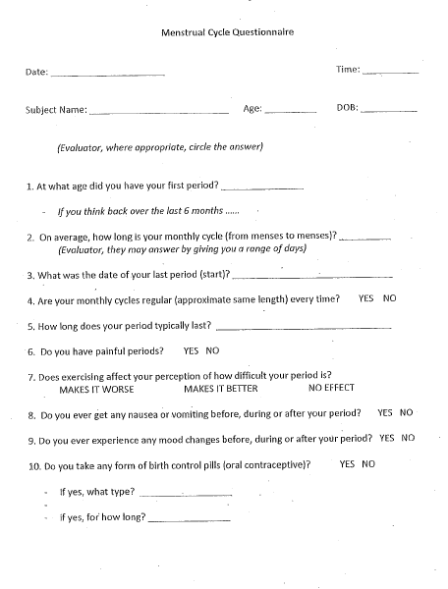

APPENDIX F
FOOD LOG

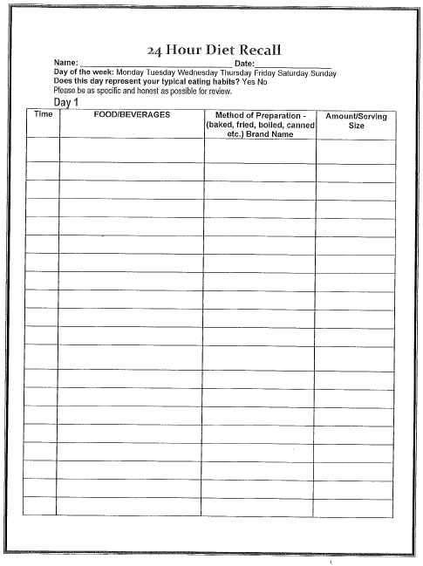
APPENDIX G
DATA COLLECTIONS FORMS
ORIENTATION SESSION
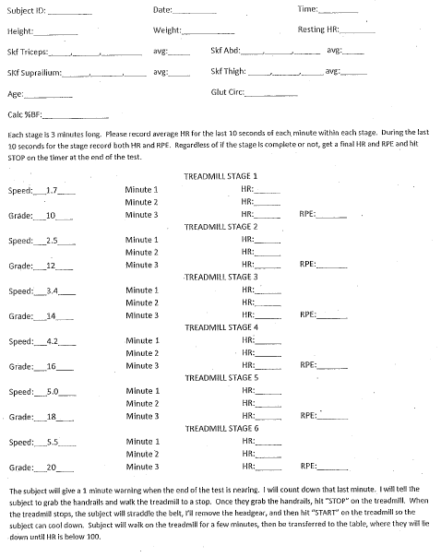

EXPERIMENTAL SESSION
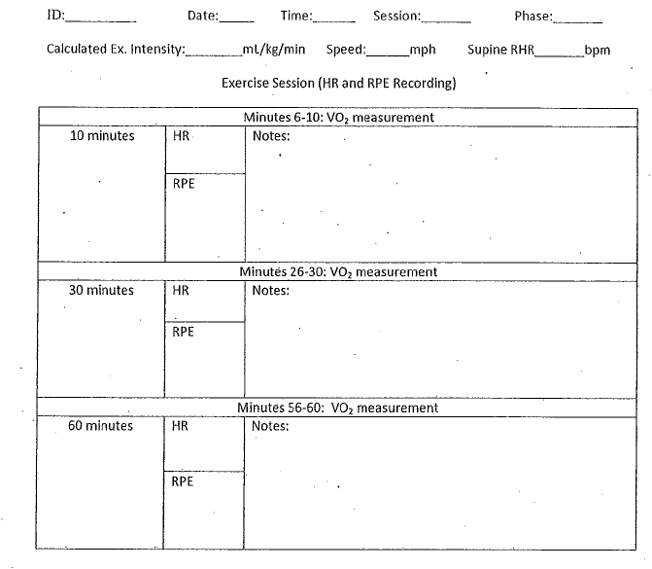

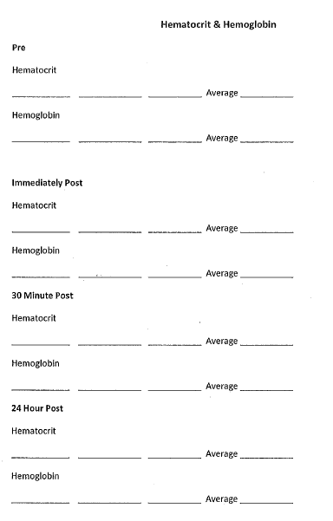

SUBJECT COMPLIANCE

Subject Compliance

Have you had anything to eat or drink, besides water, within the last two hours?

Yes No

Have you had any anti-inflammatory drugs (Advil, Tylenol, etc.) within the last 24 hours?

Yes No

Have you participated in any strenuous exercise within the last 24 hours?

Yes No

Have you had any caffeine or alcohol within the last 24 hours?

Yes No

Do you have your diet log?

Yes No

REFERENCES
Amelink, G. J., & Bar, P. R. (1986). Exercise-induced protein leakage in the rate: Effects hormonal manipulation. Journal of Neuroscience, 76, 61–8.

Amelink G. J., Koot R. W., Erich W. B., et al. (1990). Sex-linked variation in creatine kinase release, and its dependence on oestradiol, can be demonstrated in an in-vitro rat skeletal musclepreparation. Acta Physiologica Scandinavian, 138 (1), 115-24

American College of Sports Medicine. (2011). ACSM Issues New Recommendations on Quantity and Quality of Exercise. Retrieved from http://www.acsm.org/about-acsm/media-room/news-releases/2011/08/01/acsm-issues-new-recommendations-on-quantity-and-quality-of-exercise

Apple, F. S., Rogers, M. A., Sherman, W. M., & Ivy, J. L. (1984). Comparison of serum creatine kinase and creatine kinase MB activities post marathon race versus post myocardial infarction. Clinica Chimica Acta; International Journal of Clinical Chemistry, 138(1), 111-118.

Apple F. S., Rogers M. A., Casal D. C., Sherman W. M., & Ivy J. L.. (1985). Creatine kinase-MB isoenzyme adaptations in stressed human skeletal muscle of marathon runners. Journal of Applied Physiology, 59(1), 149-153.

Babiker, F. A., De Windt, L. J., van Eickels, M., Grohe, C., Meyer, R., & Doevendans, P. A. (2001). Estrogenic hormone action in the heart: regulatory network and function. Cardiovascular Research, 53, 709–19.

Bar, P. R., Amelink, G. J., Oldenburg, B., & Blankenstein M.A. (1988). Prevention of exercise-induced muscle membrane damage by oestradiol. Life Sciences, 42, 2677-2681.

Booth E. A., Flint R. R., Lucas K. L., et al. (2008). Estrogen protects the heart from ischemia-reperfusion injury via COX-2-derived PGI2. Journal Cardiovascular Pharmacology, 52(3), 228-35

Carter A, Dobridge J, & Hackney A.C. (2001). Influence of estrogen on markers of muscle tissue damage following eccentric exercise. Human Physiology, 27(5), 626-626.

Chavanne T, Gallup G. (1998). Variation in risk taking behavior among female college students as a function of the menstrual cycle. Evolution and Human Behavior. 19(1), 27-32.

Chen, Y., Serfass, R., & Apple, F. (2000). Loss of myocardial CK-MB into the circulation following 3.5 hours of swimming in a rat model. International Journal of Sports Medicine, 21(8), 561–5.
Cornell University. (2013). Creatine Kinase- CK. Retrieved from https://ahdc.vet.cornell.edu/clinpath/modules/chem/CK.HTM

Dawson, E. A., Shave, R., George, K., Whyte, G., Ball, D., Gaze, D., & Collinson, P. (2005). Cardiac drift during prolonged exercise with echocardiographic evidence of reduced diastolic function of the heart. European Journal of Applied Physiology, 94(3), 305-309.

Dill D. B., Costill D. L. (1974). Calculation of percentage changes in volumes of blood, plasma, and red cells in dehydration. Journal of Applied Physiology. (37), 247-248.

Ebbeling, C. B., & Clarkson, P. M. (1989). Exercise-induced muscle damage and adaptation. Sports Medicine, 7(4), 207–234.

Enns D. L., Tiidus P. M. (2008). Estrogen influences satellite cell activation and proliferation following downhill running in rats. Journal of Applied Physiology 104 (2), 347-53

Enns, D. L., & Tiidus, P. M. (2010). The influence of estrogen on skeletal muscle. Sports Medicine, 40(1), 41-58.

Enns, D. L., & Tiidus, P. M. (2010). The influence of estrogen on skeletal muscle: Sex matters. Sports Medicine, 40(1), 41-58.

Gilbert, S. F. (2013). Hormones and Mammalian Egg Maturation. Retrieved from http://scientopia.org/img-archive/scicurious/img_674.jpg

Hackney, A. C., C. S. Curley, & B. J. Nicklas. (1991). Physiological responses to
submaximal exercise at the mid-follicular, ovulatory and midluteal phases of the menstrual cycle. Scandinavian Journal of Medicine Science and Sport, 1: 94 – 98.

Hutcheson, K. A., Nordvall, M. P., Dennehy, C. A., Gummere, L. A., & Schneider, C. M. (1998). Plasma ck-mb isoforms following strenuous endurance exercise. Medicine & Science in Sports & Exercise, 30(Supplement), 103.

Kallman, A. L. (2011). Influence of estrogen on IL-6 response to prolonged treadmill running in elite female runners. ProQuest, UMI Dissertations Publishing).

Komulainen, J., S. Koskinen, R. Kalliokoski, T. Takala, and V. Vihko. (1999). Gender differences in skeletal muscle fibre damage after eccentrically biased downhill running in rats. Acta Physiologica Scandinavian, 165(1), 57–63

Lane, R. J. M., & Roses, A. D. (1981). Variations of serum creatine kinase levels with age in normal females: Implications for genetic counselling in Dechenne muscular dystrophy. Clinica Chemica Acta, 113, 75–86.

Miller, T. D., Rogers, P. J., Bauer, B. A., O’Brien, J. F., Squires, R. W., Bailey, K. R., & Bove, A. A. (1989). Does exercise training alter myocardial creatine kinase MB isoenzyme content? Medicine & Science in Sports & Exercise 21(4), 437–40.

Milne K. J., Noble E. G. (2008). Response of the myocardium to exercise: sex-specific regulation of hsp70. Medicine & Science in Sports & Exercise 40(4), 655-63

National Institute on Aging. (2013). National Institute on Aging. Retrieved from http://www.nia.nih.gov/health/publication/hormones-and-menopause

Pivarnik J. M., Marichal C. J., Spillman T., & Morrow J. R. (1992). Menstrual cycle phase affects temperature regulation during endurance exercise. Journal of Applied Physiology, 72(2), 543-548.

Pfeilschifter, J., Koditz, R., Pfohl, M., & Schatz, H. (2002). Changes in pro-inflammatory cytokine activity after menopause. Endocrine Reviews, 23(1), 90-119.

Pottratz, S., Bellido, T., Mocharia, H., Crabb, D., & Manolagas, S. (1994). 17β- estradiol inhibits expression of human interleukin-6 promoter-reporter constructs by a receptor-dependent mechanism The Journal of Clinical Investigation, 93, 944-950.

Puder, J., Freda, P., Goland, R., & Wardlaw, S. (2001). Estrogen modulates the hypothalamic-pituitary-adrenal and inflammatory cytokine responses to endotoxin in women. The Journal of Clinical Endocrinology & Metabolism, 86(6), 2403-2408.

Rosano, G. M., Sarrel, P. M., Poole-Wilson, P. A., & Collins, P. (1993). Beneficial effect of oestrogen on exercise-induced myocardial ischaemia in women with coronary artery disease. The Lancet, 2(8864), 133–6.

Schwarz, E., Shafer, C., Bode, J., & Bode, C. (2000). Influence of the menstrual cycle on the LPS-induced cytokine response of monocytes. Cytokine, 12(4), 413-416.

Smith, I., Elton, R. A., & Thomson, W. H. S. (1979). Carrier detection in X linked recessive (Duchenne) muscular dystrophy: Serum creatine phophokinase values in premenarchial, menstruating, postmeopausal, and pregnant normal women. Clinica Chimica Acta, 98, 207–16.

Squadrito, F., Altavilla, D., Squadrito, G., Campo, G., Ariotta, M., Arcoraci, V., & Minutoli, L. (1997). 17Beta-oestradiol reduces cardiac leukocyte accumulation in myocardial ischaemia reperfusion injury in rat. European Journal of Pharmacology, 2(335), 185–92

Tiidus, P. M., Holden, D., Bombardier, E., Zajchowski, S., Enns, D., & Belcastro, A. (2001). Estrogen effect on post-exercise skeletal muscle neutrophil infiltration and calpain activity. Canadian Journal of Physiology and Pharmacology, 79(5), 400-400.

Tiidus, P. (2003). Influence of estrogen on skeletal muscle damage, inflammation, and repair. Exercise and Sports Science Reviews, 31(1), 40-44.

Tiidus, P. (2005). Can oestrogen influence skeletal muscle damage, inflammation, and repair? British Journal of Sports Medicine, 39(5), 251–53.

Tiidus, P. M., & Bombardier, E. (1999). Oestrgen attenuates post-exercise myeloperoxidase activity in skeletal musce of male rats. Acta Pharmacologica Scandinavia, 166, 85-90.

Tiidus, P., Holden, D., Bombardier, E., Zajchowski, S., Enns, D., & Belcastro, A. (2001). Estrogen effect on post-exercise skeletal muscle neutrophil infiltration and calpain activity. Canadian Journal of Applied Physiology, 79, 400-406.

Tiidus P. M., Deller M, Liu X. L. (2005). Oestrogen influence on myogenic satellite cells following downhill running in male rats: a preliminary study. Acta Physiologica Scandanvian, 184(1), 67-72.

Tiidus, P. (2003). Influence of estrogen on skeletal muscle damage, inflammation, and repair. Exercise and Sports Science Reviews, 31(1), 40-44.

Timmons B. W., Hamadeh M. J., Devries M. C., & Tarnopolsky M. A.. (2005). Influence of gender, menstrual phase, and oral contraceptive use on immunological changes in response to prolonged cycling. Journal of Applied Physiology, 99(3), 979-985.

Totsuka, M., Nakaji, S., Suzuki, K., Sugawara, K., & Sato, K. (2002). Break point of serum creatine kinase release after endurance exercise. Journal of Applied Physiology, 93(4), 1280–6.

